

Parvum Lexicon Stemmatologicum

A brief lexicon of stemmatology
The Parvum lexicon stemmatologicum (PLS) is a scholarly digital resource providing explanations for technical terms related to stemmatology, a discipline of classical and mediaeval philology aiming at understanding the historical evolution of textual traditions. The PLS was initiated, within the framework of the Studia Stemmatologica research network, by Odd Einar Haugen, who was its editor-in-chief until May 15, 2015.
The necessity of creating such a digital resource becomes evident if one realises that stemmatology is by nature an interdisciplinary discipline, using concepts and methods from a variety of different fields: linguistics, codicology, palaeography, book history, etc. In addition, stemmatology is at the same time an old discipline (dating back from the first half of the nineteenth century in its modern form and from the Hellenistic period in its most ancient attestations) and a discipline that has recently undertaken a methodological revolution, not only because of the digital turn in the humanities, but perhaps more importantly because of the influence of phylogenetics. The PLS attempts to address the challenge of integrating old and new concepts, and besides includes the presentation of methods and tools used in stemmatology and sometimes borrowed from other disciplines, such as computer science, mathematics or biology.
Moreover, as any other venerable discipline of the humanities, stemmatology has developed according to more or less national schools or traditions, in which the same concepts are not always used in exactly the same way. The PLS tries to address this linguistic aspect by providing equivalents of the terms in French, German, Italian, and – where appropriate – Latin.
The list of editors and contributors to the PLS reflects the multidisciplinary and multicultural dimensions of this collective scholarly endeavour. In the last weeks before the release of this version 1.0 (Nov. 13, 2015), much of the work of reviewing this very complex dictionary has been taken up by Marina Buzzoni, Aidan Conti, Odd Einar Haugen, in addition to the two present editors.
The lexicon is certainly not yet perfect, the length and depth of entries varies and there may even be contradictions left here and there, but we agreed that its present state is good enough as a first online version (available also as downloadable pdf and html files). We are working on ideas to turn this resource into a second, completely revised version as a book publication. If you have suggestions, corrections, improvements, do not hesitate to send them to stemmatology (at) gmail.com.

Caroline Macé & Philipp Roelli, editors-in-chief
License: CC-BY-NC (https://creativecommons.org/licenses/)
The PLS was created through volunteer work without major funding, nonetheless it has received support from several institutions – to which we express our thanks – in particular to the Finnish Cultural Foundation, Institutum Romanum Finlandiae, the University of Bergen, the University of Helsinki, Ca’ Foscari University of Venice, the University of Zürich, and COST Action IS1005.

Contributors

Editors-in-Chief
Caroline Macé, Frankfurt am Main, Germany
Philipp Roelli, Zürich, Switzerland

Editorial board
Marina Buzzoni, Venice, Italy
Aidan Conti, Bergen, Norway
Marko Halonen, Helsinki, Finland
Odd Einar Haugen, Bergen, Norway (editor-in-chief until mid 2015)
Tuomas Heikkilä, Rome, Italy
Teemu Roos, Helsinki, Finland

Contributors
AC Aidan Conti, Bergen, Norway
CH Chris Howe, Cambridge, UK
CL Claudio Lagomarsini, Siena, Italy
CM Caroline Macé, Leuven, Belgium
GH Gerd Haverling, Uppsala, Sweden
HW Heather Windram, Cambridge, UK
JT Jamie Tehrani, Durham, UK
JZ Joris van Zundert, The Hague, The Netherlands
KH Katharina Huber, Norwich, UK
MB Marina Buzzoni, Venice, Italy
MH Marko Halonen, Helsinki, Finland
OH Odd Einar Haugen, Bergen, Norway
PR Philipp Roelli, Zürich, Switzerland
SN Svetlina Nikolova, Sofia, Bulgaria
TA Tara Andrews, Bern, Switzerland
TB Thomas Bein, Aachen, Germany
TH Tuomas Heikkilä, Rome, Italy
TR Teemu Roos, Helsinki, Finland
VM Vincent Moulton, Norwich, UK

External Reviewers
Daniel Apollon, Bergen, Norway
Eugenio Burgio, Venice, Italy
Carmen Cardelle de Hartmann, Zürich, Switzerland
Christian Janss, Oslo, Norway
Erika Kihlman, Stockholm, Sweden

Contents
- Abbreviations and editorial signs
- Addition
- Alignment
- Analysis of forms
- Ancestor
- Annotated Bibliography
- Anticipation
- APE
- Apograph
- Apomorphic
- Apparatus
- Archetype
- Arrhythmia
- Assimilation
- Author
- Autograph
- Base text
- Bayes’ theorem
- Bayesian phylogenetics
- Bédier, Joseph
- Bifid / binary / bifurcating / bipartite
- Bifurcation
- Bindefehler
- Bootstrapping
- Branch
- Character
- Chi-squared test
- Cladistics
- Cladogram
- Cladorama
- Codex
- Codex descriptus
- Codex interpositus
- Codex optimus
- Codex unicus
- Codicology
- CollateX
- Collation
- Colophon
- Combinatio
- Common errors method
- Computer-assisted stemmatology
- Conjecture
- Consensus tree
- Constitutio textus
- Contamination
- Contamination, extra-stemmatic
- Contamination, simultaneous
- Contamination, successive
- Contini, Gianfranco
- Contributors
- Copy
- Copy text
- Copying of texts
- Copyist
- Corruption
- Cycle
- Data display network
- Data formats
- Data formats for character data
- Data formats for textual data
- Data formats for trees
- Degree
- Descendant
- Diasystem
- Dictation
- Diffraction
- Directed acyclic graph (DAG)
- Dispositio
- Distance matrix
- Dittography
- Divinatio
- Document
- Duplication
- Ecdotics
- Edge
- Edition, best-manuscript
- Edition, critical
- Edition, digital
- Edition, diplomatic
- Edition, documentary
- Edition, eclectic
- Edition, monotypic
- Edition, synoptic
- Editions, history of
- Editions, types of
- Eigenfehler
- Eliminatio codicum descriptorum
- Eliminatio lectionum singularium
- Emendatio
- Emendatio ex fonte
- Error
- Error, common
- Error, conjunctive
- Error, indicative or significant
- Error, separative
- Error, types of
- Examinatio
- Exemplar
- Exemplar shift
- Facsimile
- Family (of witnesses)
- Fragment
- Gloss
- Gloss-incorporation
- Glyph
- Graph
- Group (of witnesses)
- Haplography
- Havet, Pierre Antoine Louis
- Home
- Homoeoarcton
- Homoeoteleuton
- Homoplasy
- Hyparchetype
- Innovation
- Interpolation
- Irigoin, Jean
- Itacism
- Jukes–Cantor model
- Juxta
- Lachmann, Karl
- Lachmann’s method
- Lacuna
- Leaf
- Lectio brevior, lectio potior
- Lectio difficilior, lectio potior
- Lectio facilior
- Lectio singularis
- Leitfehler
- Leithandschrift
- Likhachov, Dmitrij Sergeevich
- Locus criticus
- Locus desperatus
- Loss rate (of witnesses)
- Maas, Paul
- Manuscript
- Material accident
- Media transmitting texts
- Metathesis
- Method, Leitfehler-based
- Method, maximum likelihood
- Method, maximum parsimony
- Methods, distance-based
- Misreading
- Mouvance
- MrBayes
- NeighborNet
- Neighbour joining
- Neo-Lachmannian Philology
- Networks, evolutionary
- New Philology
- Newick format
- Nexus
- Node (vertex)
- Node, internal
- Normalisation
- Omission
- Origin
- Original
- Outgroup
- Palaeography
- Parablepsis
- Paradosis
- Parallelism
- Paris, Gaston
- Parsimoniously informative
- Parsimony
- Pasquali, Giorgio
- Path
- PAUP
- PHYLIP
- Phylogenetic networks, types of
- Phylogenetic tree
- Phylogenetics
- Phylogram
- Phylomemetics
- Plesiomorphic
- Polarisation
- Polygenesis
- Quentin, Henri
- R (Statistical Programming Language)
- Reading
- Reading, primary
- Reading, secondary
- Reading, variant
- Recensio
- Recension
- Recension, closed and open
- Recentiores non deteriores
- Reconstruction
- Redaction
- Redactor
- Reeve, Michael D.
- Reference text
- Regularisation
- Reticulation
- Reticulogram
- Revision
- RHM
- Root
- Saut du même au même
- Schlyter, Carl Johan
- Scribal conjecture
- Scribe
- Scuola storica
- Segre, Cesare
- Selectio
- Semstem
- Set
- Siglum
- Sonderfehler
- Split
- SplitsTree
- Stemma
- Stemmatics
- Stemmatology
- StemmaWeb
- Stemweb
- Subarchetype
- Substitution
- Subtree
- Symplesiomorphic
- T-Rex method
- Taxon
- Text
- Textual criticism
- Textual scholarship
- Textual variance
- Timpanaro, Sebastiano
- Tools
- Tradition
- Tradition, artificial
- Tradition, indirect
- Transmission
- Transmission, types of
- Transposition
- Tree
- Tree, unrooted
- Trennfehler
- UPGMA
- Usus scribendi
- Variance (Mathematical)
- Variant (reading)
- Variant graph
- Variant location
- Version
- Vulgarisation
- Vulgate
- West, Martin Litchfield
- Witness
- Work

Abbreviations and editorial signs
Editions and apparatuses tend to use a lot of abbreviations and sigla. Unfortunately even within one and the same scholarly field there are often different, and even contradictory usages; nonetheless it seemed to make sense to list a few abbreviations and editorial signs that are often used.
1. Critical signs are used within the text to indicate editorial interventions or doubts.
Brackets:
- < … > addendum should be added to the text (but is lost in the archetype)
- […] delendum should be deleted from the text (but stands in the archetype)
- (…) is sometimes used for resolved abbreviations from the manuscript, like: eccl(esia)m. Usually only used when editing a single witness (cf. copy text)
- ⌊...⌋ addendum ex interpretatione may be used to characterise text that was translated back by the editor from an old translation whose exemplar seems to have had it.
Note that brackets are especially prone to different usage. Philologists of the classical languages often use them as stated, but e.g. the Oxford Classical Texts series uses them differently:
- < ... > addendum
- { ... } delendum.
Maas (1960) recommends [[ ... ]] or { ... } as delendum, reserving [...] for mechanical lacunae.
Some other often used editorial signs:
- † … † locus desperatus, unresolvable corruption, sometimes referred to as ‘crux’
- *** lacuna
- ạḅ dots below letters indicate uncertain readings
- ⌊ ... ⌋ may be used for an addition based on a mediaeval translation in a different language than the text's (indirect tradition)
- A¹, A² ... readings introduced by later hands (details should be explained in a section on sigla, usually right before the edited text) – cf. sigla.
Among the witnesses quoted in the apparatus criticus, manuscripts are usually abbreviated with capital Latin letters, early prints with minuscule Latin ones, and families (i.e. the readings of reconstructed hyparchetypes) by Greek capital letters.
2. Next to those critical signs, abbreviations are often used in the apparatus criticus, generally written in Latin.
Some commonly used abbreviations:
- a.c. ante correctionem a reading in a manuscript before it was altered (be it by the same scribe or a later one)
- a.m. alia manu written by another hand
- conj. conjecit conjecture by a modern scholar (usually followed by his name)
- corr. correxit corrected
- del. delevit deleted
- eras. erasum erased
- exp. expunxit expunged
- inv. invertit inverted
- iter. iteravit repeated
- lac. lacunaa lacuna in the witness
- l. dub. lectio dubia hard to decipher reading
- (in) mg. in margine written in the margin
- om. omisit an omission in some manuscripts
- add. addidit an addition in some manuscripts
- p.c. post correctionem a reading in a manuscript after it was altered (be it by the same scribe or a later one). In case several layers of change can be identified, numbers may clarify to which one a particular change belongs (see sigla)
- ras. sub rasura mechanically deleted in the manuscript by scraping off
- s.l. supra lineam addition made above the line in a manuscript
- superscr. superscriptum the same as s.l.
- ut vid. ut videtur ‘as it seems’, for uncertain manuscript readings.
- transp. transposuit transposed
A long list of signs and abbreviations can be found in appendix 1 of Bernabé and Hernández Muñoz (2010).
3. In the apparatus fontium, names of authors and titles, especially of Biblical books, are often abbreviated.

References
– Bernabé, Alberto, and Felipe G. Hernández Muñoz. 2010. Manual de crítica textual y edición de textos griegos. 2nd ed. Madrid: Akal.
– Maas, Paul. 1960. Textkritik. 4th ed. Leipzig: Teubner. – First ed. 1927.
In other languages
DE: Abkürzungen und Sigla
FR: abréviations et signes critiques
IT: abbreviazioni e segni convenzionali
PR (with help from CM)

Addition
An addition is any segment of text that a copyist introduces into the copied text (one that is not present in the exemplar). In the process of collating and editing the term addition is a relative one which only indicates that a segment of text which is lacking in the base-text is present in some witness(es), without making a judgement whether the addition is secondary or not.
Cf. its contrary omission, and types of errors.

References
– Havet, Louis. 1911. Manuel de critique verbale appliquée aux textes latins. Paris: Librarie Hachette.

In other languages
DE: Hinzufügung
FR: addition
IT: aggiunta / interpolazione
AC, CM

Alignment
During collation it may be useful to align the text of several or all witnesses, that is to write their text in a txt-document with spaces so that the parts corresponding to one another are below one another. Compare the illustration below. Alternatively many editors use spread-sheets containing one word per cell to align their collations. There are software programs able to perform this task quite well today.
Cf. data formats for textual data.
Illustration
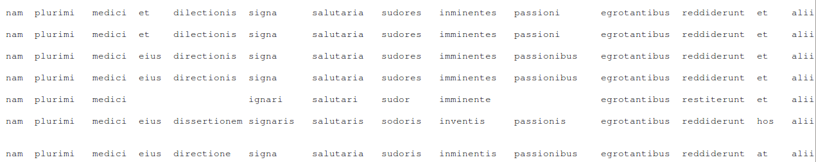
Fig. 1. An aligned collation from a medical text, currently being edited at the University of Zurich, displaying seven witnesses' text. Where words are missing they are replaced by blank space.

In other languages
DE: Alignment (there seems to be no German word in use)
FR: alignement
IT: allineamento
PR

Analysis of forms
As Gaston Paris stated for the first time, in textual criticism a clear distinction should be made between "the analysis of readings" (i.e. the substance of the text, in Contini's terminology) and the "analysis of forms" (i.e. the linguistic features of the text): "Les leçons sont établies sur la classification des manuscrits, les formes sont restituées d'après l'appréciation critique de la langue du poète" (1872: VII, "The readings are established based on the classification of the manuscripts, the forms are restituted according to a critical appreciation of the poet's language").
If Lachmann's method often allows to reconstruct, with various degrees of certainty, the original readings of a given text, it is much more difficult, and to a large extent even impossible, to reconstruct its original "form" (i.e. orthography, punctuation..., see: normalisation). For an adaptation of this principle to texts written in Middle Arabic, see La Spisa 2012.
A further distinction should be made, within the analysis of forms, between what Trovato calls "core" ("the original language of a text") and "patina" ("the linguistic sedimentation that is certainly due to the copyists") (Trovato 2014, 231; see also Leonardi 2014, 45-52). Cf. vulgarisation.

References
– La Spisa, Paolo. 2012. "Perspectives ecdotiques pour textes en moyen arabe: l'exemple des traités théologique de Sulaymān Al-Ġazzī", in: Zack, Liesbeth - Schippers, Arie (eds.), Middle Arabic and Mixed Arabic.Diachrony and Synchrony. Leiden: Brill, 187-208.
– Leonardi, Lino (ed.). 2014. Gianfranco Contini. Filologia. Bologna: il Mulino.
– Paris, Gaston. 1872. La vie de saint Alexis. Poème du XIe siècle et renouvellements des XIIe, XIIIe et XIVe siècles. Paris: Franck.
– Trovato, Paolo. 2014. Everything You Always Wanted to Know about Lachmann’s Method: A Non-Standard Handbook of Genealogical Textual Criticism in the Age of Post-Structuralism, Cladistics, and Copy-Text. Foreword by Michael D. Reeve. Firenze: Libreriauniversitaria.it edizioni.

In other languages
DE: Analyse der Formen
FR: analyse des formes
IT: analisi delle forme
CM

Ancestor
An ancestor of a preserved witness is a witness from which it was directly or indirectly copied. It may be extant or lost. The youngest ancestor of a witness is its exemplar; on the other hand its earliest ancestor that can be reconstructed from all preserved witnesses is called the archetype. In the ideal situation of a tradition without contamination, all ancestors of a witness are in a series of always one exemplar until the archetype is reached. With contamination the situation becomes more complicated, as one manuscript can be copied on several exemplars, or at least receive some readings from different ancestors.
The antonym to 'ancestor' is 'descendant'. Compare the similar distinction between exemplar and copy, which, in contrast to the former two terms, may not have intermediate witnesses between the two.

In other languages
DE: Vorfahre
FR: ancêtre
IT: antenato
PR

Annotated Bibliography
This brief, annotated, general bibliography consists of each editor's favourite stemmatological book and a short phrase why he or she considers it very important:
– Beccaria, Gian Luigi, ed. 2004. Dizionario di linguistica, e di filologia, metrica, retorica. Nuova edizione. Torino: Einaudi. – An encyclopedic dictionary which includes the definitions of major notions in the field of textual criticism, accompanied by illustrative examples. A collaborative work carried out by 40 scholars.
– Bein, Thomas. 2011. Textkritik: Eine Einführung in Grundlagen germanistisch-mediävistischer Editionswissenschaft. Frankfurt am Main: Peter Lang. – An introduction in scholarly editing of mediaeval German texts, with exercises for students and a short glossary of stemmatological and philological terms.
– Foulet, Alfred, and Mary Blakely Speer. 1979. On Editing Old French Texts. Lawrence: The Regents Press of Kansas. – One of few introductions to the editing of mediaeval texts; of great interest also for other literatures than Old French. It contains a concise introduction to editorial philology and the Bédier controversy, and a detailed and practical discussion of actual editing.
– Greetham, David C. 1994. Textual Scholarship: An Introduction. New York: Garland. – A fine introduction to the academic study of texts, putting editorial philology into a broader context, such as the disciplines of bibliography (in various forms), palaeography and typography. Of the nine chapters, ch. 8 and 9 deal with textual criticism and scholarly editing, and even if this book is written mostly from the perspective of modern (i.e. post-Gutenberg) texts, the author shows that he has an impressive overview of the entire field.
– Havet, Louis. 1911. Manuel de critique verbale appliquée aux textes latins. Paris: Librarie Hachette. – An extensive study of the types of errors and a fascinating attempt to explain how they arise in the course of historical transmission. Havet argued that earlier explanations favouring graphical misapprehension were perhaps overly simple and missed more likely sources for variation. The book is also known for distinguishing true variants (leçons vraies) and authentic variants (leçons authentiques).
– Hunger, Herbert, Otto Stegmüller, Hartmut Erbse, Max Imhof, Karl Büchner, Hans-Georg Beck, and Horst Rüdiger. 1961–1964. Geschichte der Textüberlieferung der antiken und mittelalterlichen Literatur. Vol. I: Antikes und mittelalterliches Buch- und Schriftwesen. Überlieferungsgeschichte der antiken Literatur. Vol. II: Überlieferungsgeschichte der mittelalterlichen Literatur. Zürich: Atlantis-Verlag. – Gives a good and detailed overview of different kinds of textual traditions from antiquity and the middle ages (incl. the Bible). Every section is written by one of the then leading experts in the field.
– Lemey, Philippe, Marco Salemi, and Anne-Mieke Vandamme, eds. 2009. The Phylogenetic Handbook: A Practical Approach to Phylogenetic Analysis and Hypothesis Testing. 2nd ed. Cambridge: Cambridge University Press. – The book presents a broad review of phylogenetic techniques, including among others, maximum parsimony, maximum likelihood, and distance-based methods. Each topic is divided into two chapters, one detailing the theory and assumptions underlying the approach in question and another one containing step-by-step instructions for running analyses based on the approach using one or more software packages.
– Luiselli Fadda, Anna Maria. 1994. Tradizioni manoscritte e critica del testo nel Medioevo germanico. Roma: Laterza. – Part I (Il segno scritto) focuses on the Germanic manuscript traditions in a comparative perspective. Part II (Codici e copisti) provides a full introduction to the mediaeval codex as a material object, and to the copy process theory. Part III (Il recupero storico del testo) deals with the major issues of restitutio textus. A brief glossary is provided at the end of the book (pp. 265-271).
– Martens, Gunter, ed. 2013. Editorische Begrifflichkeit: Überlegungen und Materialien zu einem “Wörterbuch der Editionsphilologie”. Berlin: Walter de Gruyter. – The book contains 18 essays/articles dealing with the project of a ‘Dictionary of scholarly editing’.
– Nutt-Kofoth, Rüdiger, Bodo Plachta, H.T.M. van Vliet, and Hermann Zwerschina, eds. 2000. Text und Edition: Positionen und Perspektiven. Berlin: Erich Schmidt. – The book contains 18 essays on scholarly editing with a focus on its history and on the relationship between texts and their editions.
– Stussi, Alfredo, ed. 2006. Fondamenti di critica testuale. Nuova edizione aggiornata. Bologna: il Mulino. – This handbook contains nine essays taken from works written by highly influential authors in the history of scholarly editing (G. Paris, J. Bédier, A. Vàrvaro, G. Contini, C. Segre, S. Timpanaro). A couple of essays deal with authorial philology (A. Stussi) and the philology of printed texts (N. Harris). The last chapter (A. Bozzi) provides a brief overview of digital philology.
– Semple, Charles, and Mike Steel. 2003. Phylogenetics. Oxford: Oxford University Press. – This graduate-level textbook is mathematical in nature and nicely brings together numerous results central to the area of phylogenetics which otherwise would be spread over an ever increasing body of literature. In addition, it outlines how algorithms for phylogenetic tree reconstruction could be derived from the mathematical theory and also comments on the biological significance of some of the included concepts. The book is self-contained and easy to read with exercises at the end of each chapter.
– Trovato, Paolo. 2014. Everything You Always Wanted to Know about Lachmann’s Method: A Non-Standard Handbook of Genealogical Textual Criticism in the Age of Post-Structuralism, Cladistics, and Copy-Text. Foreword by Michael D. Reeve. Firenze: Libreriauniversitaria.it edizioni. – Introduction to Neo-Lachmannian philology and especially Italian scholarship in the field during the 20th century.
- Van Reenen, Pieter, and Margot Mulken, eds. 1996. Studies in Stemmatology. With the assistance of Janet Dyk. Amsterdam: John Benjamins. – A basic introduction to principles, methods, techniques, and application of stemmatology. Includes some critical reflection on the various approaches and traditions. A good overall primer for people new to the field.
PR

Anticipation
Anticipation loosely describes a possible cause for an omission in a text. The term suggests a copyist who reads ahead (in the exemplar) of the text being written (in the copy) and therefore omits a section of the exemplar in the copy text.
Cf. types of errors.

In other languages
DE: Antizipation
FR: anticipation
IT: anticipazione
AC

APE
APE or Assistant for Philological Explorations is a free and open source (MPL/GPL licenses) stand alone computer program (that is, non web based but rather to be installed and run on a local machine). Its functional purpose is to assist in the exploration and interpretation of text corpora stored on a local computer system. APE allows users to create annotations locally, so they remain stored on the local machine. But APE is also able to link information found on the Internet to the text of a computer stored file as annotation. APE contains an editor that allows for the display of primary sources (such as facsimile and transcriptions) and the creation and addition of annotations to such primary sources.
APE's latest version has been developed for Windows '98/NT in Delphi 7. Tested compatibility is up to Windows 7, but APE is likely to work seamlessly with Windows 8 as well.
APE differs from most annotation tools in that it goes to length to support canonical referencing — i.e. references such as "De finibus, book 1, sections 32–3" that point to particular sections in a work rather than to places in concrete instances of the work in, for instance, books. To this end it applies a DNS or middleware-like strategy that maps such canonical references to concrete links that point into concrete digital representations of the text. This means that links associated with canonical references are not hard links (i.e. directly to some digital resource) but identifiers (URNs) that must be resolved by an external process. One can compare this process to how a contacts list works. The canonical reference is the name used in everyday life, e.g. 'Louisa'. The formal name of this person (e.g. 'Louisa C. Radtcliff') which is listed in the contacts list is the URN (formal identifier). The contacts list gives the phone number (the actual link) of the phone that will connect you to the person identified by that particular name. Therefore if the person changes her phone number, her (canonical referenced) identity remains the same, and only the phone number needs to be updated in the list. APE supports this type of reference inter alia by letting users define a canonical referencing system in separate XML files.
This strategy gives APE two advantages. The first is that if a webpage’s address (http link) changes, only one change has to be made in the annotation system. As can be perused from the example in table 1, the user would only change the one concrete link (in the rightmost column), while all the canonical references used in the texts and annotations would remain the same. The second advantage is that users can keep to a well known and well established referencing system rather than having to adopt a hypertext-based referencing system not specifically fitted for referencing the textual resources worked with.
Canonical reference used/read by user | URN/Identifier used by machine | Resolved http link to actual web page
Genesis 1:4 | //bible/kingjamesversion/genesis/1/4 | https://www.biblegateway.com/passage/?search=Genesis+1-4&version=KJV
Genesis 1:4 | //bible/statenvertaling/genesis/1/4 | http://www.statenvertaling.net/bijbel/gene/1.html
Genesis 1:4 (Statenvertaling) | //bible/statenvertaling/genesis/1/4 | http://www.statenvertaling.net/bijbel/gene/1.html
Table 1: Tabular example of resolving canonical references as hypertext links to concrete information on the Internet.

References
– Boot, Peter. 2009. Mesotext: Digitised Emblems, Modelled Annotations and Humanities Scholarship. Amsterdam: Amsterdam University Press.
– Köhler, Dieter. 2006. “Persistent Links for the Internet: Fundamentals and Implementation.” In Literary and Linguistic Computing 21 (Suppl. Issue): 77–86.
– ———. 2015. APE: “Assistant for Philological Explorations.” Personal web page for Dieter Köhler. Accessed 5 October 2015. http://www.philo.de/ape/.
JZ

Apograph
The word was borrowed from the Greek ἀπόγραφον ‘transcript, copy’ (cf. autograph).
An apograph is a new manuscript produced by a copyist who is copying a text found in an earlier manuscript, an exemplar. If the older manuscript is still extant the apograph is generally not used when a text is edited, since it contains nothing of independent value regarding the textual contents (codex descriptus). However, if a part of the older manuscript is not legible or even lost, the apograph may be used to provide information about that particular part. In addition, the apograph will provide the scholar with interesting information about the transmission of the text.

References
– Pasquali, Giorgio. 1952. Storia della tradizione e critica del testo. 2nd ed. Firenze: Le Monnier. || See p. 43.
– West, Martin L. 1973. Textual Criticism and Editorial Technique Applicable to Greek and Latin Texts. Stuttgart: Teubner. || See pp. 12, 68, 86, 118–119.

In other languages
DE: Abschrift
FR: apographe
IT: apografo
GH

Apomorphic
From Greek ἀπό (a preposition meaning “from”, “out of”) and μορφή (“form”).
In cladistics, as theorised by Willi Hennig (cf. Schmitt 2013), a character or a character state may be plesiomorphic (ancestral or primitive) or apomorphic (derived). The polarisation of characters (the determination of the direction of character change), which is at the core of the phylogenetic method, is comparable to the concept of "error of copying" in the Lachmann's method. An apomorphic character state is equivalent to a secondary reading.

References
– Kitching, Ian J., Peter L. Forey, Christopher J. Humphries, and David M. Williams. 1998. Cladistics: The Theory and Practice of Parsimony Analysis.2nd ed. Oxford: Oxford University Press.
– Schmitt, Michael. 2013. From Taxonomy to Phylogenetics: Life and Work of Willi Hennig. Leiden: Brill.

In other languages
DE: apomorph
FR: apomorphique
IT: apomorfo
CM

Apparatus
[æpəˈreɪtəs]
The word is derived from the Latin apparātus (gen. apparātūs) 'preparation, equipment, instruments etc.' which is an abstract noun to the verb ad-parō 'to prepare, provide, furnish'. An apparatus (pl. apparatus or apparatuses) is a critical tool that complements the text of the editor and elucidates one or more of the following: the editorial (re)construction of the text (critical apparatus), the witnesses in which the current portion of the text is present, and the identification of source material referenced within a text. The term is most commonly used for the critical apparatus.
Critical apparatus
The term apparatus criticus may have been used for the first time in Bengel's book title D. Io. Alberti Bengelii Apparatus criticus ad Novum Testamentum, Tubingae 1763 (cf. Timpanaro 1981, 35; Timpanaro 2005, 65). The use of sigla seems to have been widespread already in the renaissance during collation but was not used in the actual editions (which leads Flores 2002 to his claim that Heinsius might be considered the inventor of the apparatus criticus, cf. Reeve 2006).
A critical apparatus (apparatus criticus) records variants among witnesses to the text according to editorial principles, which may limit recorded readings to 'significant' variants or offer a fuller range of variant readings. Broadly speaking, it is possible to distinguish a positive apparatus, in which the instances of both accepted and rejected readings are recorded, and a negative apparatus, in which only discordant readings are noted. For example, where a text reads notae, a negative apparatus might appear as: 12 notae] uotae ABC. An example of a positive apparatus for the same scenario might appear as: 12 notae DFGLOP] uotae ABC.
Other types of apparatuses
An additional register, the apparatus fontium, may be provided to identify sources for passages in the edited text. An apparatus locorum parallelorum may indicate any similar passage which need not be a source. The apparatus biblicus is a special type of an apparatus fontium. A comparative apparatus may show differences between quoted text in a work (e.g. a florilegium) and the quoted source itself. Other kinds of apparatuses may be used to give further information about the edited text, e.g. listing marginal notes in the witnesses, or indicating parallel passages within the same work (see Giannouli 2015).

Illustration
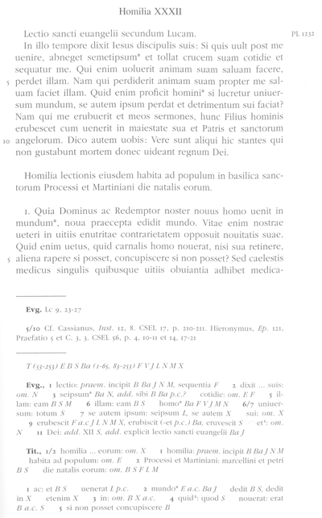
Fig. 1. A page from the Corpus Christianorum Series Latina edition of Gregory the Great's homilies on the gospels showing an apparatus fontium as the top register of the apparatus and a critical apparatus below (from Étaix 1999, 277).

References
– Battezzato, Luigi. 2006. “Johannes Livineius (1546–1599) and the Birth of the Apparatus Criticus.” In: History of Scholarship: A Selection of Papers from the Seminar on the History of Scholarship held annually at the Warburg Institute, edited by Christopher Ligota and Jean-Louis Quantin, 75–111. Oxford: Oxford University Press.
– Étaix, Raymond, ed. 1999. Gregorius Magnus: Homiliae in euangelia. Corpus Christianorum Series Latina (CCSL), vol. 141. Turnhout: Brepols.
– Flores, Enrico, and Domenico Tomasco. 2002. “Nascita dell'apparato critico.” In: Vichiana, 4a seria, anno 4 (1/2002): 3–6.
– Giannouli, Antonia. 2015. “Critical editions and the complementary apparatuses to a critical apparatus.” Comparative Oriental Manuscript Studies Bulletin 1/1: 21–28. Accessed 11 October 2015 http://www1.uni-hamburg.de/COMST/bulletin.html.
– Pöhlmann, Egert. 1994–2003. Einführung in die Überlieferungsgeschichte und in die Textkritik der antiken Literatur. Vol. 1: Antike (1994), Vol. 2: Mittelalter und Neuzeit (2003). Darmstadt: Wissenschaftliche Buchgesellschaft.
– Reeve, Michael D. 2006. “Lucretius from the 1460s to the 17th century: Seven questions of attribution.” Aevum 80 (1): 165–184. http://www.jstor.org/stable/20861797
– Timpanaro, Sebastiano. 1981. La genesi del metodo del Lachmann. 2nd ed. Padova: Liviana. – 1st ed., Firenze: Le Monnier, 1963.
– ———. 2005. The Genesis of Lachmann’s Method. Translated by Glenn W. Most. Chicago: University of Chicago Press. – Translated from Timpanaro 1981.

In other languages
DE: Apparat, kritischer Apparat
FR: apparat, apparat critique
IT: apparato, apparato critico
AC and PR (etymology)

Archetype
[ˈɑːkɪtaɪp]
The word is derived from the classical Greek compound ἀρχέτυπον 'archetype, pattern, model, exemplar' which was often opposed to ἀπόγραφον 'copy' (cf. apograph). The compound itself consists of ἀρχή 'beginning' and τύπος 'the effect of a blow or of pressure' and thus 'impression, seal, engraving etc.'. Renaissance scholarship (written in Latin) tends to use the word in the classical Latin sense as 'autograph' (Irigoin 1977); this may cause confusion as the scholarly modern meaning (below) is rather different.
An archetype is a reconstruction of the (or: one of the) original text state(s) as far as the surviving witnesses can attest the original state of the text. Since the original has very rarely survived from classical or mediaeval times and since a large part of the earliest manuscripts of any work is normally lost, it is hardly ever possible to reconstruct the text of the original. The archetype is thus only an approximation to the original text, getting as far back in the reconstruction as the extant witnesses allow, and its text is just as good as the preserved manuscripts allows it to be. In some cases, however the archetype may be extant. For example, Giorgio Pasquali speaks of the “archetipo conservato delle Metamorfosi di Apuleio” (1934, 33).
In a stemma, the archetype is placed immediately below the original, and, especially in classical philology, it is often denoted by Greek letters. The illustration shows the (possibly long and complex) path between the original (X) and the archetype (α). It should be noted that for some works, more than one version of the original may be assumed (e.g. one reworked by the author), and that for similar reasons more than one (state of the) archetype may exist. Editors may correct evident errors in their reconstructed archetypal text and use philological judgement to try to approach the original text further (cf. emendatio).
In certain traditions (especially very contaminated or fragmentary ones) it may be impossible to arrive at an archetype. In some cases there may be more than one archetype (e.g. when a text is assembled from various sources). See also hyparchetype.
The term most recent common ancestor (MRCA) in evolutionary biology corresponds to the 'archetype' in textual criticism. The archetype in a stemma corresponds to the root in a phylogenetic tree.
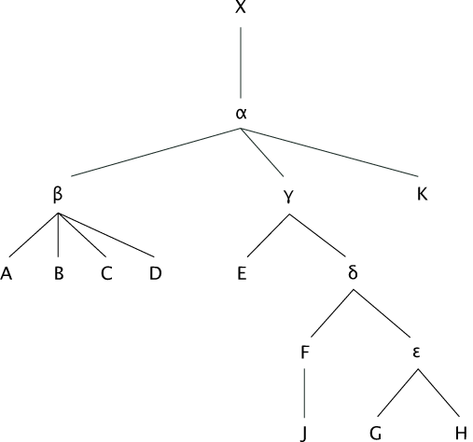
Fig. 1. A re-drawn and simplified version of the stemma published in Maas (1960, 7).
In fig. 1, X is the original, α the archetype, while β and γ are hyparchetypes.

References
– Berschin, Walter. 2007. “Lachmann und der Archetyp.” In Theoretical Approaches to the Transmission and Edition of Oriental Manuscripts, edited by Judith Pfeiffer and Manfred Kropp, 251–257. Beirut: Orient-Institut Beirut.
– Irigoin, Jean. 1977. “Quelques réflexions sur le concept d’archétype.” Revue d’Histoire des Textes 7: 235–245. – Reprinted in Jean Irigoin. 2003. La tradition des textes grecs: Pour une critique historique, 37–53. L’âne d’or, vol. 19. Paris: Les Belles Lettres.
– Maas, Paul. 1960. Textkritik. 4th ed. Leipzig: Teubner. – 1st ed. 1927.
– Pasquali, Giorgio. 1934. Storia della tradizione e critica del testo. Firenze: Le Monnier. – 2nd ed. Firenze: Le Monnier, 1952.
– Reeve, Michael D. 1985 [1986]. “Archetypes.” Sileno: Rivista di studi classici e cristiani 11 (1–4): 193–201. – Reprinted in Michael D. Reeve. 2011. Manuscripts and Methods: Essays on Editing and Transmission, 107–117. Roma: Edizioni di storia e letteratura.
– ———. 2007. “Reconstructing Archetypes: A New Proposal and an Old Fallacy.” In Hesperos:Studies in Ancient Greek Poetry Presented to M.L. West, edited by P.J. Finglass et al., 326–340. Oxford: Oxford University Press. – Reprinted in Michael D. Reeve. 2011. Manuscripts and Methods: Essays on Editing and Transmission, 119–131. Roma: Edizioni di storia e letteratura.
– Trovato, Paolo. 2005. “Archetipo, stemma codicum e albero reale.” Filologia italiana 2: 9–18.

In other languages
DE: Archetyp
FR: archétype
IT: archetipo
OH and PR (etymology)

Arrhythmia
Arrhythmia, from Greek ἀρρυθμία, refers to a lack of regularity (ῥυθμός) or a skip in a beat or pulse. In textual criticism, the term describes a skip in the reading activity of the eyes which in turn can produce haplography, if the eyes skip ahead in the exemplar, or dittography, if the eyes skip back in the exemplar text.
Cf. types of errors.

In other languages
Graeco-Latin term used throughout.
AC

Assimilation
Assimilation may refer to two distinct but similar processes. The first describes the way in which a scribe may write a word so that it resembles another nearby word. For example, 'an excellent examplic of the rhetoric' in which 'example' has been assimilated to the coming 'rhetoric' (West 1973, 24).
The second process described as assimilation refers to the incorporation of wording from a parallel narrative, witness or text into the copy text. This process is sometimes referred to as contamination, a term which is viewed as somewhat misleading in its pejorative connotations, or horizontal transmission.
Cf. types of errors.

Reference
– West, Martin L. 1973. Textual Criticism and Editorial Technique Applicable to Greek and Latin Texts. Stuttgart: Teubner.

In other languages
DE: Assimilation
FR: assimilation
IT: assimilazione
AC

Author
The author of a work is the person (possibly persons) who wrote it. The term is usually employed in the case of works whose penning involves a creative element; thus the author is differentiated (albeit gradually) from a compiler or redactor, and even more so from the scribe. This same criterion is used today in copy-right laws. In ancient and mediaeval literature there are works which cannot be attributed to a single author and many whose author is anonymous or pseudonymous. If the work is preserved in the author's handwriting, the manuscript that kept it is called an autograph. In New Philology the concept author is abolished in the wake of postmodernism (esp. Barthes 1968).

References
– Barthes, Roland. 1968. “La mort de l’auteur.” Mantéia 5. – Reprinted in Roland Barthes. 1977. Image, Music, Text. Translated by Stephen Heath. New York: Hill and Wang.
– Schnell, Rüdiger. 1998. “‘Autor’ und ‘Werk’ im Deutschen Mittelalter: Forschungskritik und Forschungsperspektiven.” In: Neue Wege der Mittelalter-Philologie: Landshuter Kolloquium 1996, edited by Joachim Heinzle, L. Peter Johnson, and Gisela Vollmann-Profe, 12–73. Wolfram-Studien, vol. 15. Berlin: Erich Schmidt Verlag.

In other languages
DE: Autor
FR: auteur
IT: autore
PR

Autograph
The word is derived from the Greek adjective αὐτόγραφος ‘written with one’s own hand’. In manuscript studies, an autograph is a witness written by the author himself. For texts from antiquity and the middle ages it is very rare that such autographs are today still extant (examples in Chiesa 1994). For scholars of stemmatology, matters become more complicated if the author revised the autograph, sometimes repeatedly. Copyists may copy revised and unrevised text or choose between the two, which may lead to a situation of having an archetype containing variants in some places. An example of an extant mediaeval autograph is the work Periphyseon by 9th century author John Scotus Eriugena (cf. Jeauneau & Dutton 1996) in Reims, Bibliothèque Municipale, 875. This manuscript is written in several hands, at least one of which seems to be the author’s. In case the author wrote only one autograph and it is extant, it is equivalent to the text’s archetype.

References
– Jeauneau, Edouard, and Paul Edward Dutton. 1996. The autograph of Eriugena. Turnhout: Brepols.
– Chiesa, Paolo, and Lucia Pinelli, eds. 1994.Gli autografi medievali: Problemi paleografici e filologici. Spoleto: Centro italiano di studi sull'alto Medioevo (CISAM).

In other languages
GE: Autograph
FR: autographe
IT: autografo
PR

Base text
Cf. copy text.

Bayesian phylogenetics
[ˈbeɪzɪən]
Bayesian methods are a general approach to statistical inference where observations are combined with formally specified a priori knowledge, or prior for short. Inference is performed by probability calculus and the result is an updated, a posteriori, state of knowledge, or posterior for short. Both the prior and the posterior are represented as probability distributions over different states of affairs. In phylogenetics, the states of affairs over which the prior and posterior are given typically correspond to different phylogenetic tree structures and the associated parameter values.
The advantages of Bayesian phylogenetic methods include a natural way to express prior knowledge, an automatic quantification of uncertainty, and the possibility to combine different data sources that may, e.g., describe different subsets of the taxa, or different data types such as DNA and protein sequences as well as phenotypic observations.
A popular software package for Bayesian phylogenetic inference is MrBayes. See tools.
In other languages
DE: Bayessche Phylogenetik
FR: phylogénie bayésienne
IT: filogenesi Baynesiana
TR

Bayes’ theorem
The Bayes' theorem (attributed to Rev. Thomas Bayes, c. 1701-1761) is a simple result in probability theory. Despite its simplicity, it can be used to derive very interesting and useful results by combining prior knowledge and empirical evidence.
The prior knowledge is represented in terms of a probability, Pr[hypothesis], associated to any given hypothesis. In the case of stemmatological analysis, the hypothesis may, for instance, correspond to a statement that a specific stemma represent the actual copying history of the tradition under study. In case there is no reason to prefer any of the stemmata over others, the prior may be uniform so that Pr[hypothesis] = 1/M, where M is the number of possible stemmata.
The application of Bayes' theorem requires that the probability of the empirical evidence given a hypothesis can be evaluated. If, for instance, evidence is in the form of a number of extant textual variants and the hypothesis corresponds to a stemma, we also need a probabilistic model describing the probabilities of different changes of the text in the process of copying. Given such a model, we can evaluate the probability of the evidence, Pr[evidence | hypothesis].
The theorem states that the prior probability, Pr[hypothesis], and the probability of the evidence given the hypothesis, Pr[evidence | hypothesis], can be combined in the following way to obtain the posterior probability of the hypothesis given the evidence, Pr[hypothesis | evidence]:
Pr[hypothesis | evidence] = Pr[hypothesis] x Pr[evidence | hypothesis] / Pr[evidence],
where 'x' denotes multiplication.
The last quantity, Pr[evidence], may sometimes cause difficulties since it requires that we are able to associate a probability to the evidence without an assumed hypothesis. This often requires that we evaluate the sum of Pr[hypothesis] x Pr[evidence | hypothesis] over all possible hypotheses, which may be computationally infeasible. However, even if this is not possible, it is possible to obtain relative posterior probabilities of different hypotheses from the derived formula:
Pr[hypothesis1 | evidence] / Pr[hypothesis2 | evidence] = Pr[hypothesis1] / Pr[hypothesis2] x Pr[evidence | hypothesis1] / Pr[evidence | hypothesis2],
where the problematic term Pr[evidence] does not appear.
Some controversy is associated to Bayes' theorem, which is related to the subjective interpretation of probability as a degree of belief, and its role as the basis of Bayesian statistics and more particularly, Bayesian phylogenetics. However, the theorem itself is a direct consequence of the basic axioms of probability and hence, its mathematical validity is under no controversy.

In other languages
DE: Satz von Bayes
FR: théorème de Bayes
IT: teorema di Bayes
TR, KH, VM

Bédier, Joseph
Bédier, Joseph (Paris, 1864 – Le Grand-Serre, 1938) was a French Romance philologist. He was a student of Gaston Paris. After his first noteworthy research about the French tradition of Fabliaux (1893), he studied the fragments of Thomas of Britain's Tristan and published an important work about the origins of Romance epic poems (Les légendes épiques, 1908-13). One of Bédier's main contributions is probably the essay about the manuscript tradition of Jean Renart's Lai de l'Ombre, where he strongly criticised Lachmann's method and proposed, as an alternative, to edit a «bon manuscrit» ([best manuscript] edition), without changing it. [Paolo Trovato recently proposed a new stemma of the Lai according to Neo-Lachmannian philology, cf. extra-stemmatic contamination].
Bédier’s skepticism about the stemmatic method and his conviction that one should faithfully follow one manuscript is sometimes called “Bédierism”. Favourably received by French mediaevalists, this doctrine, which was rather pragmatic than theoretically elaborated, and, in a strongly anti-German context, aiming at surpassing the number of German editions of mediaeval French texts by using a less strict and less time-consuming method (Duval 2006), has inspired an anti-reconstructionist (and perhaps anti-historical) trend of scholarship that has called itself “nouvelle philologie” / “ [new philology]”. The central point in Bédier’s criticism is his realisation that most stemmata are bifid [dichotomic]. According to Bédier, this tendency of stemmata to be bifid cannot correspond to reality and he explains it by claiming that most philologists want to be free in their choices of variants (making eclectic editions), a freedom that a dichotomic tree grants them, since, if there are only two branches, they are equally valuable in genealogical terms. This lead Bédier to rule out Lachmann’s method all together. Since the time of Bédier, many articles and studies have appeared to reassess Bédier’s calculation of bifid stemmata and to address his criticisms. In some of his own editions Bédier did not follow his own principle of faithfulness to one manuscript, but often felt free to rewrite the text and make it more accessible.

By Bédier
– Bédier, Joseph. 1928. “La tradition manuscrite du ‘Lai de l’ombre’: Réflexions sur l’art d’éditer les anciens textes.” Romania 54: 161–196, 321–356.
On Bédier
– Bähler, Ursula, and Alain Corbellari, eds. 2009. Gaston Paris – Joseph Bédier: Correspondance. L’Europe des philologues, Correspondance, vol. 1. Firenze: Edizioni del Galluzzo (SISMEL).
– Baker, Craig. 2010. “Bédier, Joseph.” In Handbook of Medieval Studies: Terms – Methods – Trends, edited by Albrecht Classen, 2170–2176. Berlin: Walter de Gruyter.
– Castellani, Arrigo. 1957. Bédier avait-il raison? La méthode de Lachmann dans les éditions de textes du moyen âge. Leçon inaugurale donnée à l’Université de Fribourg le 2 juin 1954. Discours Universitaires nouvelle série, vol. 20. Fribourg: Éditions Universitaires.
– Corbellari, Alain. 1997. Joseph Bédier, écrivain et philologue. Publications romanes et françaises, vol. 220. Geneva: Droz.
– Duval, Frédéric. 2006. “La philologie française, pragmatique avant tout? L’édition des textes médiévaux français en France.” In Pratiques philologiques en Europe: Actes de la journée d’études organisée à l’École des Chartes le 23 septembre 2005, edited by Frédéric Duval, 115–150. Études et rencontres de l’École des Chartes, vol. 21. Paris: École des Chartes.
– Grier, James. 1988. “Lachmann, Bédier and the bipartite stemma: Towards a responsible application of the common-error method.” Revue d’Histoire des Textes 18: 263–277.
– Guidi, Vincenzo, and Paolo Trovato. 2004. “Sugli stemmi bipartiti: Decimazione, asimmetria e calcolo delle probabilità.” Filologia italiana 1: 9–48.
– Hall, J.B. 1992. “Why are the stemmata of so many manuscript traditions bipartite?” Liverpool Classical Monthly 17: 31–32.
– Hering, Wolfgang. 1967. “Zweispaltige stemmata: Zur Theorie der textkritischen Methode.” Philologus 111: 170–185.
– Irigoin, Jean. 1954. “Stemmas bifides et états de manuscrits.” Revue de Philologie, 3è ser., 28: 211–217.
– Irigoin, Jean. 2003. La tradition des textes grecs: Pour une critique historique, 67–78. L’âne d’or, vol. 19. Paris: Les Belles Lettres.
– Kleinlogel, Alexander. 1968. “Das Stemmaproblem.” Philologus 112: 63–82.
– Timpanaro, Sebastiano. 1965. “Ancora su stemmi bipartiti e contaminazione.” Maia 17: 392–399.
– Trovato, Paolo. 2013. “La tradizione manoscritta del ‘Lai de l’ombre’: Riflessioni sulle tecniche d’edizione primonovecentesche.” Romania 131: 338–380.
– Whitehead, Frederick, and Cedric E. Pickford. 1973. “The Introduction to the ‘Lai de l’ombre’: Sixty Years Later.” Romania 94: 145–156.
CL, CM

Bifid / binary / bifurcating / bipartite
All these adjectives are used in conjunction with the nouns 'tree' or 'stemma', they derive from Latin and contain the element bi- ‘two’. Bifid is derived from Latin bifidus ‘divided into two parts’, bipartitus is a Latin synonym for bifidus, and binarius means anything ‘that contains or consists of two’. 'To bifurcate' stems from Latin bifurcus ‘having two prongs or points’ (all Latin meanings from Lewis and Short 1879).
A bifid stemma is a stemma codicum in which the original or the archetype produces exactly two branches out of which the entire transmission ensues. The term was first used by Joseph Bédier who observed that, in the field of Old French manuscript traditions, almost all stemmata were 'bifid' which led him to question the validity of the Lachmannian approach (cf. Bédier 1913 and 1928). Bédier speaks of a silva portentosa (an 'unnatural / monstrous forest') of nearly exclusively bifid trees he found in the many stemmata of Old French texts he inspected. Several theories have been proposed to explain or rationalise this phenomenon (already by Bédier himself): partly based on alleged forms of mediaeval text transmission, partly on psychological grounds: according to the latter editors tend to continue trying to find Bindefehler until they end up with only two families (possibly mistaking some shared, but polygenetic innovations as Bindefehler). This has the convenient side-effect for the editor that he must (and: may) choose between the two family’s divergent reading instead of following the automatic criterion of choosing the reading of the majority of the families in most cases (unless all three groups differ, or in the case of more than three groups there be the same number exhibiting the most common readings). The psychological argument thus amounts to the fact that the editor would like to have some freedom in determining his text.
A glance at the many (and often complicated) stemmata printed in volume I of the Geschichte der Textüberlieferung seems to indicate that bifid stemmata are much less prevalent for classical (Greek and Latin) texts; this impression is confirmed looking at some mediaeval Latin editions printed in the collection Corpus Christianorum Continuatio Mediaevalis. Whether these differences are due to the much more standardised classical languages or to different approaches by the editors would be interesting to study. In a recent study of stemmata in Old Norse philology, Haugen (2015) came to very similar figures for bifid stemmata as in the Old French tradition, even if there has been very little contact between the critics of the two traditions. This is consistent with a methodological rather than a historical explanation, i.e. that the high incidence of bifid stemmata may reflect the procedure of building stemmata rather than the actual manuscript tradition.
In contrast a binary stemma or tree is one that has exclusively vertices (nodes) with at most two children (not only on the top level like bifid stemmata). Although it is rather unlikely that real traditions of any size are of this kind, one does meet such stemmata not too rarely (cf. examples printed in Bédier 1928). Again, this may be accounted for with a psychological argument as described above. In mathematics one speaks similarly of ternary and n-ary trees which have a maximum of 3 (or n) children anywhere. Bifurcating is a synonym for binary in manuscript studies, whereas bipartite may be used as a synonym for bifid or binary.
Illustration
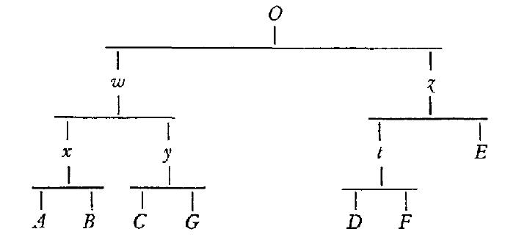
Fig. 1: The initially proposed binary stemma for the Lai de l'ombre by Bédier (reprinted in 1970, 6). Later Bédier accepted the critcism by Gaston Paris (1890) and modified the stemma to make it tripartite (by moving E directly below the archetype). According to Trovato, there is extra-stemmatic contamination in this tradition in the case of manuscript E (Trovato 2013, 294).

Other usage
In mathematics a bipartite graph is a graph whose nodes can be arranged into two disjoint sets such that every edge connects a node in one of them to one in the other (i.e. in either of the two sets there are no nodes that are connected with one another). It can be proved by induction that every tree is a bipartite graph (in this mathematical sense). These two meanings of ‘bipartite’ should therefore not be confused.

References
– Bédier, Joseph, ed. 1913. Jean Renart: Le lai de l’Ombre. Société des anciens textes français. Paris: Firmin-Didot.
– Bédier, Joseph. 1928. “La tradition manuscrite du Lai de l’Ombre: Réflexions sur l’art d’éditer les anciens textes.” Romania 54: 161–196, 321–356. – Reprint, Paris: Champion, 1970 gallica.bnf.fr/ark:/12148/bpt6k8980
– Castellani, Arrigo. 1957. Bédier avait-il raison? La méthode de Lachmann dans les éditions de textes du moyen age. Leçon inaugurale donnée à l’université de Fribourg le 2 juin 1954. Fribourg: Éditions universitaires.
– Guidi, Vincenzo, and Trovato, Paolo. 2004. “Sugli stemmi bipartiti: Decimazione, asimmetria e calcolo delle probabilità.” Filologia italiana 1: 9–48.
– Haugen, Odd Einar. 2015. “The silva portentosa of stemmatology: Bifurcation in the recension of Old Norse manuscripts.” Digital Scholarship in the Humanities. Advance access 21 march 2015, http://dx.doi.org/10.1093/llc/fqv002
– Hunger, Herbert et al. 1961–1964. Geschichte der Textüberlieferung der antiken und mittelalterlichen Literatur. 2 vols. Zürich: Atlantis-Verlag.
– Lewis, Charlton, and Charles Lewis. A Latin Dictionary. London and New York: Harper and Brothers and Oxford University Press.
– Paris, Gaston. 1890. Review of Le Lai d'Ombre of Joseph Bédier. Romania 19: 609–615.
– Trovato, Paolo. 2013. “La tradizione manoscritta del ‘Lai de l’ombre’: Riflessioni sulle tecniche d’edizione primonovecentesche.” Romania 131: 338–380.

In other languages
DE: zweigespalten (Maas), binär / zweigliedrig, Bifurkations- (only as first part of compounds), bipartit / zweiteilig (the usage is not fixed!)
FR: bifide, binaire, bifurqué, bipartite (usage as in English)
IT: bifido / bipartito / biforcato; binario/ bipartito / biforcato.
PR (with help from CL and OH)

Bifurcation
In stemmtology a bifurcation is a 'division into two forks or branches (viewed either as an action or a state)' (according to the Oxford English Dictionary). See further bifid / binary / bifurcating / bipartite.
PR

Bindefehler
German word, from binden 'to bind' and Fehler 'error'. See error, conjunctive.
PR

Bootstrapping
Bootstrapping is a method to obtain some more information and certainty about the correctness of a derived phylogenetic tree or stemma. It involves taking many random samples (usually up to and onward from a 1000 samples) from the original data matrix and constructing stemmata based on those samples. Then for each sample it is determined how often a taxon coincides with the taxa of the stemma computed for the full data set. It is assumed that the higher the number of times a taxon is also derived in the samples the more certain or correct one can be about that taxon's position corresponding to the true stemma. Usually this certainty is indicated as a percentage index on that taxon in the tree visualisation.

References
– Efron, Bradley, Elizabeth Halloran, and Susan Holmes. 1996. “Bootstrap confidence levels for phylogenetic trees.” Corrected version. Proceedings of the National Academy of Sciences of the United States of America (PNAS) 93: 13429–13434.
– Skovgaard, Ole. 2004. “Quality of Tree: Bootstrap.” Teaching material published on the server of Roskilde Universitet. Accessed 7 October 2015. http://akira.ruc.dk/~olesk/sekvens/bootstr.htm.

In other languages
English term used throughout.
JZ

Branch
A branch, or a subtree, is a part of a (phylogenetic) tree that can be separated from the rest of the tree by removing a single edge. For example, in a tree (A, (B, (C, D))) – see the Newick format for trees – the nodes B, C, and D comprise a single branch but the nodes B and C do not. Branches are bound together by Bindefehler in the common errors method, and may be called a family.
Branch length means the same as edge length.

Illustration
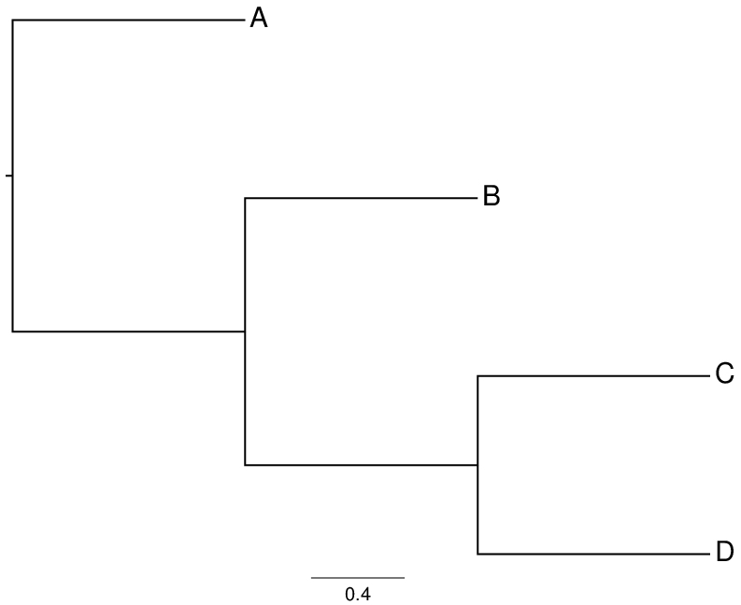
Fig. 1. A tree with branch (B, (C, D)).

In other languages
DE: Zweig, Unterbaum
FR: branche, sous-arbre
IT: ramo, sottografo
TR

Character

1. In linguistics and text encoding
A character is an independent unit of a writing system. The Unicode Standard states that characters are “the abstract representations of the smallest components of written language that have semantic value” (2015, ch. 2, p. 15). In this usage, a character is more or less synonymous with a letter (German Buchstabe) or grapheme.
The Unicode Standard contrasts characters with glyphs, which “represent the shapes that characters can have when they [i.e. the characters] are rendered or displayed.” (2015, ch. 2, p. 15)

Illustration
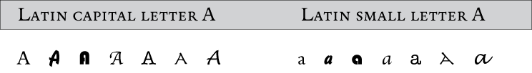
Ill. 1. The character “a” represented by various glyphs.

References
– The Unicode Standard. 2015. Version 8.0. Edited by Julie D. Allen et al. Unicode Consortium, Mountain View, CA. http://www.unicode.org/versions/Unicode8.0.0.

2. In phylogenetics
In phylogenetics, a character refers to an individual feature that is used to characterise the taxa (see taxon). For instance, if the taxa are different species of butterflies, the wing span could be a feature, and the colour of the wings another, and each of them would be encoded as a character. A character can take on a number of different states. In the case of the wing colour, the states could be different colours: light blue, dark blue, green, and so on. If the taxa are represented as DNA sequences, the characters correspond to different positions, or loci (singular locus), in the DNA sequences, and the character states are A,T,G,C. A character matrix refers to a table containing a number of character sequences where each row corresponds to a taxon and each column corresponds to a character. A character may also be missing which is often encoded as '?'.
There are various data formats for representing character data, a popular one being the nexus format.

In other languages
DE: Zeichen, Kennzeichen
FR: caractères, signe graphique
IT: carattere, segno grafico
OH (1), TR (2)

Chi-squared test
Chi-squared tests are used to test the significance of statistical findings. Formally chi-squared (or χ²) denotes a category of statistical tests that can be used to calculate whether the distribution of values in a statistical sample conforms to a known theoretical distribution (the actual chi-squared distribution). If no further specification is given, usually 'chi-squared' means the Pearson's chi-squared test. Pearson's chi-squared tests if the frequency of observed events is distributed according to an expected theoretical distribution. A simple example of it in stemmatology would be to calculate whether variants found in witnesses are uniformly divided between witnesses:
Witness | Variants
W1 | 80
W2 | 54
W3 | 34
W4 | 16
W5 | 36
If the appearance of spelling variation is random, we expect the frequencies in the cells of this table to be uniformly divided, thus we would expect values not to deviate significantly from 44, the average of all values found. Chi-squared allows us to judge how far the frequencies deviate from that average, or in other words in how far they should or should not be attributed to chance. Chi-squared can be computed as follows:
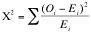
Here O is the observed value, E is the expected value. So χ² is the sum of the squares of the differences between each observed value and the expected value divided by the expected value, so in this case:
Usually chi-squared distribution tables are used to check if the computed value is larger than a critical χ² value. If so, we will conclude that the distribution of values found is not random. (An example of such a table can be found at http://www.medcalc.org/manual/chi-square-table.php.) For this we need to know the degrees of freedom in this test, which is simply the number of cells containing values minus 1, so 4. The row for a degree of freedom of 4 in the look-up table shows that the found value is larger even than the χ² value associated with a probability (p) of 0.001 that a distribution is due to chance. So for these spelling variants we can conclude they are not.
In a similar vein Pearson's chi-squared test can be applied in cases where two variables need to be tested, e.g. spelling and grammar variants distribution. For more details, however, we have to refer to existing statistics tutorials.

Reference
– Columbia Center for New Media Teaching and Learning (CCNMTL). “D. The Chi-Square Test.” Quantitative Methods in the Social Sciences e-Lessons. Accessed 11 October 2015. http://ccnmtl.columbia.edu/projects/qmss/the_chisquare_test/about_the_chisquare_test.html.

In other languages
DE: Chi-Quadrat (χ²)-Test
FR: test du chi carré (χ²)
IT: test del chi-quadrato (χ²)
JZ

Cladistics
[kləˈdɪstɪks]
Cladistics (from Greek κλάδος ‘branch’ and the suffix -istic from Greek -ιστικός) is "a method of classification that groups taxa hierarchically into discrete sets and subsets. Cladistics can be used to organize any comparative data (e.g. linguistics) but its greatest application has been in the field of biological systematics. Cladistics methods were made explicit by the German entomologist Willi Hennig (1950), and became widely known to English speakers in 1965 and 1966 under the name 'phylogenetic systematics'. (...) The aim of cladistic analysis is to hypothesize the sister-group hierarchy and express the results in terms of branching diagrams. These diagrams are called cladograms, a reference to the fact that | they purport to express genealogical units or clades." (Kitching et al. 1998, 1-2).
Strictly speaking, the cladistic method implies a clear distinction between apomorphic and plesiomorphic characters or character states (characters can be molecular, but also morphological, physiological, etc.). This distinction is not necessarily made in other types of phylogenetic methods, which often rely on big data taken from molecular biology. Therefore, cladograms that result from such an analysis do not necessarily show genealogical relationships, but rather groups based on mere similarities.
References
– Kitching, Ian J., Peter L. Forey, Christopher J. Humphries, and David M. Williams. 1998. Cladistics: The Theory and Practice of Parsimony Analysis. 2nd ed. Oxford: Oxford University Press.
– Lipscomb, Diana. 1998. Basics of Cladistic Analysis.Washington DC: George Washington University. http://www.gwu.edu/~clade/faculty/lipscomb/Cladistics.pdf. Accessed 28/10/2015.
– Schmitt, Michael. 2013. From Taxonomy to Phylogenetics: Life and Work of Willi Hennig. Leiden: Brill.

In other languages
DE: Kladistik
FR: cladistique
IT: cladistica
CM, MH

Cladogram
[ˈklædəʊɡræm, also ˈkleɪd-]
From κλάδος ‘branch’(cf. cladistics) and a contracted form of dendrogram ('tree-graph') or diagram, in both cases ultimately from γράμμα 'anything written'.
In cladistics, according to Kitching et al. (1998), a cladogram is "a branching diagram specifying hierarchical relationships among taxa based upon homologies (synapomorphies). A cladogram includes no connotation of ancestry and has no implied time axis" (Kitching et al. 1998, 202). A phylogenetic tree, on the other hand, is "an hypothesis of genealogical relationships among a group of taxa with specific connotations of ancestry and an implied time axis" (Kitching et al. 1998, 213). For an older definition cf. phylogram.
References
– Cameron, H. Don. 1987. “The upside-down cladogram. Problems in manuscript affiliation.” In Biological Metaphor and Cladistic Classification.An Interdisciplinary Perspective, edited by Henry M. Hoenigswald and Linda F. Wiener, 227-242. Philadelphia: University of Pennsylvania Press.
– Kitching, Ian J., Peter L. Forey, Christopher J. Humphries, and David M. Williams. 1998. Cladistics: The Theory and Practice of Parsimony Analysis. 2nd ed. Oxford: Oxford University Press.
– Reinert John F., Ralph E. Harbach, and Ian J. Kitching, 2009. "Phylogeny and classification of tribe Aedini (Diptera: Culicidae). Zoological Journal of the Linnean Society 157: 700–794. doi: 10.1111/j.1096-3642.2009.00570.x.
– Wilkerson, Richard C., Yvonne-Marie Linton, Dina M. Fonseca, Ted R. Schultz, Dana C. Price, and Daniel A. Strickman. 2015. "Making Mosquito Taxonomy Useful: A Stable Classification of Tribe Aedini that Balances Utility with Current Knowledge of Evolutionary Relationships." PLoS ONE. 10.1371/journal.pone.0133602.g002 (accessed 31.10.2015).
In other languages
DE: Kladogramm
FR: cladogramme
IT: cladogramma
CM, MH

Illustration
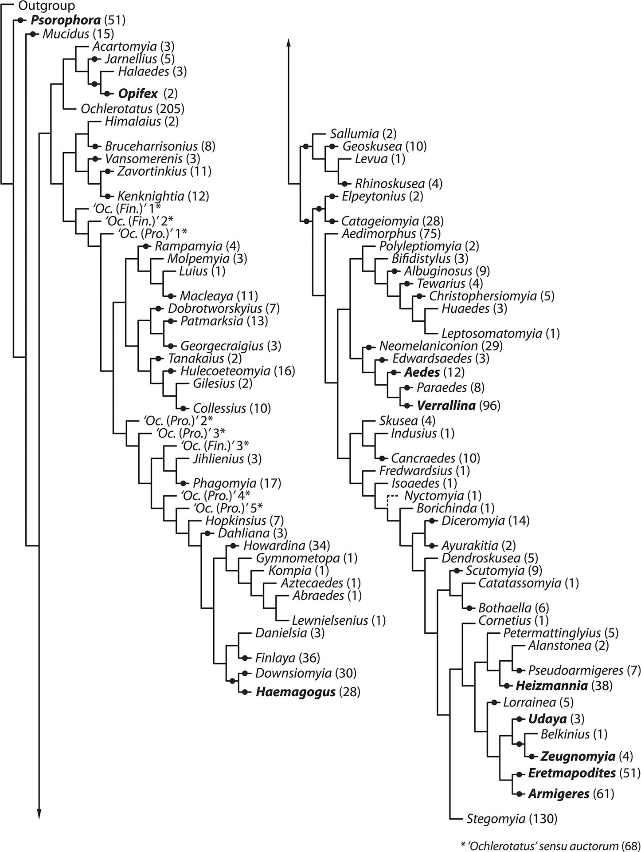
Fig.1. A tree of kind of mosquitoes derived from cladograms. "Tree derived from the single most parsimonious cladogram in Reinert, Harbach & Kitching 2009" (from Wilkerson et al. 2015).

Cladorama
[klædəʊˈrɑːmə]
Cladorama is an alternative term for the family treein textual criticism. See Pieter van Reenen and Margot van Mulken (1996, 84).
Etymology: The word was coined as a previously unattested Greek compound κλαδόραμα from κλάδος ‘branch’ and ὄραμα ‘that which is seen, sight, spectacle’.

Reference
– Reenen, Pieter van, and Margot van Mulken, eds. 1996. Studies in Stemmatology. Amsterdam: John Benjamins.
OH, PR.

Codex
the codex (pl. codices) is the usual book form of late antiquity and especially of the middle ages. The word derives from Latin cōdex, with variant caudex, ‘log of wood’. The etymology refers to the technique used in antiquity of binding wooden plates containing writing (in Latin: tabulae, tabellae) together. The codex replaced the scroll which was the usual book form of antiquity around the 3rd century AD. Among its advantages are that handling and storage are easier. Basis for a codex is normally a double folio of parchment. Several folios are gathered and folded into a quire. Depending on how many folios form a quire it is called “binio” (two double folios), “ternio” (three double folios), “quaternio” (four double folios) etc.
Normally a codex consists of several quires which are bound and embedded in two wooden covers that are often jacketed with leather or precious metal. Usually, in a codex the folios (and not the pages) are counted; the letter ‘r’ (= ‘recto’) refers to the front of a folio, the letter ‘v’ (= ‘verso’) to the back. If the folio is written in columns, these may be referred to with minuscules like ‘a’, ‘b’, ‘c’. As air and/or humidity can cause a distortion of the parchment, many codices have metallic closures to keep the folios as plain as possible.
It is not uncommon that one or more folios (leaves) are missing from a codex, or even a whole quire or more. In editions, the composition of a codex is often displayed in diagrams showing each quire, in which solid lines indicate preserved folios and dotted lines lost folios.
Cf. manuscript.

References
– Haugen, Odd Einar, and Åslaug Ommundsen, eds. 2010. Vår eldste bok. Bibliotheca Nordica, vol. 3. Oslo: Novus.
– Roberts, Colin H., and Theodore C. Skeat. 1983. The Birth of the Codex. London: Oxford University Press.

Illustration
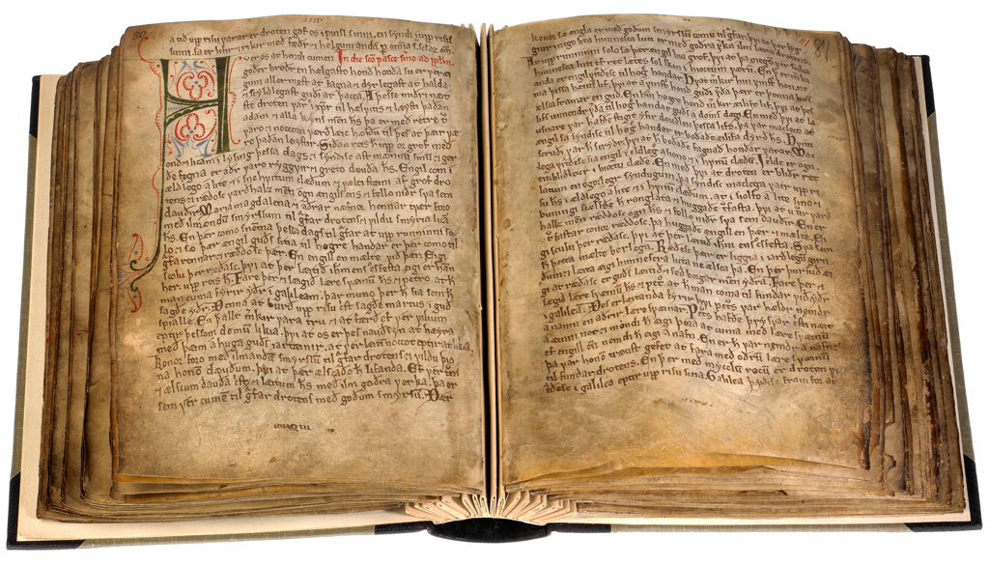
Fig. 1. The Old Norwegian Homily Book in the manuscript Copenhagen, AM 619 4to (ca. 1200–1225). This manuscript is well preserved, but the binding is of a recent date. The photograph clearly shows how the manuscript is built up of individual quires.

Illustration
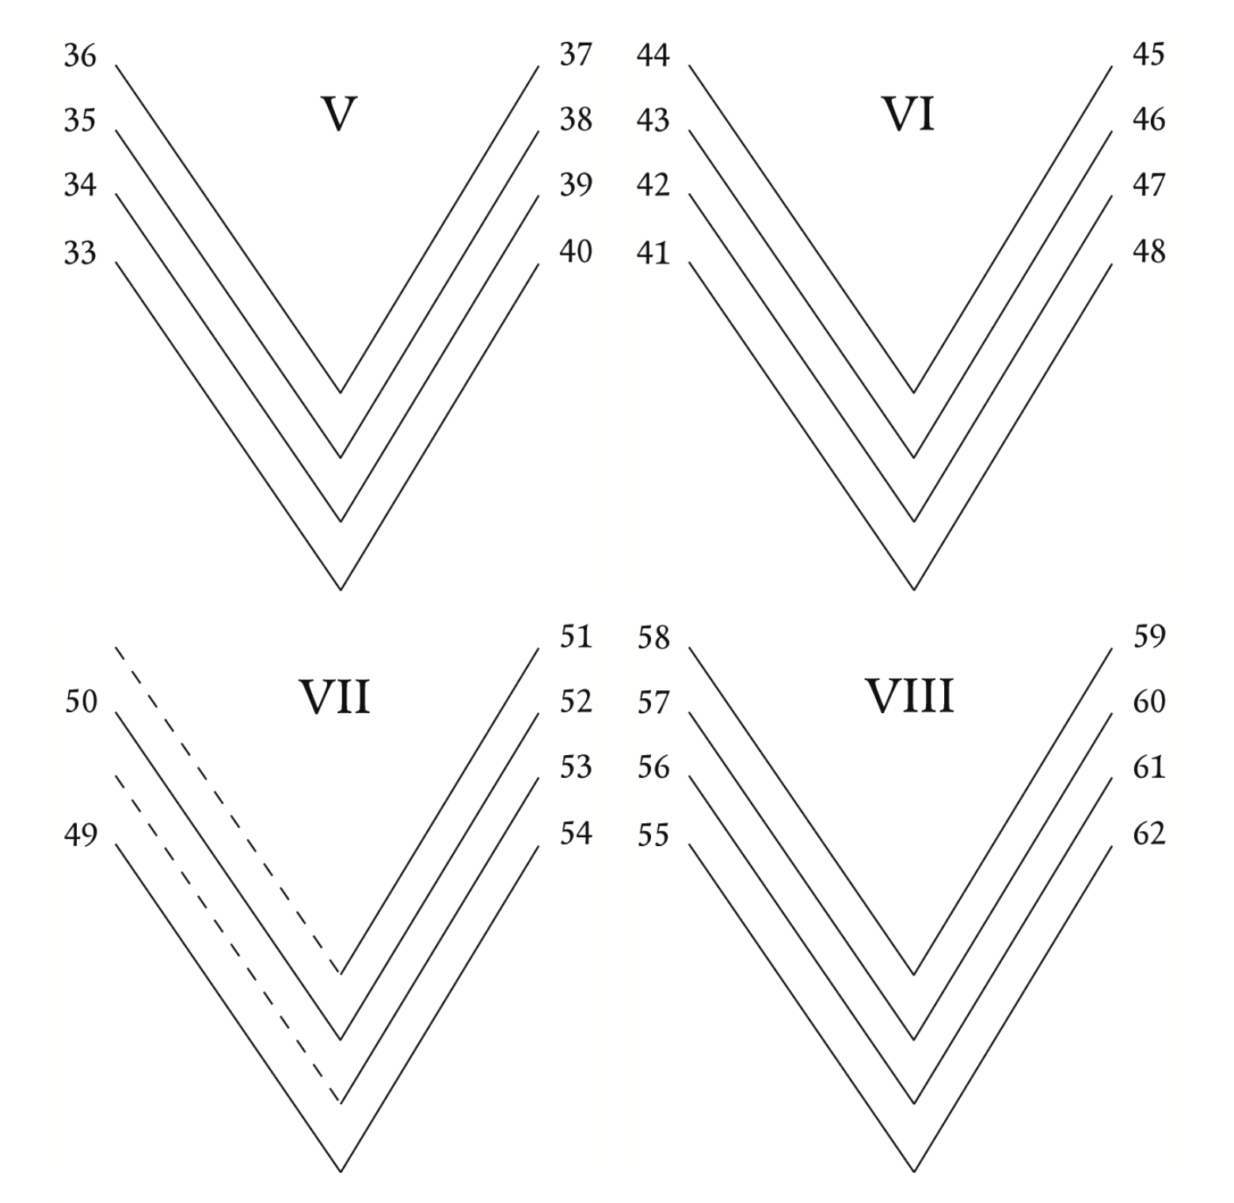
Fig. 2. Detail from the collation of the manuscript AM 619 4to (from Haugen and Ommundsen 2010, 251). This diagram shows four of the quires, V–VIII, each being a quaternio of 8 folios or 4 double folios (bifolia). In quire VII, two leaves are missing and indicated by dotted lines. Note that lost folios usually are not numbered, so that in quire VII, there will be only six numbered folios.

In other languages
DE: Codex/Kodex
FR: codex
IT: codice
TB, OH (illustrations)

Codex descriptus
A codex descriptus (plural codices descripti) is a copy of another (extant) manuscript. Given two extant witnesses, A and B: if recensio demonstrates that B descends from A, which means that it contains all the errors of A plus at least one more Eigenfehler (cf. Maas 1960, § 8), i.e. one of a kind that does not imply a different filiation than A (cf. Timpanaro 1981, 120), B is a codex descriptus and therefore useless for the reconstruction of the archetype. Nonetheless, such a codex can provide important information as far as the history of textual transmission is concerned. It is often difficult to irrevocably prove that a codex is entirely a descriptus.
In Latin descriptus means 'copied, transcribed' from the verb de-scrībō.

References
– Maas, Paul. 1960. Textkritik. 4th ed. Leipzig: Teubner. – First ed. 1927.
– Timpanaro, Sebastiano. 1981. La genesi del metodo del Lachmann. 2nd ed. Padova: Liviana. – 1st ed., Firenze: Le Monnier, 1963.
– ———. 2005. The Genesis of Lachmann’s Method. Translated by Glenn W. Most. Chicago: University of Chicago Press. – Translated from Timpanaro 1981.

In other languages
The Latin term is used throughout.
MB

Codex interpositus
A codex interpositus (plural codices interpositi) is an intermediary manuscript located between two manuscripts in the stemma. If a codex interpositus is lost, its existence may be postulated in some cases (e.g. when a witness is assumed to derive from a less corrupt model). For example: in his edition of the Old English text known as Soul and Body, Douglas Moffat (1990) gives the stemma provided below, where E and V are the extant witnesses, Z, Y, and X the lost ones. X is a codex interpositus (though not a hyparchetype) which, according to the editor, should have cointained the episode of the “holy soul” present in its apograph V but lacking in E.

Illustration
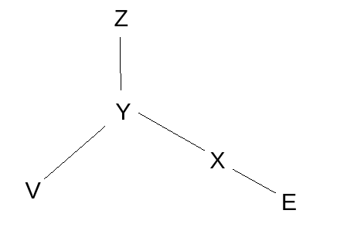
Note that one needs to have at least two extant copies in order to identify a lost intermediary, and many more manuscripts may have been lost on the way without leaving a trace (if they lead to zero or one descendant(s)). Those “ideal / theoretical” lost intermediaries can sometimes (although rarely) be corroborated in reality if their extant copies share mistakes which can only be explained by material accidents (Irigoin 1986), or by the type of script used in their common ancestor (Timpanaro 2005, Appendix B, 145-156).
Cf. Quentin.

Bibliography
– Irigoin, Jean. 1986. “Accidents matériels et critique des textes.” Revue d’Histoire des Textes 16: 1–36.
– Moffat, Douglas, ed. 1990. The Old English Soul and Body. Cambridge: Brewer.
– Timpanaro, Sebastiano. 1981. La genesi del metodo del Lachmann. 2nd ed. Padua: Liviana. – 1st ed., Firenze: Le Monnier, 1963.
– ———. 2005. The Genesis of Lachmann’s Method. Translated by Glenn W. Most. Chicago: University of Chicago Press. – Translated from Timpanaro 1981.

In other languages
Latin term used throughout.
MB, CM, OH

Codex optimus
A codex optimus is the best manuscript in a manuscript tradition. What is ‘best’ is obviously a matter of definition and possibly of taste, but it usually means that it is the oldest and/or best preserved manuscript and as such best suited for an edition of the work in question. Some editions, in this lexicon referred to as documentary editions, select a single manuscript as the base, hence the term best-manuscript editions.
Since the search for errors (or, more neutrally, innovations) is central to the stemmatological method, it follows that a manuscript at a higher position in the stemma usually is a better manuscript than a manuscript situated lower, other things being equal. This does not exclude the possibility of stemmatologically lower positioned manuscripts being better in terms of e.g. literary quality, but that should be regarded as a different matter. The text of such a manuscript may be seen as a new redaction or even version (and possibly be edited for its own sake).
It is not uncommon that the oldest preserved witnesses in a tradition are fragmentary, so that the supposedly best manuscript is not found at the top of the stemma, but still closer to the origin of the tradition than later manuscripts. This is the case with the Old Norwegian Konungs skuggsjá ‘The King’s Mirror’ (mid-13th century), in which the fragments β and γ are located above the main manuscript, hovedh[åndskriftet], which is commonly regarded as the codex optimus. The fragments β and γ are very short, so neither can be termed a codex optimus in any meaningful sense. A fragment is simply not a codex any more, even if it once might have been part of a complete codex.
In Latin, optimus is the superlative of the adjective bonus ‘good’.
Cf. also best-manuscript edition.

Illustration
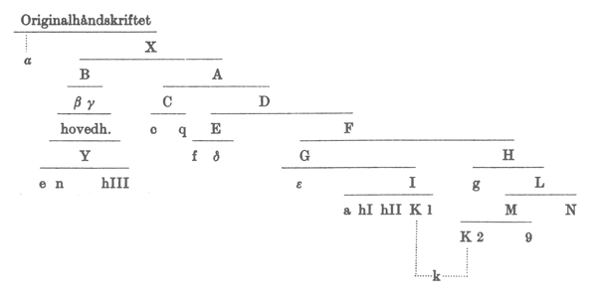
Fig. 1. A stemma for Konungs skuggsjá, from the edition by Ludvig Holm-Olsen (1983, xiv). Originalhåndskriftet is the original, now lost manuscript, while hovedh[åndskriftet] in the B branch is the main manuscript, København, Den Arnamagnæanske Samling, AM 243 bα fol. Above the main manuscript are located the two fragments β and γ. In this stemma, α is another fragment, which, if complete, would have been an obvious candidate for being the codex optimus.

Bibliography
– Holm-Olsen, Ludvig, ed. 1983. Konungs skuggsiá. 2nd ed. Norrøne tekster, vol. 1. Oslo: Kjeldeskriftfondet.

In other languages
The Latin term is generally used, or modern equivalents such as best manuscript.
OH

Codex unicus
Latin for 'the only codex'. The expression is used for a codex which is the only extant one bearing the text in question. In this case no actual recensio leading to a stemma is required, but emendatio of its errors is likely to become more difficult than in the case of having recourse to several manuscripts. The codex unicus may, indeed, be very far removed from the original.

In other languages
The Latin term is used throughout.
PR

Codicology
Codicology is the study of codices (sing. codex), i.e. of handwritten books from the classical and mediaeval period. Formerly, codicology was a part of palaeography, but in recent times, palaeography has been defined as the study of handwritten script, while codicology is the study of early books as such. Codicology thus is akin to the modern study of books, but it has a focus on the handwritten aspects of book-making as opposed to the study of printed books.
There is a specific terminology for the description of codices. Denis Muzerelle (formerly at IRHT in Paris) has created an online source, Vocabulaire Codicologique, which also contains terms in other languages.

Internet resources
– Codicologia at IRHT (Institut de recherche et d’histoire des textes) in Paris
See also manuscript.

In other languages
DE: Kodikologie
FR: codicologie
IT: codicologia
OH

CollateX
CollateX is a free and open source (GPL license) software library originally written in the Java computer language which allows it to run on virtually any platform. Its application in stemmatology and textual criticism is for automatically identifying and reporting variant readings between witnesses. Its strengths are its ability to analyse many multiple witnesses at once, its capability of detecting transpositions, its speed, and its baseless text comparison approach. CollateX is not published as a stand alone or web application, but as a component or web service that can be called by other programs. It offers various output possibilities, inter alia JSON, TEI parallel segmentation, and graph representations.

References
– The Interedition Development Group. CollateX: Software for Collating Textual Sources. Accessed 6 October 2015. http://collatex.net/
– Haentjens Dekker, Ronald, Dirk van Hulle, Gregor Middell, Vincent Neyt and Joris van Zundert. 2015. “Computer-supported collation of modern manuscripts: CollateX and the Beckett Digital Manuscript Project.” Literary and Linguistic Computing 30 (3): 452–470. http://dx.doi.org/10.1093/llc/fqu007.
JZ

Collation
Latin collatio ("comparison"), from the verb conferre.
In the Lachmannian method, collatio is part of recensio. It can be defined as the comparative examination of the witnesses in order to determine the variant readings in all witnesses.
If the collation is done manually, a collation exemplar or reference text (sometimes referred to as a base text for collation which is distinguished from a base text used for an edition) is chosen, against which the other witnesses are compared. Especially with broad textual traditions collation can be very exacting. A traditional method to cope with this difficulty is to proceed by singling out and then collating a limited number of variant locations or loci critici (selecti). This is for example the method carried out by Federico Sanguineti in his edition of Dantis Alagherii Comedia (2001).
It is possible nowadays to collate the witnesses in a semi-automated way, but this requires that every witness is first transcribed (see the explanation of the procedure by Tara Andrews in Macé 2015, 332-335). A number of collation software programs have been developed over the past years, see for example CollateX.

References
– Fadda, Anna Maria Luiselli. 1994. Tradizioni manoscritte e critica del testo nel Medioevo germanico. Roma: Laterza.
– Maas, Paul. 1960. Textkritik. 4th ed. Leipzig: Teubner. – First ed. 1927.
– Macé, Caroline, ed. 2015. “Chapter 3. Textual Criticism and Text Editing.” in Alessandro Bausi et al., eds., Comparative Oriental Manuscript Studies. An Introduction.Hamburg: Tredition: 321-465.
– Montanari, Elio. 2003. La critica del testo secondo Paul Maas: Testo e commento. Firenze: Edizioni del Galluzzo.
– Pasquali, Giorgio. 1952. Storia della tradizione e critica del testo. 2nd ed. Firenze: Le Monnier. – 1st ed., Firenze: Le Monnier, 1934.
– Sanguineti, Federico, ed. 2001. Dantis Alagherii Comedia. Firenze: Edizioni del Galluzzo.
– Stussi, Alfredo, ed. 2006. Fondamenti di critica testuale. Bologna: il Mulino. – First ed. 1998.
– Timpanaro, Sebastiano. 1981. La genesi del metodo del Lachmann. 2nd ed. Padova: Liviana. – 1st ed., Firenze: Le Monnier, 1963.
– ———. 2005. The Genesis of Lachmann’s Method. Translated by Glenn W. Most. Chicago: University of Chicago Press. – Translated from Timpanaro 1981.

In other languages
DE: Kollationierung
FR: collation
IT: collazione
Often the Latin term collatio is also used.
MB, CM

Colophon
From the Greek κολοϕών 'summit, finishing touch'.
The term colophon refers to notes or short texts added to a codex or book that supply information about the production and/or the use of the volume. Such information may include the name of the scribe(s) or printer(s), the place and date of production as well as the title of the work(s) in the book, the person who commissioned the work, the person who bought or sold the book, directions or curses (anathemata) and personal comments related to the book by the scribe, printer and later users. The term scribal colophon can be used to specify information provided by the person(s) responsible for copying the book. The more encompassing term, colophon, may also include notes inscribed by contemporary or later users of the book. Colophons, especially those in printed books, may be emblematic or pictorial.
For stemmatology, colophons, which are often essential sources of historical and geographical information, can consequently aid in determining relationships within a stemma codicum or another representation of genealogical relationships between witnesses.
In extraordinary cases, the information provided in colophons can help establish direct relationships between manuscripts. For example, in a ninth-century copy of Hilary of Poitiers' De Trinitate (Paris, BnF, Lat. 12132) the names of two scribes found in short notices indicating the beginnings and ends of their stints allows us to place the manuscript in Rheims. Additional historical information, a material accident and correspondences in layout have allowed scholars to identify the exemplar of the manuscript (Paris, Bibliothèque nationale, Lat. 2630) and so a direct relationship (for further details, see Vezin 1979 and Parkes 2008, 63 and 88-89).
For traditions within Western Europe, the largest collection of colophons is found in the catalogue assembled by the Bénédictines of Bouveret (1965-82), which lists colophons alphabetically by name (usually of the scribe of the book – even if the scribe did not write the colophon itself – or the scribe of the colophon). For entries without personal names, colophons are listed by location (lieux) or alphabetically following the text (anonymes). Heavily reliant on information provided in manuscript catalogues published at the time, this invaluable work is not exhaustive. Specific examinations of individual colophons and broader studies of manuscript collections and their colophons (see for example Condello and de Gregorio 1995) continue to augment and refine knowledge of textual traditions.

References
– Beal, Peter. 2008. A Dictionary of Manuscript Terminology, 1450–2000. Oxford: Oxford University Press.
– Bénédictines de Bouveret. 1965–1982. Colophons de manuscrits occidentaux des origins au XVIe siècle.6 vols. Fribourg: Editions Universitaires Friboug Suisse.
– Condello, Emma, and Giuseppe de Gregorio. 1995. Scribi e Colofoni: Le sottoscrizioni di copisti dalle origini all'avventa della stampa. Biblioteca del Centro per il Collegamento degli Studi Medievali e Umanistici in Umbria, vol. 14. Spoleto: Centro Italiano di Studi sull’Alto Medioevo.
– Parkes, Malcolm B. 2008. Their Hands before Our Eyes: A Closer Look at Scribes. Aldershot: Ashgate.
– Vezin, Jean. 1979. “Hincmar de Rheims et Saint-Denis: à propos de deux manuscrits du De Trinitate de saint Hilaire.” Revue d'Histoire des Textes 19: 289–298.
AC

Combinatio
Combinatio is the conjectural process by which an original reading is reconstructed through the combination of two (or more) partially erroneous readings in the witnesses (see, among others, Avalle 1972, 116 and Luiselli Fadda 1994, 240). Along with divinatio and selectio, combinatio is one of the three main operations that characterise emendatio.

References
– Avalle, D’Arco Silvio. 1972. Principî di critica testuale.Padova: Antenore.
– Luiselli Fadda, Anna Maria. 1994. Tradizioni manoscritte e critica del testo nel Medioevo germanico. Roma: Laterza.

In other languages
Latin term used throughout.
MB

Common errors method
In the context of stemmatology, common means ‘shared’ (not ‘simple’ or ‘vulgar’), so 'common errors' is the traditional expression used for 'shared innovations' (cf. the notion error). Usually one means by this expression that these common errors did not arise polygenetically. Stemmata are drawn and rooted by considering common and significant errors only. Witnesses that share only readings that are not common errors (shared innovations) are not closely related as the archetype will already have contained these readings. For further details compare Lachmann's method.

In other languages
DE: gemeinsame Fehler, Methode der Fehlergemeinschaften
FR: (méthode des) erreurs communes
IT: metodo degli errori (comuni)
PR

Computer-assisted stemmatology
Statistical methods have been used in textual criticism at least since the beginning of the 20th century (Quentin 1926, Greg 1927), and attempts at using computers for the classification of manuscripts appeared as early as the 1960's (Dearing 1968, Froger 1968, Griffith 1968, Zarri 1971, Irigoin and Zarri 1979). Recently, the field of bioinformatics seemed to offer many opportunities in that respect. Indeed stemmatology and the study of evolution in e.g. biology have much in common: the former studies the evolution of texts and the latter that of organisms. The use of computerised approaches developed in the field of phylogenetics have proved to be very useful for stemmatology as well.
Possibly the greatest advantages of computer-assisted methods are their speed, calculation power, the possibility of using different methods on the same data, of assessing the results and of easily redoing the calculation whenever necessary (after having added a new witness, for example). The algorithms underlying the methods used are often black boxes, however, and one should also keep in mind that the quality of the input is of primary importance for the reliability of the results. Data used by computer programs must be encoded in some way by philologists, and not only the data format is important, but also the preparation of the data (based on manual collation or on computer-assisted collations, themselves based on transcriptions).
Computer assisted methods and tools used in stemmatology treated in this lexicon are: bootstrapping, chi-squared test, distance-based methods, Juxta, maximum parsimony method, Method, Leitfehler-based, NeighborNet, Neighbour joining, PAUP, PHYLIP, RHM, SplitsTree, Semstem, Stemmaweb, UPGMA.
See Trovato 2014, 179–227 for a partial survey of computer-assisted stemmatology, and Reeve 2000 for a critical evaluation of the results.

References
– Dearing, Vinton A. 1968. “Abaco-Textual Criticism.” The Papers of the Bibliographical Society of America 62 (4): 547–578.
– Froger, Jacques. 1968. La critique des textes et son automatisation. Paris: Dunod.
– Greg, Walter Wilson. 1927. The Calculus of Variants: An Essay in Textual Criticism. Oxford: Clarendon Press.
– Griffith, John G. 1968. “A Taxonomic Study on the Manuscript Tradition of Juvenal.” Museum Helveticum25 (2): 101–138.
– Irigoin, Jean, and Gian Zarri, eds. 1979. La pratique des ordinateurs dans la critique des textes. Paris 29–31 mars 1978. Paris: Éditions du CNRS.
– O'Hara, Robert, and Peter Robinson. 1993. “Computer-assisted Methods of Stemmatic Analysis.” In The Canterbury Tales Project: Occasional papers, edited by Norman Blake and Peter Robinson, 1: 53–74. Oxford: Office for Humanities Communication.
– Quentin, Henri. 1926. Essais de critique textuelle (Ecdotique). Paris: Picard.
– Reeve, Michael D. 2000. “Cuius in usum? Recent and future editing.” The Journal of Roman Studies 90: 196–206. – Reprinted in Michael D. Reeve. 2011. Manuscripts and Methods: Essays on Editing and Transmission, 339–359. Rome: Edizioni di storia e letteratura.
– Roelli, Philipp. 2014. “Petrus Alfonsi or On the mutual benefit of traditional and computerised stemmatology.” In Analysis of Ancient and Medieval Texts and Manuscripts: Digital Approaches,edited by Tara Andrews and Caroline Macé, 45–70. Turnhout: Brepols.
– Trovato, Paolo. 2014. Everything You Always Wanted to Know about Lachmann’s Method: A Non-Standard Handbook of Genealogical Textual Criticism in the Age of Post-Structuralism, Cladistics, and Copy-Text. Foreword by Michael D. Reeve. Firenze: Libreriauniversitaria.it edizioni.
– Zarri, Gian Piero. 1971. “L’automazione delle procedure di critica testuale: Problemi e prospettive.” Lingua e Stile 6: 397–414.

In other languages
DE: computergestützte Stemmatologie
FR: stemmatologie assistée par ordinateur
IT: stemmatologia digitale
CM, PR

Conjecture
A conjecture is the introduction into the text of a reading without a bases in the witnesses available to the person doing the conjecture. One should differentiate between conjectures by scribes (see scribal conjecture) as opposed to conjectures by modern editors (which are done by divinatio, cf. also emendatio).

In other languages
DE: Konjektur
FR: conjecture
IT: congettura
PR

Consensus tree
Often phylogenetic analysis is not unanimous. In such cases, the result may be a set of phylogenetic trees rather than a single best tree. This happens in particular in bootstrap analysis. A consensus tree is a representation of a set of phylogenetic trees that attempts to summarise them in a way that captures their most frequently occurring characteristics. More specifically, a consensus tree usually represents the splits that occur in a majority of the trees; in a tree a split corresponds to an edge. The edges are often labelled by the number of trees where the corresponding split occurs.

In other languages
DE: Konsensusbaum, Consensus-Baum
FR: arbre consensus
IT: albero di consenso
TR

Constitutio textus
Constitutio textus, or the determination of the critical text, is used in two related but distinct contexts. The term can refer broadly to the process of producing a critical text within the genealogical or Lachmannian method. In Paul Maas’s handbook, the term is not specifically defined but can be associated with the overall editorial process: “The task of textual criticism is to produce a text as close as possible to the autograph (original) (constitutio textus)” (Aufgabe der Textkritik ist Herstellung eines dem Autograph (Original) möglichst nahekommenden Textes (constitutio textus); 1960, 5). Consequently, it is possible to use the term broadly to cover the process of textual criticism: recensio, the examinatio and the establishment of a stemma codicum; emendatio, that is selectio, divinatio and combinatio; and dispositio, the final stage of producing the critical edition in which the text is laid out, apparatuses drafted and other complementary materials such as an introduction, descriptions of manuscripts and notes are incorporated. In this sense, the term appears to be employed in the sense of 'the reconstruction of the text'.
However, most contemporary scholars employ a rather more restricted definition whereby the term refers to the stage of producing a critical edition in which readings are compared and reduced to that which will appear in the edition. In this respect, the constitutio textus stage follows recensio (or overlaps with the final stage of recensio), that is the analysis of readings in witnesses that produces a stemma codicum, and precedes the final stage of preparing the edition, dispositio. For example, in Olivieri’s work on Philo’s De Providentia the constitutio textus is clearly seen as following the construction of the stemma and the elimination ofcodices descripti. One specific quotation demonstrates this usage of constitutio textus: “L offers a rather good text, but it is never the only source of the best variant reading: it can therefore be excluded for the constitutio textus" (Olivieri 2010, 110).
In this more restricted concept of the term, constitutio textus clearly applies to the efforts to produce a text as close as possible to the original or, depending on the principles of the editor, the archetype, but not to the entire, overarching process of reconstructing a text.
References
– Maas, Paul. 1960. Textkritik. 4th ed. Leipzig: Teubner. – First ed. 1927.
– Olivieri, Mauri. 2010. “Philo’s De Providentia: A Work between Two Traditions.” In Studies on the Ancient Armenian Version of Philo’s Works, edited by Sara Mancini and Paola Pontani, 87-124. Leiden: Brill.

In other languages
Latin term used throughout.
AC

Contamination
The confluence of readings from more than one exemplar is known as contamination. This has very frequently happened to texts both in antiquity and in the middle ages. Already the philological editions from the time of the first editions of Homer in Alexandria were based on the principle of comparing different manuscripts with one another in order to obtain a text that was as accurate as possible. For classical texts, the best we can hope for is generally to get an idea of what such an edition in late antiquity was like.
The term contamination derives from the Latin verb contaminare, which means ‘to defile with filth, pollute, spoil, corrupt’, which implies that the phenomenon is something very negative. Indeed Paul Maas claims that "Gegen die Kontamination ist kein Kraut gewachsen" (Maas 1960, 30: "there is no remedy against contamination", literally "there is no herb against contamination"). This is so because this practice complicates the work of text editors since it makes it more difficult to get a clear picture of how the various manuscripts in a tradition are related to each other. This in turn makes it more difficult to get a clear picture of what the archetype was like. For philologists working in the Lachmannian tradition, contamination has therefore been a very negative phenomenon.
Following the more descriptive terminology introduced by Giorgio Pasquali (1952), a text tradition can be seen as vertical or horizontal. The former type is non-contaminated and easily applicable to a Lachmannian analysis, while the latter is contaminated and thus much more difficult to analyse from a stemmatological point of view.
In his edition of Lucretius, Karl Lachmann believed that he was dealing with a tradition relatively free from contamination. For this he has been criticised by (among others) the latest editor of that text, Enrico Flores, who thinks that Lachmann underestimated the degree of contamination in the transmission of Lucretius (and in ancient texts generally). This is the case also in several mediaeval text traditions. When Lachmann edited mediaeval German texts he applied the same principles to those texts that he had applied to classical texts. His colleagues and successors in the 19th century recognised through stemmatological research the greater importance of contamination in mediaeval German texts. The research on the relationship between the most significant Middle High German manuscripts (Liederhandschriften, song books) has shown that there have been, without doubt, common sources which the writers of different codices transcribed.
Cf. extra-stemmatic contamination, successive contamination, and simultaneous contamination.

References
– Flores, Enrico, ed. 2002. Titus Lucretius Carus: De rerum natura. Edizione critica con introduzione e versione, vol. 1 (Libri I–III). Napoli: Bibliopolis. || See p. 24.
– Maas, Paul. 1960. Textkritik. 4th ed. Leipzig: Teubner. – First ed. 1927.
– Pasquali, Giorgio, 1952. Storia della tradizione e critica del testo. 2nd ed. Firenze: Le Monnier. || See pp. 146–147, 177 f., 183.
– Reynolds, L. D., and Nigel G. Wilson. 1974. Scribes and Scholars. A Guide to the Transmission of Greek and Latin Literature. 2nd ed. Oxford: Clarendon Press. || See pp. 54, 193, 212–213, 247.
– Segre, Cesare. 1961. “Appunti sul problema della contaminazione nei testi in prosa.” In Studi e problemi di critica testuale. Convegno di Studi di Filologia italiana nel Centenario della Commissione per i Testi di Lingua (7–9 Aprile 1960), 63–67. Bologna: Commissione per i Testi di Lingua.
– West, Martin L. 1973. Textual Criticism and Editorial Technique Applicable to Greek and Latin Texts. Stuttgart: Teubner. || See pp. 12–13, 35–37.

In other languages
DE: Kontamination
FR: contamination
IT: contaminazione
TB, GH

Contamination, extra-stemmatic
Extra-stemmatic – or according to Trovato (2014, 134) preferably called 'extra-archetypal' – contamination is contamination by a lost witness that stems from a branch of the tradition which branched off before the tradition's archetype. Such contamination may thus preserve some readings that go beyond the archetype. Trovato (2014, 289–297, cf. illustration below) believes this to be the case e.g. in the stemma of the Lai de l'Ombre (see Bédier).
The term was coined by Timpanaro (appendix c) who contrasts it to intra-stemmatic (that is "normal") contamination.
Illustration
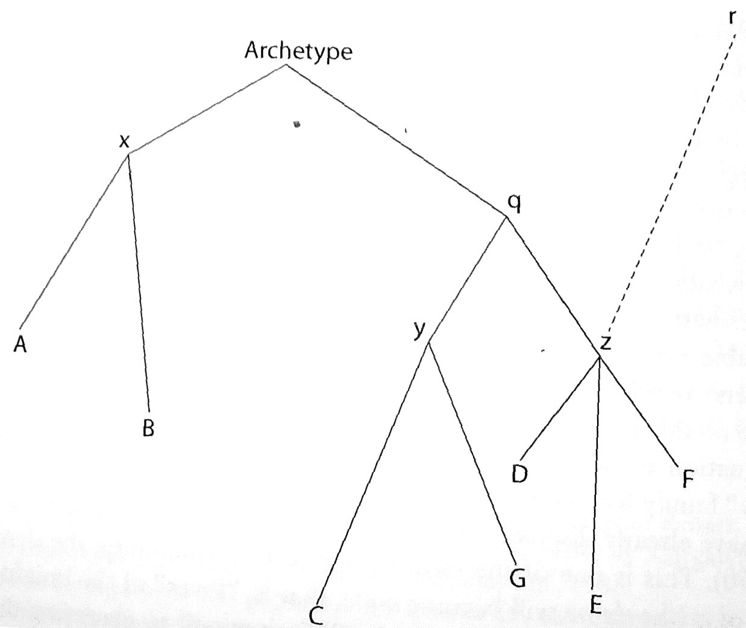
Fig. 1. Trovato (2014, 294): Extra-stemmatic contamination happened from lost witness r to z.
References
– Timpanaro, Sebastiano. 1981. La genesi del metodo del Lachmann. 2nd ed. Padova: Liviana. – 1st ed., Firenze: Le Monnier, 1963.
– ———. 2005. The Genesis of Lachmann’s Method. Translated by Glenn W. Most. Chicago: University of Chicago Press. – Translated from Timpanaro 1981.
– Trovato, Paolo, 2014. Everything you always wanted to know about Lachmann’s method: a non-standard handbook of genealogical textual criticism in the age of post-structuralism, cladistics, and copy-text; foreword by Michael D. Reeve. Firenze: Libreriauniversitaria.it edizioni.
In other languages
DE: extrastemmatische Kontamination
FR: contamination extrastemmatique
IT: contaminazione extrastemmatica
PR

Contamination, simultaneous
Alberto Varvaro (2010, 191; cf. Trovato 2014, 132) introduced a distinction between simultaneous and successive contamination, or contamination of readings and exemplars respectively. The former is an instance of contamination that happens when a scribe uses more than one exemplar to copy his text from and chooses between variants. Cf. successive contamination.

References
– Trovato, Paolo. 2014. Everything you always wanted to know about Lachmann’s method: a non-standard handbook of genealogical textual criticism in the age of post-structuralism, cladistics, and copy-text; foreword by Michael D. Reeve. Firenze: Libreriauniversitaria.it edizioni.
– Varvaro, Alberto. 2010. “Considerazioni sulla contaminazione, sulle varianti adiafore e sullo stemma codicum.” In Storia della lingua italiana e filologia, Atti del VII Convegno ASLI, Associazione per la Storia della Lingua Italiana (Pisa–Firenze, 18–20 dicembre 2008), edited by Claudio Ciociola, 191–196. Firenze: Cesati.

In other languages
DE: simultane Kontamination
FR: contamination simultanée
IT: contaminazione simultanea
PR

Contamination, successive
Successive contamination means contamination that happens due to the use a different exemplar from a certain point onwards by the scribe. This may, e.g., happen if the first exemplar is incomplete and the scribe finds a different witness to copy the rest of the text from (cf. exemplar shift). Cf. simultaneous contamination (also for the coinage of the term).

In other languages
DE: sukzessive Kontamination
FR: contamination successive
IT: contaminazione successiva
PR

Contini, Gianfranco
Contini, Gianfranco (Domodossola, 1912–1990) was an Italian philologist, academic and literary critic, considered one of the most important scholars in the fields of Romance and Italian Philology of the 20th century.
After his graduation in Pavia (1932) he studied in Torino and Paris (1934–36). Then he taught French Literature and Romance Philology in the universities of Pisa, Freiburg and Florence.
Amongst Contini's main contributions and critical editions (the latter mainly in the field of Old Italian literature) are the first complete edition of Italian poetry of the 13th century (Poeti del Duecento, 1960), his essays about Dante Alighieri (Un'idea di Dante, 1970), and his studies about the methodology of text editing (in Italian “ecdotica”, in French “ecdotique”) and textual criticism (Breviario di ecdotica, 1986). Contini also devoted himself to the study and valorisation of Italian poets and writers of the 20th century, such as Eugenio Montale and Carlo Emilio Gadda.
The Italian school of philology, of which Contini is an eminent member, can be called neo-Lachmannian (in a different meaning than that given by Ben Salemans to this term). This school is characterised by the combination of a historicist / reconstructionist methodology with a strong interest in linguistics, codicology, history of manuscripts. The Italian school remained mostly immune to French Bédierism and French-American New philology.
Contini coined the concept diffraction.

Works by Contini
– Contini, Gianfranco. 1986. Breviario di ecdotica. Milano: Riccardo Ricciardi. – Reprinted, Torino: Einaudi, 1990 (Einaudi Paperbacks, Letteratura, vol. 222).

Works on Contini
– Arduini, Beatrice. 2010. “Contini, Gianfranco.” In Handbook of Medieval Studies: Terms – Methods – Trends, edited by Albrecht Classen, 2249–2253. Berlin: Walter de Gruyter.
– Zinelli, Fabio. 2006. “L’édition des textes médiévaux italiens en Italie.” In Pratiques philologiques en Europe: Actes de la journée d’études organisée à l’École des Chartes le 23 septembre 2005, edited by Frédéric Duval, 77–114. Études et rencontres de l’École des Chartes, vol. 21. Paris: École des Chartes.
CL, CM

Copy
A copy is a transcript of an existing document, generally referred to as the exemplar. The new document thus produced is sometimes referred to as an apograph. A handwritten copy is seldom identical to its exemplar in all details: usually there will be some changes in the copy made either consciously or unconsciously by the scribe. Only in some cases, and especially if the text is short, it can, however, be identical with the exemplar word by word. Even so, there will always be differences in graphic form or display.
In the genealogical method, the changes made in the copy, or apograph, are seen as errors and they can be used to group the manuscripts according to the rule of common errors. Note that some critics prefer a more neutral term than error, e.g. variant or innovation.
Cf. also descendant.

Reference
– West, Martin L. 1973. Textual Criticism and Editorial Technique Applicable to Greek and Latin Texts. Stuttgart: Teubner.

In other languages
DE: Kopie, Abschrift
FR: copie
IT: copia
OH

Copying of texts
Texts were copied in different ways and for different reasons: different methods were used (1), the copyists had different intentions and attitudes towards the texts they were copying (2) and as a result different kinds of changes were introduced into the texts (3).
1. Methods used in copying
Texts may be copied in different ways. In some cases the copyist had an older manuscript, an exemplar, of the text in front of him / her when he / she wrote the new text (i.e., copying by visual inspection), but in other cases the text was read aloud to one or several copyists who wrote down what they heard (i.e. copying by dictation).
Sometimes the copyist used, often with the intention to get as accurate a text as possible, more than one manuscript when he produced his new manuscript. To the modern scholar this procedure poses a challenge known as contamination.
In some cases, however, the copyist willfully introduced changes – for instance in order to improve the text (cf. emendation) or to change its scope (cf. editions, history of).
In the universities in mediaeval Europe particular ways of copying and spreading texts were developed. In a university lecture the teacher read a text aloud to the students (cf. expressions like lectio, lecture and Vorlesung): in the beginning the intention was that they should learn the text by heart. However, when the matters taught gradually became more complex, it was clear that it was necessary to take notes during the lectures. As a result the so-called reportatio arose: it was a collection of notes which the student could bring home and study. Sometimes such annotations spread among the students. The teaching of several important mediaeval philosophers is known to us through such transcriptions of their oral lectures.
A famous modern example of a publication made on the basis of lecture notes made by others is Ferdinand de Saussure’s Cours de linguistique générale. This fundamental work was published in 1916 (three years after the author’s death) on the basis of annotations made by his students during lectures which he held between 1907 and 1911.
Some of Aristotle’s transmitted work goes back to lecture notes too, but in that case the annotations are believed to derive from the author’s own pen (cf. editions, history of).
Another procedure connected to the mediaeval universities is the so-called pecia system. It was developed in the early 13th century in the Italian universities and spread from there to other universities. A manuscript was broken up into often rather short sections which were called peciae ‘pieces’: four folios was often the size of such a section. Students would rent them, section by section, and in that manner create their own copies of the text. In many cases there may have been more than one approved exemplar divided into peciae and in such cases contamination and exemplar shift may have occurred.

2. Attitudes to copying
Texts were not always copied with the same respect for the original wording of the text. A literary text of high prestige, such as Vergil’s Aeneid, was usually copied with great respect for the original wording. Anonymous texts of a technical nature were, however, more likely to be affected by notable changes in both language and technical terminology.
The relationship between the copyist and the text may differ, too. The copyist may be a professional scribe, who copied a text because somebody else wanted it to be copied, or somebody who was copying it for his (or her) own purposes. The copyists differed as far as regards the degree to which they were capable of understanding the texts which they were copying. This affects the kind of changes which were introduced into the texts – a copyist who does understand the text he or she is copying well is more likely to introduce a synonym instead of the word used in the exemplar than a copyist who has a limited understanding of the text.
If the copyist was producing a new manuscript for his own purposes, it is much more likely that he would intentionally introduce changes. A medical doctor copying a medical treatise may for instance change the terminology (because he preferred other terms than the ones used in the original text) or either abbreviate the text or add other material to it. Such deliberate changes are not rare in the traditions to technical texts and in works of a grammatical nature, which therefore often occur in different versions. Such changes, are however, also frequent in some ancient novels and in some hagiographic texts. Certain texts which were to be used in schools were deliberately modified, too.

3. Changes introduced when copying
A number of different changes are introduced when texts are copied. Some of these changes are deliberate and intentionally introduced by the scribes, whereas others are mistakes or errors. It is, however, not always easy to decide whether a variant is the result of a deliberate change or of an error. Typical changes which occur when a text is copied include (cf. also types of errors):
1) The copyist may misinterpret a word, a letter or an abbreviation. Changes in the script, i.e. in the kind of letters used, has created textual problems in antiquity as well as in the middle ages and beyond. Such changes took place in antiquity (for instance as a result of the change from the Old Roman cursive to various forms of uncial script) as well as in the middle ages (for instance as a result of the change from the uncial to minuscule script). The practice not to leave a space between words (scriptio continua) in ancient manuscripts made the chances of committing mistakes even greater.
2) Omission might occur because the copyist unintentionally skips a passage and thus creates a lacuna: it often happens because one line starts with the same word as another (saut du même au même), or it may happen because a word that should be written twice is written just once (haplography). Sometimes, however, it happens because the manuscript that is being copied is damaged – a part of the text might have become illegible or one or several leaves might have been lost.
3) The copyist may unintentionally add more material to the text. New material may be added simply because a word, which should be written just once, unintentionally is written twice (dittography), or when a gloss, perhaps written in the margin in the older manuscript, is introduced into the text itself (interpolation).
4) The copyist may change the order of things in the text. This happens because the copyist keeps not just a single word but a whole phrase in his mind before writing it down. In poetry the order of the verses has often been changed. In prose word order is frequently subject to change.
5) The copyist may unintentionally change a word in the text. This might happen because he keeps not just a single word but a whole phrase and its meaning in his mind before writing it down. The word introduced instead is then often a synonym.
6) The copyist may change a word in the text because he misunderstands the original (cf. no. 1) or because he does not understand a rare word in the original and replaces it with a more familiar one. The text is thus rendered more banal; when there is a choice between such a banal reading (lectio facilior) and a more rare and sophisticated one (lectio difficilior), the latter is usually considered to be the better choice, because it is more probable that a common and banal word has replaced a more rare one than the other way around.
7) The copyist may introduce mistakes induced by phonetic and orthographic changes. This is probably more likely to happen when a text is copied by dictation and it is more likely to happen in a period in which orthographic rules are less severe. This frequently happens in the “vulgarised” texts (cf. vulgarisation).
8) The copyist may introduce mistakes induced by the context. Sometimes a word is wrongly assimilated to an adjacent word or to words recently copied. The endings of the words might be confused, thus bringing disorder to syntax.
9) The copyist may introduce mistakes induced by the intellectual or ideological context in which he is living. There are, for instance, some mistakes in the manuscripts of non-Christian texts which betray the influence of Christian thought (e.g. when we read Sathana instead of Athana in a manuscript of Petronius).
Most of these changes (1–9) are generally not deliberate and could therefore be defined as errors. There are, however, also some changes which imply a certain degree of intention:
10) Changes may be introduced because the copyist recognises a problem in the text and tries to correct it (cf. emendation). This kind of corruption is more insidious than inadvertent miscopying, since it is less easily detected afterwards.
11) Changes may be introduced because the copyist uses more than one manuscript when copying a text (cf. contamination).
12) The orthography or the grammar of a text may be improved or the technical terminology of a text may be changed (cf. normalisation).
13) A text may be abbreviated and turned into a shorter version – sometimes with a somewhat different focus or scope than the original version (cf. editions, history of).
14) New material or sections of texts may be added to a text. In certain cases new versions, or recensiones, are thus created of earlier texts (cf. editions, history of).
Many of the errors mentioned above suggest that manuscripts were copied by visual inspection, i.e. in a situation where the copyist had an older manuscript, an exemplar, in front of him. Omissions caused by saut de même au même and mistakes created by an incorrectly interpreted older script imply this.
Changes that are more likely to occur when a text is copied by dictation, are major changes in orthography and morphology. Such changes seem to have been particularly frequent in the copying of Latin texts in the early middle ages, when the orthographic norm was not very strong.

References
– Bayet, Jean, ed. 1961. Tite-Live: Histoire romaine.Livre I.Texte établi par Jean Bayet et traduit par Gaston Baillet. Paris: Les Belles Lettres. || See p. LXXXVI.
– Haverling, Gerd V.M. 2008. “On Variation in Syntax and Morphology in Late Latin texts.” In Latin vulgaire – Latin tardif VIII: Actes du VIIIe Colloque International sur le latin vulgaire et tardif, Oxford, 6–9 septembre 2006,edited by Roger Wright, 351–360. Hildesheim: Olms Weidmann.
– Howatson, Margaret C. 1969. The Oxford Companion to Classical Literature.2nd ed. Oxford: Oxford University Press. || See p. 57.
– Klopsch, Paul. 2003. “Die Überlieferung der lateinischen Literatur im Mittelalter.” In Egert Pöhlmann, Einführung in die Überlieferungsgeschichte und die Textkritik der Antiken Literatur: Mittelalter und Neuzeit, 47–95. Darmstadt: Wissenschaftliche Buchgesellschaft. || See pp. 91–93.
– Pasquali, Giorgio. 1952. Storia della tradizione e critica del testo. 2nd edition. Firenze: Le Monnier. || See pp. 113–120, 187.
– Reynolds, Leighton Durham, and Nigel G. Wilson. 1974. Scribes and Scholars: A Guide to the Transmission of Greek and Latin Literature. 2nd ed. Oxford: Clarendon Press. || See pp. 51–52, 200–210.
– Siri, Francesco. 2013. “Lectio, disputatio, reportatio: Note su alcune pratiche didattiche nel XII secolo e sulla loro transmissione.” In Medioevo e filosofia per Alfonso Maierù, edited by Massimiliano Lenzi, Ceaare A. Musatti and Luisa Valente, 109–128. Roma: Viella libreria editrice.
– West, Martin L. 1973. Textual Criticism and Editorial Technique Applicable to Greek and Latin Texts. Stuttgart: Teubner. || See pp. 16–18, 20–29.

In other languages
DE: abschreiben, kopieren
FR: copier
IT: copiatura di testi
GH

Copyist
A copyist is a person who is making a copy by hand of a document. Since the copy is handwritten, a copyist can also be referred to as s scribe. In some cases, the scribe was the producer of the original document, and in these cases, the scribe cannot be seen as a copyist. This applies to many charters and letters in which the scribe often identified himself or herself at the end of the document.
See the entry scribe for a fuller discussion.

In other languages
DE: Abschreiber, Kopist
FR: copiste
IT: copista
OH

Copy text
A manuscript on which an edition is based (Greg 1959: 19), usually the supposedly best manuscript. In English also called the base text (but there may be a subtle difference, cf. collation), sometimes the German expression Leithandschrift is also used in English. The details of the usage vary to some point (cf. Sahle 2013: 171). Altick and Wright define the copy text as (1971: 134): "The text of a work, in print or in manuscript, from which a new edition is set. More narrowly, the edition or manuscript which is closest to the author’s intention and which is used as the basis for a critical edition". Greg saw that a copy text should only be used for accidental readings (cf. variant reading) whereas the Lachmannian method should be used for substantial ones.
See also editions, types of.

References
– Greg, Walter Wilson. 1950. “The Rationale of Copy-Text.” Studies in Bibliography 3: 19–36.
– Altick, Richard D., and Andrew Wright. 1971. Selective Bibliography for the Study of English and American Literature. London: Macmillan.
– Sahle, Patrick. 2013. Digitale Editionsformen: Zum Umgang mit der Überlieferung unter den Bedingungen des Medienwandels. Norderstedt: Books on Demand.

In other languages
DE: Leithandschrift, Basistext
FR: texte de base, manuscrit de base
IT: manoscritto guida / copy-text (English term used)
PR

Corruption
From the Latin corruptio / corruptēla 'that which corrupts: corruption, seduction, bribery' from corrumpo 'to break to pieces, etc.'.
A corruption in a text is an innovation in a textual tradition that makes no sense. If the corruption can be traced back to the archetype, the editor has to resort to conjecture or mark the reading as a locus desperatus that cannot be understood or emended with the current knowledge of the text.

In other languages
DE: Korruptel(e)
FR: corruption
IT: corruttela
LAT: corruptēla
PR

Cycle
In a graph, two nodes are said to be adjacent if they are connected by an edge. A cycle is a sequence of adjacent nodes, i.e., a path, (N₁,...,N_{k}) such that N_{k} is also connected to N₁ by an edge. In a directed graph, if all the edges satisfying the above definition are traversed in the forward direction, the cycle is said to be directed. There are by definition no cycles in trees. In textual criticism cycles turn up in the case of contamination.

Illustration
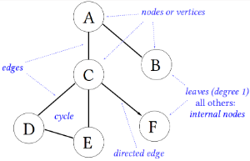
Fig. 1. Example of a graph depicting the names of important parts of a graph or tree.

In other languages
DE: Zyklus
FR: cycle
IT: ciclo
VM, TR, PR (drawing)

Data display network
Also: implicit network, cf. phylogenetic networks, types of.

Data formats
Data formats are ways to formally represent different kinds of data following a commonly agreed structure and semantics. Data formats are usually machine-readable, meaning that they can be created and processed by computer programs. Examples of common data formats are portable document format (suffix .pdf) for text and image documents, hypertext markup language (suffix .html or .htm) for web content, and plain text (suffix .txt).
In our context there are data formats for:
– textual data,
– character data,
– trees,
– networks.
In other languages
DE: Datenformate
FR: formats de données
IT: formati di dati (English form often used)
TR

Data formats for character data
In case the data is encoded as sequences of characters, for example, by encoding each variant reading as a letter (A, B, C, …), then the data can be represented as a character matrix. Apart from writing it as plain text, a character matrix can be encoded using the common Nexus format.
TR

Data formats for textual data
Only some basic information about digital formats for textual data and their pros and cons can here be provided. Those currently most often used for text data are:
– plain text (file suffix .txt): The text of each witness in the tradition may be represented as a single plain text file, or one witness may be printed on one line and the entire tradition may be kept in one file. Plain text files do not allow the encoding of formatting like italics, bold, font size or the like. A plain text file uses an encoding system, such as Unicode (e.g., UTF-8, UTF-16), ISO, MS Windows, or Mac. Accessing a text document using a wrong encoding system will result in garbled content. UTF-8 unicode is the de facto standard today for European alphabets.
– markup text (.html and .xml): Adding tags (either opening and closing to define an action [like printing it in italics] on the text in-between <tag> .... </tag>, or as a single "self-closing tags like <tag/>) allows to add formatting to plain text files. Internet pages are of this kind (html), whereas .xml especially according to the tagging rules defined by the Text Encoding Initiative(TEI) are now de facto standard for storage and interchange of written documents. These formats can be easily manipulated by a plain text editor on any platform, in contrast to the following formats that require specialised software:
– OpenDocument text document (.odt) is the open standard format used in open-source word processing programs (like OpenOffice and LibreOffice). It uses its own markup for the text and saves all additional data (like pictures) in a compressed file (using the zip algorithm). Its advantage over xml is that it can be easily visualised in most text editing software (now also including MS Word) and it allows many types of markup for text layout (page sizes, margins, etc.) and styles (headings, italics, fonts and font sizes, etc.).
– Microsoft Word (.doc or .docx; including many different sub-versions) are formats owned by Microsoft. They require a Word-compliant word processing software to access the content. Its uses and functionality are similar to odt. Standard word processing programs (like OpenOffice or Word) can export data as plain text or mark-up text (html, some versions of xml), this may be a necessary step to make the data readable for specialised stemmatological software.
Spreadsheets, that is tables with rows and columns that may contain numbers, formulas or text, use their own formats:
– Comma separated values (.csv) is a plain text (cf. above) format for spreadsheet data. It can represent only the textual content but no formatting information. The words can be separated by commas (','), tabulators, spaces, or other special characters. The words can also be enclosed in delimiting characters such as parentheses.
– OpenDocument spreadsheet document (.ods) is the open standard format for spreadsheet documents. A textual tradition can be organised so that each text occupies a single row and each word occupies a single column from left to right. Adding gaps in suitable places in each of the texts so as to ascertain that the same or comparable words in each of the texts are places in the same column is called alignment. This can be done either manually in a spreadsheet program or automatically using alignment tools. Alternatively, each text may be placed in a single column in the document so that each word takes a single row, starting from the top, and different witnesses can be put into different columns.
– Microsoft Excel (.xls or xlsx; including many different sub-versions) belongs to Microsoft and requires that Excel-compliant spreadsheet software is used to access the content. It can be used as an alternative to OpenDocument. Again standard word processing programs can export spreadsheet data as .csv (which may be formatted into plain text), which may be a necessary step to make the data readable for specialised stemmatological software.
TR, PR

Data formats for trees
There are a number of data formats for representing phylogenetic or other kinds of trees. Perhaps the most common one, which shall be discussed here exemplarily, is Newick. It uses brackets in quite an intuitive way. Representation on various levels of detail are possible. For example, the two strings
(A, (B, (C, D))); (A:1.0,(B:0.6,(C:0.2,D:0.1):0.6):0.2);
encode the same bifurcating tree topology with four labelled leaf nodes, respectively with and without edge lengths. The resulting trees are shown in Fig. 1.

Illustration
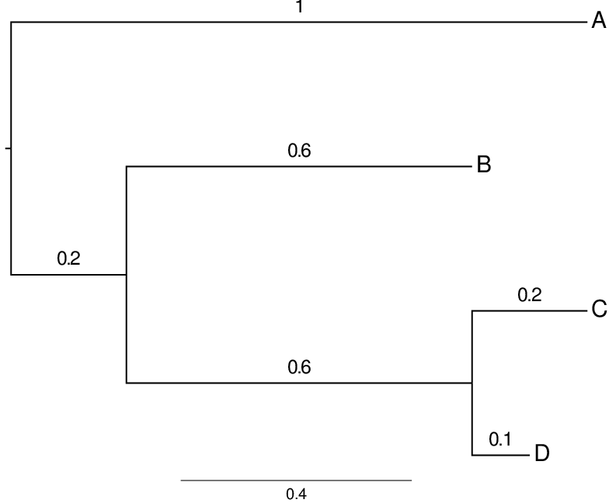

Fig. 1: Left: A tree without edge lengths. Right: A tree with edges drawn proportional to their lengths. The edge lengths are also shown as numbers. (The figures were drawn using the program FigTree.)
If the tree is unrooted, an arbitrary node is chosen to be used first. Any node may be specified as root in the tree in this format. The format uses the file extension .nwk. It is used for instance in Phylip, MrBayes and PAUP*.
TR, PR

Degree
In a graph, the degree of node v is the total number of edges that contain v. For example in the graph below, the node B has degree three.
The indegree of a node v is the number of directed edges that point towards v. So, in the graph, the indegree of node C is two. Similarly, the outdegree of a node v is the number of directed edges that point away from v. Thus the outdegree of node C in the graph is one.
A leaf in a graph is a node with indegree one and outdegree zero, or in the undirected case, degree one.

Illustration
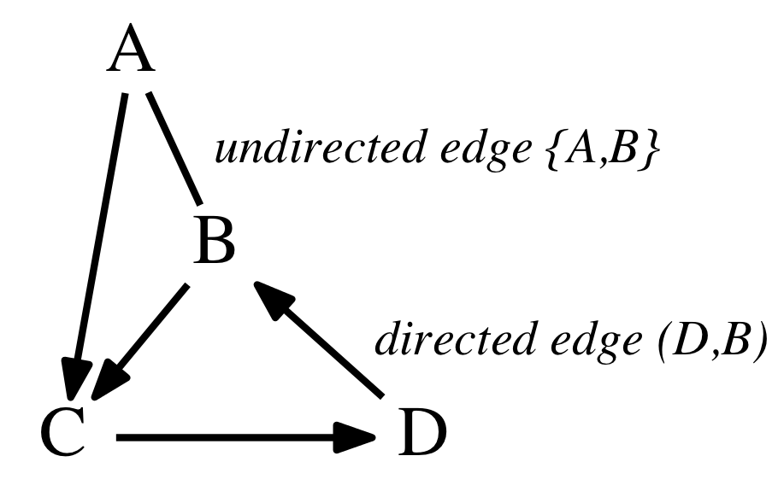

In other languages
DE: Grad
FR: degré
IT: grado
TR, VM, KH

Descendant
The opposite of an ancestor.

In other languages
DE: Nachkomme
FR: descendant
IT: discendente
PR

Diasystem
The word is a learned formation of the Greek διά ‘through’ and σύστημα ‘whole compounded of several parts, system’.
A term applied to textual criticism by Cesare Segre (1976) to express the idea that the text transmitted in a given manuscript represents the contact between the linguistic system of the author and those of the copyists who filter the exemplar through their own code. A diasystem can thus be seen as a sort of compromise between two or more semiotic systems coming into contact with one another:
“Che cosa accade se i ritocchi linguistici e stilistici non sono attuati dall’autore stesso, ma da copisti, editori, ecc.? Da un punto di vista teorico, si verifica l’interferenza tra due sistemi: quello dell’autore e quello del copista, editore, ecc. Il copista mantiene, per lo più in quantità cospicua, il sistema dell’autore, ma vi interviene realizzando in parte un proprio sistema. … Il risultato di questa Sprachmischung potrebbe essere definito, a mio avviso, un diasistema … il sistema di compromesso tra due sistemi in contatto.” (Segre 1979, 53-70).
(What happens if the linguistic and stilistic adjustments are not made by the author himself, but rather by copyists, editors, etc.? From the theoretical point of view, what takes place is an interference between two systems, i.e. the system of the author and that of the copyist, editor, etc. The copyist usually keeps a conspicuous amount of the author-system, but he also partially filters it through his own. The result of this Sprachmischung could be defined as a diasystem …, namely a compromise between two systems coming into contact.)
Segre makes a semantic redefinition of the linguistic notion 'diasystem' coined by the dialectologist Uriel Weinreich in 1954 and indicating a higher-order system which subsumes all low-order discrete systems.

References
– Segre, Cesare. 1976. “Critique textuelle, théorie des ensembles et diasystèmes.” Académie royale de Belgique, Bulletin de la classe des lettre set des sciences morale set politiques 62: 279–292.
– ———. 1979. “Critica testuale, teoria degli insiemi e diasistema.” In Cesare Segre. 1979. Semiotica filologica: Testo e modelli culturali, 53–70. Torino: Einaudi.
– Weinreich, Uriel. 1954. “Is a structural dialectology possible?” Word 10: 388–400.

In other languages
DE: Diasystem
FR: diasystème
IT: diasistema
MB

Dictation
Texts were frequently copied by visual inspection, i.e. in a situation where the copyist had an older manuscript that was to be copied in front of him / her. Sometimes, however, they have been copied by dictation, i.e. when somebody read the text found in the exemplar aloud to one or several copyists. Some scholars also distinguish this “external” dictation from “internal” dictation (French: dictée intérieure), when a copyist memorises a passage of the exemplar for a few seconds and “dictates” it to him/herself to actually copy it.

Reference
– Bayet, Jean, ed. 1961. Tite-Live: Histoire romaine. Livre I. Texte établi par Jean Bayet et traduit par Gaston Baillet. Paris: Les Belles Lettres. || See p. LXXXVI.

In other languages
DE: Diktat
FR: dictée
IT: dettatura
GH

Diffraction
The term ‘diffraction’ (also ‘multiple innovation’) refers to the substitution of the original [reading], when particularly difficult, infrequent or rare, with several innovative (but trivial) readings or attempts of clarification by the scribes.
The concept of diffraction, connected with the notion of lectio difficilior, was first explored theoretically by Gianfranco Contini in 1955 and further expanded by the same scholar in a speech given in 1967. Contini draws this term from physics, and applies it to the field of textual criticism. He then distinguishes the categories of diffraction 'in praesentia', where the reading that has caused diffraction is preserved in at least one witness, and 'in absentia',where the reading that has caused diffraction is lost. The following is an example of the second category, given by Contini himself (1967) and taken from the tradition of the Old French Vie de saint Alexis (l. 155, L, A, P, P2, and S being the manuscripts that transmit the diffracted readings):
(l. 154: Plainons ensemble le dol de nostre ami)
L tu de tun seinur, jo·l frai pur mun filz
A tu pur tun sire e je pur mun chier filz
P tu por tun seignor, je.l ferai por mun fiz (P2 tu t. seigneur…)
S l’une son fil et l’autre son ami.
The readings of the extant manuscripts are not admissible either for metrics (L P P2), or morphology (A) or for their meaning in the context (S). It has been argued by Adolf Tobler, in his review of Gaston Paris’ edition of Alexis(1872), that the original, lost reading could be:
tu por tun per(...).
Using Contini’s terminology, one may assume that the rare meaning of per (masculine!) 'spouse' has generated diffraction yielding to the different trivial readings attested in the witnesses: seinur(L)/ seignor (P) 'lord/husband', sire (A) 'lord/husband' [nominative], son fil(S) 'his son'.

References
– Contini, Gianfranco. 1955. “Ancora sulla canzone ‘S’eo trovasse Pietanza’ ”. Siculorum Gymnasium8, 122–138.
– ———. 1968. La critica testuale come studio di strutture(1967).In Gianfranco Contini.1986. Breviario di ecdotica,135–148. Milano: Riccardo Ricciardi.
– Gorni, Guglielmo. 1990. “‘Divinatio’, ‘lectio difficilior’ e diffrazione nella filologia di Contini”. Filologia e criticaXV/2–3, 230–258.
– Paris, Gaston, ed. 1872. La Vie de Saint Alexis: Poème du XIe siècle. Paris: Franck.
– Tobler, Adolf. 1872. “Compte rendu de l’édition du Saint Alexis par Gaston Paris”. Göttingen gelehrte Anzeigen5. Juni 1872, 881–903.

In other languages
DE: Diffraktion
FR: diffraction
IT: diffrazione
CL, MB

Directed acyclic graph (DAG)
A directed acyclic graph (DAG) is a directed graph in which there are no directed cycles, i.e., it is not possible to arrive at the same node where one started by following only edges in the direction into which they are pointing.

Illustration
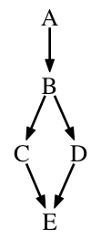
Fig. 1. A DAG.
For instance, the directed graph below is a DAG even though there is an (undirected) cycle B-D-E-C-B because any traversal of the cycle requires that one travels against the direction of at least one edge.
Stemmata for transmissions that are not contaminated are DAGs.

In other languages
DE: gerichteter azyklischer Graph
FR: graphe orienté acyclique
IT: grafo aciclico orientato
TR

Dispositio
In textual criticism, the term dispositio refers to the final stage of the editorial work when the critically established text is positioned on the page, together with the critical apparatus.
Usually, the reconstructed text is placed in the upper part of the page, followed by two (or more) apparatus areas: (1) apparatus fontium et locorum parallelorum; (2) critical apparatus in the proper sense (either in its negative or positive version). An illustration of how a critical edition may look like is provided under the entry apparatus.
If different recensions of the same work have been postulated by the editor, their texts are usually given in parallel columns (e.g. Batts 1971), thus providing a synoptic edition.

References
– Batts, Michael S., ed. 1971. Das Nibelungenlied: Paralleldruck der Handschriften A, B, und C, nebst Lesarten derübrigen Handschriften.Tübingen: Niemeyer.
– Luiselli Fadda, Anna Maria. 1994. Tradizioni manoscritte e critica del testo nel Medioevo germanico. Roma: Laterza. || See pp. 246–248.
MB

Distance matrix
In mathematics and graph theory, a distance matrix is a matrix A containing the pairwise distances (d) of a set of pointsa_{1...n} in the form [[d_{ij}]]. An example from every-day life are road distance tables that list the pairwise distances between towns (cf. illustration).

Illustration
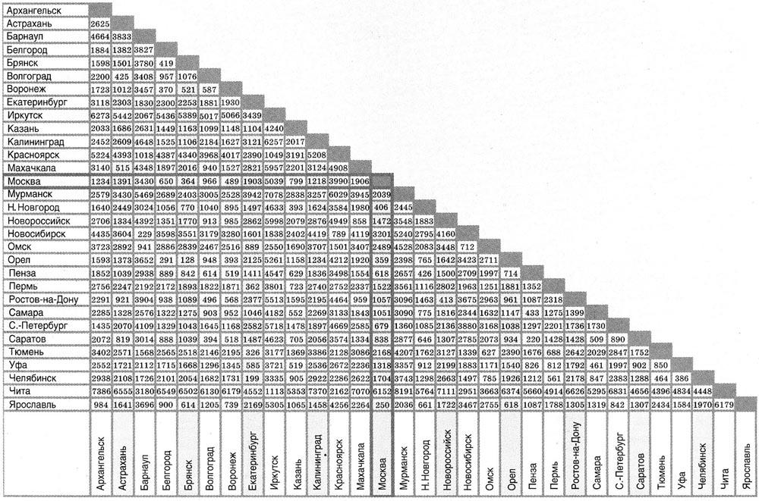
Fig.1. An every-day example of a distance matrix listing road distances (in km) between important Russian tows.
In the case of stemmatics, the points a_{1...n} are text-samples fromn witnesses. The mapping from a space of text-strings (w) to the distance matrix may be described as f: L(w×n) → ℝ(n×n). For n points this matrix will thus be an n×n-matrix. The distance between the points may be measured by any metric on the underlying space on which the points are defined. Therefore, the mapping f depends on the metric used, i.e. the kind of distance measure one chooses to use between the points. A simple example would be to define any change of a letter as a distance 1, so the distance between a=‘hortus’ and b=‘ortus’ would be d_{ab} = 1.
From the definition of a metric follow some basic properties: the matrix is symmetrical (the distance from a to b is by definition equal to the one from b to a); its trace is 0 (the distance between a and a must be 0 for all a); all entries d_{ab} ≤ 0, and equal to 0 if and only if a = b; for its entries the triangle inequality holds (d_{ac} ≤ d_{ab} + d_{bc}). As the matrix is by definition symmetrical, often only its lower left half is given (as in the illustration above) as the upper right half would be its mirror-image.
For manuscript traditions an adequate metric may be defined (one that reflects the psychological “distance” between readings) and a distance matrix calculated. The aim here should be to assign a large distance to changes that are unlikely to happen independently and may be hard to revert by a thinking copyist (cf. Leitfehler), whereas trivial changes (like orthographic ones) should be assigned a very small distance. Cf. Leitfehler-based method.
There is standard software to approximate the optimal tree from a given distance matrix, e.g. in the open-source PHYLIP package. Note that no oriented tree (i.e. a real stemma) can be gained from a distance matrix without additional information as the latter does not contain orientation. Cf. polarisation.
Cf. distance-based methods.

In other languages
DE: Distanzmatrix
FR: matrice de distance
IT: matrice di distanza
PR

Dittography
Dittography (from Greek διττός ‘twice’ and γράφειν ‘to write’) is the writing of a word or part of a word twice, e.g. renonown for renown. As a consequence, new material may be added to the text (cf. addition).
The opposite case, when what should be written twice is written once, is called haplography.

References
– Havet, Louis. 1911. Manuel de critique verbale appliquée aux textes latins. Paris: Hachette.
– Reynolds, Leighton Durham, and Nigel G. Wilson. 1974. Scribes and Scholars: A Guide to the Transmission of Greek and Latin Literature. 2nd ed. Oxford: Clarendon Press. || See p. 205.
– West, Martin L. 1973. Textual Criticism and Editorial Technique Applicable to Greek and Latin Texts. Stuttgart: Teubner. || See pp. 24, 133.

In other languages
DE: Dittographie
FR: dittographie
IT: dittografia
GH

Divinatio
Two slightly different meanings of divinatio may be differentiated:
(i) Strictly speaking, divinatio is one of the three main operations which characterise emendatio, along with selectio and combinatio. Divinatio consists in correcting the alleged corrupted readings or corrupted textual passages only by conjecture, e.g. by providing additions, deletions or substitutions (see, among others, Avalle 1972, 111-112, and Luiselli Fadda 1994, 236-237).
(ii) Paul Maas, in his work Textkritik,gives divinatio a broader meaning, which is very close to the notion of emendatio ope ingenii (see emendatio and constitutio textus). Maas uses this term to designate the third and final stage of textual restoration.
References
– Avalle, D’Arco Silvio. 1972. Principî di critica testuale. Padova: Antenore.
– Luiselli Fadda, Anna Maria. 1994. Tradizioni manoscritte e critica del testo nel Medioevo germanico. Roma: Laterza.
– Maas, Paul. 1960. Textkritik. 4th ed. Leipzig: Teubner. – First ed. 1927.
MB

Document
From Latin documentum, which means a 'lesson, example, instance, specimen', that is 'anything that provides instruction' as this abstract noun is derived from the verb doceo 'to teach, inform, instruct'. In the middle ages the word documentum may also mean 'testimony, quotation in support' (according to Niermeyer, s.v.), thus preparing the modern meaning.
There are various approaches to define the rather elusive concept 'document'. It may designate any symbolic representation of language on a material support, so it is a carrier of text. Among librarians e.g. Schürmeyer (1935, p. 537) has a wider understanding of what a document is: "Man versteht heute unter einem Dokument jede materielle Unterlage zur Erweiterung unserer Kenntnisse, die einem Studium oder Vergleich zugänglich ist." (Today one understands as a document any material basis enlarging our knowledge available for study or comparison). This very wide approach would then comprise e.g. physical objects found in archaeology that do not contain writing. Donker Duyvis also offers a rather broad definition: “A document is the repository of an expressed thought" (translation from Voorhoeve 1964, p. 48). In our present context, however, it seems preferable to require a linguistic character of a document.
The definitory problem becomes even more acute in the computer age. Here a (computer) document is a file representing a (traditional) document and thus (human) language, but the boundaries remain rather elusive as every file is basically a sequence of 1s and 0s carrying some information. Cf. data formats for textual data.
Documents include: scrolls, manuscripts, books, charters, treaties, inscriptions, microfilms etc. Their copying produces a transmission. All its witnesses are documents. A single document may be edited in a documentary edition. In everyday language, a document is often something containing only a single page, like legal documents.

References
– Buckland, Michael. 1998. “What is a digital document?” Document Numérique 2 (2): 221–230. – Shortened online version, accessed 12 October 2015: http://people.ischool.berkeley.edu/~buckland/digdoc.html
– Donker Duyvis, Frits. 1942. Normalisatie op het gebied der documentatie. ’s-Gravenhage: Nederlandsch Instituut voor Documentatie en Registratuur.
– Schürmeyer, Walter. 1935. “Aufgaben und Methoden der Dokumentation”. Zentralblatt für Bibliothekswesen 52: 533–543. – Reprinted in Peter R. Frank. 1978. Von der systematischen Bibliographie zur Dokumentation. Darmstadt: Wissenschafliche Buchgesellschaft.
– Voorhoeve, Nicolaas Anthony Johannes. 1964. “F. Donker Duyvis and standardization”. In F. Donker Duyvis: His life and work, 39–50.’s-Gravenhage: Nederlandsch Instituut voor Documentatie en Registratuur.

In other languages
DE: Dokument
FR: document
IT: documento

PR

Duplication
Duplication, or the repetition of a segment of text, is another term used for dittography and is a type of addition.
Cf. types of errors.
In other languages
DE: Verdoppelung
FR: doublement
IT: duplicazione / dittografia
AC

Ecdotics
Ecdotics is the academic field studying the way texts are (to be) edited. This branch of scholarship focuses especially on how historic texts are edited critically. It is closely related to textual criticism in general. The term is rarely used in English (there is no entry in the Oxford English Dictionary), but common in French and Italian.
The word is derived from Greek ἐκ-δίδωμι 'to give out' in many senses, including 'to edit a text (etc.)'. In French the term is already in use in the 19th century and is often used as a synonym to or a subset of textual criticism, e.g. in Henry Quentin (1926).

References
– École nationale des chartes. 2001–2002. Conseils pour l'édition des textes médiévaux. Paris: Éditions du CTHS. Volumes: Conseils généraux, coord. Olivier Guyotjeannin et Françoise Vieillard, 2001; Actes et documents d'archives, coord. Olivier Guyotjeannin, 2001; Textes littéraires, coord. Pascale Bourgain et Françoise Vieillard, 2002.
– Contini, Gianfranco. 1986.Breviario di ecdotica. Torino: Einaudi.
– Quentin, Henry. 1926. Essais de critique textuelle (ecdotique). Paris: A. Picard.
– Segre, Cesare. 1991.Due lezioni di ecdotica.Pisa: Scuola normale superiore.

In other languages
DE: Ekdotik
FR: ecdotique
IT: ecdotica
PR

Edge
An edge is a direct connection between two nodes in a graph. It is often represented as a line, either straight or curved. The meaning of an edge depends on the context. For instance, in a phylogenetic tree, an edge typically indicates direct descent, but if two edges end in a node, they may also represent reticulation events such as horizontal gene transfer or contamination. An edge may be either undirected or directed. In the latter case, the direction is often shown by drawing the line as an arrow.
An edge may also have additional properties. For instance, the weight of an edge may correspond to the importance or support of the edge so that a large weight suggests that the edge is very important or that it has high statistical support whereas a low weight suggests the opposite. The length of an edge in a phylogenetic tree or network, on the other hand, often represents temporal difference or a mutation rate (or a combination of them) so that any two taxa at opposite ends of a long edge tend to be more different from one another than two other taxa at the opposite ends of a short edge.
See also: graph.

In other languages
DE: Kante
FR: arête
IT: lato, spigolo, (arco)

Illustration
Fig. 1. Example of a graph depicting the names of important parts of a graph or tree.
TR, PR (drawing)

Edition, best-manuscript
A best-manuscript edition is an edition based on the supposedly best manuscript, typically the earliest and/or best preserved manuscript in the tradition. For practical purposes, the term goes back to Joseph Bédier, who after struggling with the Old French Lai de l'Ombre for a number of years, drawing a number of conflicting stemmata, finally decided for a single, good manuscript. To determine which manuscript is "best" may be highly subjective.
For a fuller discussion, see the entries on codex optimus and editions, types of.
In other languages
DE: Ausgabe / Edition nach der besten Handschrift
FR: édition du meilleur manuscrit
IT: edizione, codice migliore / ottimo
OH

Edition, critical
A critical edition is an edition in which the text has been constituted on the basis of more than one source according to the genealogical principle. As it uses more than one source, in this respect it is an eclectic edition. What sets the critical edition apart is that it is based on a strict recension of the manuscript sources and the attempt to edit the archetypal text (possibly with some changes where the archetype is clearly faulty), and it is thus closely associated with the Lachmannian tradition of textual editing. Editors who do not agree with this reconstructive tradition, usually refer to their editions in other terms than critical.
For a fuller discussion of the term, see editions, types of. See also constitutio textus.

In other languages
DE: kritische Edition
FR: édition critique
IT: edizione critica
OH

Edition, digital
Theoretically, any type of edition can be published in electronic format (in the past on CD-ROM, nowadays on the web). A major distinction must be made, however, between static, digitised editions (reproducing the features of an edition in printed form) and dynamic, truly digital editions (taking full advantage of the digital medium) (Sahle 2013).
The vast majority of digital editions that exist, are documentary editions (see Pierazzo 2014), probably because their methodology (linking the image of a single document to a transcription and an edited text) was more suited for the electronic format. Only few "truly critical and truly digital" editions exist so far, and they mostly reproduced in electronic format the traditional critical apparatus (see Fischer 2013 for two different examples, see also Andrews 2013 and Robinson 2013).
Many new features are possible in the digital medium: there are no limitations of space and of paper format, linking is much easier and on the whole the edition is no longer constrained to a single dimension of reading. A few examples show some of these new possibilities:
Example 1: A tradition with much variation
Wolfram of Eschenbach's Parzival, project led by Michael Stolz, University of Bern. http://www.parzival.unibe.ch/editionen.html. Features include a synoptic view of edited text and manuscripts, clickable apparatus entries, synoptic views of recensions or manuscripts.
Example 2: Glosses
For editing glosses to a text, a digital edition can be very advantageous as the manuscript containing them can be visualised beside the edition instead of only being described. E.g. Heidi Eisenhut's "Die Glossen Ekkeharts IV. im Codex Sangallensis 621", http://monumenta.ch/heidieisenhut/cd/seite/283.html?kapitel=&bildnummer=283.
Example 3: Incorporation in metacorpora
Richard Rufus's texts are currently being edited by a team led by Riga Wood (Princeton University). Their text is integrated into the metacorpus "Corpus Corporum", http://mlat.uzh.ch/MLS/xanfang.php?corpus=7&lang=0. This allows it to be searched and compared with other text, besides enabling features like clicking words to visualise dictionary entries about them.

References
– Andrews, Tara L. 2013. “The Third Way: Philology and Critical Edition in the Digital Age.” Variants 10: 61–76.
– Fischer, Franz. 2013. “All texts are equal, but… Textual plurality and the critical text in digital scholarly editions.” Variants 10: 77–91.
– Haugen, Odd Einar, and Daniel Apollon. 2014. “The Digital Turn in Textual Scholarship: Historical and Typological Perspectives.” In Digital Critical Editions, edited by Daniel Apollon, Claire Bélisle, and Philippe Régnier, 35–57. Urbana: University of Illinois Press.
– Macé, Caroline, and Jost Gippert. Forthcoming. “Textual Criticism and Editing in the Digital Age.” In Oxford Handbook of Greek & Latin Textual Criticism, edited by W. de Melo and S. Scullion. Oxford: Oxford University Press.
– Pierazzo, Elena. 2014. “Digital Documentary Editing and the Others.” Scholarly Editing: The Annual of the Association for Documentary Editing 35. http://www.scholarlyediting.org/2014/essays/essay.pierazzo.html.
– Robinson, Peter M. W. 2013. “Towards a Theory of Digital Editions.” Variants 10: 105–131.
– Sahle, Patrick. 2013. Digitale Editionsformen: Zum Umgang mit der Überlieferung unter den Bedingungen des Medienwandels. 3 vols. Norderstedt: Books on Demand.
– Shillingsburg, Peter L. 2006. From Gutenberg to Google: Electronic representation of literary texts. Cambridge: Cambridge University Press.
– van Zundert, Joris. 2015. “By way of conclusion: Truly scholarly, digital and innovative editions.” In Analysis of Ancient and Medieval Texts and Manuscripts: Digital Approaches, edited by Tara L. Andrews and Caroline Macé, 335–346. Turnhout: Brepols.

In other languages
DE: digitale Edition / Ausgabe
FR: édition électronique / digitale
IT: edizione elettronica / digitale
CM, PR

Edition, diplomatic
A diplomatic edition is an edition which is based on a single manuscript and usually follows it very closely in matters of orthography, so that it is suited for e.g. linguistic studies. In many cases, obvious mistakes are not corrected, but perhaps only pointed out in the apparatus.
Diplomatic editions are particularly frequent in the field of vernacular languages, since many of these lack a standard orthography. The editor then has to chose between the orthography of the manuscript or some type of regularised orthography and will often find the first solution easiest and also truest to the source.
The term derives from Latin diploma, originally a folded piece of writing material, and by extension to the study of the writing on such documents. The term diplomatics was coined by the Benedictine monk Jean Mabillon in his influential treatise De re diplomatica (1681), in which he developed the study of written documents with regards to their script, date and authenticity, and a diplomatic edition is thus an edition suited for this kind of study. The term diplomacy in the meaning ‘the managing of international relations’ has the same root in the word diploma, although it has acquired a quite different meaning.
For a fuller discussion of the term, see editions, types of.

In other languages
DE: diplomatische Edition
FR: édition diplomatique
IT: edizione diplomatica
OH

Edition, documentary
A documentary edition is an edition based on a single manuscript, often the supposedly best manuscript, the codex optimus, but in some cases also a manuscript of particular literary or linguistic value. In the latter case, the codex optimus will usually have been edited, so making a new documentary edition is a way of supplementing the editions of the work in question. Quite a few editions of vernacular texts are documentary since they primarily are intended for linguistic studies.
A closely related term is diplomatic edition, which is commonly used for an edition which follows a single source closely. However, while a documentary edition may regularise the orthography of the source, a diplomatic edition usually never do this (cf. Haugen 2014).
A documentary edition can also be termed monotypic, since it is based on a single source.
For a fuller discussion of the term, see editions, types of.

Reference
– Haugen, Odd Einar. 2014. “The making of an edition: Three crucial dimensions.” In Digital critical editions, edited by Daniel Apollon, Claire Bélisle and Philippe Régnier, 203–245. Urbana: University of Illinois Press.

In other languages
DE: vergleichende Edition / (Text)Ausgabe, occasionally also Dokumentationsausgabe
FR: édition documentaire
IT: edizione documentaria
OH

Edition, eclectic
An eclectic edition is an edition which is based on more than one manuscript. The eclectic edition will not reflect a single manuscript throughout, such as a documentary edition does, but tries to approximate an earlier stage of the textual transmission by selecting readings from several manuscripts. The eclectic edition will select the supposedly best readings wherever there are conflicting readings in the manuscripts.
In many branches of textual editing and especially in branches where a truly critical edition is attainable, an eclectic edition is usually seen as a less stringent and sometimes naïve type of edition. For this reason, the term ‘eclectic’ often has a pejorative ring to it, as in ‘lack of any stringent method or perspective’.
In the editing of Biblical texts, where the manuscript material is so overwhelming that a truly critical edition is impossible, eclectic editing is an accepted strategy, but a distinction is sometimes drawn between “thoroughgoing eclecticism” and “reasoned eclecticism” (cf. Amphoux 2014, 239–241).
The term ‘eclectic’ is also used as a neutral term within the editing of modern texts by leading American critics, following the copy-text theory of Walter Wilson Greg. The edition of the works by the Swedish author August Strindberg (1849–1912) is one example of such an eclectic edition, in the sense that the edited text is based on the original manuscript, but that later changes presumably by the author will be introduced in the edited text if deemed substantial (cf. Kondrup 2011, 126–127). Rather than searching for the original text, as the editors tend to do in classical and mediaeval philology, the editor of an eclectic edition of modern works tends to search for the intention of the author.
For a contextual discussion of the term, see editions, types of.

References
– Amphoux, Christian-Bernard, ed. 2014. Manuel de critique textuelle du Nouveau Testament. Bruxelles: Safran.
– Greg, Walter Wilson. 1950. “The Rationale of Copy-Text.” Studies in Bibliography 3: 19–36.
– Kondrup, Johnny. 2011. Editionsfilologi. København: Museum Tusculanum.

In other languages
DE: eklektische Edition
FR: édition éclectique
IT: edizione eclettica (only in the sense of "hybrid")
OH

Edition, monotypic
A monotypic edition is an edition based on a single manuscript (a modern formation based on Greek μόνος ‘single’ and τύπος ‘blow, beat, type, imprint etc.’). The term, which originates in the field of printmaking, has been used in e.g. Haugen (2013, p. 40) in order to focus on the singularity of an edition. In this lexicon, the term documentary edition is used in the same meaning.

Reference
– Haugen, Odd Einar. 2013. “Editionen westnordischer Mittelaltertexte in Skandinavien – ein historischer Überblick.” In Geschichte der Edition in Skandinavien, edited by Paula Henrikson and Christian Janss, 13–47. Berlin: Walter de Gruyter.
OH

Editions, history of
This entry gives an overview of the history of editing from the Alexandrian period until early modern time, with a focus on classical texts in Greek and Latin. It does not cover the edition of modern texts, and like the other contributions in this lexicon, it does not cover editions in other philological traditions. For a typological perspective, see editions, types of.
The philological practice of comparing several manuscripts in order to reconstruct a text was born in the great library of Alexandria in the 3rd century BC (cf. eclectic editions in editions, types of). Important editions of pre-classical Greek poets, e.g. Homer, were created there. The Alexandrians also introduced various signs in order to draw attention to suspicious or problematic readings and they discussed such problems in commentaries and scholia. The Alexandrian philologists were often able to take into consideration a rather large number of different manuscripts: this was the case when Aristarchus of Samothrace worked on Homer at Alexandria in the 2nd century BC. It is, however, not likely that Aristarchus used all that material for a systematic study of the internal relationship between the manuscripts in a modern sense: he rather seems to have compared a version of the text, which he considered particularly reliable, to other versions and thus produced a text which was free from obvious faults and which then replaced the multitude of earlier versions.
This Alexandrian practices of comparing manuscripts in order to produce a canonical version of a text, of drawing attention to problems in the text with the help of a number of signs, and of writing commentaries and scholia on such matters were introduced in Rome in the 2nd and 1st centuries BC. In Rome there was no such public library until Augustan times, but there was an organised book trade already in the first part of the 1st century BC. In such an environment new editions of classical authors were regularly created.
It is probable that such methods were normally used when new editions of classical texts were produced in expensive parchment codices in late antiquity. Sometimes these new editions were sponsored by wealthy private persons (cf. e.g. the new edition of Livy from around 400 AD, which was sponsored by the Symmachi and the Nicomachi). This activity in late antiquity is of fundamental importance for the survival of classical literature, since the literary works which were not edited and re-written on parchment had poor chances of surviving into the middle ages (cf. media transmitting texts).
In the early middle ages literacy decreased considerably – especially on the continent. Reading, writing and copying of books became a matter mainly dealt with in the monasteries. Around 800 there was a revival of the interest in classical literature in both the Latin West and in the Greek East. Classical literary works were now copied and studied.
In the late middle ages and early Renaissance, literacy and learning became more common outside the church and the interest in classical literature increased: as a result there was a further increase in the search for and in the copying of such texts. There was now more contact with the Greek-speaking world and westerners, first Italians and then others, were learning Greek again. There was also an increasing production of new texts in both the classical and in the vernacular languages which were copied and edited.
When the printing technique was introduced in the 15th century, religious texts such as the Bible but also classical literary texts were among the first ones to be printed. The early editions thus created were sometimes based on only one manuscript (cf. documentary editions in editions, types of). Unfortunately, these early editors and printers did not always regard it as necessary to keep the manuscripts that they had used. Important information about the preceding manuscript traditions was therefore often lost. Often, however, there were also attempts to compare different manuscripts with one another and thus establish a better text, but the comparison of the manuscripts was then rather arbitrary and it was based on the probability of the different readings in mostly relatively recent manuscripts (cf. e.g. the edition of the New Testament in Greek by Erasmus of Rotterdam).
Many texts were then reprinted in the 16th, 17th and 18th centuries on the basis of such first editions (textus receptus). This practice was challenged by several 17th and 18th century scholars, who thought that editions should be based on the older manuscripts. Thus a new method developed according to which the internal relationship between the text witnesses should be studied and, if possible, an archetype be established. This is the method associated with the name of the German 19th century scholar Karl Lachmann.
Some of the variation found in the manuscripts of ancient and mediaeval texts is due to the fact that sometimes an ancient or mediaeval author published more than one version of his text. We know, for instance, that several classical Greek and Latin texts were revised after publication by their authors or got into circulation before the text had been fully revised. In such cases the various stages of elaboration may be represented by varying readings in the later transmission of the text. Sometimes an edition was made from a text which was not intended for publication in that form by the author. Some of Aristotle’s transmitted work goes back to lecture notes, which seem to have been made by the author himself. The teaching of several mediaeval philosophers is known to us from such annotations made by their students (cf. reportatio in copying of texts).
Both in antiquity and in the middle ages there were various attitudes to the copying of texts. Some texts were treated with much respect for the original wording of the text, but in other cases the copyists felt more free to intervene and introduce changes – this is, for instance, often the case in technical texts of various kinds, but it sometimes also happened to literary texts (cf. copying of texts: attitudes). As a result we can distinguish between closed text traditions, where there was little or no room for such changes, and open traditions, where there is sometimes considerable variation between the different manuscripts containing the same text. In open traditions scholars often distinguish different recensiones (i.e. versions) of the same text.
Sometimes new editions were made because of a change in ideology or perspective. This happened to certain pagan texts, which occur in both a “pagan” and a “Christian” edition (e.g. Epictetus’ Enchiridion). This happened also to the Decem libri historiarum by the 6th century Gallo-Roman bishop and aristocrat Gregory of Tours, which was abbreviated and renamed Historia Francorum a couple of generations after the author’s death: the Gallo-Roman author himself purported to write about the history of the world from a Christian perspective (putting contemporary events in Gaul into the perspective of God’s plan for the human race), but some of his later readers, who were living in a world in which the Gallo-Roman elite had merged with the Frankish one and a new common French national identity had been born, were only interested in the parts of his texts which dealt with the Frankish kings and thus turned his text into a chronicle of the Merovingian kings.
A particular kind of edition is the anthology (anthologia or, in Latin, florilegium). Such an anthology often contains texts written by several different authors or a selection of texts written by the same author. In antiquity important anthologies containing the works of several different poets were thus created (Anthologia Graeca and Anthologia Latina). There were, however, also anthologies produced for school purposes. In the middle ages there were anthologies of elegant letters, which should serve as models for those writing letters. Many mediaeval manuscripts contain collections of extracts from different authors.

References
– Bayet, Jean, ed. 1961. Tite-Live: Histoire romaine. Livre I. Texte établi par Jean Bayet et traduit par Gaston Baillet. Paris: Les Belles Lettres. || See pp. XCI–C.
– Gastgeber, Christian. 2003. “Die Überlieferung der griechischen Literatur im Mittelalter.” In Egert Pöhlmann, Einführung in die Überlieferungsgeschichte und die Textkritik der Antiken Literatur: Mittelalter und Neuzeit, 1–46. Darmstadt: Wissenschaftliche Buchgesellschaft. || See pp. 28–29.
– Haverling, Gerd V. M. 2008. “On Variation in Syntax and Morphology in Late Latin texts.” In Latin vulgaire – Latin tardif VIII: Actes du VIIIe Colloque International sur le latin vulgaire et tardif, Oxford, 6–9 septembre 2006, edited by Roger Wright, 351–360. Hildesheim: Olms Weidmann.
– Heldmann, Georg. 2003. “Von der Wiederentdeckung der antiken Literatur zu den Anfängen methodischer Textkritik.” In Egert Pöhlmann, Einführung in die Überlieferungsgeschichte und die Textkritik der Antiken Literatur. Mittelalter und Neuzeit, 97–135. Darmstadt: Wissenschaftliche Buchgesellschaft. || See pp. 97–104, 108–130, 131 f.
– Howatson, Margaret C. 1969. The Oxford Companion to Classical Literature. 2nd ed. Oxford: Oxford University Press. || See p. 57.
– Klopsch, Paul. 2003. “Die Überlieferung der lateinischen Literatur im Mittelalter.” In Egert Pöhlmann, Einführung in die Überlieferungsgeschichte und die Textkritik der Antiken Literatur. Mittelalter und Neuzeit, 47–95. Darmstadt: Wissenschaftliche Buchgesellschaft. || See pp. 67–70, 78f.
– Pasquali, Giorgio. 1952. Storia della tradizione e critica del testo. 2nd ed. Firenze: Le Monnier. || See pp. 15–21, 146 f., 397–465.
– Pfeiffer, Rudolf. 1968–1976. History of classical scholarship. Oxford: Clarendon Press.
– Pöhlmann, Egert. 1994. Einführung in die Überlieferungsgeschichte und die Textkritik der Antiken Literatur: Altertum. Darmstadt: Wissenschaftliche Buchgesellschaft. || See pp. 27 f., 31–34, 36 f., 46–49, 61 f., 71 f., 75.
– Pöhlmann, Egert. 2003. “Textkritik und Texte im 19. Und 20. Jh.” In Egert Pöhlmann, Einführung in die Überlieferungsgeschichte und die Textkritik der Antiken Literatur: Mittelalter und Neuzeit, 137–182. Darmstadt: Wissenschaftliche Buchgesellschaft. || See pp. 137–143.
– Reynolds, Leighton Durham, and Nigel G. Wilson. 1974. Scribes and Scholars: A Guide to the Transmission of Greek and Latin Literature. 2nd ed. Oxford: Clarendon Press. || See pp. 8 ff., 21, 33 f., 35-37, 194.
– Salles, Catherine. 2010. Lire à Rome. Petite Bibliothèque Payot. New ed. Paris: Belles Lettres. – 1st ed., Paris: Belles Lettres, 1992. || See pp. 158 f., 175 f.
– West, Martin L. 1973. Textual Criticism and Editorial Technique. Stuttgart: Teubner. || See p. 15.
GH

Editions, types of
An edition is generally understood as a rendering of a text transmitted in one or more sources in a new medium. This brief typology will only consider editions of texts which have primarily been transmitted in handwritten form, typically from antiquity or the middle ages. A major distinction may be drawn between, on the one hand, texts which are based primarily on a single source, here referred to as documentary editions if they only reflect a single source or synoptic if they reflect several, parallel sources, and, on the other hand, editions which constitute their text on the basis of more than one source, eclectic editions.
1. A documentary edition is based on a single source and will usually render this with a high degree of accuracy. Some editors, especially of mediaeval texts, will not even correct obvious mistakes in the text, while others will do so in the apparatus, and yet others in the text itself, relegating the suspect reading to the apparatus. The rendering may keep very closely to the orthography of the source or it may regularise this to a smaller or higher degree. Also here, many editions of mediaeval texts, especially in the vernacular, will keep the orthography of the source texts, so that it can be used for e.g. linguistic studies. This type of documentary edition is usually referred to as a diplomatic edition. Other editors, perhaps especially of classical texts or mediaeval texts in the classical languages will regularise the text to some degree.
A facsimile edition is also a documentary edition, but since it is a reproduction of the source, not a transcription, it is a rather different kind of edition. Some manuscripts may be so clear and well-preserved that a facsimile offers a sufficient edition of the text, but in most cases, aspects of the handwritten text have to be explained and clarified. For example, many mediaeval vernacular manuscripts have so many abbreviations that they are difficult to interpret, even if the writing as such is clear and unambiguous. It should be noted that many facsimile editions have very useful introductions, often covering the history of the manuscript as well as dealing with palaeographical and linguistic aspects of it.
2. A synoptic edition is basically a set of documentary editions of the same text. In a printed edition, the text is usually set out in columns so that it is easy to compare readings across the manuscripts. For this reason, there is a limit to the number of parallel texts being presented on a single page or a single spread of pages. More than four parallel columns are uncommon.
The synoptic format may also be used for eclectic editions, such as the many synoptic editions of the Gospels, pioneered by Johann Jakob Griesbach with his Synopsis evangeliorum (1st ed. 1776). In some cases, the textual variation is so large that it is impractical to display the variant texts in a parallel format, and they are therefore published one after another, such as e.g. the four main versions of the Old Norse Gospel of Nicodemus, Niðrstigningar saga, published sequentially by Carl Richard Unger (1877, vol. 2, p. 1–20).
In a digital edition, several transcriptions of the same text may be made available in a text archive. It is thus left to the users to establish their own, window-based synoptic editions on their screen or in print-outs.
3. An eclectic edition is based on more than one source and establishes the text on the basis of an analysis of these sources. Usually, the eclectic edition will not reflect a single source throughout, but rather tries to approximate an earlier stage of the textual transmission. In stemmatology, this is commonly referred to as the archetype in the tradition, and it is placed below the presumed original of the text. See the discussion of the stemma for these concepts.
Since an eclectic text is based on more than one source and since these typically will display orthographic variation the editor is forced to choose between an edition which switches between several orthographies or which in some way is regularised. The latter solution is usually preferred. The regularisation may be according to a general norm for the language in question, such as for many editions of Latin texts. Even editions of mediaeval Latin will often be regularised towards the classical Latin language. As for vernacular texts, in most traditions the only viable option is to regularise the orthography of the text according to the internal norm of the main manuscript. See further discussion under regularisation.
A critical edition (based on the Lachmannian method) is usually also an eclectic edition in the sense that its text has been constituted on the basis of more than one source. Since Joseph Bédier’s criticism of reconstructive editing (1928), many editors, especially of mediaeval vernacular texts, have opted for best-manuscript editions, in which the text follows the supposedly best manuscript with a minimum of textual emendation. The German Leithandschriftenedition belongs to this type. However, also best-manuscript editions are based on an recension of the manuscript sources. If not, they should be regarded as documentary editions in the terminology used here.
There are a number of edition typologies. A broad typology of editions, of old as well as of modern texts, can be found in Greetham (1994, Appendix II). The typology presented here is based on Haugen (2014) and is illustrated in ill. 1. It focuses on the criterion of text selection rather than of text representation. For the latter, see the entry regularisation.
Cf. digital edition.

Illustration
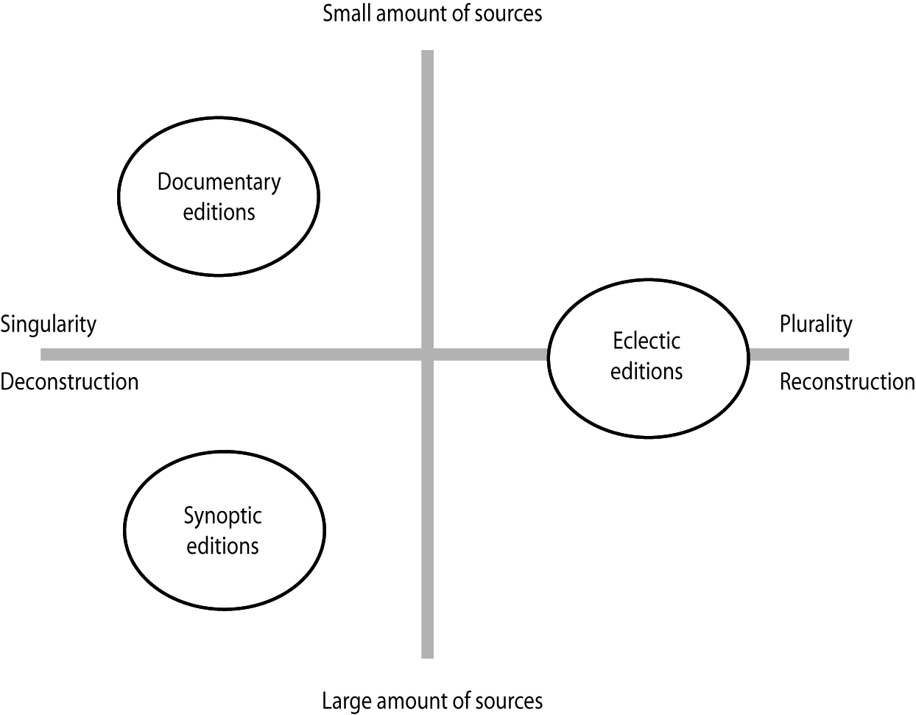
Ill. 1. Typology of editions of classical and mediaeval texts.

References
– Bédier, Joseph. 1928. “La tradition manuscrite du Lai de l’Ombre: Réflexions sur l’art d’éditer les anciens textes.” Romania 54: 161–196, 321–356. – Reprint, Paris: Champion, 1970 gallica.bnf.fr/ark:/12148/bpt6k8980.
– Greetham, David. 1994. Textual Scholarship: An Introduction. Garland reference library of the humanities, vol. 1417. New York: Garland.
– Haugen, Odd Einar. 2014. “The making of an edition: Three crucial dimensions.” In Digital critical editions, edited by Daniel Apollon, Claire Bélisle and Philippe Régnier, 203–245. Urbana: University of Illinois Press.
– Griesbach, Johann Jakob, ed. 1776. Synopsis evangeliorum Matthaei, Marci et Lucae. Halle: Curt.
– Unger, Carl Richard, ed. 1877. Heilagra manna søgur: Fortællinger og Legender om hellige Mænd og Kvinder. 2 vols. Christiania: Bentzen.

In other languages
DE: diplomatische, synoptische, eklektische, kritische – Edition / (Text)Ausgabe
FR: édition – diplomatique, synoptique, éclectique, critique
IT: edizione – diplomatica, sinottica, eclettica, critica
OH

Edition, synoptic
A synoptic edition is an edition which renders the text of two or more manuscripts in parallel columns across one or two pages, or above each other, in horizontal rows. The term is closely linked to the practice of making printed editions and thus limited to the typographical space created by one or two pages in a book.
A synoptic edition can also render other sources than single manuscripts, for example bringing together already existing editions. The main advantage of a synoptic edition is that it makes textual comparison easy for the reader. If the textual variation within a manuscript tradition is high, it can overload the critical apparatus, making a synoptic edition (or several documentary editions) a viable alternative for the editor.
There are a number of problems to consider for the editor of a synoptic edition, such as how to deal with transpositions or larger additions or omissions in the text. For this reason, more than one synoptic edition can easily be made on the basis of the same source material. Today digital editions allow more freedom of space and can be an alternative to a synoptic edition.
For a fuller discussion of the term, see editions, types of.

In other languages
DE: synoptische Edition
FR: édition synoptique
IT: edizione sinottica
OH

Eigenfehler
[ˈaɪɡn̩fe:la]
German for "(a witness's) own mistake", cf.lectio singularis.
PR

Eliminatio codicum descriptorum
Latin, literally 'the removal of copied codices'.
Operation of textual criticism by which those witnesses that after recensio are found to be descripti (i.e. copies of an extant manuscript) are removed, in that they are not of any use for the restoration of the text (constitutio textus). Cf. Maas(1960, §8).
The operation of eliminating the descripti conceals many dangers: to be sure that a codex is descriptus, one should prove that its own set of readings diverging from those of the alleged antecedent are all the result of independent conjectures, and do not depend on any other witnesses. If not all of them do, the younger codex would be a sibling of the earlier, rather than a descriptus, as pointed out by Sebastiano Timpanaro (1981, in particular p. 119):
“Si pone allora il problema: queste lezioni possono esser frutto di congettura, o sono tali da non poter in alcun modo essere escogitate congetturalmente? Nel secondo caso, il codice più recente è fratello, non figlio del più antico, e quindi non dev’essere eliminato."
"This raises the following problem: can these readings be the fruit of conjecture, or are they such that they could not have been excogitated conjecturally in any way whatsoever? In the latter case, the more recent manuscript is a brother of the older one, not its son, and therefore must not be eliminated [...]." (Transl. Most 2005, p. 154).

References
– Maas, Paul. 1960. Textkritik. 4th ed. Leipzig: Teubner. – 1st ed. 1927.
– Pasquali, Giorgio. 1952. Storia della tradizione e critica del testo. 2nd ed. Firenze: Le Monnier. – 1st ed., Firenze: Le Monnier, 1934.
– Reeve, Michael D. 1989. “Eliminatio codicum descriptorum: A methodological problem.” In Editing Greek and Latin texts: Papers given at the Twenty-Third Annual Conference on Editorial Problems, University of Toronto, 6–7 November 1987, edited by John N. Grant, 1–35. New York: AMS Press.
– Timpanaro, Sebastiano. 1981. La genesi del metodo del Lachmann. 2nd ed. Padova: Liviana. – 1st ed., Firenze: Le Monnier, 1963.
– ———. 2005. The Genesis of Lachmann’s Method. Translated by Glenn W. Most. Chicago: University of Chicago Press. – Translated from Timpanaro 1981.

In other languages
Latin term used throughout.
MB

Eliminatio lectionum singularium
Latin, literally 'the removal of singular readings'.
The operation of textual criticism by which the so-called lectiones singulares (i.e. the secondary readings presented by a single witness only, and not belonging to the rest of the tradition) that have been singled out after recensio, are discarded on the ground that they they are not of any use for the reconstruction of the text (constitutio textus). Cf. Maas (1960, §8).
It would be safer to record all the lectiones singulares that are not trivial errors in the critical apparatus, both because they convey readings not attested anywhere else, and also because the recovery of a possible new witness may lead to a reinterpretation of them as non singulares. This procedure is especially crucial for the edition of mediaeval vernacular texts. Cf. among others, Brambilla Ageno (1975).

References
– Brambilla Ageno, Franca. 1975. L’edizione critica dei testi volgari. Padova: Antenore.
– Maas, Paul. 1960. Textkritik. 4th ed. Leipzig: Teubner. – 1st ed. 1927.

In other languages
Latin term used throughout.
MB

Emendatio
Emendatio (“correction”) is the second major stage of the so-called Lachmannian method of textual restoration (constitutio textus), placed between recensio and dispositio. Based on the assumption that the copying process of a text spoils its original content and language, emendatio consists of correcting the “errors” and “corruptions” which the editor has detected as a result of recensio.
Broadly speaking, emendatio can be mechanical – when it is carried out ope codicum, that is by choosing the “correct” readings only on the basis of the reconstructed stemma codicum(technically this stage is still part of recensio) – or by judgement – when it is carried out ope ingenii and the editor restores the “original” readings either conjecturally (divinatio) or according to internal criteria like lectio difficilior, usus scribendi, as well as any other peculiarities ascribed to the potential author of the work, the language variety he/she presumably used or the alleged period of composition (selectio). Sometimes the reconstructed reading is obtained by combining variants that are only partially correct (combinatio). Cf. Avalle (1972, p. 116).

References
– Avalle, D’Arco Silvio. 1972. Princìpî di critica testuale. Padova: Antenore.
– Maas, Paul. 1960. Textkritik. 4th ed. Leipzig: Teubner. – First ed. 1927.
– Wettlaufer, Ryan Donald. 2013 No longer written: the use of conjectural emendation in the restoration of the text of the New Testament, the Epistle of James as a case study. Leiden: Brill.

In other languages
GE: emendatio (the Latin term refers to the whole process), Emendation
FR: emendatio, correction.
IT: emendatio (the Latin term refers to the whole process), emendamento per congettura.
MB

Emendatio ex fonte
The correction of a plainly wrong quotation in a text on the basis of the reading transmitted by the source of the quotation. For example: in the laudatory poem for St. Catherine Or mi conforta, bella contained in the so-called Laudario di Modena, l. 89 reads as follows: “cusí la te’ a mostrare ch’eri sanctificata”, while in the Legenda aurea: De s. Katherina one reads: “de eius corpore pro sanguine lac [“latte” = “milk”] emanauit”. Therefore l. 89 should be emended as “ensí late a mostrare ch’eri sanctificata” [“milk poured (from your body) to show that you were holy”].

Reference
– Del Popolo, Concetto. 2001. “Un paragrafo di critica testuale: emendatio ex fonte.” In Studi e Problemi di Critica Testuale LXIII: 5-28.

In other languages
DE: emendatio ex fonte
FR: émendation à partir de la source
IT: correzione per la fonte
MB

Error
Error, a fundamental concept in the common errors method, refers to mistakes in the transmission of a text. As such an error is a type of secondary reading and in some cases is used as shorthand for secondary reading (West 1973, 32, note 3). An error can also be seen as an innovation in the textual tradition, although the latter term generally implies intention whereas error commonly implies an unplanned change. Generally speaking, errors represent copying errors although other processes of reproduction, such as dictation, can produce errors.
The common errors method uses significant, or kinship-revealing, errors to posit relationships among witnesses. Conjunctive errors indicate a common ancestor, that is they allow witnesses to be grouped together into families. Separative errors demonstrate the independence of a witness from another and allow the critic to distinguish relationships within a family. The determination of errors (or more clearly, secondary readings) and the relationships among witnesses allows one to root a textual tree, that is establish the position of the archetype in a stemma.
The term, error, finds disfavour among a number of textual scholars for a number of reasons, including the pejorative connotations associated with the word. Contemporary computer-assisted statistical methods generally employ not errors but variants, which are used to group witnesses. Consequently, these methods and their tools produce undirected trees or attempt to root the tree by a variety of methods.
Because of the centrality of the term in textual criticism, scholars have developed a rather extensive descriptive vocabulary to describe errors (and variants) and often the processes by which they arise (for examples, see types of errors). If one considers only the result (rather than the impetus), all errors (and indeed secondary readings and innovations) can be categorised as omission, addition, transposition and substitution.
The contrast between terms describing the impetus for an error and those examining the result, is evident in comparing homoeoteleuton and omission: homoeoteleuton describes an omission resulting from eye-skip between words with similar or identical endings; omission notes the absence of text but posits nothing as to how the phenomenon arose. Terms that describe the cause of a secondary reading lend little to categorisation, but can be helpful in assessing the significance of a reading.

References
– West, Martin L. 1973. Textual Criticism and Editorial Technique Applicable to Greek and Latin Texts. Stuttgart: Teubner.

In other languages
DE: Fehler
FR: erreur
IT: errore
AC

Error, common
Cf. common errors method.

Error, conjunctive
Conjunctive errors are errors that show that two witnesses can be grouped together against other witnesses. For an error to be conjunctive, it must be highly unlikely that it arises from polygenesis. Because these errors are used in the construction of the stemma, they must be significant. As Maas (1960, 27) notes, an analysis of the overall profile of a witness is necessary to determine the likelihood for kinship.
The following example illustrates a conjunctive error within a group of three manuscripts deriving from a single archetype. In the following clause, two distinct readings are reported:
- N causa quod omnia existentia sint
- T, S causa quod divina existentia sint
N records the contextually required omnia. T and S have the error, divina. If other readings in T and S provide separative errors that indicate that one does not derive from the other, then the conjunctive error demonstrates that the two can be traced to a common hyparchetype. The relationship between the three manuscripts can be illustrated accordingly.
Illustration
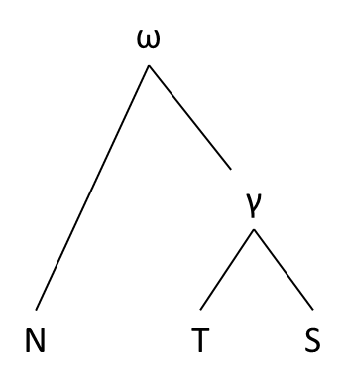
Fig. 1: The relationship of three manuscripts based on a conjunctive error. The simplified example is based on the manuscripts of Thomas Aquinas' In Librum Beati Dionysii de Divinis Nominibus Expositio 11, 4 (cf. Pera 1950).

References
– Maas, Paul. 1960. Textkritik. 4th ed. Leipzig: Teubner. – 1st ed. 1927.
– Pera, Ceslai, ed. 1950. In Librum Beati Dionysii de Divinis Nominibus Expositio. Torino: Marietti.

In other languages
DE: Bindefehler
FR: erreur conjonctive
IT: errore congiuntivo
MH, AC

Error, indicative or significant
The Lachmannian/Maas method is based on the concept of error. As Trovato (2014, 56) puts it, "only important monogenetic errors should be used as indicative errors to reconstruct a genealogy of the copies known to us". Maas was the first to call errors which can be used to make stemmatic inferences Leitfehler or errores significativi (‘indicative/significant errors’). He formulates this as "zu stemmatischen Folgerungen verwendbare Fehler" ("errors that may be used to reach conclusions about the stemma"; p. 26). Significant errors encompass both separative errors (errores separativi, Trennfehler) and conjunctive errors (errores conjunctivi, Bindefehler).
In practice, it is difficult to assess which readings are significant, or as Salemans puts it, "relationship-revealing" (Salemans 2000, passim), and this difficulty has been noted by many scholars. Roughly speaking, a significant error is an error that cannot be easily produced independently by several copyists (polygenesis), and cannot be corrected easily, in other words a good significant error will be irreversible and not reproducible. It is not easy to determine a priori which types of variant readings will indeed satisfy to those two criteria, and some scholars have suggested that the character of being significant or not is not something absolute, but rather something that is more or less likely. This is why some have tried to "weight" variant readings: Macé/Sanspeur 2000, Spencer et al. 2004, Macé/De Vos/Geuten 2012, etc. There have been as well some attempts at automating partly the procedures to measure the significance of variants (see Roelli/Bachmann 2010, Camps/Canfiero 2015), but at any event the evaluation of the variant readings will remain largely a philological task.
Illustration
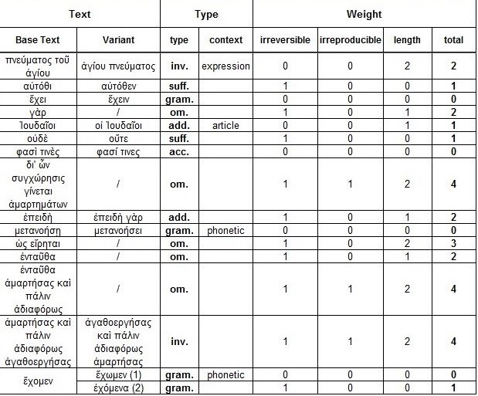
Fig. 1. Macé, De Vos, and Geutens 2012, 114 (Figure 2)

References
– Camps, Jean-Baptiste, and Florian Cafiero. 2015. “Genealogical Variant Locations and Simplified Stemma: a Test Case.” In: Tara Andrews and Caroline Macé (eds.), Methods and means for digital analysis of classical and medieval texts and manuscripts. Turnhout: Brepols Publishers, 69-93.
– Maas, Paul. 1960. Textkritik. 4th ed. Leipzig: Teubner. – 1st ed. 1927.
– Macé, Caroline, and Clotaire Sanspeur. 2000. “Nouvelles perspectives pour l'histoire du texte des Discours de Grégoire de Nazianze. Le cas du Discours 6 en grec et en arménien.” Le Muséon 113: 377-416.
– Macé, Caroline, Ilse De Vos, and Koen Geuten. 2012. “Comparison of stemmatological and phylogenetic methods to understand the copying history if the Florilegium Coislinianum.” In: Alessandra Bucossi and Erika Kihlman (eds.). Ars edendi lectures Series, vol. II. Stockholm: Stockholm University Press, 107-129.
– Roelli, Philipp, and Dieter Bachmann. 2010. “Towards Generating a Stemma of Complicated Manuscript Traditions: Petrus Alfonsi’s Dialogus.” Revue d’histoire des textesN.S. 5: 307–321.
– Salemans, Ben J.P. 2000. Building Stemmas with the Computer in a Cladistic, Neo-Lachmannian, Way. The Case of Fourteen Text Versions of Lanseloet van Denemerken (PhD). Nijmegen: Nijmegen University Press. http://www.dbnl.org/arch/sale003buil01_01/pag/sale003buil01_01.pdf
– Spencer, Matthew, Line R. Mooney, Aidan C. Barbrook, Barbara Bordalejo, Christopher J. Howe, and Peter Robinson. 2004. “The Effects of Weighting Kinds of Variants.” In: Reenen, Pieter van - August den Hollander - Margot van Mulken (eds.). Studies in stemmatology II.Amsterdam - Philadelphia: John Benjamins Publishers, 227-240.
– Trovato, Paolo. 2014. Everything You Always Wanted to Know about Lachmann’s Method: A Non-Standard Handbook of Genealogical Textual Criticism in the Age of Post-Structuralism, Cladistics, and Copy-Text. Foreword by Michael D. Reeve. Firenze: Libreriauniversitaria.it edizioni.

In other languages
DE: Leitfehler
FR: erreur significative
IT: errore guida / significativo
CM, MH

Error, separative
In the common errors method, separative errors (Lat. errores separativi, Ger. Trennfehler) are errors that indicate that a witness is independent of another witness. Because such errors are used to reach conclusions about the stemma, separative errors have to be significant. Maas (1960, 26) offers an abstract description in which one witness (B) is determined independent of another (A) by an error in the latter, A, that the textual scholar feels confident cannot have been removed by conjecture in B, thereby demonstrating that B cannot derive from A because it does not repeat the error of A.
A more concrete example may illustrate the point. Two manuscripts, S and T, of a text share a significant number of conjunctive errors and are consequently postulated as deriving from the same hyparchetype. However, in the following sentence, the manuscripts report two different readings:
- S At ille obiit viridis.
- T At ille obiit viribus.
Here,T reports viribus where S correctly has viridis, a separative error that indicates S is not derived from T(provided that the reading in S does not represent an independent scribal conjecture).
In another reading, S records a variant that while grammatical is not contextually appropriate and T offers the preferred reading:
- S Sed officia boni civis, boni amici, boni filii secutus est.
- T Sed officia boni civis, boni amici, boni filii executus est.
In this case, in which S reports secutus where T has the contextually required executus, the separative error shows T cannot be derived from S (provided that the reading in T does not arise from interposed scribal conjecture).
Because the identification of separative errors indicates that neither of the witnesses derives from the other, the relationship in the following illustration can be posited.
Illustration
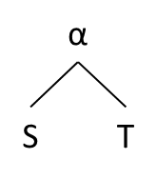
Fig. 1: The relationship of two manuscripts based on a separative error. The example is simplified and emended, based on the manuscripts of Seneca's Epistulae Morales ad Lucilium, 93, 4 (cf. Reynolds 1965).

References
– Maas, Paul. 1960. Textkritik. 4th ed. Leipzig: Teubner. – 1st ed. 1927.
– Reynolds, Leighton Durham, ed. 1965. L. Annaei Senecae ad Lucilium Epistulae Morales. 2 vols. Oxford: Oxford University Press.

In other languages
DE: Trennfehler
FR: erreur séparative
IT: errore separativo
MH, AC

Error, types of
The vocabulary used to describe the types of error (and/or variants) that commonly arise during the course of historical textual transmission is wide and varied. Moreover, while some critics distinguish errors from the triggers or precipitators for the error, often terms are used almost interchangeably. As a rule, all errors can be classified in four general categories that also comprise variants: addition, omission, transposition, and substitution. These four operations were already recognised in antiquity's treatment of rhetoric; for example, Quintilian cites adiectio, detractio, immutatio, transmutatio (Institutio Oratoria I, 5, 6). More specific terms are often used to describe particular types of variants or errors within these categories. Examples include: dittography (addition); haplography (omission); metathesis, anasyllabism, transposition; misreading, itacism (substitution).
Because errors frequently arise due to misreading on the part of the copyist – that is an error in language processing that affects language production – textual scholars have also developed an elaborate vocabulary for the triggers or precipitators for errors (cf. copying of texts). Examples are anticipation, arrhythmia, homoeoarcton, homoeoteleuton, parablepsis, saut du même au même.
A number of terms encompass both the impetus for an innovation and the product, such as assimilation and gloss-incorporation.
This list of types and causes aims to offer a representative selection, but is not exhaustive. Several of these terms are not restricted to the category error, but may also be descriptive of secondary readings and variants. For example, gloss-incorporation may arise by accident and so be an error of transcription, but the incorporation may, on the other hand, represent a deliberate alteration on the part of an intermediary copyist acting as an editor of the text (cf. copying of texts).
Cf. error.
In other languages
DE: Arten von Fehlern
FR: erreurs, type de
IT: errori, tipi di
AC

Examinatio
That part of recensio in which the transmitted variants are examined in order to ascertain whether there still remain some corruptions that can be corrected only by emendatio.
The term is a noun of action from the past participle stem of examinare ‘to weigh; to ponder’.
Examinatio may lead to many different situations closely related to the type of tradition under inspection. "In a completely closed tradition it is theoretically feasible to reconstruct the archetype with such certainty that only a single form of the text without variants remains to be examined. In practice this is extremely unlikely to be the situation. Usually the critic is faced with pairs (sometimes triplets) of variants, all with a presumptive claim to be considered authoritative" (Kenney 1978, 191).

References
– Kenney, Edward J. 1978. “Textual Criticism.” In The New Encyclopaedia Britannica,vol. 18: 189–195. Chicago: Encyclopaedia Britannica.
– Maas, Paul. 1960. Textkritik. 4th ed. Leipzig: Teubner. – 1st ed. 1927.
– McDonald, Alexander H. 1970. “Textual Criticism.” In The Oxford Classical Dictionary, 1048–1050. 2nd ed. Oxford: Clarendon Press.

In other languages
Latin term used throughout.
MB, MH

Exemplar
An exemplar is a text which has been transcribed in a copy or apograph. The exemplar may have been copied by visual inspection by the copyist or by way of dictation of somebody else (cf. copying of texts – methods).
In the process of manuscript copying, a copy would often become the exemplar of a new copy, which then might become the exemplar of yet another copy, and so on. This kind of copying chain can be described as a directed acyclic graph.
In a stemma, an exemplar is always placed immediately above its copy. In fig. 1, the hyparchetype B was the exemplar for the fragments β and γ, which in turn were exemplars for the main manuscript (“hovedh[åndskriftet]”), which in turn was the exemplar for Y, which finally were copied in e, n and hIII. Note that due to the procedure of eliminatio codicum descriptiorum, many copies are simply removed from the stemma. The example here is a little unusual, and can be explained by the fact that the fragments β and γ are the modest remains of a once complete manuscript. If this had been preserved in a complete state, the copies below would have been removed in the elimination procedure, and this manuscript would have become the main manuscript.
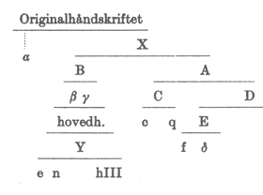
Fig. 1. A stemma for the Old Norwegian Konungs skuggsjá (mid-13th century), from the edition by Ludvig Holm-Olsen (1983, p. xiv).
Cf. also ancestor.

References
– Holm-Olsen, Ludvig, ed. 1983. Konungs skuggsiá. 2nd ed. Norrøne tekster, vol. 1. Oslo: Kjeldeskriftfondet.
– West, Martin L. 1973. Textual Criticism and Editorial Technique Applicable to Greek and Latin Texts. Stuttgart: Teubner. || See p. 12.

In other languages
DE: Vorlage, Exemplar
FR: exemplaire
IT: esemplare
OH, GH

Exemplar shift
In textual transmission, exemplar shift is a simple form of contamination. A scribe used several exemplars in copying of a text, but rather than using them simultaneously, he or she copied some parts from one exemplar and some from the other, thus shifting from one exemplar to another. A common reason for this happening will have been that the first exemplar was missing parts that the scribe was able to find in another manuscript and copied them from there. Both the methods of classical textual criticism and those of computer-assisted stemmatology can trace exemplar shift relatively well.

In other languages
DE: Vorlagenwechsel
FR: changement d'exemplaire
IT: cambio d'esemplare
TH

Facsimile
The term facsimile derives from lat. facere = 'to make' (imperative) and lat. similis = 'similar'. Nowadays, a facsimile is usually a photographic reproduction of hand-written texts or of early prints. There are only a few publishing houses world-wide that are able to produce high quality printed facsimiles, i.e. such that the facsimile looks mostly identical to the original, especially concerning the colour of ink and of drawings. Some facsimiles even imitate holes, fissures and stitching in parchment or paper as well as irregularities of the borders and other corruptions on the surface of the witness. The majority of modern facsimile editions, however, render the source as photographic plates in a modern-style book, although usually of a high quality with respect to paper, binding and cover.
Until the middle of the 19th century, hand-made facsimiles were made for many manuscripts, although typically as specimens of single pages or even smaller sections. Fig. 1 illustrate the quality of such facsimiles.

Illustrations
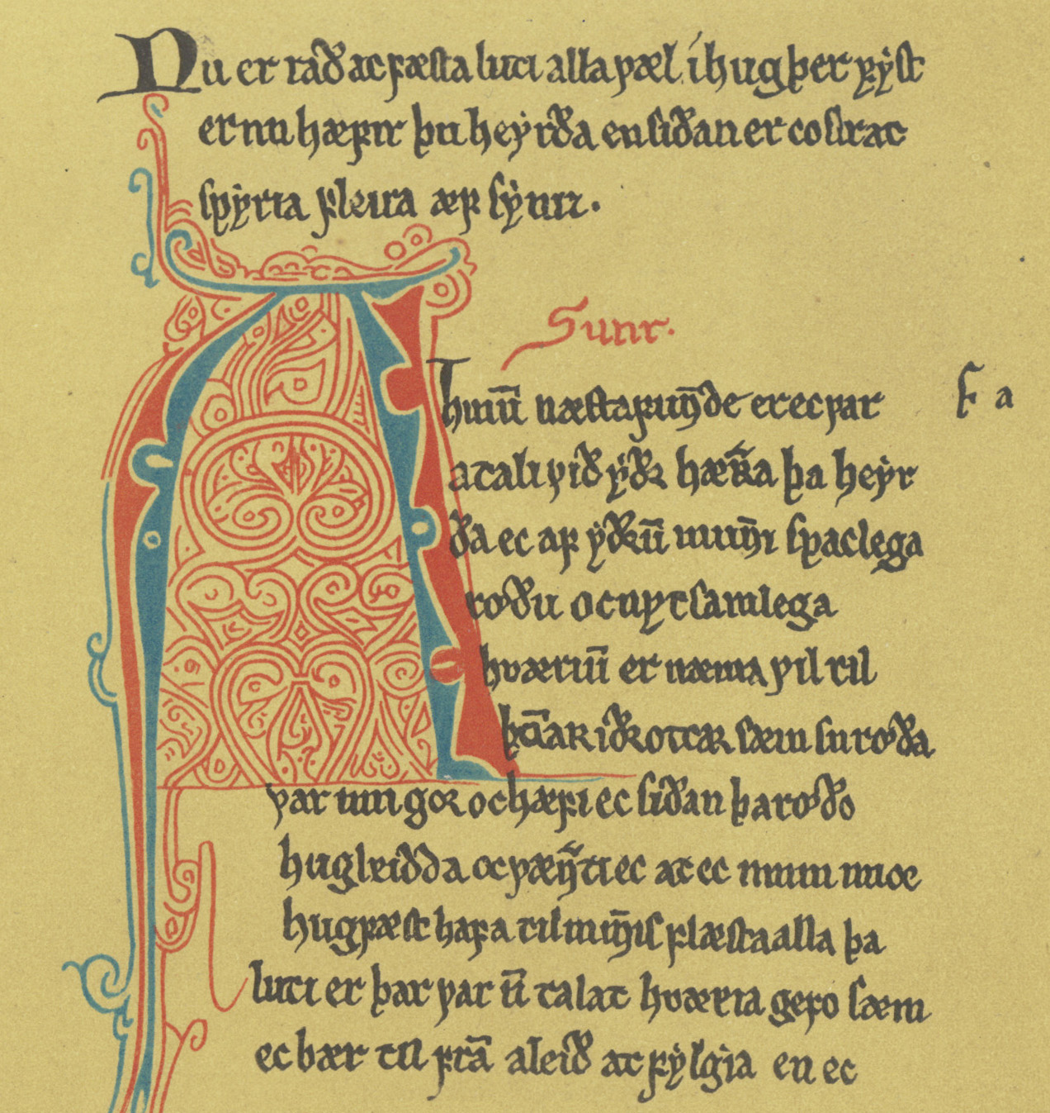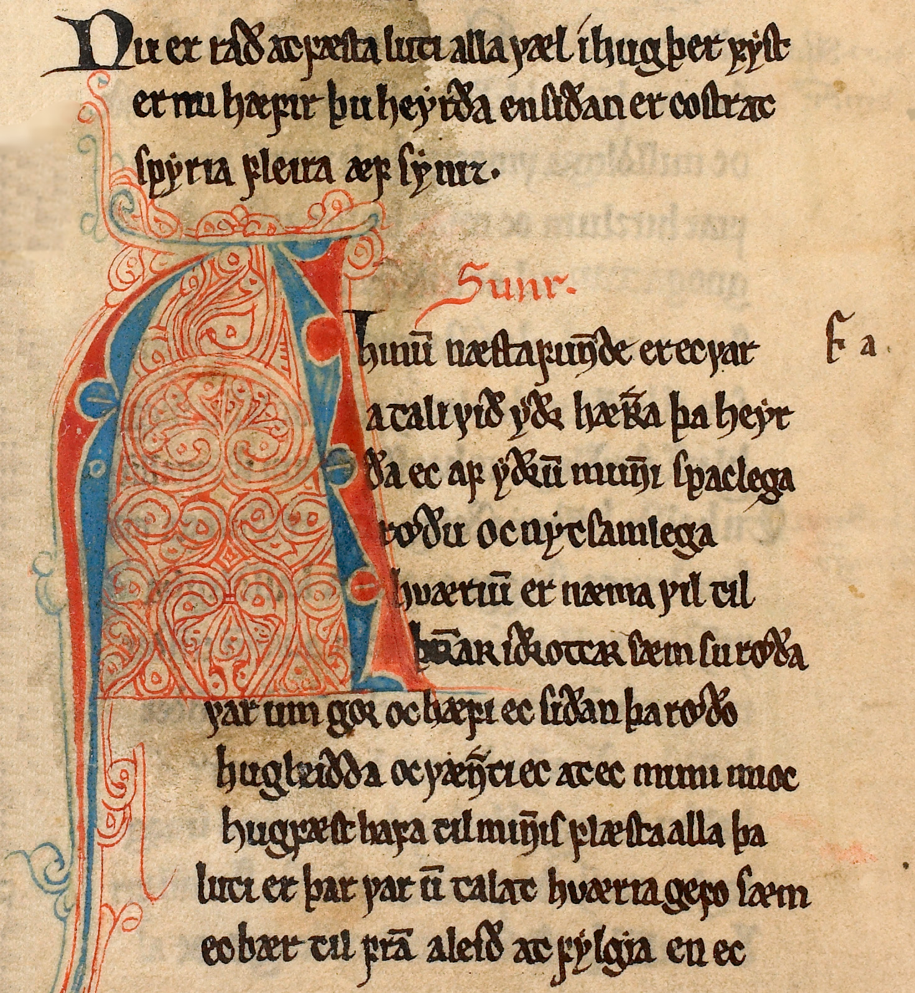
Figs. 1 and 2. Two facsimiles from the Old Norwegiancodex optimus of Konungs skuggsjá, København, Den Arnamagnæanske Samling, AM 243 bα fol (ca. 1275). Fig. 1 is a handmade mid-19th century facsimile while fig. 2 is a recent photographic facsimile. One has to look closely at the handmade facsimile in order to realise that it is a fac simile; what gives it away is first of all the evenness of the background and the fact that the writing on the backside of the leaf does not shine through.

After the development of photographic reproductions in the middle of the 19th century, a large number of facsimile editions were published of classical as well as mediaeval manuscripts. The heyday of these editions was the 20th century, but these series have largely been discontinued in the early 21th century. Many facsimile editions were published in monumental and expensive series primarily intended for the library market. For example, in the Nordic contries there were grand series like Corpus Codicum Islandicorum Medii Aevi (1930–1956), Corpus Codicum Suecicorum Medii Aevi (1943–1967), Corpus Codicum Norvegicorum Medii Aevi (1950–2002),Early Icelandic Manuscripts in Facsimile (1958–1993), and Corpus Codicum Danicorum Medii Aevi (1960–1973). Until the end of the 20th century, they were mostly printed in greyscale (often collotype), but some of the latest facsimile editions were published in full colour.
Nowadays, manuscripts and prints are primarily reproduced as digital scans by public libraries and archives and made available directly on the Internet. This development has a great influence on academic teaching, as well as on scholarly editing. Furthermore, the originals are well preserved by this practice as they have to be consulted much less. These days facsimiles have lost some importance due to the existence of such digital facsimiles (cf. digital edition).
Even if the photographic sections of the facsimile editions are regarded as obsolete by many, and by most as being of lower quality than modern high-resolution photographs, many of these facsimile editions contain introductions of a high quality to the codicology, palaeography, history and contents of the manuscript. This part of the facsimile editions may in fact prove to be their most important contribution to later philology.

References
– Urchueguía, Cristina. 2000. “Edition und Faksimile: Versuch über die Subjektivität des Objektivs.” In: Text und Edition: Positionen und Perspektiven, edited by Rüdiger Nutt-Kofoth et al., 323–352. Berlin: Erich Schmidt Verlag.
– Hansen, Anne Mette. 2005. “Faksimileudgaver og diplomatariske udgaver.” In Lesemåder: Udgavetyper og målgrupper, edited by Per Dahl, Johnny Kondrup, and Karsten Kynde, 153–177. Nordisk Netværk for Editionsfilologer. Skrifter, vol. 6. København: Reitzel.

In other languages
DE: Faksimile (Faksimileausgabe)
FR: (édition) fac-similé
IT: (edizione in) facsimile
OH, TB

Family (of witnesses)
A family (or a "class", from Latin "classis") is a group of witnesses that are related to each other by a genealogical relationship. A family is a branch in a tree-graph.
In a stemma, a family of witnesses will be gathered under the same hyparchetype. In the example below (Fig. 1), A, B, C and D could be called a family, EFGHJ another family.
If a tradition is too complex and / or too lacunary, shich makes it impossible to draw a stemma, it might still be possible to define some families, generally characterised by some significant secondary variants and ideally confirmed by the geographical origin of their witnesses. Such is the case of the Greek New Testament, for example, where it is possible to identify a "Caesarean" family, a "Byzantine" family, a "Western" family, etc.
Not all types of grouping of manuscripts may be called a family, however. Cf. group.
In large traditions, one family may be represented by one siglum in the critical apparatus.
Fig. 1. A re-drawn and simplified version of the stemma published in Maas (1960, p. 7).
Reference
– Amphoux, Christian-Bernard, ed. 2014. Manuel de critique textuelle du Nouveau Testament. Bruxelles: Safran.
– Maas, Paul. 1960. Textkritik. 4th ed. Leipzig: Teubner. – 1st ed. 1927.

In other languages
DE: Familie, Klasse
FR: famille, classe (de témoins)
IT: famiglia
CM

Fragment
Over the course of time, many manuscripts were damaged, accidentally or intentionally, so that only parts of the once complete manuscript now remain. This process of fragmentation is so widespread that many works are only known to us in an incomplete state. The Old Norwegian translation of the Latin Barlaam legend, Barlaams ok Josaphats saga(mid-13th century), has been preserved in 15 Norwegian and Icelandic manuscripts, but all manuscripts, including the codex optimus Stockholm, Kungliga biblioteket, Perg 6 fol (ca. 1275), have some degree of fragmentation (cf. the edition by Rindal 1981). Even if all 15 manuscripts are collated, a small section of the text is missing in all manuscripts. The first editors of the text, Rudolf Keyser and Carl Richard Unger (1851), chose to reconstruct this section of the text on the basis of the Latin legend.
Fragments vary in size ranging from a major part of the manuscript to perhaps only a leaf or a part, even a minor part, of a leaf. The ultimate fragmentation is the complete loss of a manuscript (see the entry on loss rate of witnesses). Different fragments of a manuscript may have ended up in different libraries today, and they may thus have different signatures. For example, the manuscript containing the Old Norwegian translation of the Old French lais by Marie de France, Uppsala, De la Gardie 4-7 fol, at one time lost a quire, which later turned up as the lining of a bishop’s mitra on Iceland, and it is now known under a new signature as Copenhagen, AM 666 b 4to.

Illustration
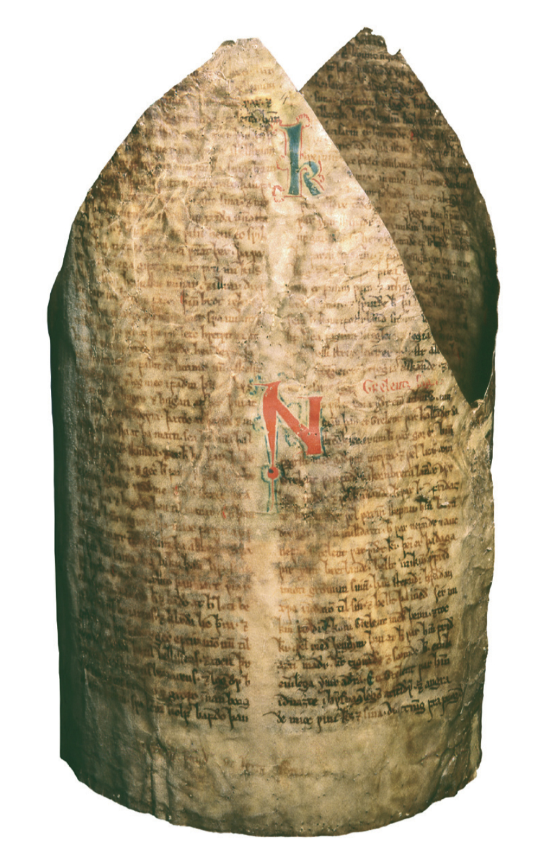
Fig. 1. The fragment of Strengleikar, now Copenhagen, AM 666 b 4to, showing how it was cut to be used as the lining in a mitra. The rest of the manuscript came to Sweden and is catalogued as Uppsala, De la Gardie 4-7 fol.

As the term indicates, a fragment is a small part of a once complete manuscript. There is no absolute cut-off point between a fragment and what might be called an incomplete manuscript, other than, perhaps, 50 % as a rule of thumb.
Certain types of manuscripts have been especially prone to the process of intentional fragmentation. After the Reformation in 1536, almost all Latin liturgical manuscripts in Norway were destroyed, so that only 15 Latin manuscripts, mostly liturgical, have been preserved out of several thousand (Haugen and Ommundsen 2010, 29–32). Many manuscripts were in fact cut up in small pieces and used as binding material in books.

Illustration
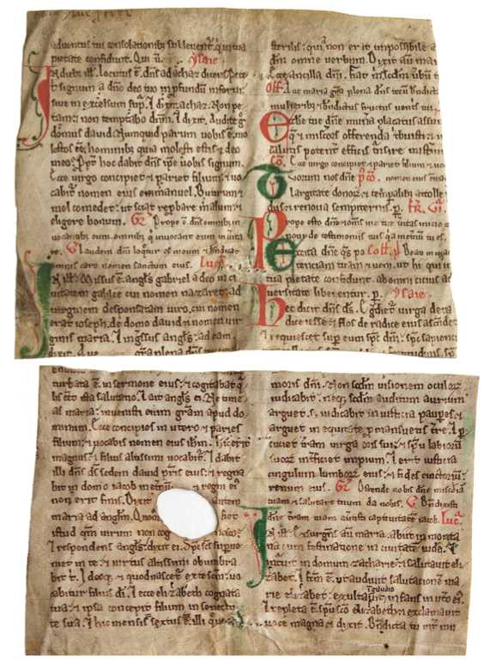
Fig. 2. These two partially preserved leaves (Oslo, NRA Lat fragm 764, fol. 1–2v) are all that remains of a liturgical manuscript kept in Norway, cf. Ommundsen (2010: 133). Note the large hole in the parchment in the lower fragment. The text continues unbroken on the other side of the hole, so it must originally have been in the leaf. It is thus not an example of a lacuna, which is the result of later damage to a manuscript.

References
– Haugen, Odd Einar, and Åslaug Ommundsen. 2010. “Nye blikk på homilieboka.” In Vår eldste bok, edited by Odd Einar Haugen and Åslaug Ommundsen, 9–33. Bibliotheca Nordica, vol. 3. Oslo: Novus.
– Keyser, Rudolf, and Carl Richard Unger, eds. 1851. Barlaams ok Josaphats saga. Christiania: Feilberg & Landmark.
– Rindal, Magnus, ed. 1981. Barlaams ok Josaphats saga. Norrøne tekster, vol. 4. Oslo: Norsk Historisk Kjeldeskrift-Institutt.
– Ommundsen, Åslaug. 2010. “Homilieboka og dei liturgiske fragmenta.” In Vår eldste bok, edited by Odd Einar Haugen and Åslaug Ommundsen, 131–150. Bibliotheca Nordica, vol. 3. Oslo: Novus.

In other languages
DE: Fragment
FR: fragment
IT: frammento
OH

Gloss
A gloss (plural glosses), from Greek γλῶσσα ‘language, tongue’, is a word or a phrase that explains a corresponding section in the text, called lemma (λῆμμα, pl. lémmata), usually written above the line or in the margin of the manuscript. Sometimes, a gloss in an older manuscript was introduced in the text of a later manuscript and thus created an interpolation.

In other languages
DE: Glosse (pronounced with a long o)
FR: glose
IT: glossa
OH

Gloss-incorporation
Gloss-incorporation is one type of introducing changes in a text transmitted through copying: A reading that was originally intended as a note or remark in an exemplar would be incorporated into the main text of a copy instead. As there were and are different types of glossae – like marginal and interlinear glosses – gloss-incorporation could happen in various intentional and unintentional ways. These marginal elements may be expository and/or provide commentary on the primary text, in which case the incorporation represents an example of an addition. Alternatively, glosses may provide a correction to a witness in which case the subsequent incorporation of the gloss represents a case of assimilation or horizontal transmission.
Gloss-incorporation is frequently used interchangeably with interpolation. Cf. types of errors.

In other languages
DE: Einfügung von Glossen im Text
FR: incorporation de gloses
IT: incorporazione di glosse
AC & TH

Glyph
A glyph is the graphic shape of a character in a writing system. The distinction between the abstract concept of a character and the concrete one of the glyph is a central distinction in the Unicode Standard (ch. 2, pp. 11–12). It is also a useful term in paleaography, even if this discipline prefers a term like letter-form. A character can be instantiated in a number of glyphs, which can sometimes look surprisingly different. This observation applies to the variation between fonts (or indeed hand-writings), but sometimes also to the distinction between regular and italic shapes.
See the entry on character for an illustration of various glyphs.

Reference
– The Unicode Standard. Version 8.0. Edited by Julie D. Allen et al. Unicode Consortium, Mountain View, CA. http://unicode.org/versions/Unicode8.0.0

In other languages
DE: Glyphe (f.)
FR: glyphe (f.)
IT: glifo (m.)
OH

Graph
A graph consists of a set of nodes (or vertices), some of which are linked to each other by edges (or links).
The edges can be either undirected or directed. A graph in which all edges are undirected is called a undirected graph; if the edges are all directed the graph is called a directed graph. An undirected edge e connecting two nodes v and w is denoted by {v,w} or equivalently {w,v}. A directed edge from node v to node w is denoted by (v,w) which is not equal to (w,v). Here is an example of a graph.
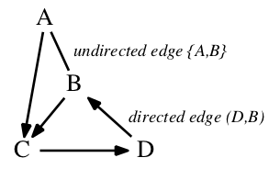
Note that this graph is mixed (i.e. neither undirected nor directed) since it has both undirected and directed edges. For introducing directionality into graphs, cf. polarisation.
A graph is connected if for every pair of nodes in the graph there is a path that connects them.
In the context of stemmatology, a stemma is a particular kind of graph in which the nodes correspond to texts (some of which may be extant and others lost or hypothetical), and the edges indicate relationships between them.
Special cases of graphs include trees and directed acyclic graphs (DAGs).
The word is originally an abbreviation from graphic formula; ultimately it is derived from the Greek verb γράφω 'to write'.

In other languages
DE: Graph
FR: graphe
IT: grafo
TR, VM, KH

Group (of witnesses)
There are several ways of grouping witnesses of a text without inferring anything about their genealogical relationships (so, they do not necessarily form a family). Witnesses can be grouped according to their external (codicological) features: their geographic origin, their age, their type (liturgical manuscript, erudite manuscript, etc.). They can also be grouped according to their similarities, either formal similarities (titles, layout, etc.), or the similarities in their variant readings, i.e. without considering whether those variants are secondary and significant or not. While those groupings might be useful, they do not lead to a stemma.
Many statistical methods consider similarities rather than genealogical relationships. For example, the chart below (Fig. 1) shows grouping of manuscripts based on their textual disagreements.
Illustration
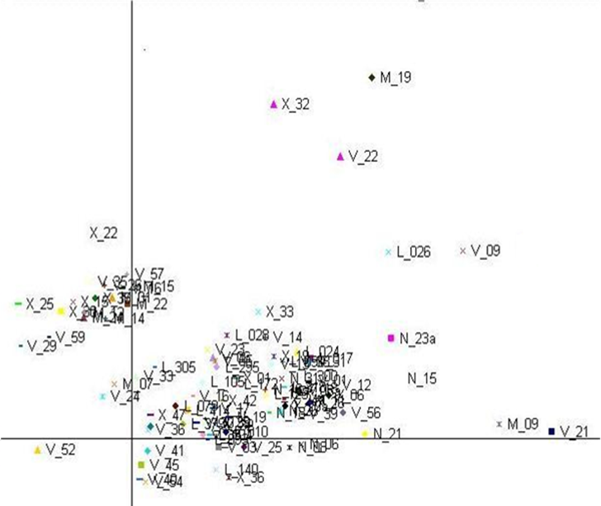
Fig. 1. Multidimensional Scaling of manuscripts of Gregory of Nazianzus' Homily 27 (based on disagreements).
In other languages
DE: Gruppe
FR: groupe (de témoins)
IT: gruppo
CM

Haplography
A haplography (from Greek ἁπλοῦς ‘single’ and γράφω ’to write’) is the writing of a segment of text once which appears twice (or more times) in the exemplar, e.g. defendum instead of defendendum. When a larger section of a text is left out, this is usually referred to as an omission, which may result in a lacuna.
The opposite, when what should be written once is written twice, is called dittography.

References
– Havet, Louis. 1911. Manuel de critique verbale appliquée aux textes latins. Paris: Hachette.
– Reynolds, Leighton Durham, and Nigel G. Wilson. 1974. Scribes and Scholars: A Guide to the Transmission of Greek and Latin Literature. 2nd ed. Oxford: Clarendon Press. || See pp. 204–205.
– West, Martin L. 1973. Textual Criticism and Editorial Technique Applicable to Greek and Latin Texts. Stuttgart: Teubner. || See pp. 24, 139.

In other languages
DE: Haplographie
FR: haplographie
IT: aplografia
GH, AC

Havet, Pierre Antoine Louis
Havet, Pierre Antoine Louis (6 January 1849, Paris – 26 January 1925, Rochecorbon) was a professor at the Collège de France where he held the chair in Latin philology from 1885-1925. In 1893, he was elected as a member of the Académie des inscriptions et belles-lettres, one of the five academies that comprise the Institut de France. In 1917, he became vice-president of the newly established Association Guillaume-Budé dedicated to the promotion of the Humanities and engaged in publishing critical editions of Greek and Latin texts (that could compete with German editions). Louis Havet was the son of Ernest Havet, who served as professor of rhetoric at the Collège de France. Havet was also a vocal supporter of Alfred Dreyfus (1859-1935), a Jewish captain charged with treason, and a played an important role in founding the Ligue des droits de l’homme which defended Dreyfus.
In addition to a number of philological studies and a course-book on Greek and Latin meter, Havet edited Plautus's Amphitryon (1895). He is perhaps best known for his Manuel de critique verbale appliquée aux textes latins (1911), an exhaustive examination of types of errors in Latin texts and how they arise during the course of historical transmission. Havet argued that earlier explanations favouring graphical misapprehension were perhaps over simple and did not fully account for the range of variation found in witnesses. His work is also known for distinguishing true variants (leçons vraies), and authentic variants (leçons authentiques). For textual criticism, the distinction is important in that it acknowledges readings that may be true without authenticity. For example, after a text has been altered in the distant past, the error is replaced by a felicitous correction, which appears to have restored the same word that the author had written, but is rather a conjecture from antiquity or the middle ages.
Concerned overwhelmingly with the genesis of variation, Havet has been criticised because his conjectures endeavoured to explain how the variation was produced, but did not take adequately into account the interpretive context for the conjecture (Timpanaro 2005, 130).
Nevertheless, Havet’s influence can be seen in the many tributes to his work, especially within France. In 1909, friends and former students honoured Havet with a volume of metrical, historical and linguistic studies offered to him on the occasion of his sixtieth birthday. After his death, his work received two encomia, fourteen years apart, in the yearbook of the Académie des inscriptions et belles-lettres.

Works by Havet

– Havet, Louis. 1866. Cours élémentaire de métrique grecque et latine. Paris: Delagrave.
– ———. 1911. Manuel de critique verbale appliquée aux textes latins. Paris: Hachette.
– ———, ed. 1895. Plauti Amphitruo. [Titus Maccius Plautus]. Paris: Bouillon.

Works on Havet
– Langlois, Charles-Victor. 1925. “Éloge funèbre de M. Louis Havet, membre de l'Académie.” Comptes rendus des séances de l'Académie des Inscriptions et Belles-Lettres 69 (1): 17–22.
– Holleaux, Maurice. 1939. “Notice sur la vie et les travaux de M. Louis Havet, membre de l'Académie.” Comptes rendus des séances de l'Académie des Inscriptions et Belles-Lettres 83 (5): 527–546.
– Timpanaro, Sebastiano. 1981. La genesi del metodo del Lachmann. 2nd ed. Padova: Liviana. – 1st ed., Firenze: Le Monnier, 1963.
– ———. 2005. The Genesis of Lachmann’s Method. Translated by Glenn W. Most. Chicago: University of Chicago Press. – Translated from Timpanaro 1981.
AC

Homoeoarcton
Homoeoarcton, or ‘identical beginning’ (from ὅμοιος 'same' and ἄρχομαι 'to begin'), describes the impetus for an omission or addition in a copyist’s text in which it is posited that eye-skip (or parablepsis) to or from similar or identical beginnings of a word has caused a copyist to miss text or write the same sequence of text twice.
Also written correctly as homoioarcton, homoearchon, homoeoarkton. See types of errors.

Reference
– West, Martin L. 1973. Textual Criticism and Editorial Technique Applicable to Greek and Latin Texts. Stuttgart: Teubner. || See p. 25.

In other languages
Graeco-Latin term used throughout.
IT: omeoarto / omeoarchia
AC

Homoeoteleuton
Homoeoteleuton, or ‘identical ending’ (from ὅμοιος 'same' and τελέω 'to end'), describes eye-skip (or parablepsis) to or from a similar or the same ending in two words which causes a copyist to produce an omission or an addition (which would likely appear as dittography).
Also written as homoioteleuton or homeoteleuton. See types of errors.

Reference
– West, Martin L. 1973. Textual Criticism and Editorial Technique Applicable to Greek and Latin Texts. Stuttgart: Teubner. || See p. 25.

In other languages
Graeco-Latin term used throughout.
IT: om(e)oteleuto
AC

Homoplasy
[həʊˈmɒpləsɪ]
From Greek ὅμοιος 'same, similar' and πλάσις 'moulding, conformation, form'.
In cladistics, a homoplasy is the occurrence of the same derived character state in two (or more) unrelated taxa. The same phenomenon is also known as convergent evolution, and in textual criticism as polygenesis. Salemans also uses as synonyms 'parallelism' and 'coincident variation' (1996, 8-9).
References
– Kitching, Ian J., Peter L. Forey, Christopher J. Humphries, and David M. Williams. 1998. Cladistics: The Theory and Practice of Parsimony Analysis. 2nd ed. Oxford: Oxford University Press.
– Salemans, Ben J.P. 1996. “Cladistic and the Resurrection of the Method of Lachmann: On Building the Stemma of Yvain”. In Studies in Stemmatology, edited by Pieter van Reenen, and Margot van Mulken, 3–70. Amsterdam: John Benjamins.
In other languages
DE: Homoplasie
FR: homoplasie
IT: om(e)oplasia
CM

Hyparchetype
A hyparchetype (or subarchetype) is a lost state of the text which in the stemma is situated below the archetype, either directly under the archetype or, possibly also, in a lower position in the stemma. In fig. 1, α is the archetype, and β and γ are hyparchetypes. While the archetype is the closest we can get to the original, hyparchetypes are the ancestors of related groups of one or more preserved manuscripts. Like the archetype, hyparchetypes are often denoted by Greek characters in the stemma, especially in Classical philology.
Paul Maas proposed the term hyparchetype exclusively for reconstructed variant-carriers (1960: 8), i.e. the first level below the archetype; in fig. 1 these would be only β and γ,while for example δ and ε would not be regarded as hyparchetyes. He calls 'variant' only readings directly below the archetype between which no mechanic choice is possible.
From Greek ὑπό 'under; below' and ἀρχέτυπον (see archetype). The variant form with sub – the Latin synonym for ὑπό – is not recommended, but is sometimes found in the literature.
Fig. 1. A re-drawn and simplified version of the stemma published in Maas (1960, p. 7).
Cf. also codex interpositus.

Reference
– Maas, Paul. 1960. Textkritik. 4th ed. Leipzig: Teubner. – 1st ed. 1927.

In other languages
DE: Hyparchetyp (Subarchetyp)
FR: hyparchétype (subarchétype)
IT: iparchetipo (subarchetipo)
OH

Innovation
In textual criticism an innovation is a change introduced at some point into a textual tradition. It is basically a positive expression for the Lachmannian notion of error, cf. also secondary reading. As it is more positive it will be used more for conscious and goal-driven interventions by scribes into texts (which can only be called errors by stretching the normal use of this word quite far). Stemmata are rooted by considering common errors (that is: shared innovation) only. Witnesses that share only readings that are not innovations, are not closely related as the archetype will already have contained these readings.
The notion of shared innovation is also used in linguistics. In historical linguistics the contrary to innovation is 'archaism'.

In other languages
DE: Neuerung
FR: innovation
IT: innovazione
PR

Interpolation
From Latin interpolatio 'a change made here and there' from interpolare 'to give a new shape; insert; polish; falsify etc.'.
An interpolation is an addition that is introduced into the text either involuntarily or voluntarily, but was in the first place written not by accident but in an attempt to restore or otherwise improve the text.
Such a case is e.g., a marginal note, like a commentary or a gloss, that is accidentally introduced into the text itself during the copying, either instead of what it was supposed to explain or in addition to it. An interpolation may also consist in a deliberate introduction of any new elements (cf. copying of texts). The term is sometimes used also about deliberate changes in a text which has been modified for usage in the schools or which has been modified not only in its contents but also in its orthographic and grammatical form.

References
– Maas, Paul. 1960. Textkritik. 4th ed. Leipzig: Teubner. – 1st ed. 1927. || p. 12.
– Pöhlmann, Egert. 2003. “Textkritik und Texte im 19. Und 20. Jh.” In Egert Pöhlmann, Einführung in die Überlieferungsgeschichte und die Textkritik der Antiken Literatur: Mittelalter und Neuzeit, 137–182. Darmstadt: Wissenschaftliche Buchgesellschaft. || See pp. 147–148, 158, 168.
– Reynolds, Leighton Durham, and Nigel G. Wilson. 1974. Scribes and Scholars: A Guide to the Transmission of Greek and Latin Literature. 2nd ed. Oxford: Clarendon Press. || See pp. 14 f., 15, 205–207.
– West, Martin L. 1973. Textual Criticism and Editorial Technique Applicable to Greek and Latin Texts. Stuttgart: Teubner. || See pp. 16, 22 f., 115, 143 ff.

In other languages
DE: Interpolation
FR: interpolation
IT: interpolazione
GH

Irigoin, Jean
Irigoin, Jean (born on November 8, 1920 in Aix-en-Provence – died on January 28, 2006 in Paris) was a classical philologist, who was very influential, especially in France, in the domain of the edition of Greek classical literature. He was also at the front line of the study of codicology, and in many publications he stressed the importance of studying the mediaeval manuscripts as archaeological objects. He wrote several articles on the fabrication and use of paper in Byzantium, and on mediaeval binding, but also on Greek palaeography. He has served as the director of the Série grecque of the famous Collection “Budé” (Collection des Universités de France, Les Belles Lettres) for many years (1964–1999). He was also professor at the Ecole Pratique des Hautes Etudes, and at the Sorbonne. Himself the student and successor of Alphonse Dain (1896-1964, he is considered the inventor of the French word “codicologie”, his best known book is “Les manuscrits”, first published in 1949), he initiated a new school of Greek philology in France.
Apart from his editions of Greek texts (esp. early Greek poetry: Bacchylides…) and his studies about the history of ancient texts (Pindar, Hippocrates, Sophocles, Plato and Aristotle…), Irigoin wrote several methodological articles, which are still relevant today:“La critique des textes doit être historique”, “Quelques réflexions sur le concept d'archétype”, “Accidents matériels and critique des textes”... They have been republished in two volumes in 1997 and 2003 (see bibliography below).

On Irigoin
– Jouanna, Jacques. 2006. “Allocution à l’occasion du décès de M. Jean Irigoin, membre de l’Académie.” Comptes rendus des séances de l'Académie des Inscriptions et Belles-Lettres 150 (1): 229–233.

By Irigoin
His bibliography: http://www.college-de-france.fr/media/professeurs-disparus/UPL35810_biblioirigoin.pdf. His most significant articles were gathered in two volumes:
– Irigoin, Jean. 1997. Tradition et critique des textes grecs. Histoire, vol. 36. Paris: Belles Lettres.
– ———. 2003. La tradition des textes grecs: Pour une critique historique. L’âne d’or, vol. 19. Paris: Belles Lettres.
CM

Itacism
[ˈiːtəsɪz(ə)m]
Itacism (from the Greek letter η, 'eta') and the related term iotacism (from the Greek letter ι, 'iota') refer to the merger in pronunciation of vowel sounds that are characteristically distinguished in spelling. These two terms were coined from the Greek, since Modern Greek has merged six different combinations of sounds (ι, ει, η, οι, υ, υι) into the sound /i/ at different stages of its development which, however, are still differentiated in spelling. Examples in English include the writing of peer (to look with concentration) for pier (a platform into a body of water) or writing there for their or they’re.
In using one spelling correspondence for a phoneme or sequence of phonemes in place of the correct correspondence, itacism represents a type of substitution which may also appear as a transposition. For example, in writing the homophone pear for pare, ‹ear› has been substituted for ‹are› if the new word arises from an error in language production. If, however, the error is believed to arise from a error in processing, or reading, one can interpret the change as the transposition of ‹e› from after ‹ar› to before ‹ar›.
Cf. types of errors.

In other languages
GE: Itazismus, Iotazismus
FR: itacisme, iotacisme
IT: itacismo, iotacismo
AC

Jukes–Cantor model
The Jukes–Cantor model is a common model of DNA sequence evolution. It is often also called the JC69 model after an article published by the two authors in 1969. The model characterises the probability that a single nucleotide (A, T, G, or C) in an ancestral sequence evolves into a given nucleotide in a descendant sequence given a single parameter, ν, which is related to both the time passed between the two states of the sequence as well as the mutation rate. The probability that any of the nucleotides, say A, evolves into a specific different nucleotide, say T, is given by ¼ – ¼ exp(-4ν/3). The probability that the same nucleotide is observed in the descendant taxon is given by ¼ + ¾ exp(-4ν/3).
The base frequencies, i.e., the probabilities of observing any given nucleotide in the ancestral sequence, are assumed to be uniform: (¼, ¼, ¼, ¼).
Alternative sequence evolution models include, for example, the K80 and F81 models, see Lemey 2009.

References
– Jukes, Thomas H., and Charles R. Cantor. 1969. “Evolution of Protein Molecules.” In Mammalian Protein Metabolism, edited by Hamish N. Munro, 21–132. New York: Academic Press.
– Lemey, Philippe, Marco Salemi, and Anne-Mieke Vandamme, eds. 2009. the Phylogenetic Handbook: A Practical Approach to Phylogenetic Analysis and Hypothesis Testing. 2nd ed. Cambridge: Cambridge University Press
In other languages
DE: Jukes-Cantor-Modell
FR: modèle de Jukes-Cantor
IT: modello di Jukes-Cantor
TR

Juxta
Juxta is an open-source tool for comparing and collating multiple witnesses to a single textual work. It applies a base text approach to aligning and comparing witnesses, meaning that one witness acts as a baseline for comparison. Juxta's stand alone interface offers side by side comparison of aligned texts, annotating identified variants and correspondences, and various high level variant visualisations such as a heat map and histogram of variants (which may be particularly useful for comparison of longer texts). Like CollateX Juxta can by means of its API also be used as web service or a software component to integrate with other software. Juxta is written in Java thus running on virtually any computer platform. JuxtaCommons is a further development of Juxta that allows it to be interfaced over the Web.

References
– http://www.juxtasoftware.org/
– http://www.scholarslab.org/podcasts/scholars-lab-presentation-using-juxta-commons-in-the-classroom/
– Gil, Alex. 2012. “On Sequences, Noise and Juxta.” Elotroalex. WordPress blog. Available at http://elotroalex.webfactional.com/?s=noise+juxta [accessed 6 June 2014]
JZ

Lachmann, Karl
Karl Lachmann (1793-1851) is considered along with the brothers Jacob and Wilhelm Grimm the founder of German philology. In his young days, he was already concerned with problems of Classical philology and older German philology and developed a method of editing, which is now named after him and which had a huge impact on numerous philologies all over Europe.
Lachmanns scholarly significance is above all based on his numerous editions of Middle High German texts (‘Nibelungenlied', of Hartmann von Aue ‘Iwein' and ‘Gregorius', Walther von der Vogelweide, Wolfram von Eschenbach, Ulrich von Lichtenstein; work on 'Des Minnesangs Frühling'), often in collaboration with other researchers. Besides, the editions of the Greek and Latin New Testament, Aesop's Fabulae, as well as the collected works G.E. Lessings, are to be named.
Lachmann neither recorded his concepts clearly nor in the form of a monograph. One has to reconstruct them from scattered comments and prefaces and by abstraction of his practical work in his editions. For a discussion of his method, see Lachmann's method.
Works by Lachmann (mostly editions)
– Lachmann, Karl. 1816. Aurelii Propertii carmina, emendavit ad codicum meliorum fidem et annotavit Carolus Lachmannus. Leipzig: Gerhard Fleischer.
– ———. 1826. Der Nibelunge Noth und die Klage. Berlin.
– ———. 1827. Walther von der Vogelweide. Berlin.
– ———. 1827. Hartmann von Aue, Iwein. Berlin.
– ———. 1829. Q. Valerii Catulli Veronensis liber. Berolinum: Reimer.
– ———. 1835. Albii Tibulli libri quattuor, ex recensione Carl Lachmanni passim mutata explicuit Ludolphus Dissenius. Gottingae: Librariae Dieterichianae [1st ed. without commentary 1829].
– ———. 1831. Novum Testamentum graece, ex recensione Caroli Lachmanni [editio minor of the Greek New Testament]. Berlin; ed. maior together with Philipp Buttmann. Berolini 1842–1850, 2 vols.
– ———. 1833. Wolfram von Eschenbach. Berlin.
– ———. 1850. Lucreti De rerum natura libri VI. Berlin: impensis G. Reimeri.
– ———. 1876. Kleinere Schriften. Vol. 1, Kleinere Schriften zur deutschen Philologie, edited by Karl Müllenhoff. Vol. 2, Kleinere Schriften zur classischen Philologie, edited by Johannes Vahlen. Berlin: Reimer.
Works on Lachmann
– Carey, Stephen Mark. 2010. “Lachmann, Karl Konrad Friedrich Wilhelm.” In Handbook of Medieval Studies: Terms – Methods – Trends, edited by Albrecht Classen, 2434–2440. Berlin: Walter de Gruyter.
– Fiesoli, Giovanni. 2000. La genesi del lachmannismo. Firenze: SISMEL Edizioni del Galluzzo.
– Ganz, Peter F. 1968. “Lachmann as an Editor of Middle High German Texts.” In Probleme mittelalterlicher Überlieferung und Textkritik: Oxforder Colloquium 1966, edited by Peter F. Ganz and Werner Schröder, 12–30. Berlin: Erich Schmidt Verlag.

Illustration
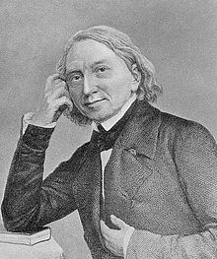
TB

Lachmann’s method
The method of reconstructing the text of a work based on the genealogical kinship of witnesses which was developed in the 19th century is often named after Karl Lachmann, although this scholar did not write any theoretical texts about it. In fact one might rather call this method "the genealogical method". In the latter part of the 19th century the method had found widespread use, and was refined for Romance texts by Gaston Paris who firmly established the idea of common errors ("fautes communes") in the 1870s. His pupil Joseph Bédier revolted against it (Bédier 1928) and advocated a best manuscript approach instead. Finally in 1927, Paul Maas wrote the first manual that tried to summarise the method coherently, almost more geometrico in a very concise and mathematical form. In later editions he addressed Bédier's criticism.
Lachmann saw philological work on texts as "Kritik" (criticism) and "Kunstübung" (exercise in the arts). For him editing a text is ‘critical’ work: it does not only consist of mere copying of witnesses but it is also distinguished by the critical examination of the entire available tradition. Thus witnesses are grouped hierarchically, which leads to the compilation of a stemma codicum based on a consistently applied typology of errors. These procedures should, as Lachmann puts it, "make clear the degree of certainty of the surviving material" ("der Grad der Sicherheit des Überlieferten zur Anschauung gebracht werden", Lachmann 1876, vol. 2, p. 81). In order to distinguish the primary (original) from the secondary reading (error), the textual critic has to be equipped not only with skills of historical linguistics and literature, but also with aesthetic skills that allow him to identify readings closer or more distant to the author whose style he thus has to know well. And in this respect, textual criticism for Lachmann is also an "exercise of the arts" including 'conjectures'. The first aim is thus to reconstruct the text of the archetype.
Lachmann formulates this target as follows (Preface 'Nibelungenlied' edition in Jenaische allgemeine Literatur-Zeitung 1817: 114): "Wir sollen und wollen aus einer hinreichenden Menge von guten Handschriften einen allen diesen zum Grunde liegenden Text darstellen, der entweder der ursprüngliche selbst seyn oder ihm doch sehr nahe kommen muss". (“We should and intend to represent from a sufficient quantity of good manuscripts that text which can account for them all, which needs must be either the original itself or come very close to it".) First, such 'good' manuscripts must be found, copied, and – most important – compared. This comparison should not only determine the quality of the manuscripts, but also their genealogical relationship. The textual documents should be arranged to groups of manuscripts, each of which descend from one hyparchetype. Thus a first step, called recensio, in the direction of the 'original' is done, which Lachmann means to do sine interpretatione (without subjectivity, without interpreting). The result of the recensio is the so-called stemma codicum. The main problem for the editor (and for modern software) is to identify to root in the tree, that is to tell which set of readings is the one from the archetype (or original) and which others are secondary ("errors").
For Lachmann, the next step, the so-called emendatio, is also not merely a subjective act, but an effort of iudicium, the well-founded evaluation of the editor. The archetypal text obtained by this procedure is 'improved' (emended) wherever the editor detects 'errors', i.e. where – according to his iudicium (the reasoned assessment) – the text shows grammatical, stylistic or metrical forms which may not be attributed to the author (and thus the original). Cf. also constitutio textus. Lachmann attempts to obtain the iudicium by careful study of meter, grammar, topical formulas, the frequency of linguistic phenomena etc. These operations are the final step to the 'original'. A verisimilibus progredi ad verum ("to progress from the probable to the true"), that is Lachmann’s depiction of this procedure in his preface to the edition of the New Testament. Correcting errors is certainly one of the most difficult and problematic parts of the text-critical work. Lachmann is aware of this, and although he always wants to return to the "genuine text", he was often careful with emendations and conjectures, at least much more cautious than some of his followers and predecessors.
In his German editions Lachmann expects that “unwandelbares Hochdeutsch” (fixed High German) and a strictly regulated meter should also belong along with the 'truth', the 'genuine' and the 'primordial'. Both postulates continue to have an effect on the mediaeval German textual criticism till today. Lachmann assumes that the poets of the Middle High German 'Blütezeit' (heyday) (the last quarter of the 12th till end of the first third of 13th century) have spoken a kind of standard language, a non-dialectal language, which had been corrupted over the process of copying by dialectal writers. Even though the idea of an uniform Middle High German literary language is abandoned today – at the most we could talk about transregional idioms – there is still a largely 'normalised' Middle High German in modern usage, especially concerning the spelling, as a concession for the reader. Lachmann's approach undoubtedly often went too far in the case of vernacular texts, which lead eventually to a reaction in the other extreme by Joseph Bédier. But Lachmann's method is still the standard technique to edit many types of texts especially in its further developed forms of Neo-Lachmannian philology.
References
– Bédier, Joseph. 1928. “La tradition manuscrite du Lai de l’Ombre: Réflexions sur l’art d’éditer les anciens textes.” Romania 54: 161–196, 321–356. – Reprint, Paris: Champion, 1970 gallica.bnf.fr/ark:/12148/bpt6k8980.
– Fiesoli, Giovanni. 2000. La genesi del lachmannismo. Firenze: SISMEL Edizioni del Galluzzo.
– Lachmann, Karl. 1876. Kleinere Schriften. Vol. 1, Kleinere Schriften zur deutschen Philologie, edited by Karl Müllenhoff. Vol. 2, Kleinere Schriften zur classischen Philologie, edited by Johannes Vahlen. Berlin: Reimer.
– Maas, Paul. 1960. Textkritik. 4th ed. Leipzig: Teubner. – First ed. 1927.
– Timpanaro, Sebastiano. 1963. La genesi del metodo del Lachmann. Firenze: Le Monnier.
– ———. 1981. La genesi del metodo del Lachmann. 2nd ed. Padova: Liviana.
– ———. 2005. The Genesis of Lachmann’s Method. Translated by Glenn W. Most. Chicago: University of Chicago Press. – Translated from Timpanaro 1981.
– Trovato, Paolo. 2014. Everything You Always Wanted to Know about Lachmann’s Method: A Non-Standard Handbook of Genealogical Textual Criticism in the Age of Post-Structuralism, Cladistics, and Copy-Text. Foreword by Michael D. Reeve. Firenze: Libreriauniversitaria.it edizioni.
In other languages
DE: Lachmanns Methode
FR: méthode de Lachmann
IT: metodo del Lachmann
TB, PR

Lacuna
A lacuna, literally in Latin a ‘hole, gap’, in a manuscript is a gap of missing text of varying length. 'Lacuna' is generally used with the physical object in mind (see material accidents), whereas 'omission' refers only to the text.
Such gaps may have several causes, for instance the scribe may have left one or several words to be copied later (e.g. in a different ink), which were then forgotten, or gaps may have occurred during the text’stransmission through physical loss. In the latter case, possibilities include that the edge of a manuscript leaf may have been cut off, insects may have eaten a hole into the page, the ink may have faded, or one or several quires may have been lost.
Copyists may deal in several ways with lacunae: they may copy the lacuna as it is, or remove the blank space, or conjecture the missing word(s) and thus produce a new reading.
Lengthy lacunae often provide good Leitfehler as (without contamination) a scribe will not be able to restore its content exactly the way it was. This fact was already noted by Maas (Textkritik, p. 9).
In the case of smaller lacunae, many editions indicate them by a series of zeroes, or a number, indicating how many characters they estimate are missing. As is the case for fragments, there is no clear cut-off point for a lacuna. If a part of a leaf is missing, nobody would hesitate to refer to the missing part as a lacuna. If longer passages, perhaps a whole quire or more, are missing, one might hesitate to describe this as a lacuna, but rather refer to the manuscript being incomplete.

Illustrations
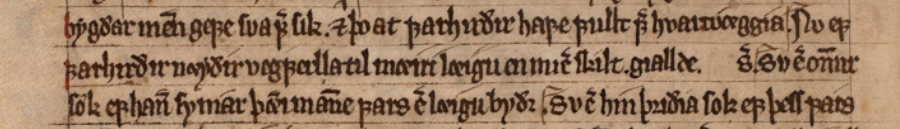
Fig. 1. An Old Norwegian law manuscript from 1325, Copenhagen, AM 309 fol, fol. 42v, l. 17–19. Towards the end of the middle line, the scribe has set aside room for a numeral, which he possibly was not able to read in his exemplar. Other manuscripts of this text shows that the correct numeral is ‘one half’.

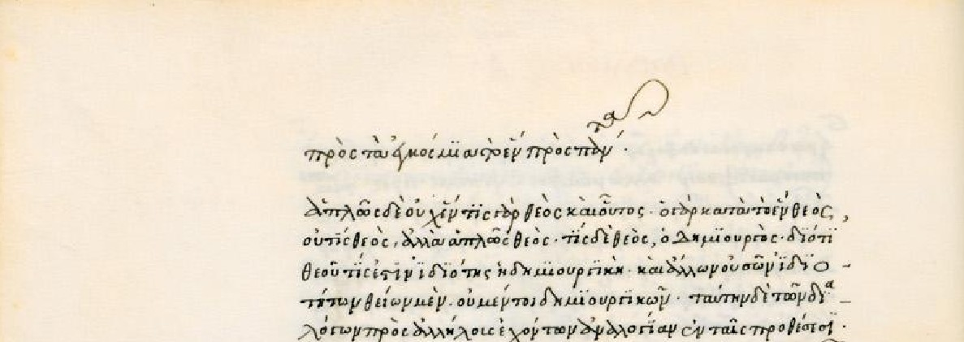
Fig. 2. Firenze, Biblioteca medicea Laurenziana, Plut. LXXXV, 8, f. 11v. There is a lacuna on the top line. Compare how this is shown in the edition in fig. 3 below.
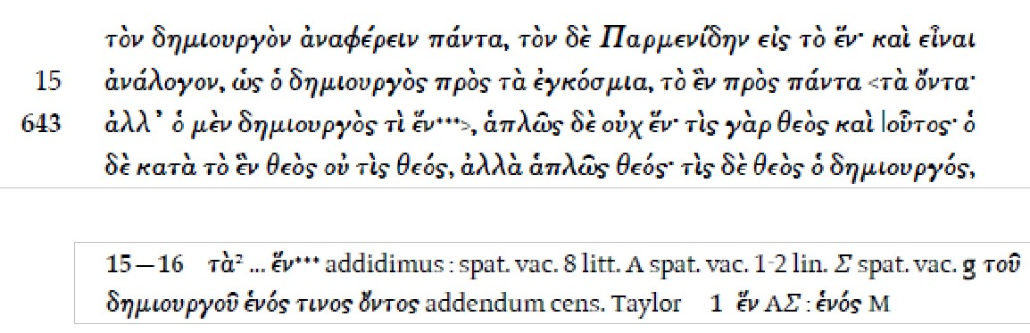
Fig. 3. Proclus,In Parmenidem I, 642-643 (ed. Steel).

References
– Maas, Paul. 1960. Textkritik. 4th ed. Leipzig: Teubner. – First ed. 1927.
– Steel, Carlos, Caroline Macé et Pieter d’Hoine (ed.). 2007. Procli In Parmenidem commentaria, t. I Libros I-III continens. Oxford: Oxford University Press.

In other languages
DE: Lacuna
FR: lacune
IT: lacuna
PR; OH, CM (examples)

Leaf
A node in a graph is a leaf (or a leaf node) if it has degree one and the only edge associated to the node is either undirected or is directed to it. Hence, in an undirected graph, all degree one nodes are leafs. In a directed graph, each degree one node is either a root or a leaf. It is usually required that a tree or a graph only have at most one root node.

Illustration
Fig. 1. Example of a graph depicting the names of important parts of a graph or tree.

In other languages
DE: Blatt
FR: feuille
IT: foglia
TR, PR (drawing)

Lectio brevior, lectio potior
A maxim from 18th century textual criticism which states that the shorter reading tends to be the better (older) one, as scribes have a tendency to incorporate explanatory secondary glosses into the text. It seems to be first used by Bengel (1734, p. 778: plerumque, si non semper, genuina est lectio brevior, verbosior interpolata). But already Le Clerc realised that this rule of thumb is much less valuable than lectio difficilior, lectio potior (cf. Timpanaro 1963, 39), as there are many cases in which text may get lost in transmission, e.g. by eye-skip (see error).

Reference
– Bengelius, Johannes Albrecht, ed. 1734. Ἡ Καινὴ Διαθήκη. Novum Testamentum Graece. Stutgardiae: apud I. B. Metzlerum.
– Lorimer, William L. 1934. “Lectio Difficilior.” The Classical Review 48 (5): 171–173.
– Timpanaro, Sebastiano. 1963. La genesi del metodo del Lachmann. Firenze: Le Monnier.
– ———. 1981. La genesi del metodo del Lachmann. 2nd ed. Padova: Liviana.
– ———. 2005. The Genesis of Lachmann’s Method. Translated by Glenn W. Most. Chicago: University of Chicago Press. – Translated from Timpanaro 1981.
PR

Lectio difficilior, lectio potior
A lectio difficilior is a more difficult reading and as such often a more original reading. When scribes met with difficult passages in the text, they often simplified the text in order to make it understandable to them. For this reason, the more difficult reading is often the better (older) one. The traditional rule therefore states thatlectio difficilior potior ‘the more difficult reading is the stronger one’. Its contrary is the ‘easier reading’ orlectio facilior, which is also know as banalisation or trivialisation of the text.
In practice it may not be trivial to decide which of several reading is difficilior or facilior as the difficulty to understand a word or phrase depends heavily on the involved person’s background, which for mediaeval scribes is often not so clear. Studying the different types of errors may help the editor to get some intuition for this. On the whole this rule is at best regarded only as a rule of thumb, similar to Lectio brevior, lectio potior. Both these rules figure among the twelve basic rules to be followed in the edition of the New Testament (cf. Aland, p. 275f.).
This rule was first clearly formulated by Jean Le Clerc (Ars critica, p. 293, 2nd ed. p. 302): Si omnia sint paria, non multum quidem interest quae eligatur, sed si una ex iis [sc. lectionibus] obscurior sit, ceterae clariores, tum vero credibile est obscuriorem esse veram, alias glossemata. ‘If all things are all similar, it does not matter much which one is to be chosen, but if one among them (sc. several readings) is more obscure and the others clearer, then it is certainly likely that the more obscure one is the true one, whereas the others are explanatory glosses (sc. also Timpanaro, p. 38). In the textual criticism of the Bible this rule was made prominent by Johann Albrecht Bengel (Novum Testamentum Graecum, 1734) and Johann Jakob Wettstein, to whom it is sometimes erroneously attributed (for more details, cf. Timpanaro 1963, p. 38–40).

References
– Aland, Kurt and Barbara. 1987. The Text of the New Testament: An Introduction to the Critical Editions and to the Theory and Practice of Modern Textual Criticism. Leiden: Brill.
– Le Clerc, Jean. 1697. Ars critica. Amsterdam 1697. – 5th ed. Amsterdam 1730. Online 2nd ed. https://archive.org/details/joannisclericia00unkngoog
– Lorimer, William L. 1934. “Lectio Difficilior.” The Classical Review 48 (5): 171–173.
– Timpanaro, Sebastiano. 1963. La genesi del metodo del Lachmann. Firenze: Le Monnier.
– ———. 1981. La genesi del metodo del Lachmann. 2nd ed. Padova: Liviana. – First ed., Firenze: Le Monnier, 1963.
– ———. 2005. The Genesis of Lachmann’s Method. Translated by Glenn W. Most. Chicago: University of Chicago Press. – Translated from Timpanaro 1981

In other languages
Latin term is used throughout
OH, GH, PR

Lectio facilior
The opposite of a lectio difficilior, i.e. a more simple reading.
PR

Lectio singularis
A reading (lectio) transmitted in a single (singularis) witness, generally due to either scribal inattention or arbitrary innovation. In the majority of cases, lectiones singularesare late, secondary readings (see reading, secondary) that do not find place in the reconstructed text (cf. also eliminatio lectionum singularium). One possible exception is represented by lectiones singulares difficiliores (Contini 1986, 101) which may be primary (see reading, primary).
Some lectiones singularescan be prticularly important for the history of transmission, and therefore the editor may decide to record them in the critical apparatus. Several examples of this practice can be found in Michael Lapidge’s edition of Bede’s Ecclesiastical History (Lapidge, Chiesa 2008-10): e.g. ms. M’s isolated reading Iustinianus (vs. Iustinus) in HE III, iiii, 1.3, considered by the editor as secondary but endowed with historical value (vol. I, p. C), is recorded in the apparatus (vol. II, p. 24).
Eigenfehler and Sonderfehler are German synonyms to lectio singularis.
References
– Beccaria, Gian Luigi, ed. 2004. Dizionario di linguistica, e di filologia, metrica, retorica. Nuova edizione. Torino: Einaudi. || See pp. 436–37, s.v. lectio.
– Contini, Gianfranco. 1986. Breviario di ecdotica, Ricciardi: Milano-Napoli.
–Lapidge, Michael, ed., and Paolo Chiesa, transl. 2008-10. Beda. Storia degli Inglesi. 2 vols. Milano: Fondazione Lorenzo Valla / Arnoldo Mondadori Editore.
– Maas, Paul. 1960. Textkritik. 4th ed. Leipzig: Teubner. – 1st ed. 1927.
–Most, Glenn, ed. and trans. 2005. Sebastiano Timpanaro. The Genesis of the Lachmann’s Method. Chicago: The University of Chicago Press. || See Ch. VI, n. 18.
In other languages
Latin term used throughout. Besides are used:
DE: Eigenfehler, Sonderfehler
FR: leçon propre
IT: lezione singolare
PR, MB

Leitfehler
[ˈlaɪtfe:la]
German for 'guiding error' (i.e. guiding the scholar towards understanding the text's genealogy), from leiten 'to guide, lead' and Fehler 'error'. See error, indicative or significant. Paul Maas coined this term (Textkritik, p. 26, where he refers to Gnomon n. 6 (1930), p. 561, but there he uses the synonym Leitkorruptel) thinking of the German term Leitfossil 'index fossil' in palaeontology, so one might also translate as 'index error'.

Reference
– Maas, Paul. 1960. Textkritik. 4th ed. Leipzig: Teubner. – First ed. 1927.
PR

Leithandschrift
Cf. copy text.

Likhachov, Dmitrij Sergeevich
Likhachóv, Dmitrij Sergeevich (Лихачёв, Дмитрий Сергеевич) (15/28.11.1906 – 30.09.1999) – a Russian philologist, one of the best specialists in the area of Russian mediaeval culture in the 20th century. Born in St. Petersburg. He graduated from Leningrad State University in 1928 (Romano-Germanic and Slavic-Russian section of the Department of Linguistics and Literature at the Faculty of Social Sciences). In 1928 he was sentenced to 5 years in prison and spent the time until 1932 in the first concentration camps on Solovetski Islands (archipelago in the White Sea) and in the camp near Lake Onega, working on the construction of the White Sea Channel ("Беломорканал"). From 1938 until his death he worked in the Sector on Old Russian Literature of the Institute of Russian Literature (Pushkin House) in St. Petersburg. He was member of the Russian Academy of Sciences (1970), Foreign Member of the Austrian (1968), British (1976), Bulgarian (1963), Serbian (1971) and Hungarian (1973) Academies of Sciences. Honorary Doctor of the University in Toruń (1964), Oxford (1967), Edinburgh (1971), Bordeaux (1982), Zurich (1982), Budapest (1985), Sofia (1988), Prague (1991), Siena (1992). The term "textology", which is very close but not identical in content to the term "Textual criticism", was introduced in the science of philology through his work in the second half of the 20th century.
This term "текстология" (textology) was created by the Russian formalist (OPOJaZ, i.e. the "Society for the Study of Poetic Language") Boris Tomachevski (17 (29).11.1890, Saint Petersburg - 24.08.1957, Gurzuf). "Textology" was used for the first time by this scholar, but it was Dmitrij Likhachov who built a comprehensive new theory of textology (mainly based on materials from Russian mediaeval literature). The term was created by combining the Latin word textus 'construction, combination, connection, context' and the Greek word λόγος 'word etc.'.
A new theory of textology by Likhachov was published for the first time in his book Лихачёв 1962 (2nd ed. 1983, 3rd edition 2001), and two years later – only the main theoretical points – in a short book Лихачёв 1964. The term textology is the only one used since the second half of the 20th century until today in the study of the texts of the mediaeval works created in the Eastern Orthodox region of Europe, as well as the texts written in Cyrillic and Latin, Slavic and non-Slavic, in Central Europe. After the 1970s it began to be also used in the study of texts created outside that region. The term textologie was used for the first time in Western scholarship by Roger Laufer (1972). It was through this book of his that the term was spread among Western scholars, with its content being expanded and changed in a number of cases and also applied for research outside the area of textual criticism (for example, terms such as 'contrastive textology' and 'semiotic textology' are used in the field of linguistics and semiotics).
Among the mediaevalists from Central and Eastern Europe the term "textology" was distributed mainly in the meaning assigned to it by Likhachov, and it also experienced some development, but this development remained almost always within the framework of the field of textual criticism. Thus today, as far as the research on Slavic mediaeval texts is concerned, 'textology' is a philological discipline whose object is to study the text of the original and translated works from the moment of their creation to their final manuscript or printed version. It has two tasks: (i) To reveal the history of the text of the work; (ii) to fix the results of this study in a scientific edition. In connection with the implementation of these tasks, textology deals with the search of all preserved texts of the work, with their comprehensive philological study separately and compared with each other, their connection with the original text (author’s text or original of the translation), and their publication. Besides its own methods, textology also uses the methods of a number of other scientific disciplines: linguistics, theory of literature, history, palaeography, codicology etc.
Unlike textual criticism, with which it shares almost everything, it may attach less importance to errors and more attention to linguistic features and their modification over time, as well as to the evidence outside the text. So it may be synonym to textual scholarship in general. This said, most Russian dictionaries translate "textual criticism" simply by текстология.

Works on textology
– Laufer, Roger. 1972. Introduction à la textologie: Verification, établisement, édition des textes. Paris: Librarie Larousse.
– Томашевский, Борис. 1928. Писатель и книга. Очерк текстологии. Ленинград: Прибой; 2nd ed. Москва: Искусство 1959. (Tomachevski, Boris. 1928. The Writer and the Book: An Outline of Textology. Leningrad: Priboj, 2nd ed. Moscow: Iskusstvo, 1959.)

Works on Likhachov
– Лихачёв, Дмитрий Сергеевич. 1989. Издание третье, дополненное. Вступительная статья В. П. Адриановой-Перетц и М. А. Салминой. Библиография составлена М. А. Салминой и Г.Н. Финашиной. Москва: Наука. (Dmitrij Sergeevich Likhachov.Third supplemented edition. Introduction by V. P. Adrianova-Peretz and M. A. Salmina. Bibliography by M. A.Salmina and G. N. Finashina. Moscow: Nauka.)
– Салмина, Марина Алексеевна. 2009. Дмитрий Сергеевич Лихачев: Библиография. 1988 – 2007; Сост., вступ. статья М. А. Салминой. Санкт-Петербург: Турусел. (Salmina, Marina Alekseevna. 2009. Dmitrij Sergeevich Likhachov. Bibliography. 1988–2007. Introduction and preparation by Marina A. Salmina. Saint-Petersburg: Tursel.)

Works by Likhachov
– Лихачёв, Дмитрий Сергеевич. 1962. Текстология. На материале русской литературы X–XVII вв. Москва–Ленинград: Изд-во Акад. наук СССР. (Textology. On the basis of material from Russian literature 10–17 centuries. Moscow–Leningrad: USSR Academy of the Sciences.)
– ———. 1964. Текстология: Краткий очерк. Москва – Ленинград: Наука. (Textology. Short essay. Moscow–Leningrad: Nauka.)
– ———. 1983. Текстология: На материале русской литературы X–XVII вeков. Издание второе, переработенное и дополненное. Ленинград: Изд-во Акад. наук СССР. (Textology. On the basis of material from Russian literature, X–XVII centuries. Second edition, revised and supplemented. Leningrad: USSR Academy of the Sciences)
– ———. 2001.При участии А. А. Алексеева и А. Г. Боброва. Текстология. На материале русской литературы X–XVII веков. Издание третье, переработенное и дополненное. Санкт–Петербург: Алетейя. (With the participation of A. A. Alekseev and A.G. Bobrov.Textology: On the basis of material from Russian literature, X–XVII centuries, Third edition, revised and supplemented. Saint-Petersburg: Aletejja).
SN

Locus criticus
A portion of the text (locus) in which the various witnesses display significant errors (cf. also variant location). The choice of a number of loci critici (selecti) allows the editor to establish a stemma in traditions that are hardly assessable in their entirety due to their width.
A recent coinage from Latin locus"passage, portion (of a text)" and criticus in the modern sense of "used for interpreting practice"; the (optional) adjective selectus alludes to the fact that the passage has been chosen for critical purposes. Though the expression seems to be first attested in the 1970s (see Balduino 1979), both Maas (first ed. 1927) and Pasquali (1952, first ed. 1934) had already introduced the similar notion of "collation by samples".
The most important editions of Dante's Divine Comedy are based on the scrutiny of loci critici: 396 of them from 200 witnesses in Barbi's preparatory work (known as "Barbi's canon"), and 477 in Petrocchi's edition (for further information see Brandoli 2007); in his 2001 edition of the Comedy, Federico Sanguineti goes back to Barbi's canon extending the collation to more than 500 witnesses.
References
– Balduino, Armando. 1979. Manuale di filologia italiana.Firenze: Sansoni.
– Brandoli, Caterina. 2007. “Due canoni a confronto: I luoghi di Barbi e lo scrutinio di Petrocchi.” In Nuove prospettive sulla tradizione della “Commedia”: Una guida filologico-linguistica al poema dantesco, edited by Paolo Trovato, 99–214. Firenze: Cesati.
– Maas, Paul. 1960. Textkritik. 4th ed. Leipzig: Teubner. – First ed. 1927.
– Pasquali, Giorgio. 1952. Storia della tradizione e critica del testo. 2nd ed. Firenze: Le Monnier. – First ed. Firenze: Le Monnier, 1934.
– Petrocchi, Giorgio (ed.). 1994. Dante Alighieri. La Commedia secondo l'antica vulgata. Second revised ed. Firenze: Le Lettere. – First ed. 1965-67.
– Sanguineti, Federico (ed.). 2001. Dantis Alagherii Comedia. Firenze: Edizioni del Galluzzo.
In other languages
Latin term used throughout.
MB

Locus desperatus
A locus desperatus (Latin for a 'hopeless passage') is a passage in an edition the editor was not able to understand. It may have arisen due to a corruption already present in the archetype. Such passages are marked with a crux in the text (cf. editoral signs). Locus deperditus ('corrupt passage') is a synonym.
An example can be found in Lucretius, De rerum natura VI, 550 (Ernout 1962: 123), where the best manuscripts have the meaningless "dupuis":
Et merito, quoniam plaustris concussa tremescunt
tecta viam propter non magno pondere tota,
nec minus † exultantes dupuis † cumque viai
ferratos utrimque rotarum succutit orbes.
("And with good cause, since buildings beside a road tremble throughout when shaken by a waggon of not such very great weight,
and they rock no less, when † any sharp pebble † on the road jolts up the iron tires of the wheels on both sides"
Trad. Munro, "any sharp pebble" is a conjecture by Munro who reads ... exultant scrupus quicumque viai).
Several emendations for this locus have been proposed besides the one by Munro, among them one by Lachmann, but none has found general acceptance yet.

Reference
– Ernout, Alfred. 1962. Lucrèce: De la nature. Paris: Les Belles Lettres.
– Munro, Hugo A.J. 1866.T. Lucreti Cari de rerum natura libri sex; with notes, translation by H.A.J. Munro. Cambridge: Bell.

In other languages
Latin is used throughout
PR

Loss rate (of witnesses)
In order to better understand the process of textual transmission it would be good to have an approximate idea of the loss rate of witnesses (manuscripts or early prints). This rate obviously varies widely according to the text concerned and the external history (e.g. war-loss is especially frequent). Trovato (2014, p. 104-108) tries to estimate numbers for some texts, mostly of prints of the early modern period. Nearly all examples he studied show loss rates of 80% upward within half a millennium, in several cases printed editions of more than 1000 initial copies have not survived at all. This makes it probable that equally low numbers of preservation must be reckoned with in antiquity and the middle ages, too.

Reference
– Trovato, Paolo. 2014. Everything You Always Wanted to Know about Lachmann’s Method: A Non-Standard Handbook of Genealogical Textual Criticism in the Age of Post-Structuralism, Cladistics, and Copy-Text. Foreword by Michael D. Reeve. Firenze: Libreriauniversitaria.it edizioni.
In other languages
DE: Verlustrate
FR: taux de perte
IT: tasso di perdita
PR

Maas, Paul
Paul Maas(Frankfurt am Main, 1880 – Oxford, 1964) was a philologist and a founding father of stemmatology. Maas studied at the universities of Berlin and Munich. After gaining his PhD (1902) in classical philology he taught in Berlin and Königsberg. As a Jew, he was persecuted by the Nazis and emigrated to the United Kingdom (1939), where he continued his career in Oxford.
One can say that the roots of all stemmatology are in the 19th and early 20th century, when German scholars Karl Lachmann and Paul Maas created strict principles for textual criticism, which are still commonly used by scholars, by philologists in particular. These principles are usually referred to as the method of Lachmann, even though Lachmann himself never wrote a guidebook about the methods he used; this was done later by Paul Maas, who is generally considered as the founder of the actual method.
According to Maas’s famous book Textkritik ‘The task of textual criticism is to produce a text as close as possible to the original (constitutio textus).’ Using Maas’s deductive methods, a scholar could reveal the relations between different manuscripts and decide which manuscript is the exemplar or copy of another, finally creating the full stemma and to reconstruct the original text as accurately as possible. Maas called this process constitutio textus. According to Maas, one can deduce the relationships between the different manuscripts in the stemma by examining the errors the manuscripts have. Maas calls these errors Leitfehler or errores significativi (‘significant errors’). The search of these errors still forms the basis of all traditional textual criticism.
Maas tried to answer Joseph Bédier's criticism of the Lachmannian method, arguing (Textkritik, p. 29f.) that it is inherently more likely that manuscripts of not very sought-after classical works are copied only once (in which case the intermediate step becomes invisible if the manuscript is lost), or twice (leading to bipartite stemmata). Bédier instead suspected psychological motives among the modern editors making them prefer binary branchings.

References
– Maas, Paul. 1960. Textkritik. 4th ed. Leipzig: Teubner. – First ed. 1927.
– Mensching, Eckart. 1987. Über einen verfolgten deutschen Altphilologen: Paul Maas (1880–1964). Berlin: Technische Universität Berlin.
MH (last § PR)

Manuscript
The word manuscript derives from Latin manus = ‘hand‘ and scribere = ‘to write’ and means a handwritten document, in a portable format, written on papyrus (mainly used in antiquity), parchment (widespread after the 3rd century AD) or paper (since the 12th century AD). Inscriptions are normally excluded from this definition. As a format, the codex is generally used for Western manuscripts since the 3rd century AD, replacing the scroll. Medieval manuscripts are often composite: they are composed of several "codicological units", that may date from different periods.
Before the invention of the printing press (mid 15th century), written texts were transmitted through copying of manuscripts. Most manuscripts carry many texts and will therefore be used as witnesses for the study of several textual traditions.
Except for the study of their contents, which is the object of textual criticism, manuscripts can also be studied as archaeological objects (codicology).

Other usage
The term manuscript is also used for the final draft of a modern text that is sent to the printer, no matter whether it is hand-written or not.

References
– Gumbert, Johann Peter. 2004. "Codicological Units. Towards a Terminology for the Stratigraphy of the Non-Homogeneous Codex." Segno e Testo 2, 17-42.
– Maniaci, Marilena, ed. 2015. “Chapter 1: Codicology.” In Comparative Oriental Manuscript Studies: An Introduction, edited by Alessandro Bausi et al., 69–266. Hamburg: Tredition. http://www1.uni-hamburg.de/COMST/handbookonline.html

In other languages
DE: Handschrift; Manuskript (usually only for the "other usage")
FR: manuscrit
IT: manoscritto
CM, TB

Material accident
Contrary to variant readings proper, material accidents in a textual tradition, do not occur because of the voluntary or involuntary intervention of a copyist, but, as the name implies, an accident affects the manuscripts (or any other text-carriers) as material objects: a page or a quire may be lost or misplaced (when the codex is rebound for example), parts of the manuscript may become illegible because of fire, water, fungi, or mice, etc.
Those material accidents, often resulting in a loss of text (or in a change of place), are important elements for the history of a text, as they may help proving a relationship between manuscripts (whereas variant readings are often subject to interpretation). The manuscripts in which a material accident occurred may have disappeared, but the consequences of it will still be visible in its descendants. Lacunae are a typical example of a material accident.
A material accident to the codex unicus will result in text loss. An example is the Latin mediaeval epic Ruodlieb. On several pages the margin was cut off and a part of any verse on these pages is missing. Modern editors may try to fill in such gaps by conjecture (Vollmann 1993 does this for Ruodlieb).
Reference
– Irigoin, Jean. 1986. "Accidents matériels et critique des textes." Revue d’Histoire des Textes 16: 1-36.
– Vollmann, Benedikt Konrad. 1993. Ruodlieb. Darmstadt: Wissenschaftliche Buchgesellschaft.
In other languages
DE: physische / materielle Beschädigung
FR: accident matériel
IT: danno materiale
CM, PR (example)

Media transmitting texts
In the history of literacy, mankind has used many different types of media for transmitting literary texts. Although it is important for textual critics to have an understanding of how texts came into being and were transmitted, only some general points of this very long history can be mentioned here. In order to embrace the whole picture, several disciplines must be combined: history and sociology of literacy (including orality) and scholarship, study of the materiality of manuscripts and printed documents (codicology), study of handwriting systems used in those documents (palaeography), study of the history of libraries and archives, etc. Any technological, ideological or intellectual changes in the history of media may have affected the history of the transmitted texts.
The ancient near east has left us libraries full of texts written on clay tablets, other media where certainly in existence but have not come down to us. The exact date when literacy becomes an important factor in Greece is disputed. The Homeric poems have clearly lived as oral tradition for a long time before they were written down. Some scholars have questioned the traditional assumption that they were written down as early as in the 8th century and assumed that this happened first at the end of the 6th c. BC. Others believe, however, that the poets who first wrote down the Homeric poems lived earlier than that and that Hesiod too used writing when he composed his poems. Books remained something of a rarity in Greece until well into the 5th c. BC.
In the late Roman republic and in the early empire literary works were still supposed to be heard and not read silently. In imperial Rome public recitations was an important way for an author to publish his work. The extent of literacy in the Roman world is disputed, but it is clear that the ability to read was much more common than the ability to write correctly. We have private letters from the Roman empire which have been dictated to scribes, thus indicating lacking or partly lacking literacy, and we have private letters written in good Latin by the private persons themselves, which seem to imply a rather diffused degree of literacy.
In the early middle ages it is, however, clear that the extent of literacy decreased considerably: it is therefore likely that recitations of texts increased in importance during that period.
The earliest examples of writing are found on objects made of stone, metal or clay. Wood was used too and wooden tablets covered with wax were frequently used in antiquity from the 6th c. BC onwards. Book scrolls made of leather seem to have been used when some of the earliest Greek texts were written down, but from the 5th century BC they tended to be replaced by the less expensive papyrus scrolls. The papyrus scroll was the form for books used in the famous library founded at Alexandria in the Hellenistic period and it would remain the most important one for several centuries.
Parchment as a material used for books is known from the 3rd century BC and was connected to the Hellenistic kingdom of Pergamon and the library founded there. With the use of this material there is also a change from the scroll to the codex. We have some fragments of parchment codices from the 1st and 2nd centuries AD, but it is from the 3rd and 4th centuries AD that the tendency to replace papyrus scrolls by parchment codices grows stronger. This change of writing material was of importance for the transmission of the classical Greek and Roman literature, since practically only the texts which were copied on parchment had a chance of surviving into the middle ages and into the modern era. Some papyri containing such texts have, however, survived in the dry climate of Egypt. Papyrus remained in use in late antiquity, but it was of less importance in the middle ages. From the 11th and 12th centuries AD, paper was used with increasing frequency in the production of books.
Parchment was very expensive and as a result, some such manuscripts were re-used: the first writing was removed by washing or scraping and another text was written on it. Such a manuscript is called a palimpsest.
The kind of writing used changed too. In the earliest phase there were only the capital letters which got their refined and elegant forms in the classical periods in Greece (5th and 4th centuries BC) and in Rome (1st century BC). Minuscule writing systems (spreading letters between four imaginary lines, not two) replaced the majuscule systems in both Greek and Latin in the early middle ages. This again was an important bottle-neck for texts to pass: those who did not get transcribed into minuscule were nearly all lost.

References
– Bischoff, Bernhard. 1986.Paläographie des römischen Altertums und des abendländischen Mittelalters. 2nd. ed. Berlin: Erich Schmidt Verlag. – English translation by Dáibhí Ó Crónin and David Ganz. Latin Paleography. Cambridge: Cambridge University Press, 1990.
– Gastgeber, Christian. 2003. “Die Überlieferung der griechischen Literatur im Mittelalter.” In Egert Pöhlmann, Einführung in die Überlieferungsgeschichte und die Textkritik der Antiken Literatur: Mittelalter und Neuzeit, 1–46. Darmstadt: Wissenschaftliche Buchgesellschaft. || See pp. 2 f., 12–18.
– Klopsch, Paul. 2003. “Die Überlieferung der lateinischen Literatur im Mittelalter.” In Egert Pöhlmann, Einführung in die Überlieferungsgeschichte und die Textkritik der Antiken Literatur: Mittelalter und Neuzeit, 47–95. Darmstadt: Wissenschaftliche Buchgesellschaft. || See pp. 61–67.
– Pöhlmann, Egert. 1994. Einführung in die Überlieferungsgeschichte und die Textkritik der Antiken Literatur: Altertum. Darmstadt: Wissenschaftliche Buchgesellschaft. || See pp. 1–9, 10–17, 18–25, 46 f., 53 ff., 79–86, 87 ff.
– Reynolds, Leighton Durham, and Nigel G. Wilson. 1974. Scribes and Scholars: A Guide to the Transmission of Greek and Latin Literature. 2nd ed. Oxford: Clarendon Press. || See p. 1 ff.
– Salles, Catherine. 2010. Lire à Rome. Petite Bibliothèque Payot. New ed. Paris: Belles Lettres. – 1st ed., Paris: Belles Lettres, 1992. || See pp. 97–116.
– Skafte Jensen, Minna. 1980. The Homeric Question and the Oral-Formulaic Theory. Copenhagen: Museum Tusculanum Press.
In other languages
DE: textüberliefernde Medien
FR: médias
IT: supporti scrittori / media
GH

Metathesis
[mᵻˈtaθᵻsɪs]
Metathesis (Gr. μετάθεσις) is the transposition of sounds or letters in a word, commonly precipitated by a slip of the ear or of the pen. As a linguistic process, metathesis has changed the written form and pronunciation of many words. For example, bird is a metathesised form of OE bryd. Usually the phenomenon refers to contiguous sounds which is called adjacent metathesis. Metathesis may also describe the transposition of non-adjacent sounds and/or letters as in Spanish palabra from Latin parabola. Cf. types of errors.
Havet (1911, 470) uses the term anasyllabism to describe the reanalysis and subsequent metathesis of the syllables of a source word which in turn transforms the word into another, such as domo for modo, and suspicio for suscipio.

Reference
– Havet, Louis. 1911. Manuel de critique verbale appliquée aux textes latins. Paris: Hachette.

In other languages
DE: Metathese
FR: metathèse
IT: metatesi
AC

Method, Leitfehler-based
The defining characteristic of Leitfehler-based methods in automated stammatology is that they weight the variant readings in the various witnesses according to their ability to serve as Leitfehler (or significant variant). They are a subcategory of distance-based methods. Thus the traditional scholarly concept of Leitfehler is taken to be a quantitative one: a variant’s usefulness as Leitfehler may be assigned a number or weight. In classical stemmatology the Leitfehler is the most important tool to arrive at a filiation of witnesses that is believed to be most correct representation. Therefore such automated methods follow the traditional procedure of finding the correct stemma codicum more closely than others that do not take this into account. The effects of weighting variants is a point of debate in the field. Some have explored this open issue and the possibilities for semi-automated weighting (Spencer et al. 2004).
An open challenge in fully automated stemmatology is the estimation of the stemmatological value of a variants computationally. One implementation of such weighting proposed by Roelli (2010 and 2014) is still largely ad hoc, requiring further research and development. This approach tries to evaluate potential candidates for 'good' variants by comparing for every pair of them in what witnesses their absence or presence occurs. If one of the four combinations of absence / presence of any of these two candidates is not represented in any witness, this is taken to be a hint that both variants suffered their change from absence to presence (or vice versa) exactly once in the tradition, which is characteristic for good traditional Leitfehler (Maas 1937). Such a comparison can be made for all combinations of potential Leitfehler while both Leitfehler in pairs with only three combinations get their score increased.

References
– Maas, Paul. 1937. “Leitfehler und Stemmatische Typen.” Byzantinische Zeitschrift, 37 (2): 289–294.
– Roelli, Philipp, and Dieter Bachmann. 2010. “Towards Generating a Stemma of Complicated Manuscript Traditions: Petrus Alfonsi’s Dialogus.” Revue d’histoire des textes N.S. 5: 307–321.
– Roelli, Philipp. 2014. “Petrus Alfonsi, or :On the Mutual Benefit of Traditional and Computerised Stemmatology.” In Analysis of Ancient and Medieval Texts and Manuscripts: Digital Approaches, edited by Tara Andrews and Caroline Macé, 43–64. Turnhout: Brepols.
– Spencer, Matthew et al. 2004. “The effects of weighting kinds of variants.” In Studies in Stemmatology II, edited by Pieter Th. van Reenen, Aurelius A. den Hollander, and Margot van Mulken, 227–240. Amsterdam: John Benjamins.
JZ, PR

Method, maximum likelihood
The maximum likelihood method is a general principle in statistics wherein the statistical hypothesis that assigns the highest probability to the observed data is preferred. A statistical hypothesis assigns a probability value (in the case of discrete data, a probability between 0 and 1, or in the case of continuous data, a non-negative probability density) to all conceivable data. The probability value assigned to the observed data is called the likelihood of the hypothesis. The hypothesis can consist of structural components such as a tree topology or parameters such as edge lengths, or both. Maximum likelihood is generally considered superior to many other approaches due to its theoretically and empirically observed favourable properties.
Phylogenetic trees that are based on a specific sequence evolution model such as the Jukes–Cantor model can be estimated using maximum likelihood (Felsenstein 1981). This may require some approximations to make the inference computationally tractable.
Reference
– Felsenstein, Joseph. 1981. “Evolutionary trees from DNA sequences: A maximum likelihood approach.” Journal of Molecular Evolution 17: 368–376.

In other languages
GE: maximale Wahrscheinlichkeit
FR: maximum de vraisemblance
IT: massima verosimiglianza
TR

Method, maximum parsimony
Maximum parsimony is a method for inferring relationships between witnesses, biological sequences or other data by finding the relationship that minimises the number of changes that needs to be invoked to account for the observed data. In general, this implies that witnesses will be grouped according to readings they share to the exclusion of others.
In other languages
DE: Methode der maximalen Parsimonie, or English used
FR: méthode de la parcimonie maximum
IT: metodo della massima parsimonia
CH, HW

Methods, distance-based
The data used as a basis for phylogenetic inference commonly arises from gene sequencing procedures or by performing a number of phenotypic measurements. However, the way the data is used varies from method to method. In distance-based methods, the data is first transformed into a distance matrix that gives, for each pair of taxa, a pairwise distance. The distance can be, for instance, the number of characters that differ between the two taxa divided by the length of the sequences. (Note that in case a specific sequence evolution model, such as the common Jukes-Cantor model is used, it may be beneficial to carry out a correction based on the model.)
Once a distance matrix is computed, a distance-based method ignores the original data and bases its operation only on the distance matrix. A popular distance-based method is the neighbour joining method. An example of a method that is not distance-based is the maximum parsimony method.

Reference
– Lemey, Philippe, Marco Salemi, and Anne-Mieke Vandamme, eds. 2009. The Phylogenetic Handbook: A Practical Approach to Phylogenetic Analysis and Hypothesis Testing. 2nd ed. Cambridge: Cambridge University Press.
In other languages
DE: distanzbasierte Methoden
FR: méthodes basées sur les distances
IT: metodi basati sulla distanza
TR

Misreading
Misreading refers to the replacement of a letter in the exemplar with a similar looking, but incorrect, letter, for example the writing of c for e. While misreading does not explicitly posit the cause for a mistranscription, it frequently implies graphical misapprehension of letter forms (cf. copying of texts(3)).
Cf. types of errors.

Reference
– Havet, Louis. 1911. Manuel de critique verbale appliquée aux textes latins. Paris: Hachette.

In other languages
GE: Fehllesung
FR: mélecture, faute graphique (Havet, §6)
IT: lettura sbagliata (rarely used) / errore di lettura / errore paleografico
AC

Mouvance
Mouvance is a concept developed by Paul Zumthor (1972) to account for and explain the range of variability found in mediaeval (and predominately anonymous) literary material. The concept relies on a distinction between a 'work', a complex collective of textual manifestations, and the individual texts, or traces, of the work. This perspective de-emphasises the hierarchy of traditional textual criticism and reconstruction while focusing on the network of interactions, both oral and written, that attends all stages of transmission and can be evinced in individual witnesses.

Illustration
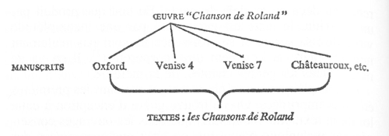
Fig. 1. Schematic representation of the relationship between text and work which yields mouvance (from Zumthor 1972, p. 92).

Reference
– Zumthor, Paul. 1972. Essai de poétique médiévale. Paris: Seuil.
In other languages
French term used throughout.
AC

MrBayes
MrBayes is a freeware program for implementing Bayesian inference of phylogeny. Bayesian phylogenetic analysis proceeds by calculating the likelihood of the character data given an initially random tree topology, set of branch lengths and model of character evolution, and iteratively modifies each of these parameters in a Markov Chain Monte Carlo (MCMC) simulation. Moves that improve the likelihood of the data are always accepted, while those that do not are usually rejected (although some may occasionally be accepted within a certain threshold so as to avoid getting trapped in local optima). Following an initial trial period (known as ‘burn in’), the likelihood scores will plane out and parameters will fluctuate between similar values, at which point trees are sampled at regular intervals to generate a posterior distribution of trees. Unlike the trees output by a cladistic analysis, which are based on a single optimality criterion (i.e., parsimony), the posterior distribution of trees represents a set of phylogenetic hypotheses that explain the distribution of character states among the taxa under a range of plausible evolutionary assumptions. The posterior distribution of trees can be summarised by a consensus tree or “maximum clade credibility tree”, while posterior probabilities for individual clades are calculated based on their frequency in the tree sample. The Bayesian approach has been found to be particularly effective when there is wide variance in the amount of evolution that has occurred in different regions of the character data or tree, since it explicitly incorporates these parameters (i.e., branch lengths and substitution model) into the analysis.
See also: Bayesian phylogenetics, tools.

Reference
– MrBayes: Bayesian Inference of Phylogeny. Computer program. http://mrbayes.sourceforge.net/
JT

NeighborNet
The NeighborNet algorithm is an algorithm based on neighbour joining to construct phylogenetic networks. Like neighbor joining, this method takes a distance matrix as input and starts with a completely unresolved tree (i.e. a tree connecting all nodes individually to a single root). It determines which two edges (or taxa/branches) may be connected to a new intermediate node because they are the least distant ones compared to any of the other branch combinations in the network. This process is repeated until there are no 'unprocessed' edges left. The difference to neighbour joining is that NeighborNet allows for collections of clusters that overlap and do not form a hierarchy. The SplitsTree software package implements several phylogenetic algorithms amongst which NeigborNet.

References
– Bryant, David, and Vincent Moulton. 2004. “Neighbor-Net: An Agglomerative Method for the Construction of Phylogenetic Networks.” Molecular Biology and Evolution 21 (2): 255–265.
– Huson, Daniel H., and David Bryant. 2006. “Application of Phylogenetic Networks in Evolutionary Studies.” Molecular Biology and Evolution 23 (2): 254–267.
– Tehrani, Jamie, Quan Nguyen, and Teemu Roos. 2015. “Oral fairy tale or literary fake? Investigating the origins of Little Red Riding Hood using phylogenetic network analysis.” Digital Scholarship in the Humanities. Advance Access 23 June 2015: http://dsh.oxfordjournals.org/content/early/2015/06/21/llc.fqv016.abstract.
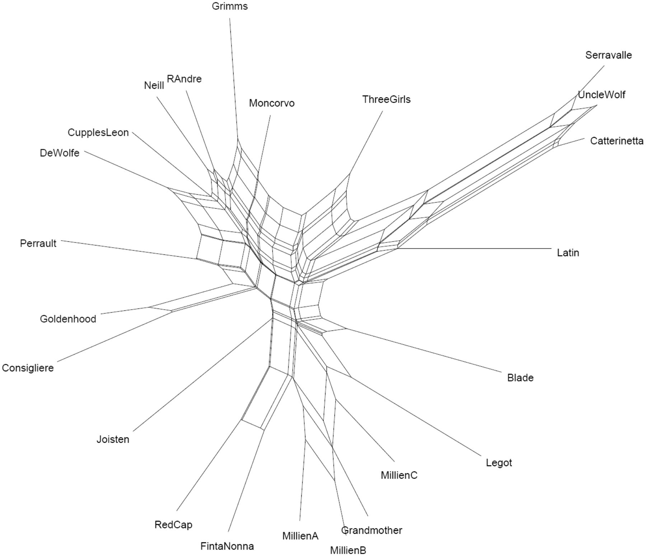
Fig. 1: Neighbornet representation of different versions of Red Ridinghood (Tehrani et al. 2015).
JZ

Neighbour joining
Neighbour joining is a method that infers relationships between witnesses (or organisms if using biological sequence data) by sequentially grouping those that show fewest differences into an unrooted tree. The illustration below shows this process in an example. A distance matrix is used as input, from this matrix another matrix, called the Q matrix, is obtained which is used to find the pair of witnesses that have the lowest distance from one another.
Neighbour joining is implemented in software packages like PHYLIP or PAUP*. The method was developed by Saitou and Nei in 1987 at Texas University. It is based on earlier work, e.g. by Fitch (1981). An important early paper using least squares to approximate the optimal tree was published by Fitch and Margoliash (1967).
Illustration
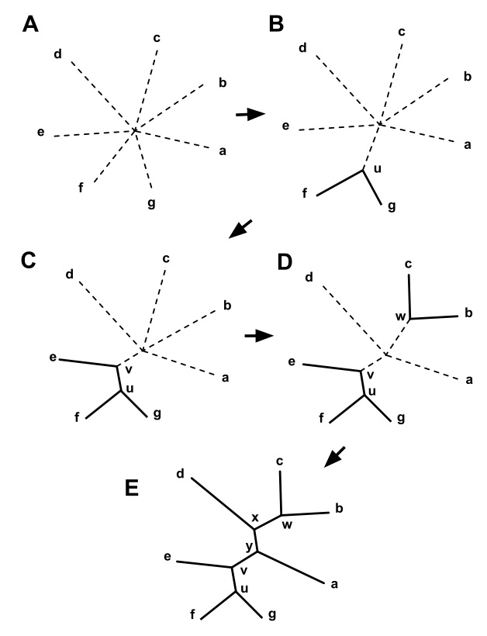
Fig. 1: A fictitious example how neighbour joining works (by Wikipedia user Tomfy).

Reference
– Fitch, Walter M., and Emanuel Margoliash. 1967. “Construction of phylogenetic trees.” Science 155 (3760): 279–284. doi:10.1126/science.155.3760.279. PMID 5334057.
– Fitch, Walter M. 1981. “A non sequential method for constructing trees and hierarchical classifications.” Journal of Molecular Evolution 18: 30–37.
– Saitou, Naruya, and Masatoshi Nei. 1987. “The neighbor-joining method: A new method for reconstructing phylogenetic trees.” Molecular Biology and Evolution 4 (4): 406–425.
CH, HW, PR

Neo-Lachmannian Philology
1. Neo-Lachmannian philology, sometimes also called “neo-lachmanni(ani)sm” (cf. Salemans 2000, Blecua 2002, Trovato 2014) on the basis of the Italian term "neo-lachmannismo", is an ambiguous label. In fact, it may refer either to an interpretation of the Lachmannian method that works with “variants” rather than with “errors” in general (see below point 2), or to the Italian philological school which, starting from Pasquali, gave a particular turn to the Lachmannian method. This school is also named “variantistica” or “nuova filologia” after Michele Barbi (Fraistat, p. 74), although it has nothing to do with the so-called “new philology”; further labels are “translachmannism” and “postlachmannism”.
The latter is a school of thought that tries to widen the historical dimension of the Lachmannian method by carefully studying the specific textual tradition of each witness, instigated by Bédier's criticism. As a consequence, recensio (including collation and the drawing of a stemma) is kept almost as it was in the original method, while the step of the constitutio textus allows for more freedom: the editor is supposed to proceed differently for different kinds of traditions. For instance some lectiones singulares (which were all discarded in the traditional Lachmannian method) may be recovered for the critical text in a second stage, if the history of the tradition permits to provide evidence for them to belong to the original. The critical edition is seen as a scientifically based working hypothesis, not as an absolute entity. This methodology was mostly developed by Italian scholars in the 20th century (cf., among others, Buzzoni/Burgio 2014; Pugliatti 1998).

References
– Blecua, Alberto. 2002. “Defending Neolachmannianism: On the Palacio:Manuscript of La Celestina”. Variants 1: 113–133.
– Buzzoni, Marina, and Eugenio Burgio. 2014. "The Italian ‘third way’ of editing between globalization and localization." In Internationalität und Interdisziplinarität der Editionswissenschaft,edited by Michael Stolz and Yen-Chun Chen. Berlin-Boston: Walter De Gruyter, 171–180.
– Fraistat, Neil, and Julia Flanders, eds. 2013. The Cambridge Companion to Textual Scholarship. Cambridge: Cambridge University Press.
– Pugliatti, Paola. 1998. "Textual Perspectives in Italy: From Pasquali’s Historicism to the Challenge of ‘Variantistica’ (and Beyond)." In Text. An Interdisciplinary Annual of Textual Studies, vol 11, edited by W. Speed Hill, E. M. Burns, P. Schillingsburg. Ann Arbor: University of Michigan Press, 155–188.
– Trovato, Paolo. 2014. Everything You Always Wanted to Know about Lachmann’s Method: A Non-Standard Handbook of Genealogical Textual Criticism in the Age of Post-Structuralism, Cladistics, and Copy-Text. Foreword by Michael D. Reeve. Firenze: Libreriauniversitaria.it edizioni.
MB
2. In the second sense, the term is more loosely and more generally used (mostly by non-Italian scholars) to denote a method that proposes to use all variants to discover proximities between witnesses, and the resulting (often: computed) tree is orientated only in a second step. Henri Quentin may be seen as the ancestor of this approach, which was soon computerized in several ways. After him, Anthonij Dees, Evert Wattel, Karl-Heinz Uthemann and Ben Salemans may be cited, in other words the school of Amsterdam: see the contributions in van Reenan et al. 1996. This method was especially meant to be used in heavily contaminatedtraditions represented by many witnesses (such as the Bible).
While the first method (the one strictu senso) sticks to the differentiation of stemmatic and non-stemmatic variants (cf. Leitfehler), the second may forego this distinction, be it for theoretical reasons of inapplicability in heavily contaminated texts, be it for the sake of ease of computerised handling.

References
– Salemans, Ben J.P. 2000. Building Stemmas with the Computer in a Cladistic, Neo-Lachmannian, Way: The Case of Fourteen Text Versions ofLanseloet van Denemerken. Nijmegen: Nijmegen University Press.
– Trovato, Paolo. 2014. Everything You Always Wanted to Know about Lachmann’s Method: A Non-Standard Handbook of Genealogical Textual Criticism in the Age of Post-Structuralism, Cladistics, and Copy-Text. Foreword by Michael D. Reeve. Firenze: Libreriauniversitaria.it edizioni.
– van Reenen, Pieter Th., and Margot van Mulken, eds. 1996. Studies in Stemmatology. Amsterdam: John Benjamins.
CM, PR

In other languages
DE: Neolachmannsche Philologie (hardly used as yet)
FR: philologie néo-lachmannienne (hardly used as yet)
IT: neo-lachmannismo

Networks, evolutionary
Also: explicit network, cf. phylogenetic networks, types of.
In other languages
DE: evolutionäre Netzwerke
FR: réseaux évolutifs
IT: reti evolutive

Newick format
Cf. Data formats for trees.
In other languages
DE: Newickformat
FR: format Newick
IT: formato Newick

New Philology
In 1990, an issue of the journal Speculum (published by the Medieval Academy of America) was devoted to the so-called "New Philology". This is a trend in philology, at the beginning within Romance philology, that claimed to introduce a new vision of the mediaeval text in the wake of the 1989 pamphlet by Bernard Cerquiglini in which he pleaded for textual variance. In a nutshell, Cerquiglini claimed that critics should not try to reduce a mediaeval tradition to one single text, but rather let the variation coexist. Although Cerquiglini’s book attracted strong criticisms from the beginning (see Varvaro 1989, Stussi 1992, but also several articles in Busby 1993 and in Gleßgen/Lebsanft 1997), the “New Philology” recently found some new defenders, even outside of Romance philology (see Driscoll 2010, and for a neutral overview Yager 2010). It should be pointed out, however, that not all proponents of the “New Philology” are comfortable with the term, but prefer e.g. “material philology”, thus underlining the turn towards the sources themselves and typically a single manuscript within its historical context (cf. Nichols 1997). This is typically seen as a contrast to and a criticism of the reconstructive aspirations of traditional philology.
The "New Philology" is in practice identical to traditional philology when a work is preserved in a codex unicus – i.e. when there by definition is no variation at all. In these cases, an edition can do little more than rendering the source as it is. The facsimile editions of the early and mid 20th century are prime examples of traditional philology having done exactly what the new philology is asking for, presenting single manuscripts in their codicological and textual individuality.
However, the majority of works, classical as well as mediaeval, are preserved in more than one manuscript, and this is where the old and the new philology tend to part – the old heading towards reconstruction and explanation, the new towards acceptance and description of the variation. Haugen (2010) points out that many works are preserved in a highly fragmented state, and that it is only by way of traditional philology that it has been possible to reconstruct them (as far as it goes) on the basis of the manuscript material. This includes, for example, major works such as the Old Norwegian King’s Mirror (Konungs skuggsjá), and the translation from Old French into Old Norwegian of the lais of Marie de France, Strengleikar, both dating from the mid 13th century and both fragmented. There seem to be no tools in the chest of New Philology for dealing with this type of tradition.

References
– Busby, Keith, ed. 1993. Towards a Synthesis? Essays on the New Philology. Amsterdam: Rodopi.
– Cerquiglini, Bernard. 1989. Éloge de la variante. Paris: Seuil.
– Driscoll, Matthew J. 2010. “The Words on the Page: Thoughts on Philology, Old and New.” In Creating the Medieval Saga: Versions, Variability, and Editorial Interpretations of Old Norse Saga Literature, edited by Judy Quinn and Emily Lethbridge, 85–102. Odense: University Press of Southern Denmark.
– Gleßgen, Martin-Dietrich, and Franz Lebsanft, eds. 1997. Alte und neue Philologie. Tübingen: Max Niemeyer.
– Haugen, Odd Einar. 2010. “Stitching the Text Together: Documentary and Eclectic Editions in Old Norse Philology.” In Creating the Medieval Saga: Versions, Variability, and Editorial Interpretations of Old Norse Saga Literature, edited by Judy Quinn and Emily Lethbridge, 39–65. Odense: University Press of Southern Denmark.
– Nichols, Stephen G. et alii. 1990. The New Philology.Special issue of Speculum 65 (1).
– ———. 1997. “Why Material Philology? Some Thoughts.” Special issue of Zeitschrift für deutsche Philologie 116: 1–21.
– Stussi, Alfredo. 1992. Review of Cerquiglini 1989. Zeitschrift für romanische Philologie 108: 199–202.
– Varvaro, Alberto. 1989. Review of Cerquiglini 1989. Medioevo romanzo 14: 474–477.
– Yager, Susan. 2010. “New Philology.” In Handbook of Medieval Studies: Terms – Methods – Trends, edited by Albrecht Classen, 999–1006. Berlin: Walter de Gruyter.

In other languages
DE: new philology, neue Philologie
FR: nouvelle philologie
IT: new philology; not to be confused with Michele Barbi's "nuova filologia"
CM, OH

Nexus
From Latin nexus 'connection'.
Nexus is a common data format for character data. An example of a simple Nexus formatted file with four manuscripts (taxa) and five characters is as follows:
#NEXUSbegin data; dimensions ntax=4 nchar=5; matrix Ms1 AABAB Ms2 AABAC Ms3 ABABA Ms4 AAABD ;end;
This means that the first word, encoded as A in the first character of each of the character sequence, is common to all four manuscripts. The second word has a common variant, encoded as A, in manuscripts Ms1, Ms2, and Ms4, but a different variant, B, in manuscript Ms3, and so forth.
Nexus files can be processed using common phylogenetic programs such as PAUP*, Phylip, and Stemmaweb.
TR

Node, internal
An internal node in a graph is a node that has degree (number of links to or from other nodes) greater than one. A tree that has more than two nodes can be decomposed into (i) one or more internal nodes, (ii) leaf nodes, and (iii) in case the tree is directed, a root node. Traditionally, in a phylogenetic tree, all extant taxa are placed in leaf nodes.
In a stemma, a text version that corresponds to an internal node is called a hyparchetype.

In other languages
GE: innerer Knoten (innere Ecke)
FR: sommet interne
IT: nodo interno / vertice interno
TR, PR (drawing)

Node (vertex)
A node is one of the two kinds of objects that form a graph, the other being the edge. In stemmatology nodes correspond to witnesses, edges to the relationship "was copied from". Vertex is a synonym for node. Cf. also internal node.

Illustration
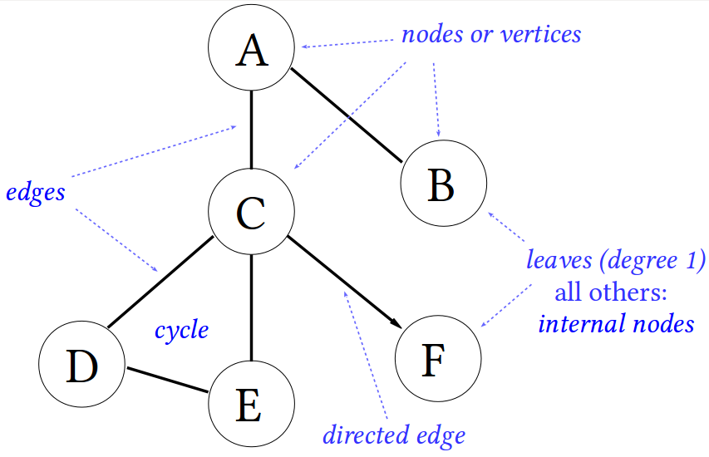
Fig. 1. Example of a graph depicting the names of important parts of a graph or tree.

In other languages
DE: Knoten / Ecke
FR: nœud / sommet
IT: nodo / vertice
PR

Normalisation
The terms normalisation, regularisation and standardisation of orthography are used synonymously. Yet at least three somewhat different meanings should be kept apart:
1. (historically) Normalisation takes place when the orthography (or other aspects of the language) of a text is changed in order to make it correspond to a certain standard. This happened to early (i.e. pre-classical) Greek and Latin texts, which underwent a process of orthographical modernisation in the classical or later periods. It also happened during the Roman Empire to certain Greek texts not originally written in classical Attic Greek, when Attic forms and inflection sometimes replaced other forms.
This also happened in the High Middle Ages to some texts which had been written or copied in the early Middle Ages. The language in some Latin and Greek texts which were copied in the early Middle Ages has in some cases been altered considerably during the transmission due to “vulgarisation” of the language of the original text. From around 800 AD there was a renaissance for classical studies in both Byzantium and in the West (in the West due to the Carolingian reform). As a result, the general knowledge about the classical forms of language improved during the following centuries. In the manuscripts to certain texts, we can see that some scribes tried to improve the language in the texts – especially in texts which had been “vulgarised” during the early Middle Ages. In the West, there was in the 10th and 11th centuries sometimes even a tendency to “correct” certain linguistic features, which were quite normal in late literary Latin, and to replace them with the corresponding classical expressions.
Certain texts – many technical handbooks but also some texts written by known historical persons – are thus affected by both “vulgarisation” (in the early Middle Ages) and “normalisation” (in the High Middle Ages). Cf. vulgarisation.

References
– Coleman, Robert. 1999. “Vulgarism and normalization in the text of Regula Sancti Benedicti.” In Latin vulgaire – Latin tardif V: Actes du Ve Colloque International sur le latin vulgaire et tardif, Heidelberg, 5–8 septembre 1997, edited by Hubert Petersmann and Rudolph Kettemann, 345–356. Bibliothek der klassischen Altertumswissenschaften, N.F. 2: 105. Heidelberg: Winter.
– Haverling, Gerd V. M. 2008. “On Variation in Syntax and Morphology in Late Latin texts.” In: Latin vulgaire – Latin tardif VIII: Actes du VIIIe Colloque International sur le latin vulgaire et tardif, Oxford, 6–9 septembre 2006, ed. Roger Wright, pp. 351–360. Hildesheim: Olms Weidmann.
– Pasquali, Giorgio. 1952. Storia della tradizione e critica del testo. 2nd ed. Firenze: Le Monnier. || See pp. 17 fn 2, 18, 118–123, 142, 189.
– Reynolds, Leighton Durham, and Nigel G. Wilson. 1974. Scribes and Scholars: A Guide to the Transmission of Greek and Latin Literature. 2nd ed. Oxford: Clarendon Press. || See p. 41.
GH
2. (modern) In editions of classical as well as of mediaeval texts, the orthography is often normalised (see: analysis of forms). Although there are variations in this practice, the tendency seems to be that Latin texts especially from antiquity, are being edited with a regularised orthography, and to a less extent also Latin texts from mediaeval times. The question of normalised Latin texts has been debated on numerous occasions, notably in the journal Symbolae Osloenses (vol. 76), in which Heinz Hofmann argues strongly for normalisation, while Hans Helander argues for keeping the orthography of mediaeval Latin texts unchanged (Helander 2001).
As for vernacular texts from the Middle Ages, there is generally no standard orthography, so these editions tend to keep the orthography of the main manuscript. See, however, the discussion of Old High German normalised orthography in the entry on Lachmann’s method. For Old Norse texts (i.e. Old Icelandic and Old Norwegian), a fairly strict standard orthography was developed in the 19th century. Many Old Norse editions, e.g. in the Íslenzk fornrit series, use this normalised orthography (commonly referred to as “normalortografi” in the Scandinavian languages). This normalised orthography is also the one found in standard grammars and dictionaries of Old Norse. The delineation of Old Norse orthography is discussed at some length by Ludwig F. A. Wimmer (1877, pp. v–xxvii).
A special case of normalisation is the one used in eclectic editions based on sources with varying orthography. In these editions, a uniform orthography is usually chosen. Often, it is the orthography of the main manuscript (copy text) on which the edition is based, but especially in the case of Old Norse texts, it can be the normalised orthography referred to above.

References
– Helander, Hans. 2001. “Neo-Latin Studies: Significance and Prospects.” Symbolae Osloenses 76: 5–102.
– Wimmer, Ludvig F. A. 1877. Oldnordisk læsebog med anmærkninger og ordsamling. 2nd ed. København: Chr. Steen & Söns forlag.
OH
3. (in collation) In the course of the preparation of the witness's data in collation, especially when using computer-assisted methods to study the transmission, certain orthographic features of the text – such as the use of capital letters, use of ‘v’ instead of ‘u’, ‘c’ instead of ‘t’ and the versatile use of ‘e’, ‘ae’ and e caudata (ę) – may need to be unified, since such features are subject to much variation in the manuscript traditions. This may be referred to as “normalisation”. It is done for instance by Roelli and Bachmann 2010.

References
– Roelli, Philipp, and Dieter Bachmann. 2010. “Towards Generating a Stemma of Complicated Manuscript Traditions: Petrus Alfonsi’s Dialogus.” Revue d’histoire des textes N.S. 5: 307–321.
GH

In other languages
DE: Normalisierung, Regularisierung
FR: normalisation, régularisation
IT: normalizzazione, regolarizzazione
GH, OH

Omission
An omission is any segment of text that a copyist does not reproduce in the copied text, but that is present in the exemplar. In the process of collating and editing the term omission is a relative one which only indicates that a segment of text which is present in the base-text is lacking in some witness(es), without making a judgement whether the omission is secondary or not. One may distinguish omissions intentionally introduced by the scribe from unintentional ones.
Cf. types of errors, addition, haplography, and lacuna.

Reference
– Havet, Louis. 1911. Manuel de critique verbale appliquée aux textes latins. Paris: Hachette.

In other languages
GE: Auslassung
FR: omission
IT: omissione
AC, CM

Original
The term 'original' derives from the Latin noun orīgo, -inis, which means 'beginning, origin'.
An original is the earliest version of a work, as it was conceived and written by the author. In a stemma, the original is placed at the top, often indicated by an X or an O, while the archetype (if different from it) will be placed below it. In classical and medieval texts, the original has in almost all cases been lost, so the text of the archetype which can be reconstructed from the preserved manuscripts should be seen as an approximation to the text of the lost original. However, in the case of preserved originals (which are known especially from late medieval sources), there is no distinction between the original and the archetype, but the preserved copies can branch off directly from the original (see also origin).
For some works, there may have been more than one original, for example in the case of a revision. A known example of this phenomenon is the transmission of Liutprand of Cremona's Antapodosis. Two redactions of this work were copied and have given rise to extant manuscripts. Cf. ill. 2 below and the study by Paolo Chiesa (Chiesa 1997). In this case the archetype (understood as the ancestor of all extant witnesses) is equal to redaction I's original (Ω).
Fig. 1. A re-drawn and simplified version of the stemma published in Maas (1960), p. 7. X represents the original, α the archetype, and β and γ are hyparchetypes.
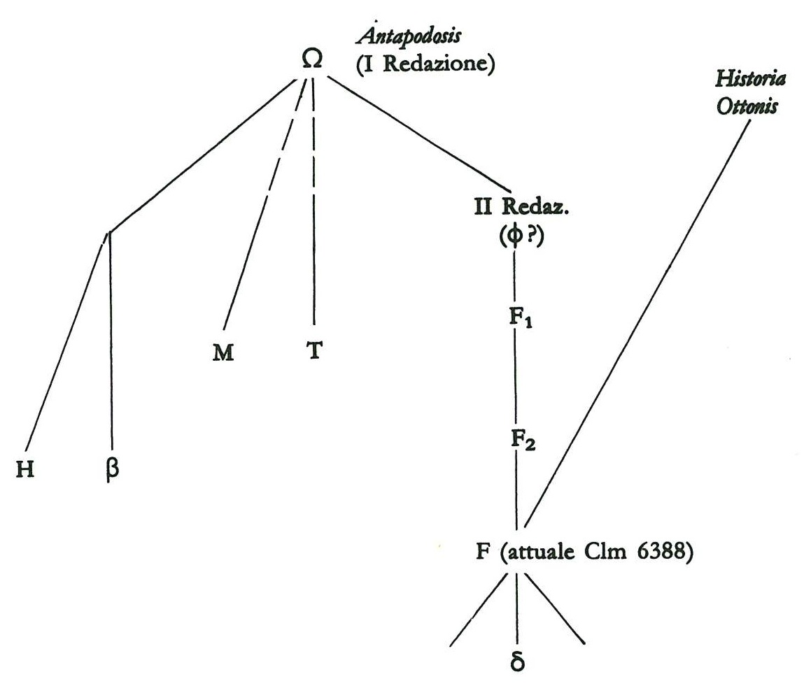
Fig. 2. The upper branches of the stemma to Liudprand's Antapodosis as proposed by Paolo Chiesa. Both Ω and "II Redaz." were written by Liutprand and are therefore two originals.

References
– Chiesa, Paolo. 1994. Liutprando di Cremona e il codice di Frisinga Clm 6388. Turnholt: Brepols.
– Maas, Paul. 1960. Textkritik. 4th ed. Leipzig: Teubner. – 1st ed. 1927.

In other languages
DE: Original
FR: original
IT: originale
TB, OH, PR

Origin
In graph terminology, an origin is a node within a connected directed acyclic graph (DAG) that has an in-degree of zero and an out-degree of >0. If such a graph has a single origin, the graph is said to be ‘rooted’ (cf. root).
In the context of stemmatology, the origin is the node within the stemma graph that represents either the original manuscript (if a single original is postulated) or the archetype from which all extant manuscripts descend (if no claim is made about the relationship of the archetype to any original.)

In other languages
DE: Ursprung
FR: origine
IT: origine
TA

Outgroup
A group outside (the organisms presently studied). The term was first used in this context 1973 according to the OED.
Such outgroups are used as an external baseline allowing to introduce direction into the undirected tree. Among biological species there is usually an outgroup of more distantly related species available, whereas in textual criticism this is rarely the case (but see the example below).
Thus outgroup comparison is a method used to polarise characters in cladistics. "For a given character with two or more states within a group, the state occurring in related groups is assumed to be the plesiomorphic state" (Watrous and Wheeler 1981, 1-11). In textual criticism, a similar method is often employed, although it has never received a theoretical framework or even a name: an indirect tradition is sometimes used to ascertain which variantreading is stemmatologically primary.

Example: Gregory of Nazianzus, Homiles in Greek (from Macé 2015)
1. The Latin (4th century) and Armenian (5th century) translations, which are a few centuries older than the oldest extant Greek manuscripts (9th cent.) of this text, contain common variant readings which are different from the rest of the tradition (Greek manuscripts M, N and X, as well as the Syriac translation):

Illustration
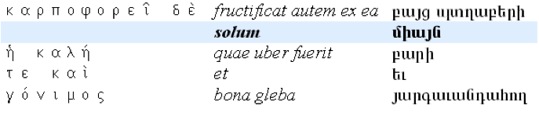
Fig. 1. Collation in Greek, Latin, and Armenian of a locus, exhibits the word "only" only in Latin and Armenian.
2. Since in some cases those Latin-Armenian variant readings must be considered original / primary, it means that the Latin and Armenian translations are on (a) different branch(es) than all the rest.

Illustration
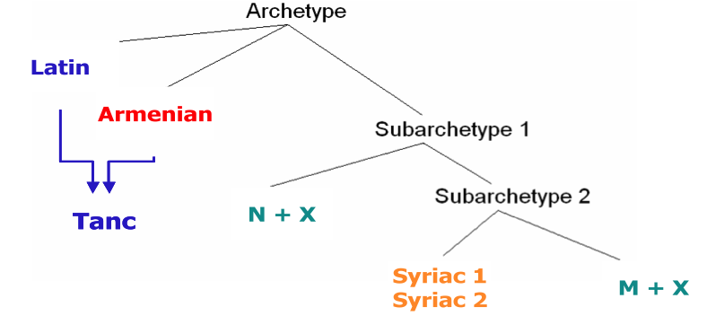
Fig. 2. Partial stemma showing that the Latin and Armenian translations branched off before any of the preserved Greek witnesses.
3. Therefore, the Latin and Armenian translations (combined as "Tanc") can be used as out-groups to polarise the variant readings opposing the Greek manuscripts M and the Greek manuscripts N, and thus to root the tree.

References
– Bryant, Harold N. 1991. “Polarization of Character Transformations in Phylogenetic Systematics: Role of Axiomatic and Auxiliary Assumptions.” Systematic Zoology 40: 433–445.
– Macé, Caroline (ed.). 2015. “Gregory of Nazianzus' Homilies. An over-abundant manuscript tradition in Greek and in translation.” in Comparative Oriental Manuscript Studies. An Introduction, eds. A. Bausi et al. Hamburg: 424–429.
– Watrous, Larry E., and Quentin D. Wheeler. 1981. “The Outgroup Comparison Method of Character Analysis.” Systematic Zoology 30: 1–11.

Illustration
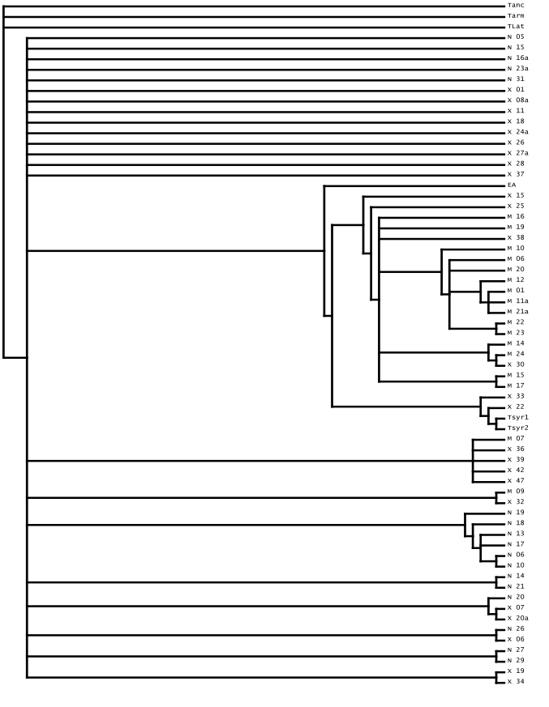
Fig. 3. Full stemma, now rooted on the outgroup Tanc.
In other languages
DE: Außengruppe, outgroup
FR: outgroup
IT: outgroup
CM

Palaeography
Palaeography is the study of handwriting in classical and medieval documents. The term was coined by Montfaucon (1708), and is derived from Greek παλαιός ‘old’ and γράφειν ‘to write’.
The study of medieval documents by the French benedictine Jean Mabillon, De re diplomatica (1681), is taken to be the first academic contribution in the field. In its widest sense, palaeography deals with reading and dating historical documents. In recent years, codicology has been established as a separate field of study, once also covered by palaeography. The focus of codicology is on books as physical objects, as opposed to the writing contained in them which remains the focus of palaeography.
Palaeography is often considered to be an auxiliary discipline (German: Hilfswissenschaft) for historians, philologists and other scholars working with old sources. For editors of handwritten sources, palaeographical knowledge is essential for the actual analysis of the text and is usually regarded as an integrated skill rather than an auxiliary discipline.
There are numerous introductions to palaeography, both general and language or script specific. One of the most influential introductions is still the one by Bernhard Bischoff, originally published in German (1986) and later in an English translation (1990).

References
– Bischoff, Bernhard. 1986. Paläographie des römischen Altertums und des abendländischen Mittelalters. 2nd. ed. Berlin: Erich Schmidt Verlag. – English translation by Dáibhí Ó Crónin and David Ganz. Latin Paleography. Cambridge: Cambridge University Press, 1990.
– Montfaucon, Bernard de. 1708. Palaeographia Graeca, sive De ortu et progressu literarum graecarum. Parisiis: apud L. Guerin, J. Boudot et C. Robustel.

In other languages
DE: Paläograpie
FR: paléographie
IT: paleografia
LAT: palaeographia
OH

Parablepsis
Parablepsis, from Gr παράβλεψις, ‘looking askance’, related to the verb for ‘look aside’, ‘overlook’, describes eye-skip in the reading practice of a copyist. As such, parablepsis is not an error in itself, but posits the precipitator in a process that leads to an omission or (less likely) an addition.
Cf. types of errors.

In other languages
DE: Parablepse (hardly in use)
FR: Greek used
IT: Greek used
AC

Paradosis
Greek term (παράδοσις) meaning 'tradition'.
In other languages
The Greek term is used throughout.

Parallelism
Cf. homoplasy.

Paris, Gaston
Gaston Paris (Avenay-Val-d’Or 1839 – Cannes 1903) was a French Romance philologist. He studied in Germany (Bonn and Göttingen). A linguist and a fine connoisseur of Latin and French mediaeval literature, Gaston Paris, together with Paul Meyer, gave an important impulse to the study of mediaeval literature in France and produced many editions. One of his students was Joseph Bédier. As Reeve 1998 convincingly showed, Paris can rightly be considered the first philologist who consistently applied and explained the common errors method, and the one who introduced the method of Lachmann in France. His 1872 edition of several versions of the French mediaeval hagiographical poem “Vie de Saint Alexis” (11th - 14th century) is methodologically exemplary. In his introduction to the edition, he distinguishes between “critique des leçons” (analysis of variants) and “critique des formes” (analysis of forms). Indeed, mediaeval copyists may transmit the readings from the exemplar they were copying and leave them semantically intact, while they might transform, more or less considerably, their “forms” (i.e. their instantiations into another stage of the history of the language). This distinction remains fundamental.

By Paris
– Paris, Gaston, and Léopold Panier, eds. 1872. La vie de saint Alexis: Poème du XIe siècle et renouvellements des XIIe, XIIIe, et XIVe siècles. Bibliothèque de l'École des hautes études. Sciences philologiques et historiques. Paris: A. Franck. – Repr. Genève: Slatkine, 1974.
On Paris
– Bähler, Ursula. 2004. Gaston Paris et la philologie romane. Publications romanes et françaises, vol. 234. Genève: Droz.
– Bähler, Ursula, and Alain Corbellari, eds. 2009. Gaston Paris – Joseph Bédier: Correspondance. L’Europe des philologues, Correspondance, vol. 1. Firenze: Edizioni del Galluzzo (SISMEL).
– Croiset, Maurice. 1904. “Notice sur la vie et les travaux de M. Gaston Paris.” Comptes rendus des séances de l'Académie des Inscriptions et Belles-Lettres 48 (1): 66–112.
– Duval, Frédéric. 2006. "La philologie française, pragmatique avant tout? L’édition des textes médiévaux français en France." InPratiques philologiques en Europe: Actes de la journée d’études organisée à l’École des Chartes le 23 septembre 2005, études réunies par Frédéric Duval, 115–150. Études et rencontres de l’École des Chartes, vol. 21. Paris: École des Chartes.
– Reeve, Michael. 1998. “Shared innovations, dichotomies, and evolution.” In Filologia classica e filologia romanza: Esperienze ecdotiche a confronto. Atti del Convegno Roma 25–27 maggio 1995,edited by Anna Ferrari, 445–505. Incontri di Studio, vol. 2. Spoleto: Centro Italiano di Studi sull’Alto Medioevo.
CM

Parsimoniously informative
A character (such as a reading in a witness, or a position in a DNA or protein sequence) that allows two members of a dataset to be grouped to the exclusion of others is called "parsimoniously informative". The character must exist in at least two different states, each of which is shared by at least two witnesses. Thus if witnesses A and B share the same reading and C and D share a different reading, the reading is informative under the principle of maximum parsimony in grouping A and B to the exclusion of C and D. However, if C and D each had different readings, the character would not be informative.

In other languages
DE: parsimonisch informativ, or the English term
FR: parcimonieusement informatif
IT: parsimoniosamente informativo
CH, HW

Parsimony
The concept of parsimony, that is the least expenditure of effort, is used in many branches of science (cf. the so-called Ockham's razor). In stemmatology it is used in the maximum parsimony method. Cf. also parsimoniously informative.

In other languages
DE: Sparsamkeit, Parsimonie
FR: parcimonie
IT: parsimonia
PR

Pasquali, Giorgio
Giorgio Pasquali (Roma, 1885 – Belluno, 1952) was an Italian classical philologist and scholar. He held a chair in Greek literature at the Universities of Messina (1920-21) and Firenze (1921-52). From 1930 to 1952 he was also a Professor of classical philology at the Scuola Normale Superiore in Pisa.
His name is closely linked to his volume Storia della tradizione e critica del testo, which he first published in 1934 (this book originated from a review of Maas' Textkritik), and which was then republished in a revised form in 1952. In this dense work Pasquali supported the need to integrate the reconstruction of a stemma with a thorough study of the history of tradition, and suggested that certain ambiguities in the transmission of Latin and vernacular texts could be explained by assuming the existence of authorial changes ab origine. The seminal force of the approach suggested by Pasquali lies in the fact that it renders the critically reconstructed text historical, in some sense mediating between Lachmann and Bédier. Many definitions that Pasquali either coined or resumed in Storia della tradizione (e.g. “closed” recension vs. “open” recension; recentiores, non deteriores) have become part of a shared philological vocabulary.
His scholarly production covers a wide spectrum of topics in textual criticism, ranging from critical editions of Greek texts from late antiquity (e.g. Proclus' commentary on Plato's Cratylus or Gregory of Nyssa's Letters) to studies on Roman and Hellenistic poetry (Quaestiones Callimacheae 1913; Orazio lirico 1920a; Preistoria della poesia romana 1936), as well as Plato’s letters (Le lettere di Platone 1938).
The series entitled Pagine stravaganti (Pagine stravaganti di un filologo 1933; Pagine meno stravaganti 1935; Terze pagine stravaganti 1942; Stravaganze quarte e supreme 1951), revealing Pasquali’s literary side, contains deliberations on classical antiquity, as well as some witty remarks on pedagogic and didactic issues. Particularly original for his time are also his linguistic comments on Italian and other European languages – which appeared in two posthumous collections of essays (Conversazioni sulla nostra lingua1953, and Lingua nuova e antica 1964).

Works by Pasquali
– Pasquali, Giorgio. 1908. Procli Diadochi in Platonis Cratylum commentaria.Lipsiae:in aedibus Teubneri.
– ———. 1913. Quaestiones callimacheae. Gottingae: Officina Hubertiana.
– ———. 1919. Sui ‘Caratteri’ di Teofrasto. Napoli: Perrella.
– ———. 1920a. Orazio lirico.Firenze: Le Monnier.
– ———. 1920b. Filologia e storia. Firenze: Le Monnier. – 2nd ed. 1964.
– ———. 1923. Le Lettere di Gregorio di Nissa. In Studi italiani di filologia classica III (1923), 75–128.
– ———. 1933. Pagine stravaganti di un filologo. Lanciano: Carabba
– ———. 1934. Storia della tradizione e critica del testo. Firenze: Le Monnier. – 2nd revised edition 1952.
– ———. 1935. Pagine meno stravaganti. Firenze: Sansoni.
– ———. 1936. Preistoria della poesia romana. Firenze: Sansoni.
– ———. 1938. Le lettere di Platone.Firenze : Le Monnier.
– ———. 1942. Terze pagine stravaganti. Firenze: Sansoni.
– ———. 1951. Stravaganze quarte e supreme.Venezia: Neri Pozza.
– ———. 1952. Vecchie e nuove pagine stravaganti di un filologo. Firenze: La Nuova Italia.
– ———. (post.) 1953. Conversazioni sulla nostra lingua.Torino: Edizioni Radio Italiana.
– ———. (post.) 1964. Lingua nuova e antica, edited by G. Folena. Firenze: Le Monnier.

Works on Pasquali
– Bornmann, Fritz (ed.). 1988. Giorgio Pasquali e la filologia classica del Novecento. Atti del Convegno Firenze-Pisa, 2–3 dicembre 1985. Firenze: Olschki.
– Bornmann, Fritz, Giovanni Pascucci, and Sebastiano Timpanaro (eds.). 1986. Giorgio Pasquali. Scritti filologici: letteratura greca, letteratura latina, cultura contemporanea, recensioni. Firenze: Olschki.
MB

Path
Given a graph, a path is a sequence of distinct nodes (N₁,N₂,...,N_{k}) where each pair of consecutive nodes is connected by an edge, i.e., N₁ is connected to N₂, N₂ is connected to N₃, etc. In this example, the path is said to connect N₁ to N_{k}.
In other languages
DE: Weg
FR: chemin
IT: percorso
TR, KH, VM

PAUP
PAUP (Phylogenetic Analysis Using Parsimony) is a proprietary, and thus commercial, non-free software package for constructing and interpreting phylogenetic trees. It is able to apply a maximum parsimony method, but also various others methods (that may, however, be less suitable to stemmatological analysis). It offers a rich set of settings to tune the behaviour of various methods, and to adapt the lay-out of computed trees. PAUP uses the Nexus file format which is shared by several bioinformatics software packages. Different versions for various platforms are available with slight variations in available functionality. PAUP can both be used as a command line tool or through a graphical interface. However, given lack or incomplete support for current platform GUIs such as Windows 8 and Max OS X, usage as a command line tool is advised.

References
– http://paup.csit.fsu.edu/
– Swofford, David L., 2002. PAUP*: Phylogenetic Analysis Using Parsimony (* and Other Methods). Version 4, beta version. Sunderland: Sinauer Associates. Available at http://www.tsu.edu/PDFFiles/CBER/Miranda/PAUP%20Manual.pdf. Accessed 6 June 2014, but no longer accessible 27 October 2015.
JZ

PHYLIP
['fʌɪlɪp]
PHYLIP stands for PHYLogeny Inference Package. Phylip claims to be the most widely distributed and oldest (since 1980) package of programs for inferring phylogenetic trees. It is free software, written in C consisting of 30+ smaller programs that can be operated through a menu structure. It is platform independent and executable versions are available for the latest installments of Windows, Mac OS, and Linux. Like PAUP Phylip features maximum parsimony, maximum likelihood, and several distance based approaches to build phylogenetic trees, including bootstrapping and consensus trees. Phylip uses a specific input and ouput file format.

References
– http://evolution.genetics.washington.edu/phylip.html. Accessed 9 October 2015.
– Felsenstein, Joseph. 1989. “PHYLIP – Phylogeny Inference Package (Version 3.2).” Cladistics 5: 164–166.
JZ

Phylogenetic networks, types of
Phylogenetic networks can be categorised in various ways. One of the most important dichotomies is the data display vs explicit network distinction.
A data display (or implicit) network is a type of phygenetic network that attempts to display the various, possibly conflicting, phylogenetic signals in the data. No attempt is made to omit statistically insignificant or otherwise unimportant ones. In contrast, an explicit (or evolutionary) network represents a specific hypothesis about the genealogical relationships between the units of study (taxa).
A prime example of a data display network is a NeighborNet. In these networks, parallel edges correspond to splits, and so NeighborNets tend to become quite complicated if there are many of these splits. The user therefore needs to take some care to interpret the network and distinguish what are probably the most important signals, and which are less important ones. An example of an explicit network is the T-Rex method.
See also phylogenetics.

Reference
– Morrison, David A. 2011. Introduction to Phylogenetic Networks. Uppsala: RJR Productions. – Available at http://www.rjr-productions.org/Networks. Accessed 27 October 2015.

In other languages
DE: phylogenetische Netzwerke
FR: réseaux philogénétiques
IT: reti filogenetiche
TR

Phylogenetics
Philogenetics studies phylogenesis, a word derived from the Greek words φῦλον 'race, tribe, classes', γένεσις 'origin, formation, genesis' thus meaning the 'formation of the classes (of biological species)'. The term was coined by Ernst Haeckel (1866, II, xx. p. 299).
Phylogenetics refers to the inference of evolutionary history from biological data, often nucleotide (DNA/RNA) or protein sequence data, and in particular, construction of phylogenetic trees or networks.
There are a number of computational methods for constructing phylogenetic trees. These include methods that are based on a distance matrix representing pair-wise distances between the data sequences such as neighbour joining and UPGMA. Other methods, such as maximum parsimony and maximum likelihood, use the actual sequences. Methods based on Bayesian statistical inference have also been proposed; see for example the MrBayes software.
In some cases, the evolutionary history can be more appropriately represented as a phylogenetic network rather than a tree. This may be due to different factors such as horizontal gene transfer. Some network methods can also be used to represent conflicting evidence in the data, even if the evolutionary history is assumed to be tree-like. Popular network construction methods include NeighborNet and MedianNetwork.
Phylogenetic methods are increasingly applied to other kinds of data, in which case they may be referred to as phylomemetics.
Amongst those applications outside the field of biology, the use of computer-assisted phylogenetic methods in stemmatology has proved to be very promising. There are indeed strong conceptual and methodological similarities between evolutionary biology and the genealogy of manuscripts, which have been noted since long (Reeve 1998 provides an interesting historical survey of the relationships between the two fields, see also Platnick and Cameron 1977, and Robins 2007). Early attempts at applying software used in biology to stemmatics are Cameron 1987, and O'Hara and Robinson 1993.
Despite clear analogies between the two approaches, there are also differences between biological phylogeny and the branching of a textual tradition. Some of them are of size and scale: a single biological species may consist of billions of slightly different individuals, and the whole process that is studied may have taken millions of years to happen, whereas very large textual traditions will be made up of a few thousand witnesses at most. Another relevant difference is that manuscripts are copied by thinking scribes who may on purpose alter the text or use more than one exemplar (contamination, to some extant this exists in biology as well, as horizontal gene-transfer).
A further problem is that the graph created by a computer is not oriented: the computer cannot say which of the manuscripts is the oldest or most original (the root), it simply shows how the manuscripts are related to each other. This must needs be so as long as the differences between witnesses are defined as commutating (thus the difference between witness A and witness B must always be equal to the difference between B and A). A scholar is required to determine how the tree should be oriented (and thus be converted to an actual stemma) and draw conclusions of it. In biology this rooting can usually be done by including a distantly related outgoup, which is usually not possible for a textual tradition, whose original is, so to speak, created "ex nihilo" by its author.
See: Cladistics.
Bibliography
– Cameron, H. Donald. 1987. “The upside-down cladogram: Problems in manuscript affiliation.” In Biological Metaphor and Cladistic Classification: An Interdisciplinary Perspective, edited by Henry M. Hoenigswald and Linda F. Wiener, 227–242. Philadelphia: University of Pennsylvania Press.
– Haeckel, Ernst. 1866. Generelle Morphologie der Organismen: allgemeine Grundzüge der organischen Formen-Wissenschaft, mechanisch begründet durch die von Charles Darwin reformirte Descendenz-Theorie. 2 vols. Berlin: Reimer.
– Huson, Daniel H., Regula Rupp and Celine Scornavacca. 2010. Phylogenetic Networks. Cambridge: Cambridge University Press.
– Lemey, Philippe, Marco Salemi, and Anne-Mieke Vandamme, eds. 2009. the Phylogenetic Handbook: A Practical Approach to Phylogenetic Analysis and Hypothesis Testing. 2nd ed. Cambridge: Cambridge University Press.
– Morrison, David A. 2011. Introduction to Phylogenetic Networks. Uppsala: RJR Productions. – Available at http://www.rjr-productions.org/Networks. Accessed 27 October 2015.
– O'Hara, Robert, and Peter Robinson. 1993. Computer-assisted Methods of Stemmatic Analysis.In The Canterbury Tales Project Occasional Papers, edited by Norman Blake and Peter Robinson, vol. 1, 53–74. Oxford: Office for Humanities Communication.
– Platnick, Norman I., and H. Donald Cameron. 1977. “Cladistic methods in textual, linguistic and phylogenetic analysis.” Systematic Zoology 26: 380–385.
– Reeve, Michael D. 1998. “Shared innovations, dichotomies, and evolution.” In Filologia classica e filologia romanza: esperienze ecdotiche a confronto: Atti del Convegno Roma 25-27 maggio 1995, edited by Anna Ferrari, 445–505. Spoleto: Centro Italiano di Studi sull’Alto Medioevo.
– Robins, William. 2007. “Editing and Evolution.”Literature Compass 4 (1): 89–120.
In other languages
DE: Phylogenetik / Phylogenese / Phylogenie
FR: phylogénétique / phylogenèse / phylogénie
IT: filogenetica / filogenesi / filogenia
CH, HW, TR, CM, PR, MH

Phylogenetic tree
A phylogenetic tree on a set X is a tree whose set of leaves is equal to X and which is meant to represent the phylogenetic relatedness between these objects in X. In biology these objects tend to be organisms or groups of organisms (such as species), in textual criticism they are witnesses of a text. Usually such trees are rooted and the root represents the last common ancestor (in textual criticism called the archetype). For mathematical convenience it is often assumed that there are no interior nodes with degree two since otherwise an arbitrary number of equivalent trees could be obtained by adding degree two nodes along any edge in the tree (see, e.g. Aluru 2005). Note that this is a technical requirement and it does not suggest that, in terms of textual criticism, there could not exist preserved witnesses that have exactly one descendant.
Cf. cladogram, phylogram.

Reference
– Srinivas Aluru, ed. 2005. Handbook of Computational Molecular Biology. Boca Raton, Florida: Chapman & Hall/CRC.

In other languages
DE: phylogenetischer Baum
FR: arbre phylogénétique
IT: albero filogenetico
Illustration
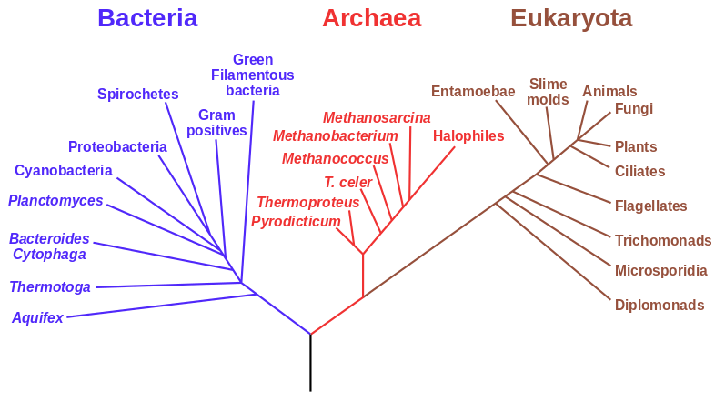
Fig. 1. An example of a phylogenetic tree of the major groups of life forms, based on RNA data and proposed by Carl Woese. (Source: https://en.wikipedia.org/wiki/File:Phylogenetic_tree.svg)
TR, PR

Phylogram
From φῦλον 'phylum' 'race, tribe, classes' (cf. phylogenetics) and a contracted form of dendrogram ('tree-graph') or diagram, in both cases ultimately from γράμμα 'anything written'.
In the 1960s a differentiation between phenograms, cladograms and phylograms was introduced in evolutionary biology. A phenogram is a tree-graph of phenotypic features, a cladogram of clades, and a phylogram of phyla. Therefore the differences between these tree-graphs are related to their underlying features: phenograms use phenotypic information, while the other two convey information about genealogical relationship. There is no general agreement on how a phylogram differs from a cladogram. Mayr (1965, 82) maintained that a phylogram, contrary to a cladogram, conveys information also about the rate of evolutionary change; however this issue is open to debate (cf. Sokal et al. 1965, critically reviewing Mayr 1965). According to Mayr's view they are both types of phylogenetic trees.
In textual criticism, in order to arrive at a stemma codicum one is interested in genetic relationship. Witnesses which share the same ancestor are placed under the same branch. In a phylogram (like in a cladogram) each node represents a split in the tradition. If we follow Mayr, we may assert that, compared to a cladogram, a phylogram shows not only that two texts are different (represented by a node), but also how much evolution has taken place between them. The amount of change is represented by the length of the branch: the longer the branch, the greater the variation between the texts.
However, there are more recent approaches that limit only phylograms to conveying genealogical information and allow cladograms to convey any type of information about the taxa, without connotation of ancestry (cf. Kitching, and a fuller discussion in cladogram), in which case a cladogram is not a phylogenetic tree.

Illustration
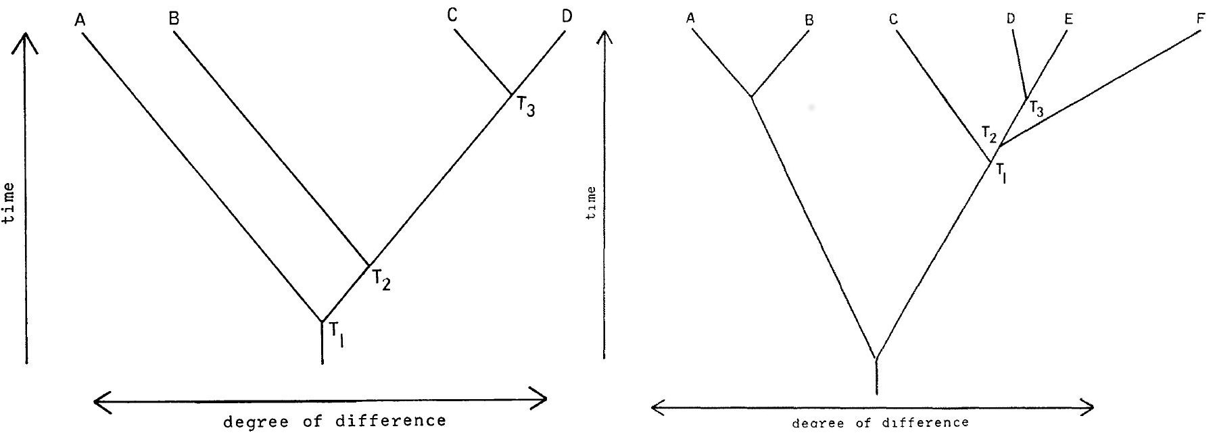
Fig. 1. A cladogram and phylogram according to Mayr (Mayr 1965, 81 and 82, respectively). The phylogram (right) represents the evolution of apes with F as Homo sapiens.

References
– Kitching, Ian J., Peter L. Forey, Christopher J. Humphries, and David M. Williams. 1998. Cladistics: The Theory and Practice of Parsimony Analysis. 2nd ed. Oxford: Oxford University Press.
– Mayr, Ernst. 1965. "Numerical Phenetics and Taxonomic Theory". Systematic Zoology 14, No. 2, Sep. 1965, 73-97.
– Sokal, Robert R, Joseph Camin et al. 1965. "Numerical Taxonomy: Some Points of View". Systematic Zoology 14, No. 3, Sep. 1965, 237-243.
In other languages
DE: Phylogramm
FR: phylogramme
IT: filogramma
PR, MH, TR

Phylomemetics
[fʌɪlə(ʊ)miː'mεtɪks]
The inference of historical relationships between objects using data other than biological sequences. Phylomemetics may include the inference of copying histories of witnesses based on shared readings.
The word was coined in analogy to phylogenetics, but containing Richard Dawkins's (1976, xi. 206) coinage meme 'a cultural element or behavioural trait whose transmission and consequent persistence in a population, although occurring by non-genetic means (esp. imitation), is considered as analogous to the inheritance of a gene' (OED). Dawkins derived the word from Greek μίμημα 'anything imitated' by abbreviation.
References
– Dawkins, Richard. 1976. The Selfish Gene. Oxford: Oxford University Press.
– Howe, Christopher J., and Heather F. Windram. 2011. “Phylomemetics—Evolutionary Analysis beyond the Gene.” PLoS Biol 9(5): e1001069. doi:10.1371/journal.pbio.1001069. Accessed 28 October 2015.
In other languages
DE: Phylomemetik (rarely used)
FR: phylomemetique (rarely used)
IT: filomemetica (rarely used)
CH, HW, PR

Plesiomorphic
From Greek πλησίος 'close, near' and μορφή 'form'.
In cladistics, as theorised by Willi Hennig (cf. Schmitt 2013), a character or a character state may be plesiomorphic (ancestral or primitive) or apomorphic (derived). The polarisation of characters (the determination of the direction of character change), which is at the core of the phylogenetic method, is comparable to the concept of "error of copying" in the Lachmann's method. A plesiomorphic character state is equivalent to a primary reading.
See: symplesiomorphic.

References
– Kitching, Ian J., Peter L. Forey, Christopher J. Humphries, and David M. Williams. 1998. Cladistics: The Theory and Practice of Parsimony Analysis. 2nd ed. Oxford: Oxford University Press.
– Schmitt, Michael. 2013. From Taxonomy to Phylogenetics: Life and Work of Willi Hennig. Leiden: Brill.

In other languages
DE: plesiomorph (adj.), Plesiomorphismus (noun)
FR: plésiomorphique (adj.), plesiomorphisme (noun)
IT: plesiomorfo (adj.), plesiomorfismo (noun), plesiomorfia (noun)
CM

Polarisation
Polarisation is a term used in cladistics to “refer to the imposition of direction onto character state change or character transformation. A character is said to be polarised when the [ancestral, primitive] state has been distinguished from the apomorphic [derived] state” (Kitching et al. 1998², 48 – see also the glossary, ibidem, p. 213).
In textual criticism, “polarisation” might be used to indicate the same operation amongst variants: i.e. the imposition of direction onto variation. A variant location is said to be polarised when the primary variant (primitive state) has been distinguished from the secondary variant (derived state) (See Robinson and O'Hara 1996). The terms ‘primary / secondary variants’ may be preferred against controversial terms such as ‘error / mistake’ and ‘good / original reading’. This terminology, although not accepted by everyone, indeed offers the advantage of clarity. For instance, a correction could be secondary, but it would be unusual to characterise it as a ‘mistake’. It is also a relative terminology, which implies a judgement about the chronology of the variation, and not about the ‘correctness’ of the variants (although ‘correctness’ is often one of the criteria used to establish this chronology). A primary variant could give way to a secondary variant, which in turn may be seen as the primary variant in a further variation.
In the Maas-Lachmann method, only secondary readings may be used to draw the stemma, as in cladistics, in theory, only an apomorphic state of a given character (i.e. the result of a genetic mutation) indicates the existence of a new clade.
In both fields, textual criticism and evolutionary biology, establishing which is the primitive and which is the derived state has always been a very difficult question, giving rise to many debates (see Robins 2007). Therefore, the possibility of drawing unrooted trees, without any presupposed assumptions about the direction of the variation, but relying on the principle of parsimony, has been welcomed by biologists and by textual scholars (see Robinson and O’Hara 1996, and Robins 2007).
The problem is, however, that in textual criticism an unrooted tree cannot be considered a stemma as information about the direction is needed for many problems. The question therefore remains how to introduce chronology and directionality into the set of variation. This should be, and usually is done by using both external criteria, about the history of the manuscripts (see Robinson and O’Hara 1996), as well as internal criteria in order to polarise some of the variant states. Out-group comparison is another method, unfortunately not always applicable, but very efficient, to orientate a tree.

References
– Kitching, Ian J., Peter L. Forey, Christopher J. Humphries, and David M. Williams. 1998. Cladistics: The Theory and Practice of Parsimony Analysis. 2nd ed. Oxford: Oxford University Press.
– Robins, William. 2007. “Editing and Evolution.”Literature Compass 4 (1): 89–120.
– Robinson, Peter M. W., and Robert J. O’Hara. 1996. “Cladistic Analysis of an Old Norse Manuscript Tradition.”Research in Humanities Computing4: 115–137.

In other languages
DE: Polarisation
FR: polarisation
IT: polarizzazione
CM

Polygenesis
Polygenesis (from the modernly coined Greek πολυγένεσις, itself from πολύς 'many' and γένεσις 'origin') is the phenomenon of the same error – or change – being produced independently in different parts of a text's transmission. This may happen either by chance or because under certain circumstances certain kinds of errors appear more regularly or with greater probability. A Leitfehler is a variant that is unlikely to arise polygenetically.

In other languages
DE: Polygenese
FR: polygénèse
IT: poligenesi
AC

Quentin, Henri
Henri Quentin (Saint Thierry, 1872 – Roma, 1935) was a Benedictine monk and a specialist of hagiography and of history of the Church, he was responsible for the Pontifical Commission for the Revision of the Vulgate. In the field of textual criticism, he is known for the invention of a method in which the manuscripts are compared in small groups of three, in search for intermediaries. In a first step, the manuscripts are grouped on the basis of their variants' agreements. The notion of “error” is used only in a second step: to orientate the sequences of manuscripts. He invented the method of “zéro caractéristique”: if two manuscripts have 0 agreements against a third one, then this third manuscript must be either an intermediary between the two or their common ancestor (cf. Salemans 1996, 12-13, n. 18).

By Quentin
– Quentin, Henri. 1922. Mémoire sur l'établissement du texte de la vulgate. Rome: Desclée.
– ———. 1926. Essais de critique textuelle (ecdotique). Paris: Picard.

On Quentin
– Salemans, Ben J.P. 1996. “Cladistic and the Resurrection of the Method of Lachmann: On Building the Stemma of Yvain”. In Studies in Stemmatology, edited by Pieter van Reenen, and Margot van Mulken, 3–70. Amsterdam: John Benjamins.
CM

Reading
A reading is a short piece of text, often a single word or phrase, which typically varies between manuscripts, and for this reason will often be synonymous with a variant reading. The fact that a segment of text is called a reading may imply that it may be open to interpretation, i.e. that the word(s) in question can be read in more than one way.

In other languages
DE: Lesart
FR: leçon
IT: lezione
LAT: lectio
OH

Reading, primary
Any variant reading used for the purpose of classification of a textual tradition should be polarised: if on a certain variant location there are two variant readings A and B, one of them should be the primary reading (the original or ancestral reading), and the other the secondary reading (the error).
In other languages
DE: primäre Lesart
FR: leçon primaire
IT: lezione primaria
CM

Reading, secondary
The term "secondary reading" covers more or less the same meaning as the term "error" in textual criticism, but may be preferred to it for reasons of clarity.
Any variant reading used for the purpose of classification of a textual tradition should be polarised: if on a certain variant location there are two variant readings A and B, one of them should be the primary reading (the original or ancestral reading) and the other the secondary reading (the error). This terminology is influenced by cladistics and is less vague than the traditional terminology used in textual criticism. Contrary to the term "error", the term "secondary reading" is not absolute, but relative: reading B can be secondary vis-à-vis reading A, but primary vis-à-vis reading C. In addition, not all secondary readings are linguistic mistakes, a correction can be a secondary reading, indeed any type of change (or innovation) can be a secondary reading.
In other languages
DE: sekundäre Lesart
FR: leçon secondaire
IT: lezione secondaria
CM

Reading, variant
‘Variant’ is originally an adjective, from Old French variant, from Latin variantem, participle of variare "to change".
A variant in a witness (manuscript, edition…) is a reading which is different from other readings in other witnesses to the same text on the same variant location.
Example: κύριον A D G : θεὸν B C F, where κύριον (in the reference text and in 3 manuscripts) and θεὸν (in 3 other manuscripts) are two variants.
The purpose of collation is to collect (all) variant readings in (all) witnesses. If virtually every word or even every character in a text can be subject to variation, in reality only a (smaller or larger) number of places in a text will: those places are called ‘variant locations’
The term ‘variant’ is neutral, it does not imply any decision about the direction of the variation. In the common errors method, however, only significant secondary readings (also called errors) can be used for the classification of the witnesses, often resulting into a stemma.
On the basis of that classification, the editor will choose the variants that will find their place in the reconstructed text (critical edition), the alternative variants will find their way to the critical apparatus. However, if all variants must be noted in the collation, not all will necessarily be recorded in the apparatus, depending on what the editor wants to be reflected in it: the critical decisions only (in that case only significant readings will be reported), the geographical / regional variations of the textual tradition (in that case even some orthographic variants may be recorded), etc. See also the distinction between analysis of (significant) variants and analysis of forms.
In many statistical methods, variants are used without inferring anything about the direction of variation (polarisation). Even if the result of that kind of classification may be displayed as atree, the witnesses grouped on the basis of their similarities form groups rather than families.
References
– Colwell, Ernest C., and Ernest W. Tune. 1964. “Variant Readings: Classification and Use.” Journal of Biblical Literature 83 (3): 253–261.
–Irigoin, Jean. 1979. "Sélections et utilisations des variantes." in Jean Irigoin, and Gian Zarri, eds. 1979. La pratique des ordinateurs dans la critique des textes. Paris 29–31 mars 1978. Paris: Éditions du CNRS: 265-271.
–Love, Harold. 1984. “The Ranking of Variants in the Analysis of Moderately Contaminated Manuscript Traditions.” Studies in Bibliography 37: 39-57.

In other languages
GE: alternative Lesart, Variante
FR: (leçon) variante
IT: lezione alternativa, variante
CM

Recensio
In textual criticism, recensio is the analysis of the handwritten material of a text, if possible with the aim of establishing a stemma of the manuscript tradition. It is thus a part of the constitutio textus in Lachmann's method. This process requires the enumeration and examination of the material, manuscript by manuscript, and thus reflects the original Latin meaning of the word (cf. recensēre ‘count, enumerate’ or in more general terms, ‘examine, review, survey’).
The Latin term recensio should be used throughout, to differentiate the process of recensio from the other meanings of the word "recension" (see recension), but modernisations of the Latin term do appear in literature, especially in the terms open and closed recensions. Maas contrasts recensio with examinatio in his Textkritik.

Reference
– Maas, Paul. 1960. Textkritik. 4th ed. Leipzig: Teubner. – 1st ed. 1927.
OH

Recension
The term is an adaptation of the Latin recensio.
In some scholarly traditions it is used as a synonym of ‘redaction’; e.g. in the Oxford English Dictionary the meaning of ‘recension’ under point 2a reads as follows: “The revision of a text (esp. a theological text); a particular form or version of a text resulting from such revision.”. In this sense, a recension is a version of a work which is the result of a process of (intentional) revision by a (group of) scribe(s) or redactor(s).
If a work is preserved in one or more recensions that are substantially different from the original, the editor might decide to edit the different recensions separately, possibly in a synoptic edition. It is sometimes hard to tell where a recension stems from, in some cases it can even be suspected that it might be the result of an authorial revision. Some examples in Andrés Sanz 2008.
Although the terms recension, redaction and version are often used interchangeably, there have been attempts to clarify this terminology, and to use each term for one specific kind or level of revision. Cardelle de Hartmann et al. (2014, p. 232), for example, try to establish a difference of nuances of meaning between recension, redaction and version, in which series the amount and weight of the changes are taken to be increasing.
A distinction is often drawn between closed and open recensions of manuscript traditions, in the sense that in a closed recension, each manuscript has been copied from a single exemplar, while in an open recension there may be more than one exemplar for a single copy.

Other usage
In several modern languages (Dutch, French, German, Italian, Spanish, Swedish...) the word recensio in a modernised spelling is used for a review in a journal or a newspaper. A book review typically goes through the text to be reviewed, so there is again the fundamental meaning of enumeration and examination in this usage. In English this usage of the word has become obsolete (OED meaning 1b: last use in 1872).

References
– Cardelle de Hartmann, Carmen, Darko Senekovic, and Thomas Ziegler. 2014. Modes of variability: the textual transmission of Petrus Alfonsi’s Dialogus. InPetrus Alfonsi and his Dialogus. Background – Context – Reception,edited by Carmen Cardelle de Hartmann, and Philipp Roelli, 227–248. Florence: SISMEL.
– Andrés Sanz, María Adelaida, Jacques Elfassi, and José Carlos Martín, eds. 2008.L'édition critique des oeuvres d'Isidore de Séville: les recensions multiples. Actes du colloque organisé à la Casa de Velázquez et à l'Université Rey Juan Carlos de Madrid (14-15 janvier 2002). Paris: Institut d'études augustiniennes.

In other languages
DE: Rezension
FR: recension
IT: recensione
OH, CM

Recension, closed and open
A distinction is often drawn between closed and open recensions (in the sense of recensio). The dichotomy was first coined by Giorgio Pasquali (1952, 126; first ed. 1934) who labelled as "closed" a recension in which the original readings are mechanically reconstructible, and as "open" all non-mechanical recensions which force the philologist to rely on internal criteria like usus scribendi and lectio difficilior to discriminate between two or more equivalent readings.
There are many types of non-mechanical (and therefore "open") recensions, mostly – though not necessarily – caused by contamination (cf., among others, Alberti 1979; Timpanaro, transl. Most 2005, 137 and n. 51; Trovato 2014, 74-75). In many cases, a closed recension corresponds to a vertical transmission (see Fig. 1) and an open recension to a horizontal, contaminated transmission (see Fig. 2). However, bipartitism of stemmatic configurations (see bifid / binary / bifurcating / bipartite), as well as external factors such as mnemonic transmission can lead to an open recension also in the presence of an apparently vertical transmission (on this specific point see Contini in Leonardi 2014, 37-38, and Segre 1998; for "vertical" vs. "horizontal" transmission, see Contini in Leonardi 2014, 27).
A stemma established for a closed recension does not have any crossing branches in its highest projections (though the contrary – i.e. that a stemma without crossing branches necessarily corresponds to a closed recension – does not hold):

Illustration
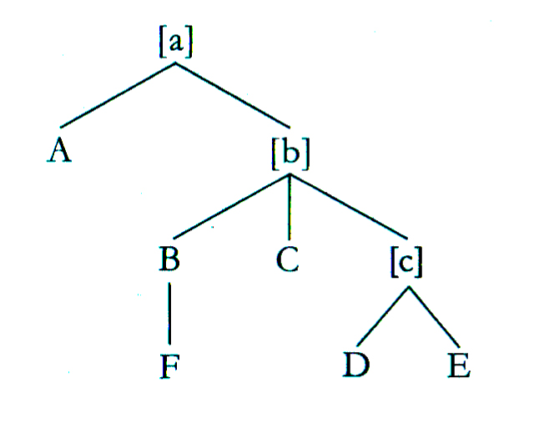
Fig. 1. A closed recension. In this stemma, any manuscript (or, in square brackets, hyparchetype) is the copy of only one exemplar. From West (1973, 32).
On the other hand, a contaminated tradition is a paradigmatic example of an open recension. The stemma representing that tradition will have crossing or converging branches, either solid (often to indicate a high degree of influence) or dotted (often to indicate a lower degree of influence).
Martin West (1973) discusses in some detail how one should distinguish between closed and open recensions, and how to deal with them. For the closed recension, see pp. 31–37, and for the open recension, pp. 37–47.

Illustration
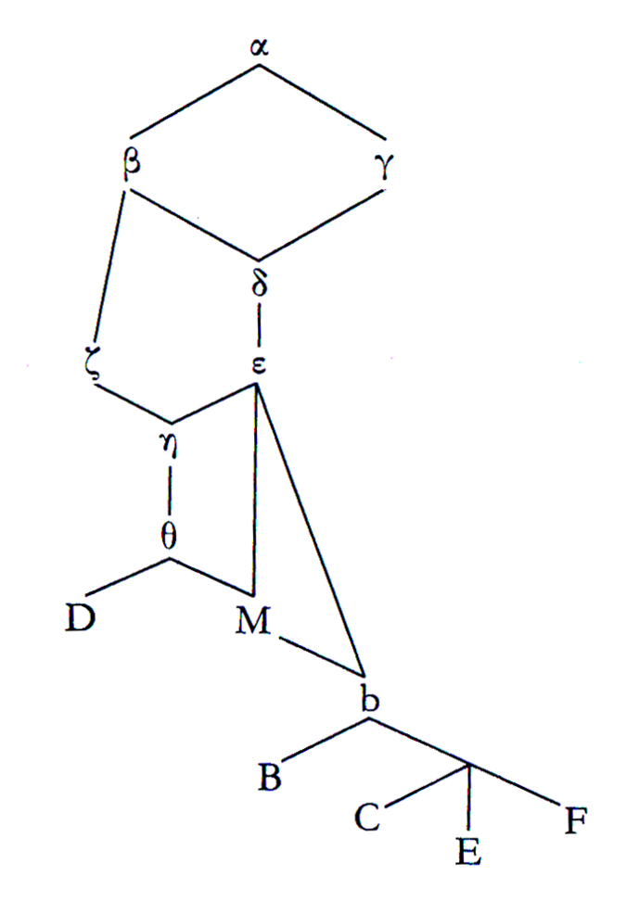
Fig. 2. An open recension. In this stemma, several manuscripts are the copies of more than one exemplar. From West (1973, 40).

References
– Alberti, Giovan Battista. 1979. Problemi di critica testuale. Firenze: La Nuova Italia.
– Leonardi, Lino (ed.). 2014. Gianfranco Contini. Filologia. Bologna: il Mulino.
– Most, Glenn (ed. and trans.). 2005. Sebastiano Timpanaro. The Genesis of the Lachmann’s Method. Chicago-London: The University of Chicago Press.
– Pasquali, Giorgio. 1952. Storia della tradizione e critica del testo. 2nd edition. Firenze: Le Monnier.
– Segre, Cesare. 1998. "Dalla memoria al codice". In Ecdotica e comparatistica romanze, edited by Alberto Conte. Milano-Napoli: Ricciardi, 3-10.
– Trovato, Paolo. 2014. Everything You Always Wanted to Know about Lachmann’s Method: A Non-Standard Handbook of Genealogical Textual Criticism in the Age of Post-Structuralism, Cladistics, and Copy-Text. Foreword by Michael D. Reeve. Firenze: Libreriauniversitaria.it edizioni.
– West, Martin L. 1973. Textual Criticism and Editorial Technique Applicable to Greek and Latin Texts. Stuttgart: Teubner.

In other languages
DE: geschlossene / offene Rezension
FR: recension fermée / ouverte
IT: recensione chiusa / aperta
OH, MB

Recentiores non deteriores
Literally ‘the more recent (witnesses need not) be the worse ones’ in Latin. This is a rule from 18th century textual criticism against the use of editing texts from the oldest extant manuscripts only. Before then textual variants were often selected by majority in all witnesses or according to the witness’s age. Both these procedures became obsolete with the genealogical, so-called Lachmannian method. Indeed, a very young manuscript may be a direct copy from a very good, lost old manuscript and should therefore not be left out of consideration only because of its age. The first to discriminate between äusserliches and inneres Alter ("exterior" vs. "interior" age), meaning that younger witnesses may contain older readings, is assumed to be the 18th century New Testament scholar Johann Salomo Semler (1765: 88-89).
Some remarks on the history of this maxim can be found in Timpanaro (1981, 39). Due to practical reasons (in very broad traditions), there are today still editions being made based only on a selection among the oldest extant manuscripts. Although this is understandable from a practical point of view, its inherent danger should not be neglected. A good example of the value of this rule is the new edition of Petrus Alfonsi’s Dialogus, a text contained in more than 80 extant witnesses. There, two of the best manuscripts (B2 and V7) for the constitutio textus are several centuries younger than the oldest ones which are very close in time to the original.
This principle was formulated e.g. by Friedrich August Wolf as: Novitas enim codicum non maius vitium est quam hominum adolescentia: etiam hic non semper aetas sapientiam affert. (Prolegomena ad Homerum 1795, 3). ("The recency of manuscripts, to be sure, is not a worse defect than men's youth: also there age does not always bring along wisdom").

References
– Cardelle de Hartmann, Carmen, et al., eds. Forthcoming in 2016. Petrus Alfonsi, Dialogus. Firenze: SISMEL.
– Pasquali, Giorgio. 1952. Storia della tradizione e critica del testo. 2nd ed. Firenze: Le Monnier. || See in particular chapter 4 "Recentiores, non deteriores".
– Semler, Johann Salomo. 1765. Vorbereitung zur theologischen Hermeneutik zu weiterer Beförderung des Fleisses angehender Gottesgelerten. 3. Stück, 1. Abteilung. Halle: Carl Hermann Hemmerde.
– Timpanaro, Sebastiano. 1981. La genesi del metodo del Lachmann. 2nd ed. Padova: Liviana. – 1st ed., Firenze: Le Monnier, 1963.
– ———. 2005. The Genesis of Lachmann’s Method. Translated by Glenn W. Most. Chicago: University of Chicago Press. – Translated from Timpanaro 1981.
– Trovato, Paolo. 2014. Everything You Always Wanted to Know about Lachmann’s Method: A Non-Standard Handbook of Genealogical Textual Criticism in the Age of Post-Structuralism, Cladistics, and Copy-Text. Foreword by Michael D. Reeve. Firenze: Libreriauniversitaria.it edizioni. || See in particular pp. 125–128.

In other languages
Latin term is used throughout.
PR, MB

Reconstruction
Reconstruction is the attempt to restore any partially lost artifact. In the context of textual criticism, it is the attempt to restore the primary text of the work, i.e. its original, based on the study of the history of the text attested in the preserved evidence, as well as based on evidence outside the texts. Regarding mediaeval works, reconstruction often does not coincide with the critical text established and published in the critical edition, which contains the earliest form of the text that could be reached by the critical study, i.e. the archetype.

In other languages
DE: Rekonstruktion
FR: reconstruction
IT: ricostruzione
SN

Redaction
A redaction (from Lat. redāctus, past part. of redigĕre 'to bring back', in the middle ages also 'to draw up, pen' (Niermeyer, s.v.)) is a different version of the same work which originated during the process of transmission. Since a redaction is characterised by a conspicuous number of both formal and content variants, it deserves an autonomous treatment from the editorial point of view (Stussi 2006, p. 17).
The application of the reconstructive method implies that the text to be restored, though “corrupted” by scribal interventions, is substantially unitary. Yet, there may be texts that “live in variants”, in that they are reshaped either by the authors themselves or by copyists who act as co-authors and editors (cf. also the distinction between “active” and “quiescent” tradition proposed by Alberto Vàrvaro (2004) from 1970).
The presence of different redactions is particularly evident in many vernacular mediaeval textual traditions: the cases of Spanish romances (see, among the first to focus on this topic, Menéndez Pidal 1953), French fabliaux (Rychner 1960), Italian Cantari (De Robertis 1961), and some Middle German poetic texts (see e.g. the Akkon-Sprüche recently edited in two versions, a long and a short one, by Cammarota 2011) are typical. Another paradigmatic example is the Old English homily Sermo Lupi ad Anglos by Archbishop Wulfstan transmitted in five witnesses (I, E, C, B, H) that can be traced back to three different redactional versions (B/H, C, I/E). These versions can probably be ascribed to the author himself who carried on working on the text after the first redaction (B/H) was released, therefore producing a second (C) and finally a third (I/E) redaction of the Sermo (see Luiselli Fadda 1994, pp. 213–217).
In Old Norse philology, redactions are most commonly used about the major variants of law texts, such as the Gulaþing and the Frostaþing redactions of the landslǫg of King Magnús Lagabǿtir (1274). In this field, a redaction is a version of the text with a specific, legal status, and thus of a more substantial kind than those produced by individual scribes.
Different terms are used, almost interchangeably, to indicate the results of a (intentional) process of revision: redaction, recension and version. It would be useful to work out a typology of those intentional changes, and to define more accurately the different possible results (for an attempt, see recension). Obviously, the revisions may occur at different levels: a linguistic revision of the text may induce normalisation or vulgarisaton of it, an adaptation of the contents may go as far as to changing names, add recent events, or, in the case of technical works, adapt to personal needs etc.; a transformation of the rhetorical form, from verse to prose for example, is also possible, or a radical shortening, either by omission of a substantial part of the work or by contraction of its contents, etc. A complete change of language, i.e. a translation of a work, might sometimes be called a version of this work, but it is probably better to consider that a translation of a work belongs to its indirect and not to its direct tradition. Quotations or insertions of parts of the work within another one are also normally considered as part of the indirect tradition.

Other usages
1. The term redaction can also designate the process of putting source material into a definite, esp. written, form, as well as the process of revising and/or editing texts, esp. in preparation for publication (see Oxford English Dictionary, s.v. ‘redaction’, 1a and 1b).
2. Redaction criticism (after German Redaktionsgeschichte, 19th cent.) is essentially a literary discipline dealing with the study of the editorial formation of biblical literature (cf. Perrin 1969). The textual criticism of the Hebrew Bible and of the New Testament tends to use the terms ‘redaction’ and ‘redaction history’ in opposition to earlier stages of oral and written transmission. In some cases such “redactional” activity may amount to rewriting, remixing or directly authoring portions of texts.

References
– Cammarota, Maria Grazia, ed. 2011. Freidank. L’indignazione di un poeta-crociato. I versi gnomici su Acri. Roma: Carocci.
– De Robertis, Domenico. 1961. “Problemi di metodo nell’edizione dei Cantari (1961).” Studi e problemi di critica testuale119–138. Bologna: La Commissione per i Testi di Lingua. Also in: Domenico De Robertis, Editi e rari, pp. 91–109. Milano: Feltrinelli, 1978.
– Luiselli Fadda, Anna M. 1994. Tradizioni manoscritte e critica del testo nel Medioevo germanico.Roma: Laterza
– Menéndez Pidal, Ramón. 1953. Romancero hispánico: Teoría e historia. Madrid: Espansa-Calpe.
– Perrin, Norman 1969. What is redaction criticism? Philadelphia: Fortress Press.
– Rychner, Jean. 1960. Contribution à l’étude des Faliaux. 2 vols. Genève: Droz.
– Stussi, Alfredo. 2006. Fondamenti di critica testuale. Bologna: il Mulino.
– Vàrvaro, Alberto. 2004. “Critica dei testi classica e romanza: Problemi comuni ed esperienze diverse.” In Alberto Vàrvaro, Identità linguistiche e letterarie nell’Europa romanza, 567–612. Roma: Salerno editrice.

In other languages
DE: Redaktion
FR: rédaction
IT: redazione
MB, CM

Redactor
In the transmission of classical and mediaeval texts, a redactor is a person who makes substantial changes to a text, thereby creating a new redaction of the text in question. While a redactor typically works with written texts, i.e. manuscripts, the concept can also be applied to people who transferred oral texts to writing. For example, the Eddic poems in the manuscript Copenhagen, Det Kongelige Bibliotek, GKS 2365 4to, is obviously a redaction of Eddic poems, and it is an open question whether these were copied from written or oral sources, or from a combination of both types.
Scribes were sometimes so free in their treatment of their sources that they might be regarded as redactors rather than mere copyists.
See also revision.

In other languages
DE: Redaktor
FR: rédacteur
IT: redattore
OH

Reeve, Michael D.
Reeve, Michael D. (born in 1943) is a British philologist. He was Kennedy Professor of Latin at Cambridge University (1984-2006). Besides his editions of Greek and Latin texts from antiquity to the middle ages (Cicero, Longus, Vegetius, Geoffrey of Monmouth), he greatly contributed to the theory of textual criticism and stemmatology. Being trained and having taught in several countries (esp. Germany and Italy), he is at the crossroad of several traditions of textual criticism. The following list contains only methodological contributions.

Works by Reeve
– Reeve, Michael D. 1986. “Stemmatic Method: ‘qualcosa che non funziona’?” In The role of the Book in Medieval Culture: Proceedings of the Oxford International Symposium 26 September – 1 October 1982, edited by Peter Ganz, vol. 1, 57–69. Bibliologia, vol. 3. Turnhout: Brepols.
– ———. 1988. “Shared innovations, dichotomies, and evolution.” InFilologia classica e filologia romanza: Esperienze ecdotiche a confronto: Atti del Convegno Roma 25–27 maggio 1995, edited by Anna Ferrari, 445–505. Incontri di Studio, vol. 2. Spoleto: Centro Italiano di Studi sull’Alto Medioevo.
– ———. 2000. “Cuius in usum? Recent and future editing.” The Journal of Roman Studies 90: 196–206.
– ———. 2007. “Reconstructing Archetypes: A New Proposal and an Old Fallacy.” In Hesperos. Studies in ancient Greek poetry presented to M. L. West on his seventieth birthday, edited by Patrick Finglass, Christopher Collard, and Nicholas J. Richardson, 326–340. Oxford: Oxford University Press.
His main contributions have been republished in: Reeve, Michael D. 2011. Manuscripts and Methods: Essays on Editing and Transmission. Storia e letteratura, vol. 270. Roma: Edizioni di storia e letteratura. See http://bmcr.brynmawr.edu/2012/2012-05-16.html.
CM

Reference text
When collating manually the witnesses of a text, one needs to compare them all with one single witness, that is called the reference text or collation text (Trovato 2014, 52-54). The witness that is used as reference text is not necessarily the one that might possibly be chosen as the base text for the constitutio textus (even though there is some hesitation in the terminology), and the edited text will often be very different from the reference text. The reference text is often chosen on practical grounds: either an extant edition or a manuscript that is well legible and the most complete one will be often elected as reference text. In the example below (Fig. 1), witness C was taken as reference text.

References
– Macé, Caroline (ed.). 2015. “Chapter 3. Textual Criticism and Text Editing.” In Alessandro Bausi et al. (eds.) Comparative Oriental Manuscript Studies. An Introduction. Hamburg: Tredition, 321-465.
– Trovato, Paolo. 2014. Everything You Always Wanted to Know about Lachmann’s Method: A Non-Standard Handbook of Genealogical Textual Criticism in the Age of Post-Structuralism, Cladistics, and Copy-Text. Foreword by Michael D. Reeve. Firenze: Libreriauniversitaria.it edizioni.
Illustration
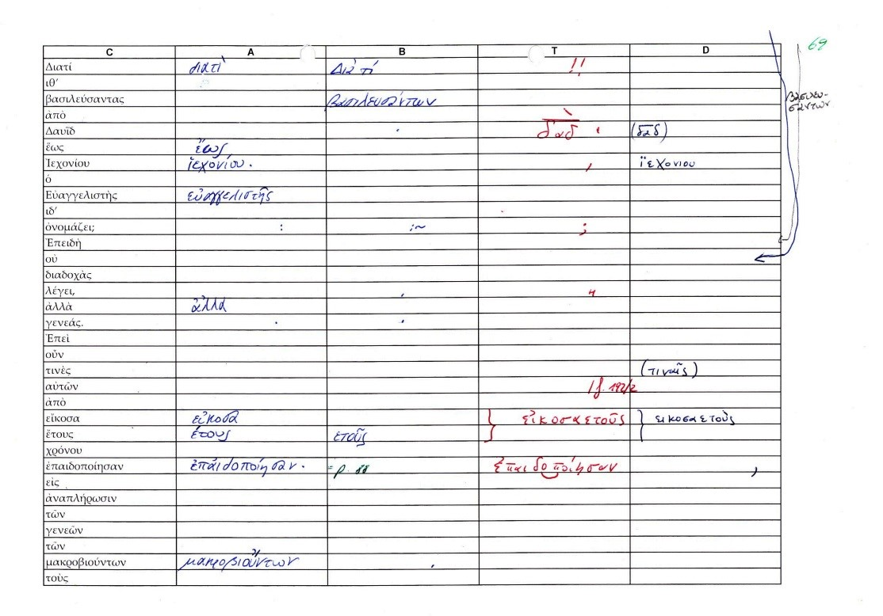
Fig. 1. Macé 2015, 333 (Fig. 3.2.1).

In other languages
DE: Kollationsexemplar
FR: exemplaire de collation (texte de référence, texte de base)
IT: esemplare di collazione
CM

Regularisation
Cf. normalisation.

Reticulation
Reticulation (from Latin reticulum ‘net’, diminutive of rete ‘id.’) in phylogenetics is a generic term that refers to processes such as horizontal gene transfer, recombination, hybridisation, which lead to evolutionary relationships that cannot be fully represented as tree structures. Reticulation may also refer to phylogenetic networks, which are diagrams representing non-treelike structures and which generalise the concept of a phylogenetic tree.
In stemmatology, reticulation results when the copying of a manuscript involves contamination between multiple exemplars.

In other languages
DE: Netzstruktur (hardly in use)
FR: réticulation (hardly in use)
IT: reticolazione
TR

Reticulogram
A reticulogram is a phylogenetic diagram representing pairwise taxon–taxon distances by means of a network. A phylogenetic tree is a special case of a reticulogram. Reticulograms can be constructed from distance data by the T-Rex method.

In other languages
English term mostly used.
DE: Retikulogramm
FR: réticulogramme
IT: reticologramma
TR

Revision
1. A revision is the introduction of intentional changes into a text in its transmission, either by an anonymous scribe or a less anonymous redactor. The term is usually reserved for more substantial changes, and typically changes for a specific purpose, such as updating the text or adding new material. Revisions tend to increase the length of the text (lectio brevior), but there are also examples of revisions which consist of text reduction or simplification, e.g. in epitomes. The word 'revision' may mean the process or the result; the result can be called a recension, redaction, or version. (For a further discussion, cf. recension).
2. More narrowly one often means by revision (or more fully 'authorial revision') a revision made to a text by its author himself. This process can have important consequences for the stemma, as it may lead to more than one original text state from which witnesses are copied.

In other languages
DE: Überarbeitung
FR: révision
IT: revisione
OH, PR

RHM
RHM is an alternative method for calculating phylogenetic distances in order to construct phylogenetic tree based on compression algorithms. The method was proposed in 2006 by Teemu Roos, Tuomas Heikkilä and Petri Myllymäki (hence its name) (Roos et al. 2006). Given a set of textual documents, the method produces a bifurcating stemma. RHM operates in a manner similar to the maximum parsimony method with certain important differences. Roos and Heikkilä (2009) have argued that RHM and maximum parsimony actually yield the best results when constructing cladistics based stemmata, but they also point out that the computational cost is high – i.e. computing a stemma for a tradition with anywhere between 10 and 50 manuscripts may take considerable time, (hours rather minutes).
The RHM method uses an approximation of Kolmogorov complexity which – theoretically – is defined as the smallest possible but complete description of an object (e.g. compressing "aaaaa" into "5a"). Theoretically smallest because for formal languages (like computer languages) it is mathematically impossible to prove that such a description is actually the smallest possible. In practice, therefore, such smallest possible descriptions are always approximated. RHM uses such an approximation to evaluate the distance (i.e. the amount of dissimilarity) between witnesses while constructing a phylogenetic tree by using GZIP compression as the approximation. The use of GZIP automatically gives greater weight to longer variants, e.g. the weight assigned to the variation “beatus” vs. “sanctus” is six units while the weight assigned to the variation “ex” vs “in” is only three units. Similarly, variation in word order is usually assigned a smaller weight than variation in the actual words. All of this is based only on the actual information content and not on scholarly evaluation.
Because RHM uses compression-based comparison without user-intervention, all weighting of variations is based on information immanent in the text without scholarly evaluation intervening. This means that the application of RHM requires less effort than an analysis based on carefully constructed encodings where, for example, variation that is considered insignificant (capitalisation, punctuation, etc.) is removed by normalisation, variation in word order is encoded using special characters, and so on. This also results in RHM using as its input aligned text files which contain the actual words, instead of encoded variant readings using arbitrary characters such as A,B,C,… as is done in, for instance, the Nexus data matrix format.
A difference between RHM and typical maximum parsimony implementations, such as that in PAUP or PHYLIP, is the search procedure used to find highly scoring tree structures. The search technique used in RHM takes a user-defined parameter, the number of search steps or iterations. The more iterations, the longer the search takes but also the better a solution can be expected. The maximum parsimony implementation in PAUP and PHYLIP on the other hand, is faster.
References
– Roos, Teemu, Tuomas Heikkilä, and Petri Myllymäki. 2006. “A Compression-Based Method for Stemmatic Analysis.” In ECAI 2006: Proceedings of the 17th European Conference on Artificial Intelligence: August 29 – September 1, 2006, edited by Gerhard Brewka et al., 805–806. Amsterdam: IOS Press.
– Roos, Teemu, and Tuomas Heikkilä. 2009. “Evaluating Methods for Computer-Assisted Stemmatology Using Artificial Benchmark Data Sets.” Literary and Linguistic Computing 24 (4): 417–433.
JZ, TR

Root
A node in a directed graph is called a root if it has indegree zero, i.e., there are no edges pointing to it. Moreover, it is usually thought that a rooted tree or a rooted graph has only one root (cf. origin). A counterexample would be a text that grew out of two texts, each of which had its own original (being its root). The presence of (at least) one root is required for a tree to be called a stemma.

In other languages
DE: Wurzel
FR: racine
IT: radice
TR, PR

R (Statistical Programming Language)
R is a free programming language designed specifically for statistical calculations and plotting resulting graphs and charts. It is available and free for use under the GNU General Public License. Versions for most computer platforms exist. R is an interpreted language, command line interaction is a usual means of engaging with it, although several GUI (Graphical User Interface) based IDEs (Integrated Development Environments) exist as well. R supports packages which enables developers to extend the language by adding libraries of R code. R is a procedural programming language supporting functions. Generally R is seen as a well featured alternative to proprietary packages such as STATA and SPSS.

References
– http://www.r-project.org/ Accessed 28 October 2015.
– http://darwin.eeb.uconn.edu/uncommon-ground/2013/09/a-gentle-introduction-to-r.html Accessed 28 October 2015.
JZ

Saut du même au même
An omission may occur because the copyist unintentionally skips a passage and thus creates an omission. If this happens because similar words or phrases appear twice on the same page, inducing the copyist to unintentionally skip the passage between the first and the second of these phrases, i.e. to ‘jump’ from the one to the other, this is called a saut du même au même (literally 'jump from the same to the same' in French) or an eye-skip.
The scholarly Greek term for words which have the same letters in the beginning is homoeoarcton, ‘similar beginning’. Similarly, the scholarly term for words that have the same letters at the end is homoeoteleuton, ‘similar end’. Both homoeoarcton and homoeoteleuton may induce a saut du même au même.

References
– Havet, Louis. 1911. Manuel de critique verbale appliquée aux textes latins. Paris: Hachette.
– Reynolds, Leighton Durham, and Nigel G. Wilson. 1974. Scribes and Scholars: A Guide to the Transmission of Greek and Latin Literature. 2nd ed. Oxford: Clarendon Press. || See pp. 204–205.
– West, Martin L. 1973. Textual Criticism and Editorial Technique Applicable to Greek and Latin Texts. Stuttgart: Teubner. || See p. 24.

In other languages
The French expression is most often used. Besides are in use:
EN: eye-skip
GE: Augensprung
IT: salto da pari a pari, omissione ex homoeoteleuto
GH

Schlyter, Carl Johan
Carl Johan Schlyter (Karlskrona, 1795 – Lund, 1888) was a Swedish scholar who made an outstanding and long-serving contribution to the editing of mediaeval Swedish laws (ill. 1). He was one of the first scholars in Sweden to receive the degree of juris doctor, and was appointed docent at the University of Lund as early as in 1816 and later became professor, first in Uppsala and a few years later in Lund. With his fellow student Hans Samuel Collin (1791–1833) he was appointed editor of the Samling af Sweriges gamla lagar (Corpus juris sveogothorum antiqui). The first volume of this large-scale edition was of the Westrogothic law, Vestgötalagen (1827), and after Collin died, Schlyter continued the editing on his own, bringing the series to its conclusion with vol. 13 in 1877.
A remarkable trait of the very first volume is a stemma of the manuscripts, added in the appendix (ill. 2). This is in many ways a modern stemma, and it is also probably the first stemma ever published, more developed than the earliest, sketchy stemmata drawn by classical scholars on the continent a few years later.
The stemma in Vestgötalagen seems to have been isolated at the time, nor was it known to Sebastiano Timpanaro in the first edition of his La genesi del metodo del Lachmann (1963), but after the publication of an article in English by Gösta Holm (1972), it has made its way in the general stemmatological literature, and is discussed e.g. in the latest edition of Timpanaro’s work (ed. Most 2005, 92–93).
The stemma in the edition of Vestgötalagen is not specifically attributed to either of the two editors, Schlyter and Collin. Britta Olrik Frederiksen has investigated the background of the stemma construction, and her conclusion is that it seems most likely that the stemma was Schlyter’s own contribution (2009, 139–148). It should be noted, however, that in spite of embellishing the edition with a stemma, the text of Vestgötalagen was not constituted in a Lachmannian sense of textual reconstruction, and Schlyter did not draw any stemmata for the following editions in the series.

Works by Schlyter
– Schlyter, Carl Johan, and Hans Samuel Collin, eds. 1827. Westgöta-lagen. Samling af Sweriges Gamla lagar, vol. 1. Stockholm: Häggström. – Note that this text has been scanned by Google Books, but for some reason they have not included the stemma, cf. http://books.google.no/books?id=aZgyAAAAIAAJ&redir_esc=y. Accessed 28 October 2015.

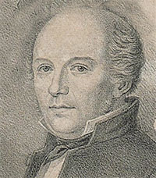
Ill. 1. Carl Johan Schlyter (1795–1888)

Works on Schlyter
– Frederiksen, Britta Olrik. 2009. “Stemmaet fra 1827 over Västgötalagen – en videnskabshistorisk bedrift og dens mulig forudsætninger.” Arkiv för nordisk filologi 124: 129–150.
– Holm, Gösta. 1972. “Carl Johan Schlyter and Textual Scholarship.” Saga och Sed 1972: 28–80.
– Timpanaro, Sebastiano. 1963. La genesi del metodo del Lachmann. Firenze: Monnier.
– ———. 1981. La genesi del metodo del Lachmann. 2nd ed. Padova: Liviana.
– ———. 2005. The Genesis of Lachmann’s Method. Translated by Glenn W. Most. Chicago: University of Chicago Press. – Translated from Timpanaro 1981.
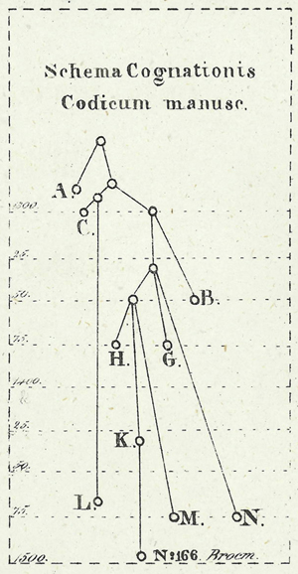
Ill. 2. The stemma in the edition of Westgöta-lagen (1827, appendix) by Carl Johan Schlyter. He called it schema cognationis codicum manuscriptorum, or 'diagram of relationship of the manuscripts'.
OH

Scribal conjecture
Scribal conjecture is a concept used to describe readings that arise when copyists or scribes deliberately make corrections of their own in the text they are copying because, for one reason or another, they are dissatisfied with the source text’s reading. For conjectures done by modern editors, cf. divinatio.
As a conjecture, a scribal conjecture is distinguished from a correction based on manuscript readings, that is through the collation of witnesses (cf. Trovato 2014, 152; and for a wider discussion of the use of the term 'conjecture', Krans 2013, 614-617).

References
– Krans, Jan. 2013. "Conjectural Emendation and the Text of the New Testament." In The Text of the New Testament in Contemporary Research, ed. by Bart D. Ehrman and Michael W. Holmes, 2nd ed., 613-635. Brill: Leiden.
– Trovato, Paolo. 2014. Everything You Always Wanted to Know about Lachmann’s Method: A Non-Standard Handbook of Genealogical Textual Criticism in the Age of Post-Structuralism, Cladistics, and Copy-Text. Foreword by Michael D. Reeve. Firenze: Libreriauniversitaria.it edizioni.

In other languages
DE: Kopistenkonjektur, Konjektur eines Kopisten
FR: conjecture de copiste
IT: congettura del copista / congettura scribale
AC

Scribe
A scribe (from lat. scriptor 'someone who writes') is anyone who wrote the text of a handwritten document, whether from scratch, as it were, or by way of copying an exemplar. In antiquity there were professional scribes working in public libraries and in bookstores or for wealthy private persons who wanted to have certain texts copied. In the early and high middle ages the scribes were often monks or nuns working in a scriptorium of a monastery. In the late middle ages there were professional scribes who worked for bookstores, libraries, municipalities, courts, or universities.
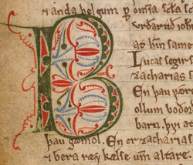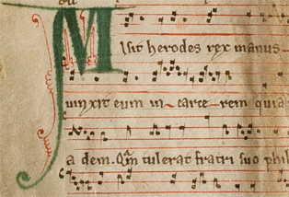
Figs. 1 and 2. Extract from two manuscripts probably written by the same scribe. Fig. 1 is from the Old Norwegian homily book (Copenhagen, AM 619 4to, fol 52v), dated to c. 1200–1225, and fig. 2 is from a fragment of a Latin liturgical manuscript (Oslo, NRA Lat fragm 1018), dated to before 1225. While scribes, especially in larger scriptoria, could be very specialised, they could also be very versatile. The scribe of these two fragments obviously was able to write in Old Norwegian and in Latin, to draw the initials (and the rubrics) himself, and also to add musical notation.

While scribes usually were professional, there were exceptions to this rule. Sometimes scribes were people who copied a text for their own purpose. The scribe may thus have been, e.g., a professional who needed a technical handbook or someone who wanted to have access to a collection of sermons or to a literary work.
In most cases, the scribe copied an existing text, and would in this sense be a copyist. The copyists' attitude towards the text they were copying may have depended on whether they were professional scribes working for others or private persons producing their own copy of a certain text (cf. copying of texts).

References
– Klopsch, Paul. 2003. “Die Überlieferung der lateinischen Literatur im Mittelalter.” In Egert Pöhlmann, Einführung in die Überlieferungsgeschichte und die Textkritik der Antiken Literatur: Mittelalter und Neuzeit, 47–95. Darmstadt: Wissenschaftliche Buchgesellschaft. || See pp. 91–93.
– Pasquali, Giorgio. 1952. Storia della tradizione e critica del testo. 2nd edition. Firenze: Le Monnier. || See pp. 473–474, 478f.
– Reynolds, Leighton Durham, and Nigel G. Wilson. 1974. Scribes and Scholars: A Guide to the Transmission of Greek and Latin Literature. 2nd ed. Oxford: Clarendon Press. || See pp. 1ff., 5ff., 72f., 86f., 223f.
– Salles, Catherine. 2010. Lire à Rome. Petite Bibliothèque Payot. New ed. Paris: Belles Lettres. – 1st ed., Paris: Belles Lettres, 1992. || See pp. 157f., 169f., 182f.
– West, Martin L. 1973. Textual Criticism and Editorial Technique Applicable to Greek and Latin Texts. Stuttgart: Teubner. || See p. 17.

In other languages
DE: Schreiber
FR: scribe
IT: scriba
GH, OH (illustration)

Scuola storica
An ecdotic perspective which developed in Italy in the thirties of the 20th century in the wake of Michele Barbi's and especially Giorgio Pasquali's approaches to textual criticism. In 1934 Pasquali published the first edition of a volume titled Storia della tradizione e critica del testo, in which he stressed the need to integrate the reconstruction of a stemma with the study of the history of tradition, and suggested that certain ambiguities in the transmission of Latin and vernacular texts could be explained by assuming ab origine the existence of authorial changes. The seminal force of the approach suggested by Pasquali lies in the fact that it injects history into the critically reconstructed text; as later on grasped by Contini (see, among others, Contini 1961), Pasquali’s historical view worked effectively as an antidote to the radical scepticism of Bédier in the face of an aura of “eternity” emanated by the stemma.
Pasquali's Storia della tradizione opened the path to what is frequently called "Neo-Lachmannism" or "Trans-Lachmannism" (see Neo-Lachmannian Philology, 1), an approach which does not reject the scientific rigour of the Lachmannian method, but rather reconsiders it critically, in the light of the more complex vision offered by the thorough study of the history of tradition. Pasquali argues that each textual problem requires a specific treatment. An editor's activity, in fact, is not mechanical, "rather, it is methodical - which means almost the opposite" (Storia della tradizione, p. xi).
Gianfranco Contini, D'Arco Silvio Avalle, Maria Corti and Cesare Segre are amongst the leading scholars in this school. One may quote Contini's famous statement according to which "in order to be a Lachmannian today, one should have passed through an anti-lachmannian training (Bédier) and a post-lachmannian experience (that is, in classical philology at least, Pasquali)." ("[...] come per essere oggi lachmanniani, sia indispensabile aver attraversato e un tirocinio anti-lachmanniano (cioè Bédier) e un'esperienza post-lachmanniana (cioè, se non altro in filologia classica, Pasquali)." Contini 1970, 344).
References
– Barbi, Michele. 1938. La nuova filologia e l'edizione dei nostri scrittori. Da Dante al Manzoni. Firenze: Sansoni.
– Buzzoni, Marina, and Eugenio Burgio. 2014. "The Italian ‘third way’ of editing between globalization and localization." In Internationalität und Interdisziplinarität der Editionswissenschaft, edited by Michael Stolz and Yen-Chun Chen. Berlin-Boston: Walter De Gruyter, 171–180.
– Contini, Gianfranco. 1961. "Tombeau de Leo Spitzer". Paragone 12: 3–12.
– Contini, Gianfranco. 1970. "La 'Vita' francese di sant'Alessio e l'arte di pubblicare i testi antichi." In Un augurio a Raffaele Mattioli. Firenze: Sansoni. 343–374.
– Chiarini, Giorgio. 1982. "Prospettive translachmanniane dell'ecdotica." In Ecdotica e testi ispanici. Verona: Fiorini, 45–64.
– Pasquali, Giorgio. 1934. Storia della tradizione e critica del testo. Firenze: Le Monnier. – 2nd revised edition 1952.
– Pugliatti, Paola. 1998. "Textual Perspectives in Italy: From Pasquali’s Historicism to the Challenge of ‘Variantistica’ (and Beyond)." In Text. An Interdisciplinary Annual of Textual Studies, vol 11, edited by W. Speed Hill, E. M. Burns, P. Schillingsburg. Ann Arbor: University of Michigan Press, 155–188.
– Vàrvaro, Alberto. 1999. "The 'New Philology' from an Italian Perspective. In Text. An Interdisciplinary Annual of Textual Studies, vol. 12, edited by W. Speed Hill et al. Ann Arbor: University of Michigan Press, 49–58.
– Zinelli, Fabio. 2006. L'édition des textes médiévaux Italiens en Italie. In Pratiques philologiques en Europe,edited by Frederic Duval. Paris: École des Chartes, 77-113.
MB

Segre, Cesare
Cesare Segre (Verzuolo [Cuneo] 1928 – Milano 2014) was an Italian semiologist, linguist and Romance philologist. He lived and studied in Torino, where he graduated in 1950 as a pupil of Benvenuto Terracini and Santorre Debenedetti. He taught at the Universities of Trieste and Pavia, where in the 1960s he became full professor of Romance philology. He was Visiting Professor in Manchester, Rio de Janeiro, Harvard, Princeton, Berkeley, and a member of the Italian Accademia della Crusca.
His theoretical contribution to the field of textual criticism is remarkable: he is one of the most outstanding scholars who applied the structuralist method to ecdotics, admirably integrating it with the approach of the Italian historical school; he coined terms such as 'diasystem' which contributed to a reshaping of the notion of “error". Paul Zumthor in his Introduction to the 1992 English translation of Essai de poétique médiévale (transl. by Ph. Bennett) claims that Segre’s books “filtered twenty years of formalism, decanting the result through a delicate re-elaboration of the material.” (p. xv).
He was also very active as an editor of mediaeval texts: his critical edition of La Chanson de Roland(1971) remains a masterpiece of methodology in textual criticism. Giving new life to a text that Bédier (1921) had edited on the sole basis of the Oxford manuscript, Segre opens it up to a diachronic dimension, both in the direction of a witty rehabilitation of the reconstructive process, and simultaneously by representing the after-life of the text itself. Furthermore, he edited Ludovico Ariosto’s Satire (1984), Il libro de' Vizî e delle virtudi by Bono Giamboni (1968) and the Orlando Furioso (with Santorre Debenedetti, 1960).
He was editor and co-editor of various scholarly journals, among which Strumenti critici(with Maria Corti, D’Arco Silvio Avalle, Dante Isella) and Medioevo romanzo, as well as scientific series like Critica e filologia (Einaudi). In 1999 Segre published a book titled Per curiosità. Una specie di autobiografia, in which he recalled the main steps of his intellectual history.

By Segre
Editions
– Debenedetti, Santorre, and Cesare Segre, eds. 1960. Orlando Furioso. Bologna: Commissione per i testi di lingua.
– Segre, Cesare, ed. 1968. Il libro de' Vizî e delle virtudi e il Trattato di virtù e di vizi. Torino: Einaudi.
– ———, ed. 1971. La Chanson de Roland. Milano: Ricciardi.
Textual and literary criticism (a selection)
– Segre, Cesare. 1969.I segni e la critica: Fra strutturalismo e semiologia. Torino: Einaudi; with a new introduction, Torino: Einaudi 2008.
– ———. 1974. La tradizione della “Chanson de Roland”. Milano-Napoli: Ricciardi.
– ———. 1977. Semiotica, Storia e Cultura. Padova: Liviana.
– ———. 1979. Semiotica filologica: Testo e modelli culturali. Torino: Einaudi.
– ———, ed. 1983. Intorno alla linguistica. Milano: Feltrinelli.
– ———. 1984. Difendo l'Ariosto: Sulle correzioni autografe delle “Satire”. Pisa: Giardini.
– ———. 1991. Due lezioni di ecdotica. Pisa: Scuola normale superiore.
– ———. 1998. Ecdotica e comparatistica romanze. Milano: Ricciardi.
– ———. 1999. Le varianti e la storia: il «Canzoniere» di Francesco Petrarca: Lezione Sapegno 1999. Torino: Bollati Boringhieri.
– ———. 1999. Per curiosità: Una specie di autobiografia. Torino: Einaudi.
– ———. 1999. Ritorno alla critica. Torino: Einaudi.
– ———. 2008. Dai metodi ai testi: Varianti, personaggi, narrazioni. Torino: Aragno.
– ———. 2012. Critica e critici. Torino: Einaudi.

On Segre
– Conte, Alberto, and Andrea Mirabile, eds. 2014. Cesare Segre. Opera critica. With an introductory essay by Gian Luigi Beccaria. Milano: Mondadori.
MB

Selectio
Selectio consists in the choice between readings bearing the same stemmatic value (IT: varianti adiafore) on the basis of internal criteria such as usus scribendi or lectio difficilior. It is one of the three main operations that characterise emendatio, along with divinatio and combinatio.

References
– Luiselli Fadda, Anna Maria. 1994. Tradizioni manoscritte e critica del testo nel Medioevo germanico. Roma: Laterza. || See pp. 237–240.
– Maas, Paul. 1960. Textkritik. 4th ed. Leipzig: Teubner. – First ed. 1927.

In other languages
Latin term used throughout.
MB

Semstem
Semstem is a method for the inference of stemmatological trees. Its origins go back to the Bayesian Structural Expectation-Maximalization algorithm (SEM, see Friedman 1998). This SEM algorithm uses maximum likelihood estimates to compute expectations and maximalisations for missing data. Semstem, proposed by Teemu Roos and Yuan Zou in 2011 (see Roos & Zou 2011), is an extension and adaptation of Semphy, an earlier phylogenetic method implementing SEM (see Friedman et al. 2002). The Semstem algorithm is aimed at uncovering latent tree structures – i.e. proposing likely stemmata. Semstem differs from other algorithms in that it is not limited to producing bifurcating trees, and that the degree (the number of incoming and/or outgoing edges) of the internal nodes is not limited either. Also the extant manuscripts used as input to the method can be used as labels for the internal nodes as well as the leaf nodes of the stemma. These aspects arguably make the results easier to interpret. The figure below illustrates these points.
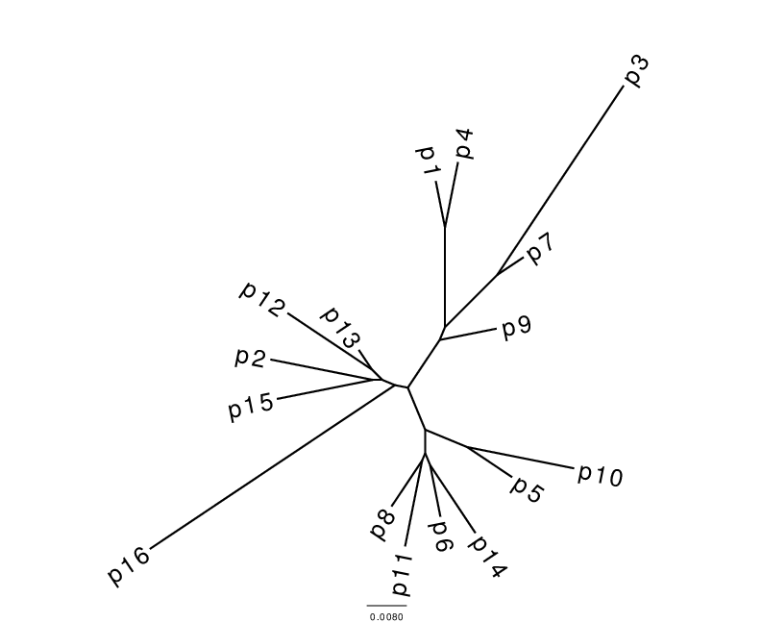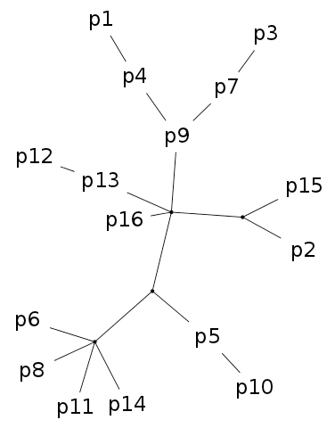
Fig. 1. Stemmata obtained from the artificial textual tradition Parzival. The Neighbour joining (NJ) tree on the left is, as always, bifurcating and all taxa are placed at leaf nodes. In the Semstem tree on the right, there are multifurcations and some of the taxa, for example p9, p7 and p4, are placed at internal nodes. The edge lengths in the Semstem result are arbitrary and chosen to best display the tree structure.

The base algorithm (SEM) infers the unknown contents of latent (or unobserved) nodes—nodes not having been considered by the algorithm for computing a previous tree structure—based on the contents of observed nodes. This additional (estimated) knowledge is then used to derive a maximum likelihood tree, the process for which again will feature a number of unobserved nodes. The algorithm iterates this process the produce a best estimate tree structure. User input is required to determine the total number of iterations before the algorithm terminates and outputs the so far best tree structure.

References
– Friedman, Nir. 1998. “The Bayesian Structural EM Algorithm.” In Uncertainty in Artificial Intelligence: Proceedings of the Fourteenth Conference (1998), edited by Gregory F. Cooper, 129–138. San Francisco: Morgan Kaufmann. Available at: www.cs.huji.ac.il/~nir/Papers/Fr2.pdf Accessed 28 October 2015.
– Friedman, Nir, Matan Ninio, Izsik Pe’er, and Tal Pupko. 2002. “A Structural EM Algorithm for Phylogenetic Inference.” Journal of Computational Biology 9 (2): 331–353.
– Roos, Teemu, and Yuan Zou. 2011. “Analysis of Textual Variation by Latent Tree Structures.” In Proceedings of the 11th International Conference on Data Mining (ICDM-2011), edited by Diane J. Cook, 567–576. Los Alamitos, California: IEEE Computer Society. Available at: http://www.cs.helsinki.fi/u/ttonteri/pub/icdm2011.pdf. Accessed 28 October 2015.
JZ, TR

Set
A set X is an unordered collection of objects, which are called the elements of X. For example, the three languages French, Russian and Chinese form a set, which we denote as X = {French, Russian, Chinese} (or equivalently, {Chinese, French, Russian} as order does not matter).

Subset (or cluster)
A set Y is a subset of a set X if every element in Y is also contained in X. For example, {French, Russian} is a subset of the set {French, Russian, Chinese}. Sometimes a subset of a set which contains at least one element is also known as a cluster.

Set union
The union of two sets X and Y, denoted X U Y is the set formed by taking all of the elements in X and all elements in Y. For example, {French, German} U {Italian, Russian, English} = {French, German, Italian, Russian, English}

Set intersection
The intersection of two sets X and Y, denoted X ∩ Y, is the set formed by taking all those elements that are in both X and Y. For example, {French, German} ∩ {Italian, Russian, French} = {French}.

Empty set
The empty set is the set that contains no elements, which is usually denoted Ø.

Disjoint sets
Two sets are called disjoint if their intersection is the empty set, that is, they have no elements in common. So, for example, the two sets {French, German} and {Italian, Russian, English} are disjoint sets as their intersection is the empty set, i.e. {French, German} ∩ {Italian, Russian, English} = Ø.

Complement of a set
If Y is a subset of a set X then the complement of Y in X, denoted by X-Y, comprises of all those elements in X that are not in Y. For example, the complement of {French, Chinese} in the set {French, Chinese, Russian, Italian} is {Russian, Italian}.
See also the entry split. The Wikipedia page set (mathematics) provides a very informative introduction to sets.
In other languages
DE: Menge, Untermenge, Vereinigungsmenge, Schnittmenge, leere Menge, disjunkte Mengen, komplementäre Mengen
FR: ensemble, sous-ensemble, union d'ensembles, intersection d'ensembles, ensembles disjoints, ensembles complémentaires
IT: insieme, sottoinsieme, unione d'insiemi, intersezione d'insiemi, insieme vuoto, insiemi disgiunti, insieme complementare / complemento (di un insieme)
VM, KH

Siglum
A siglum (plural sigla) is a letter (or other character) used to designate any number of the following: a witness or a group (or a family) of witnesses, a vertex/node in a graph, or the archetype and hyparchetypes in a textual tradition or manuscript tradition.
Often editors will distinguish witnesses from hyparchetypes by employing Roman letters for the former and Greek letters for the latter (see, for example, Fig. 1 under archetype). However, editorial practice can vary – Barber's edition of Propertius (1953), uses Greek letters for three witnesses from the fifteenth century.
A number of additional conventions also exist. For example, a lower case f with a superscript letter (fª) can be used to denote a witness preserved as a fragment as in the manuscript sigla for Ælfric's homilies established by Godden (1979) and Clemoes (1997). Additionally, lower- and upper-case Roman letters may be employed to distinguish witnesses based on their date as in Mynors' edition of Vergil (1969); manuscripts from the fourth and fifth centuries have upper-case sigla while those from the end of the eighth century and the ninth century are represented by lower-case letters. A number or a letter in superscript next to the siglum of a manuscript may also indicate another hand or another layer within the manuscript. For example, if M is the siglum of a manuscript, M¹ or Mª may indicate that another hand corrected the manuscript at some point, and, in cases where further campaigns of correction may be identified, further sigla such as M² or M^{b} etc. can be used. The same conventions can also be used to characterize composite manuscripts, in which two or more codicological units from different periods can be identified. The prime symbol is often used as well in such cases; for example, M is a manuscript copied in the 12th century, the text was incomplete and has been added later on the last pages of the same manuscript, this later addition is called M'.
Usually a table of sigla under such headings as 'manuscript sigla', 'sigla codicum', 'conspectus siglorum', or simply 'sigla' is found preceding the text of the edition. See also abbreviations and editorial signs.

References
– Barber, Eric Arthur, ed. 1953. Sexti Properti Carmina. Oxford Classical Texts. Oxford: Oxford University Press.
– Clemoes, Peter, ed. 1997. Ælfric's Catholic Homilies: The First Series. Early English Text Society, Supplementary Series, vol. 17. Oxford: Oxford University Press.
– Godden, Malcolm, ed. 1979. Ælfric's Catholic Homilies: The Second Series. Early English Text Society, Supplementary Series, vol. 5. London: Oxford University Press.
– Mynors, Roger A.B., ed. 1969.P. Vergili Maronis Opera. Oxford Classical Texts. Oxford: Oxford University Press.

In other languages
GE: Sigel
FR: sigle
IT: sigla
AC (and CM)

Sonderfehler
[ˈzɔndəfe:la]
A synonym (e.g. in Maas's Textkritik) for Eigenfehler. The German word is derived from the verb sondern 'to separate' and Fehler 'error'. See lectio singularis.

Reference
– Maas, Paul. 1960. Textkritik. 4th ed. Leipzig: Teubner. – 1st ed. 1927.
PR

Split
A split can be thought of a division of a set into two disjoint subsets. More precisely, a split of a set X is a partition of X into two, non-empty, disjoint sets A and B, so that the union of A and B is equal to X. For example, { {French, English} , {Chinese, Russian, Italian} } is a split of the set {French, English, Chinese, Russian, Italian}. To ease notation, a split {A,B} of a set X is sometimes denoted by A|B (or B|A as the order in which A and B are listed does not matter). Using this notation, the split above becomes {French, English} | {Chinese, Russian, Italian}.

Trivial split
A trivial split of a set X is any split of X of the form {x}| X-{x}, where x is some element of X. For example, {French} | {Chinese, Russian, Italian} is a trivial split of the set {French, Chinese, Russian, Italian}.

Split system
A split system ∑ on a set X is a set of splits of X. For example, { {French, English} | {German, Italian}, {French, German} | {English, Italian} }, is a split system on the set {French, English, German, Italian}, that contains two splits.

Compatible splits (incompatible splits)
Two distinct splits A|B and C|D of a set are called compatible if one of the intersections A ∩ C, A ∩ D, B ∩ C, and B ∩ D is empty. Two splits are called incompatible if they are not compatible. Note that in a phylogenetic tree with leaf set X, each of the edges induces a split of X, and that the two splits induced by any pair of distinct edges in the tree are compatible.

Compatible split system
A compatible split system on a set X is a split system on X in which any pair of splits is compatible. Note that it was proved by Peter Buneman (1971) that a compatible split system which contains all possible trivial splits can always be represented by a (unique) phylogenetic tree with leaf set X (see e.g. Theorem 3.1.4 [2]). In particular, each of the edges in the tree represents a split since its removal from the tree cuts the tree into two pieces which gives a split of the leaf set X. This implies that a split system ∑ which contains all possible trivial splits can be represented by a phylogenetic tree if and only if every pair of splits in ∑ is compatible.

Hierarchy
A hierarchy is a set H of clusters in a set X so that for any pair of sets A,B in H, either A is a subset of B, B is a subset of A, or A and B are disjoint. Note that a hierarchy on X that contains all trivial clusters can always be represented by a rooted, phylogenetic tree (see e.g. Theorem 3.5.2 in Semple & Steel 2003).

Split network
A split network on a set X is a special type of graph in which some subset of the vertices are labeled by elements of X, and certain collections of edges of the graph represent splits of X, just as the edges in a phylogenetic tree represent splits (see e.g. Section 4.3 in Huson et al. 2010). Split networks are often used to represent split systems which contain some pairs of incompatible splits, since such split systems cannot be represented in any phylogenetic tree (see above "compatible split systems").
Cf. also the entry set.

References
– Buneman, Peter. 1971. “The Recovery of Trees from Measures of Dissimilarity.” In Mathematics in the Archaeological and Historical Sciences, edited by Frank Roy Hodson, David George Kendall, and Petre Tautu, 387–385. Edinburgh: Edinburgh University Press.
– Semple, Charley, and Mike Steel. 2003.Phylogenetics. Oxford: Oxford University Press.
– Huson, Daniel, Regula Rupp, and Celine Scornavacca. 2010. Phylogenetic Networks. Cambridge: Cambridge University Press.

In other languages
English term used throughout
VM, KH

SplitsTree
SplitsTree is a program for inferring phylogenetic trees and networks. It handles various sources for phylogenetic information such as sequence alignments, distance matrices, and tree sets. SplitsTree offers various methods for building phylogenetic trees such as split decomposition, NeighborNet, consensus bootstrap trees.

References
– http://www.splitstree.org/ Accessed 28 October 2015.
– Huson, Daniel H., and David Bryant. 2006. “Application of Phylogenetic Networks in Evolutionary Studies.” Molecular Biology and Evolution 23 (2): 254–267.
JZ

Stemma
Stemma (plural stémmata), or in full stemma codicum, literally means ‘genealogical tree of the codices’. The word stemma ultimately derives from the Greek στέμμα ‘wreath, garland’, in turn from the verb στέφω ‘put / hang around’, but it is used metonomastically already in Latin antiquity to mean ‘genealogical tree’ (e.g. by Suetonius, De vita caesarum, Claudius 2). What we call today a stemma codicum was proposed in the 18th century as a tabula quaedam quasi genealogica by Bengel (§ XXIX, p. 20) in the context of such a hypothetical genealogical tree of witnesses of the New Testament. But apparently only in the 19th century were such “tables” first printed in editions. The first scholar to publish a stemma seems to have been Carl Johan Schlyter in 1827 (calling it a schema cognationis), whereas Carl Gottlob Zumpt may have been the first person to use the designation stemma codicum mss. (i.e. manuscriptorum, p. XXXVIII, but relegating the actual stemma to a foot-note) for them in 1831 (cf. Timpanaro 1963, p. 61). The term becomes the accepted technical term in the wake of Paul Maas’s Textkritik.
CM and PR have proposed this definition: A stemma (codicum) is an oriented tree-like graph representing a scholarly/scientific hypothesis about genealogical relationships between witnesses, on the basis of the text-state they contain and on the basis of historical evidence about them as objects.
Stemmata are thus related but not equal to oriented tree-graphs. The former may exhibit more than exactly one path from node A to node B, especially so in the case of contamination (usually shown in stemmata as dotted lines). A tree-graph, however, must by definition have exactly one path from any node to any other node. The oriented tree-like graph is more precisely required to be an oriented, or a directed, acyclic graph (DAG). The definition calls these graphs tree-like as they can usually be changed into tree-graphs by removing relatively few edges (those representing contamination). The orientation leads to the facts that such a tree-like graph must have a root, called the archetype, from which the rest of the tradition descends. Intermediate hyparchetypes will usually also figure in a stemma. All available information about the text should be taken into consideration to draw a stemma (including external information about the transmission).
Non-oriented graphs are occasionally also called stemmata, but for clarity it would seem preferable to differentiate these as tree-graphs or the like. See also cladorama.

References
– Bengel, Johann Albrecht. 1763. D. Io. Alberti Bengelii Apparatus criticus ad Novum Testamentum [...]. Tubingae: Sumptibus Ioh. Georgii Cottae. https://archive.org/details/dioalbertibengel00beng Accessed 28 October 2015.
– Maas, Paul. Textkritik. Leipzig 1927. First edition with the appendix: "Leitfehler und stemmatische Typen", Leipzig 1937. Last edition with changes: Leipzig 1960.
– Shanzer, Danuta. 1986. “Felix Capella: Minus sensus qum nominis pecudalis.” Classical Philology 81 (1): 62–81.
– Timpanaro, Sebastiano. 1963. La genesi del metodo del Lachmann. Firenze: Le Monnier.
– ———. 1981. La genesi del metodo del Lachmann. 2nd ed. Padova: Liviana.
– ———. 2005. The Genesis of Lachmann’s Method. Translated by Glenn W. Most. Chicago: University of Chicago Press. – Translated from Timpanaro 1981.
– Zumpt, Carl Gottlob. 1831. M. Tullii Ciceronis Verrinarum libri septem, ad fidem codicum manu scriptorum recensuit et explicavit Carolus Timotheus Zumptius. Berolini: Dümmler. http://books.google.fr/books?id=OZNbAAAAQAAJ&hl=fr&pg=PP1#v=onepage&q&f=false Accessed 28 October 2015.

Example
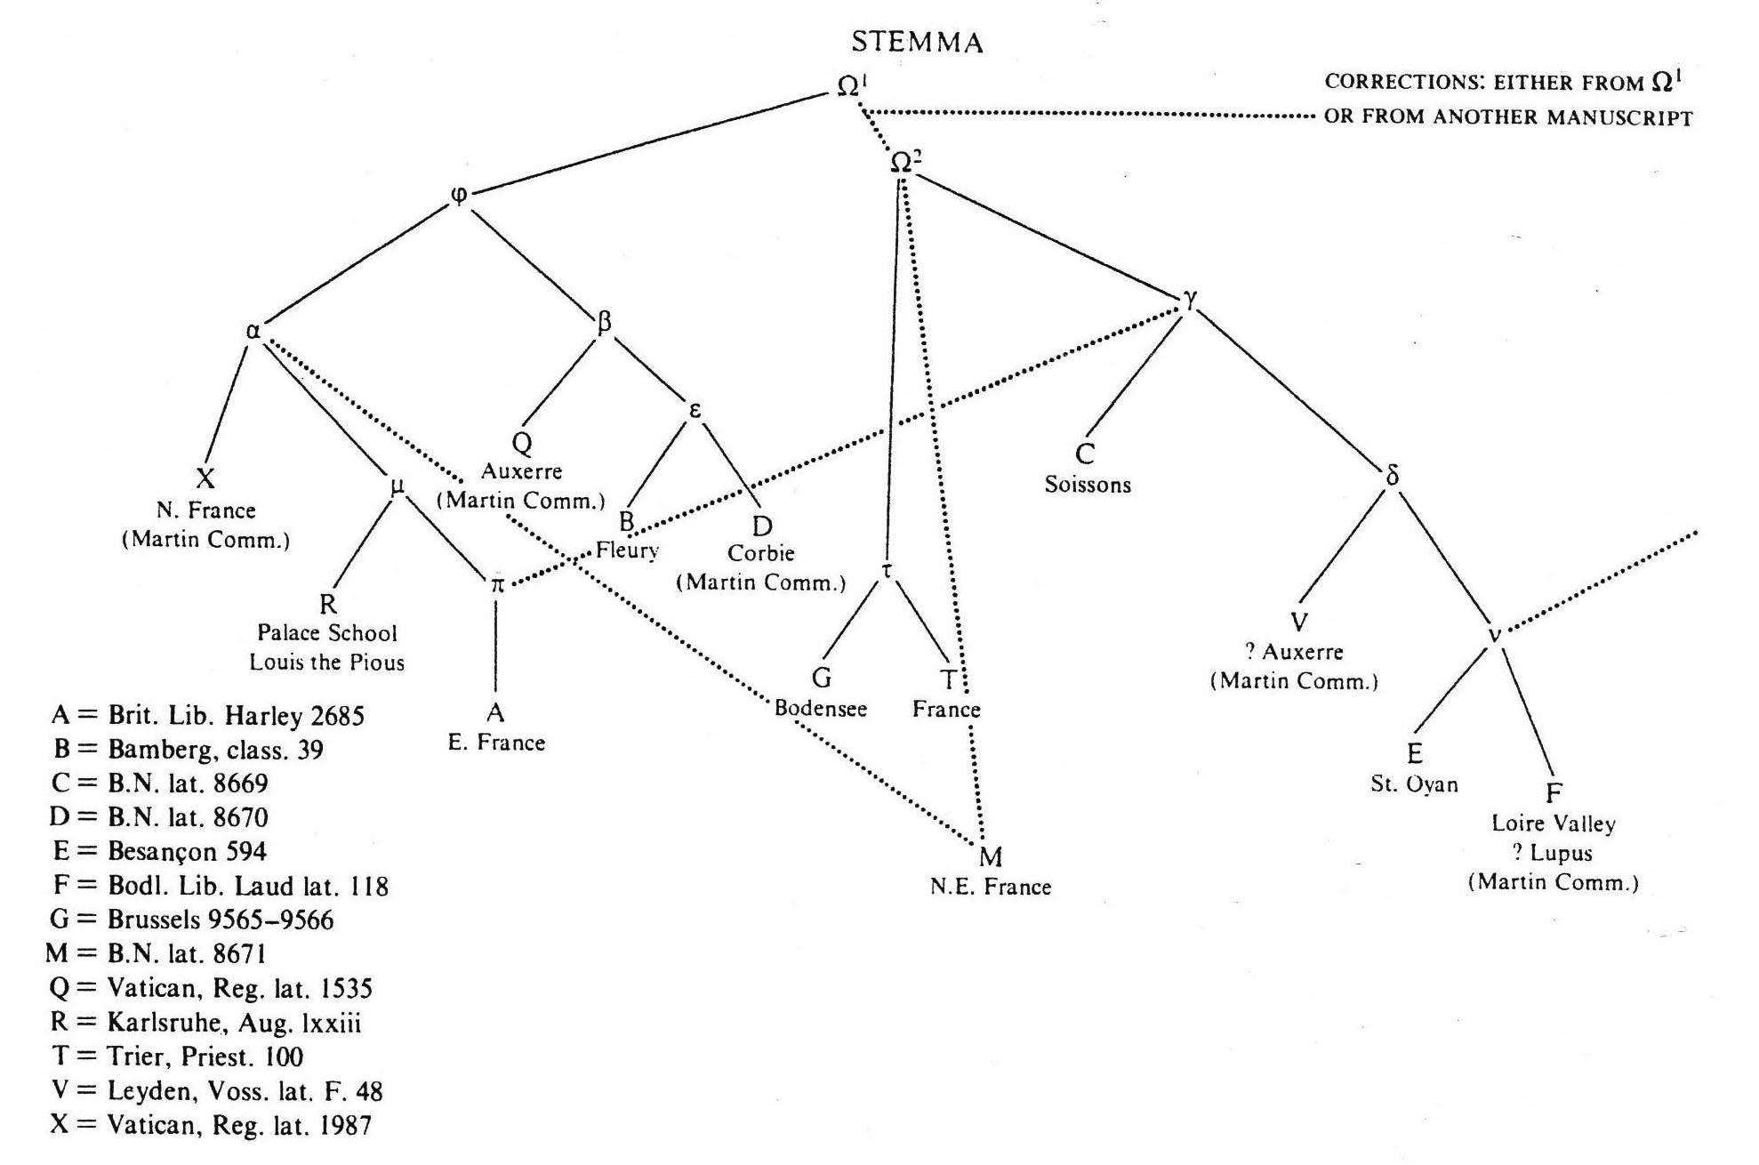
Fig. 1: example of a stemma. Stemma for De nuptiis Philologiae et Mercurii by Martianus Capella proposed by Danuta Shanzer (1986, p. 62-81). Hyparchetypes are shown in lower case Greek letters, extant manuscripts in upper case Latin ones. Dotted lines represent contamination. Ω represents the archetype which suffered corrections (possibly extra-stemmatic) after having been copied.

In other languages
DE: Stemma (also, non-technically: Stammbaum)
FR: stemma
IT: stemma (pl. stemmi)
PR, TA

Stemmatics
In some usage, the stemmatic method and stemmatics may refer exclusively to work carried out in the tradition of Lachmannian genealogical textual criticism. For example, in one guide to the transmission of Greek and Latin literature, the authors state ‘The classic statement of the theory of stemmatics is that of Paul Maas’ (Reynolds and Wilson 1991, p. 211; Maas himself uses the term in Textkritik, p. 26). However, in more recent and contemporary usage the terms ‘stemmatics’ and ‘stemmatology’ are often used interchangeably. The Oxford English Dictionary, for example, directs readers looking for information on ‘stemmatics’ to the entry on ‘stemmatology’.

References
– Oxford English Dictionary, s.v. “stemmatic, n. and adj.”. OED Online. December 2013. Oxford University Press. http://www.oed.com/view/Entry/189751?redirectedFrom=stemmatics. Accessed 19 February 2014 (only for subscribers).
– Reynolds, Leighton Durham, and Nigel G. Wilson. 1991. Scribes and Scholars: A Guide to the Transmission of Greek and Latin Literature. 3rd ed. Oxford: Oxford University Press.

In other languages
DE: Stemmatik
FR: stemmatique
IT: stemmatica
AC

Stemmatology
[stɛməˈtɒlədʒɪ]
Stemmatology is an umbrella term for all scholarly and scientific studies focused on textual genealogy and the creation of a stemma codicum. It is usually concerned with reconstructing a specific stemma starting from the basis of the surviving witnesses, but may also deal with stemmata in a more abstract sense (hence this lexicon's name). The term is usually used as a synonym to stemmatics. As with many other fields, the endings -ology (from λόγος 'word, meaningful or scientific utterance') and -ic(s) (the adjective forming suffix -ικὴ, feminine because the feminine noun τέχνη 'art, field of study' is intended) tend to be used for the same purpose, namely to label a 'scientific field about X'. If a difference between the two terms is perceived, stemmatology tends to be the wider term, whereas stemmatics may be confined to the Lachmannian method.
The Latin term 'stemmatologia' was already in use in the early 18th century, e.g. it appears in the title Stemmatologia Tigurina: Das ist Zürichisches Geschlechter Buch […] by Erhard Dürsteler (sine anno, but printed between 1706 and 1724). But the stemmata included in this book were genealogical trees of human beings, not of manuscripts. The word stemmatographia was used synonymously (cf. Joseph Ramminger, stemmatographia, in: Neulateinische Wortliste. Ein Wörterbuch des Lateinischen von Petrarca bis 1700, URL: www.neulatein.de/words/1/001317.htm (accessed on 12.12.2014)).

In other languages
DE: Stemmatologie
FR: stémmatologie
IT: stemmatologia
PR

StemmaWeb
Stemmaweb is an online application that integrates various tools and methods for creating, analysing, and interpreting stemmata and variant texts. An upload facility supports the uploading of tradition information (aligned witnesses) in various formats (spreadsheet, CSV, TEI-XML, GraphML). Hypothetical stemmata may be added through dot format files, a format for describing graphs. Stemmaweb offers generation of stemmata via Stemweb. A 'stexaminer' allows the visualisation of variants within a text tradition, according to the selected stemma hypothesis. The integrated 'relationship mapper' functionality allows to describe and classify various relationships between variants in different witnesses.

References
– http://stemmaweb.net. Accessed 28 October 2015.
– Andrews, Tara, Hendrik Blockeel, Bart Bogaerts, et al. 2012. “Analyzing Manuscript Traditions Using Constraint-Based Data Mining.” In Proceedings of First Workshop on Combining Constraint Solving with Mining and Learning (ECAI 2012 workshop), 15–20. Available at http://cocomile.disi.unitn.it/2012/papers/cocomile2012_manuscript.pdf . Accessed 28 October 2015.
JZ

Stemweb
Stemweb is developed at HIIT Helsinki Institute for Information Technology. The tool aims at inferring phylogenetic trees based upon textual data. It applies techniques such as RHM and Semstem, developed specifically for the case of finding stemmata for manuscript texts.

Reference
– https://github.com/Stemweb/Stemweb. Accessed 28 October 2015.
JZ

Subarchetype
Variant form of hyparchetype, with a Latin instead of a Greek prefix.
PR

Substitution
Substitution refers to letters, words, phrases, clauses or passages present in an exemplar that are replaced by something else in a copy.
Cf. types of errors.

Reference
– Havet, Louis. 1911. Manuel de critique verbale appliquée aux textes latins. Paris: Hachette.

In other languages
GE: Ersetzung
FR: substitution
IT: sostituzione
AC

Subtree
A synonym of branch.
In other languages
DE: Unterbaum
FR: sous-arbre
IT: sottoalbero

Symplesiomorphic
From Greek σύν (prep. "with"), πλησίος (adj. "close, near") and μορφή (noun “form”).
In cladistics, a symplesiomorphy is "the occurrence in two or more taxa of a monophyletic group of a plesiomorphic character or character state" (Kitching et al. 1998, 217).

References
– Kitching, Ian J., Peter L. Forey, Christopher J. Humphries, and David M. Williams. 1998. Cladistics: The Theory and Practice of Parsimony Analysis. 2nd ed. Oxford: Oxford University Press.
– Schmitt, Michael. 2013. From Taxonomy to Phylogenetics: Life and Work of Willi Hennig. Leiden: Brill.

In other languages
DE: symplesiomorph (adj.), Symplesiomorphie (noun)
FR: symplésiomorphique (adj.), symplésiomorphie (noun)
IT: simplesiomorfo (adj.), simplesiomorfismo (noun), simplesiomorfia (noun)
CM

Taxon
Ultimately from the Greek τάξις 'arrangement, order' by irregular modern derivation through the French taxononie.
A taxon (pl. taxa) is a unit whose evolution with respect to other related units can be studied by using phylogenetic methods. Taxa correspond to particular states of the evolving organisms or their populations. They can be represented as genomic sequences or other characteristics. In stemmatology, textual states carried by manuscripts are often considered as taxa and they can be represented as sequences of words or characters encoding variants.
In other languages
Greek term used throughout.
TR

Text
From the Latin textus 'texture, tissue; (in language:) context', in the middle ages also 'contents of speech or writing' (Niermeyer s.v.) leading to the modern meaning.
The term text is perhaps the most controversial and open-ended to be discussed in this lexicon. Without excluding the many meanings invested in this term, it is possible and probably recommendable from a stemmatological point of view to regard the text as basically a string of characters. In structuralist terms, this means that a text should be seen as being constituted along a syntagmatical axis, and that even if there are paradigmatic oppositions for any character (word, phrase, sentence, paragraph, chapter) along this axis, a single text can always be described as a discrete string of characters.
However, when more than one text is compared, as is typically done in textual criticism, the other texts make up a paradigmatic axis, metaphorically speaking at a right angle to each unit along the syntagmatic axis. In this perspective, readings constitute the units on the syntagmatic axis. In some cases, the various readings are identical, in other cases, there is a smaller or higher degree of variation, as shown in ill. 1. Cf. variant graph.
In the process of collation, texts will be compared, unit by unit. In addition to the rather simple case of one word having different forms on the same point of the syntagmatic axis, there are the added problems of omissions, additions and transpositions.

Illustration
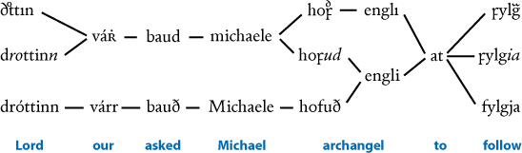
Ill. 1. Paradigmatical variation along the syntagmatical axis of a text. Extract from the Old Norse translation of the Gospel of Nicodemus, Niðrstigningar saga. In this example, the variation is purely orthographical.

In other languages
DE: Text
FR: texte
IT: testo
OH

Textual criticism
Textual criticism is a field of textual scholarship. In most cases, textual criticism aims at producing a critical edition of a text. This is done by comparing all relevant versions of the text and thus identifying and removing the “errors” – or alterations and modifications – that have changed the contents of the text during its transmission process. Hence, the aim of a textual critic is usually to reconstruct the original contents of the text. This is also called constitutio textus.
The mechanics of textual criticism was known and applied already in the antiquity, but its principles were formalised as a scholarly set of rules only in the 19th and 20th centuries, mainly by German scholars Friedrich Wolf (1759-1824), Immanuel Bekker (1785-1871), Karl Lachmann (1793-1851), and especially Paul Maas (1880-1964) in his influential book Textkritik (1927). According to the latter, the process of textual criticism contains three stages: recensio, examinatio, and emendatio. In practice, all available material is examined, after which the most trustworthy evidence is used to eliminate the changes to the original. This process allows a scholar to reconstruct as original a state of the text as possible. The fruits of such study are normally given as a critical edition of the text, faithfully explaining and justifying the scholarly decisions of the editor. In most cases, a stemma is used as a tool for describing the relationships between the witnesses of the text.
The genealogical method encapsulated in Maas’s principles has been faced with fierce criticism since the early 20th century, e.g. by Joseph Bédier (1864–1938), A. E. Housman (1859–1936), and Henri Quentin (1872–1935). Still, even the most recent computational methods of stemmatology share the basic principles of textual criticism and base their algorithms on the similarities and differences of the textual witnesses.
Textual criticism is sometimes called “lower criticism” to make a contrast to “higher criticism” that aims to establish the authorship, date and place of the original text – much based on the findings of textual criticism.
For fuller discussion of different approaches to editions, see editions, types of.

References
– Bein, Thomas. 2008. Textkritik: Eine Einführung in Grundlagen germanistisch-mediävistischer Editionswissenschaft: Lehrbuch mit Übungsteil. Frankfurt am Main: Peter Lang.
– Greetham, David C. 1999. Theories of the Text. Oxford: Oxford University Press.
– Greg, Walter Wilson. 1950. “The Rationale of Copy-Text.” Studies in Bibliography 3: 19–36.
– Habib, Rafey. 2005. A history of Literary Criticism: From Plato to the Present. Cambridge, MA: Blackwell Publishing.
– Maas, Paul. 1960. Textkritik. 4th ed. Leipzig: Teubner. – 1st ed. 1927.
– McGann, Jerome J. 1992. A critique of Modern Textual Criticism. Charlottesville: University Press of Virginia.
– Pasquali, Giorgio. 1952. Storia della tradizione e critica del testo. 2nd ed. Firenze: Le Monnier. – 1st ed., Firenze: Le Monnier, 1934.
– Pöhlmann, Egert. 1994–2003. Einführung in die Überlieferungsgeschichte und in die Textkritik der antiken Literatur. Vol. 1: Antike (1994), Vol. 2: Mittelalter und Neuzeit (2003). Darmstadt: Wissenschaftliche Buchgesellschaft.
– Tanselle, G. Thomas. 1992. A Rationale of Textual Criticism. Philadelphia: University of Pennsylvania Press.
– Tanselle, G. Thomas, and David C. Greetham, eds. 1995. Scholarly Editing: A Guide to Research. New York: The Modern Language Association of America.
– West, Martin L. 1973. Textual Criticism and Editorial Technique Applicable to Greek and Latin Texts.Stuttgart: Teubner.

In other languages
DE: Textkritik
FR: critique textuelle
IT: critica testuale
TH

Textual scholarship
Textual scholarship – sometimes also called “textual studies” – is a collective term for various disciplines studying, describing, transcribing, editing, and commenting upon texts. The variety of such disciplines covers, e.g., practically all fields of literary studies, textual criticism, book history, analytic and descriptive bibliography, stemmatology, media studies, and even rather specialised fields like palaeography, codicology, and epigraphy. The topics, subjects, methods, theories, and practices of different approaches of textual scholarship vary significantly, but they all share the common interest in the genesis and transmission of texts. According to its broadest definition, textual scholarship deals with any aspect of any system of written marking on any surface.

References
– Fraistat, Neil, and Julia Flanders, eds. 2013. The Cambridge Companion to Textual Scholarship. Cambridge: Cambridge University Press.
– Greetham, David C. 1994. Textual Scholarship: An Introduction. Garland Reference Library of the Humanities, vol. 1417. New York: Garland.
– Williams, William Proctor, and Craig S. Abbot. 2009. An Introduction to Bibliographical and Textual Studies. 4th ed. New York: Modern Language Association of America. – 1st ed. 1970.

In other languages
DE: Textforschung
FR: étude des textes
IT: scienze del testo / studio del testo
TH

Textual variance
See transmission, types of.

Timpanaro, Sebastiano
Sebastiano Timpanaro (Parma, 1923 – Firenze, 2000) was an Italian philologist and literary critic as well as an intellectual of wide-ranging interests, including Classics, history, and Marxist and Freudian theory. After graduate studies at the University of Florence, under the direction of Giorgio Pasquali, Timpanaro mainly devoted himself to classical philology, literary criticism (particularly about Giacomo Leopardi’s and Edmondo De Amicis’ works), and the history and methods of philology. However, he never took up a permanent academic position. In 1995 he was granted the Antonio Feltrinelli Prize for Philology and Linguistics.
His most influential work The Genesis of Lachmann’s Method (La genesi del metodo del Lachmann 1963; Engl. trans. Most 2005) provides a historical and critical examination of the increasing rationalisation and professionalisation applied to the study of the transmission of written texts. Parts of this book respond to the mathematical presentation of near mechanical textual criticism by emphasising the diversity of copyists’ errors and the production of variants specifically through contamination, scribal conjecture and polygenesis.
He also studied Marxist theory (see, for example, Il verde e il rosso. Scritti militanti, 1966-2000), and the relationship between psychoanalysis and textual criticism. These subjects also figure prominently in The Freudian Slip: Psychoanalysis and Textual Criticism (Il lapsus freudiano. Psicanalisi e critica testuale 1975; Engl. trans. Soper 1976), which contains a “sustained polemic against the later Freud and Freudian psychoanalysis in general […] and against the psychoanalytic explanation of so-called Freudian slips in particular, which in most cases, based on his conception of materialism and his experience of textual criticism (and proofreading), he attributes instead to exactly the same kind of mechanical processes as result so often in mistakes in transcribing manuscripts” (Most, 6).
In addition to studies on nineteenth-century Italian intellectual history, specifically in relation to classicism, Timpanaro wrote a collection of philosophical essays titled On Materialism (Sul materialismo 1997).

By Timpanaro
– Timpanaro, Sebastiano.1963. La genesi del metodo del Lachmann. Firenze: Le Monnier. – 2nd ed. Padova: Liviana, 1981.
– ———.1965. Classicismo e illuminismo nell’Ottocento italiano. Pisa: Nistri-Lischi.
– ———.1975. Il lapsus freudiano: Psicanalisi e critica testuale. Firenze: La Nuova Italia.
– ———.1986. Per la storia della filologia virgiliana antica. Roma: Salerno editrice.
– ———. 1994. Nuovi contributi di filologia e storia della lingua latina. Bologna: Pàtron.
– ———.1995. Nuovi studi sul nostro Ottocento. Pisa: Nistri-Lischi.
– ———.1997. Sul materialismo. Milano: Unicopli.
– ——— (post.). 2001. Il verde e il rosso: Scritti militanti, 1966–2000. Roma: Odradek.
– ——— (post.). 2001. Virgilianisti antichi e tradizione indiretta. Firenze: Olschki.

Translations
– Most, Glenn, ed. and trans. 2005. Sebastiano Timpanaro. The Genesis of the Lachmann’s Method. Chicago: The University of Chicago Press.
– Soper, Kate, trans. 1976. Sebastiano Timpanaro.TheFreudian Slip: Psychoanalysis and Textual Criticism.London: NLB.

On Timpanaro
– Ghidetti, Enrico, and Alessandro Pagnini, eds. 2005. Sebastiano Timpanaro e la cultura del secondo Novecento. Roma: Edizioni di storia e letteratura.
MB, AC, CM

Tools
This is a list of relevant tools for the quantitative analysis of textual data. Each tool is briefly discussed in the lexicon:
– APE
– CollateX
– Juxta
– Method, Leitfehler-based
– MrBayes
– NeighborNet
– PAUP
– PHYLIP
– RHM
– Semstem
– SplitsTree
– StemmaWeb
– Stemweb
– UPGMA

Tradition, artificial
Artificial textual traditions are used to test and develop the methods of textual criticism and computer-assisted stemmatology. They try to imitate the different aspects of the actual copying and dissemination process of a real-life text as closely as possible: e.g., in order to simulate a mediaeval textual tradition, the text may be copied by several scribes by hand and its language may be familiar to the scribes but not their mother tongue. Such laborious practices restrict the possible size of an artificial textual tradition created by actual scribes, and the biggest artificial traditions of this kind consist of slightly over a hundred copies of a text (as of May 2015). Therefore, computers have also been and are being used to mutate the original contents of a text to create an artificial tradition. Whatever the means, the basic idea is to have a data set that is comparable to real-life textual traditions but the history and development of which is known in detail. Thus, the artificial data sets help to evaluate the performance of various methods to study textual traditions.
On the other hand, the genealogical tree of a textual tradition can be simulated by defining an original and a probability rate that it is lost and another one that it is copied per time t. Weitzman pioneered this approach and plotted some cases, cf. ill below. It is interesting to note how the archetype shifts through the loss of witnesses and ends up being equal to witness 13 in this example. Many other initial text branches in Weitzman's experiment became completely extinct soon.

References
– Baret, Philippe V., Caroline Macé, and Peter Robinson. 2006. “Testing Methods on an Artificially Created Textual Tradition.” In The Evolution of Texts: Confronting Stemmatological and Genetical Methods, edited by Caroline Macé, Philippe Baret, Andrea Bozzi, and Laura Cignoni, 255–281. Linguistica computazionale, vols. 24–25. Pisa: Istituti editoriali e poligrafici internazionali.
– Roos, Teemu, and Tuomas Heikkilä. 2009. “Evaluating Methods for Computer-Assisted Stemmatology Using Artificial Benchmark Data Sets.” Literary and Linguistic Computing 24 (4): 417–433.
– Trovato, Paolo. 2014. Everything You Always Wanted to Know about Lachmann’s Method: A Non-Standard Handbook of Genealogical Textual Criticism in the Age of Post-Structuralism, Cladistics, and Copy-Text. Foreword by Michael D. Reeve. Firenze: Libreriauniversitaria.it edizioni.
– Weitzman, Michael P. 1982. “Computer Simulation of the Development of Manuscript Traditions.” ALLC Bulletin 10: 55–59.

Illustration
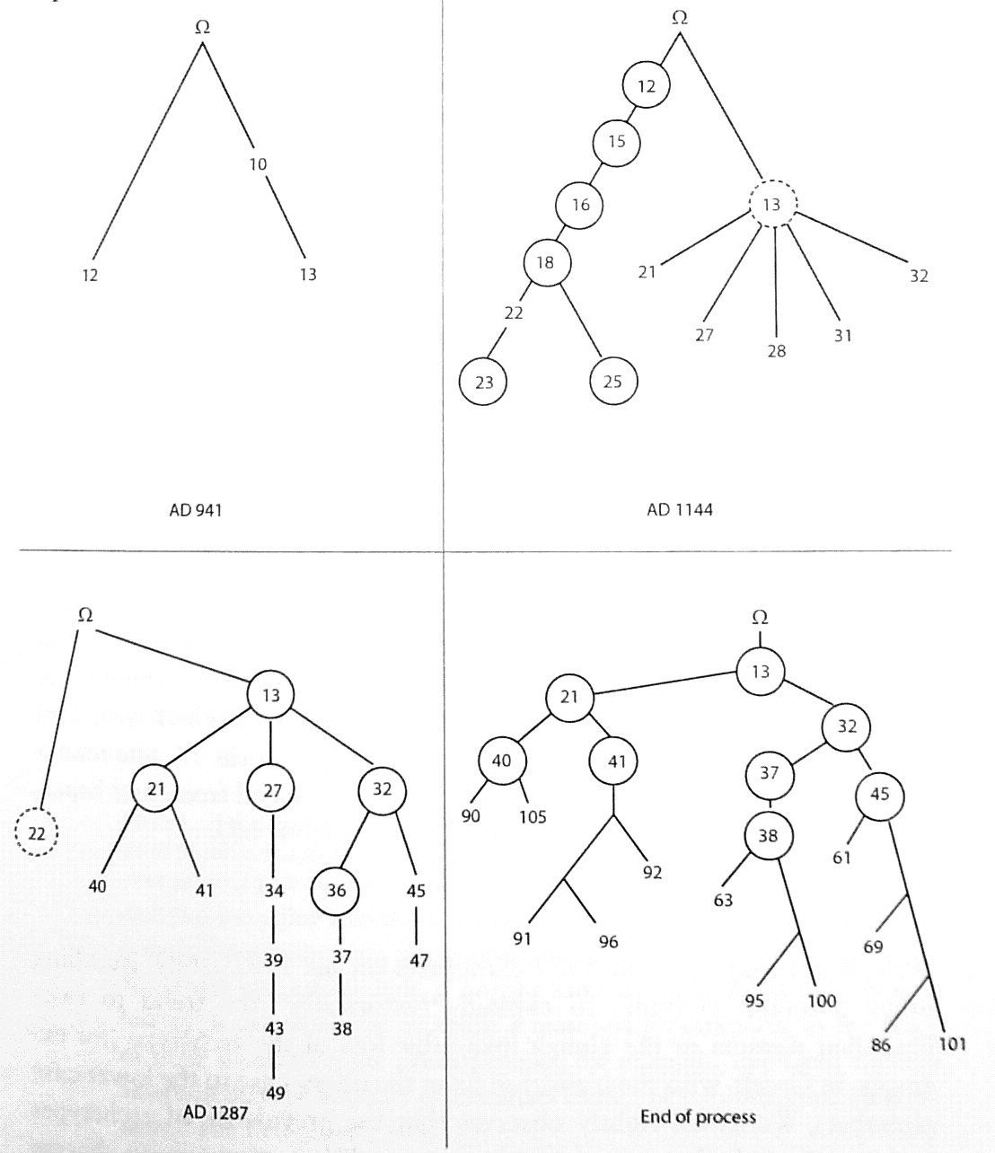
Fig. 1. Illustration from Weitzman, as reproduced in Trovato, p. 87. Here, Ω represents the original; circled manuscripts have been lost, dotted rings show manuscript that are dying in the present step.

In other languages
DE: künstliche Texttradition
FR: tradition textuelle artificielle
IT: tradizione testuale artificiale
TH, PR

Tradition
The tradition of a work is made up of the texts in which this work has been transmitted, as attested by its witnesses. The tradition is said to be 'direct' if the witnesses are 'direct', i.e. if they are assumed to be copies (manuscripts) or prints (editio princeps, incunabula) of the work itself. Part of the tradition can be 'indirect', consisting of indirect witnesses, i.e. excerpts or citations from the work in other works or translations of the work into another language.
Several other distinctions have been proposed with respect to traditions. A long-standing one is the distinction introduced by Giorgio Pasquali (1952) between vertical and horizontal transmission, i.e. uncontaminated vs. contaminated transmission (cf. contamination). Alberto Vàrvaro (2004; originally 1970, 574–587) proposed to distinguish between active and quiescent traditions (tradizione attiva and tradizione quiescente, cf. redaction): in the former, the copyist is supposed to play an "active" role in modifying the text while copying it; in the latter, the act of copying is considered more passive and therefore only few and unintentional innovations happen to be introduced. With respect to the medium of transmission, a distinction is often drawn between oral and written (and even mixed) traditions, cf. media transmitting texts.
Some scholars (like Zumthor, 73ff.) would like to draw a distinction between a manuscript tradition and a textual tradition, in the sense that a manuscript tradition is the sequence of physical copies of the work being made, while a textual tradition is the sequence of texts that are vehicles for the work.
The development of textual/manuscript traditions is sometimes studied by artificially creating such traditions (see artificial textual traditions).
Martin West (1973, 53) uses to term paradosis in a similar meaning. He defines it as: “the data furnished by the transmission, reduced to essentials.” I.e., paradosis are the different features that occur in the text due to its transmission history. The Greek word παράδοσις means 'tradition'.

References
– Hunger, Herbert. 1961–1964. Geschichte der Textüberlieferung. 2 vols. Zürich: Atlantis.
– Pasquali, Giorgio. 1952. Storia della tradizione e critica del testo. 2nd ed. Firenze: Le Monnier. – 1st ed., Firenze: Le Monnier, 1934.
– Vàrvaro, Alberto. 2004. “Critica dei testi classica e romanza: Problemi comuni ed esperienze diverse.” In Alberto Vàrvaro, Identità linguistiche e letterarie nell’Europa romanza, 567–612. Roma: Salerno editrice. – Originally published in 1970.
– West, Martin L. 1973. Textual Criticism and Editorial Technique Applicable to Greek and Latin Texts. Stuttgart: Teubner.
– Zumthor, Paul. 1972. Essai de poétique médiévale. Paris: Editions du Seuil.

In other languages
DE: Tradition
FR: tradition
IT: tradizione
OH, CM, MB, TH, PR

Tradition, indirect
In the process of establishing a text and of understanding its history, direct witnesses do not always suffice, and it often proves necessary to use indirect witnesses as well, because they may be older or provide other information than the preserved manuscripts. According to the type of indirect witness and to its degree of reliability (faithfulness or closeness to the text), the use of those witnesses for the history of the text and for the constitutio textus will pose various methodological problems, that should not be underestimated.
The indirect tradition may consist of the following types of indirect witnesses to a given text (the list is not exhaustive):
- ancient or mediaeval translations of the text in other languages,
- (exact) quotations of the text in later other texts, especially in anthologies,
- any kind of rewriting of the text, either by the author himself or by others: a paraphrase, a summary, or even another recension of the text can be considered an indirect witness to the text.
The indirect tradition can sometimes be used as an out-group element to polarise variant readings in a textual tradition, this is especially true for ancient translations. In the case of the edition of the Greek and Latin Bible, for example, quotations of passages in the works of Church Fathers are regularly mentioned in the critical apparatus, as they may help to localise geographically a family of text. It also happens that a text is preserved in a more complete form in a translation than in the direct witnesses. This is the case of Titus of Bostra, Contra Manichaeos for example, of which a longer version is preserved in a Syriac translation (edited side by side with the Greek), and some fragments as well a mediaeval anthology (John of Damascus' Sacra parallela) (Poirier et al. 2013). In a text such as Proclus' Commentary on the Parmenides, the end of the text is missing in Greek and could be reconstructed thanks to a 13th-century Latin translation, although the back translation of a translation is a tricky procedure (Steel and Van Campe 2009).

References
– Poirier, Paul-Hubert, Agathe Roman, Thomas Schmidt, Éric Crégheur, and José Declerck, eds. 2013. Titus Bostrensis, Contra Manichaeos Libri IV: Graece et Syriace. Turnhout: Brepols.
– Steel, Carlos, and Leen Van Campe, eds. 2009. Procli In Platonis Parmenidem commentaria. Vol. III, Libros VI–VII. Oxford: Clarendon.

In other languages
DE: indirekte Tradition
FR: tradition indirecte
IT: tradizione indiretta
CM

Transmission
In textual scholarship, transmission is the process, through which a text has been transmitted to the public. Transmission can take place through a number of different media, e.g. through copying by hand, printing, electronic media, or orally, normally by reproducing the contents of the text more or less faithfully. It comprises all different stages of disseminating the text and its contents, starting from the original text of the author(s), as well as all the copies and versions of the text, be they extant or not. Hence, transmission has both historical and geographical aspects. One popular way to visualise transmission is to draw a stemma describing the relationships between extant witnesses of the text.

In other languages
DE: Überlieferung
FR: transmission
IT: trasmissione
TH

Transmission, types of
Manuscript andtext traditions differ strongly among each other, which makes it necessary to use different methods to study and eventually edit the text transmitted by them. There are smooth transitions between the various kinds of textual traditions, therefore it is to some point arbitrary to define different types. To the author's knowledge there is no attempt at a typology yet. Nonetheless a few quite obvious types may be mentioned here in a sketchy form. One possibility is to group traditions according to the amount of contamination in their transmission:
– "Non-contaminated transmissions": no contamination, no “thinking” or collating scribes, thus a full stemma may be elaborated according to the rules laid out by Paul Maas (1960). Such traditions seem to be very rare for texts that are transmitted in more than a handful of witnesses.
– “Bottle-neck transmission": all extant witnesses can be traced to a bottle-neck, a witness written long after the texts composition. Stemmatics cannot reconstruct texts beyond such a bottle-neck. For classical Latin or Greek texts there is often such a bottle neck either in the 3rd c. AD (when scrolls were copied to codices) or in the 9th century when manuscripts were copied to minuscule script. Before and after the bottle-neck contamination may have been present or not. Such a bottle-neck is the rule for the transmission of texts from classical antiquity.
– “Heavily contaminated transmission”: texts that were very popular among certain groups, such texts are thus very liable to contamination. The editor may be unable to advance further than to individualise some families of witnesses, and it may be impossible to reconstruct the stemma. The Latin Bible or the Regula Bendedicti are examples.
Another criterion may be how scribes treated texts, in how authoritative and consequently inviolable scribes considered them, e.g.:
– “Growing or fluid texts”: texts not written by a single known or prestigious author, but growing around a nucleus that may have been much smaller and very different in the beginning. This is typical for many florilegia and other texts written for every-day use (‘Gebrauchstexte’). Scholarly interest is usually not centred on the “original” but on the growing tradition itself. E.g. the Indian epic Mahābhārata. It may be best to edit several forms of the text along side or to edit the vulgate (if one exists).
– “Textus receptus”: the text was standardised at a certain moment and all other text forms eradicated. This may happen for Holy Scripture, e.g. the Masoretic text of the Hebrew Bible. This is similar to the bottle-neck transmission above.
– “Fixed texts”. For texts preserved in more than one witness it is very rare that there are (nearly) no differences in their text, but this may happen in texts considered to be very holy and known by heart by their community. E.g. the Indian Ṛgveda.
Other ways of differentiating types of transmission include open / closed recensions, or the distinctions described by Bernabé (2010, 24-26).
Such different forms of traditions require different editorial approaches. It would be interesting to work out a typology of textual traditions in detail, a task that has not been attempted up till now.

References
– Bernabé, Alberto, and Felipe G. Hernández Muñoz. 2010. Manual de crítica textual y edición de textos griegos. 2nd ed. Madrid: Akal.
– Hunger, Herbert, Otto Stegmüller, Hartmut Erbse, Max Imhof, Karl Büchner, Hans-Georg Beck, and Horst Rüdiger. 1961–1964. Geschichte der Textüberlieferung der antiken und mittelalterlichen Literatur. Vol. 1, Antikes und mittelalterliches Buch- und Schriftwesen: Überlieferungsgeschichte der antiken Literatur.Vol. 2,Überlieferungsgeschichte der mittelalterlichen Literatur. Zürich: Atlantis-Verlag.
– Linde, Cornelia. 2012. How to correct the Sacra scriptura? Textual criticism of the Latin Bible between the twelfth and fifteenth century. Oxford: The Society for the Study of Medieval Languages and Literature.
– Maas, Paul. 1960. Textkritik. 4th ed. Leipzig: Teubner. – 1st ed. 1927. The Appendix “Leitfehler und stemmatische Typen” was first published in Byzantinische Zeitschrift 37 (1937): 289–294.
– Pasquali, Giorgio. 1952. Storia della tradizione e critica del testo. 2nd ed. Firenze: Le Monnier. – 1st ed., Firenze: Le Monnier, 1934.
PR

Transposition
Transposition describes an alteration in the order or a change in the position of letters, syllables, words, phrases and/or passages between the exemplar and the copy.
Cf. types of errors, addition, omission, and text.

Reference
– Havet, Louis. 1911. Manuel de critique verbale appliquée aux textes latins. Paris: Hachette.

In other languages
GE: Umstellung
FR: transposition
IT: trasposizione
AC

Tree
A tree is a connected graph in which there are no cycles. This implies that between any two nodes, there is only a single path.
In a directed tree (below left), it is also required that no node has indegree greater than one, i.e., that no node has more than one edge pointing to it. Therefore, it is possible that a directed graph has no cycles but it is not a directed tree – for example, consider the graph obtained by inverting the direction of all the edges in the graph below. A directed tree always has exactly one root (a node that has no edges pointing to it). Below, node A is the root.
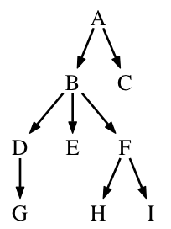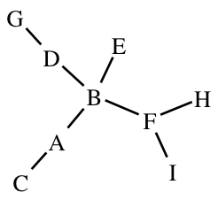
An undirected tree (above right) can always be directed by picking one of the nodes as the root and orienting all edges away from it. Picking node A as the root in the undirected graph below yields the directed tree on the left.
Nodes that have degree one are called leaf nodes (C,G,E,H,I above). The other nodes are called internal (or interior) node (A,B,D,F above).
A directed tree is bifurcating if the outdegree of each node is either zero or two. An undirected tree is bifurcating if all nodes have degree either three or one. Nodes whose degree exceeds the said limit (for directed trees two and for undirected trees three) are called multifurcating, an example being node B above with outdegree three and degree four.
A stemma is often a tree, although occasionally loops are introduced in the graph (which will then become a DAG) in order to represent instances of contamination. It is customary to associate extant manuscripts with the leaf nodes, in which case the interior nodes represent extant ancestors (whose descendants are then codices descripti) or hypothetical lost manuscripts which may remain unlabeled.

In other languages
EN: Baum
FR: arbre
IT: albero
TR, VM, KH

Tree, unrooted
A diagram depicting relationships among witnesses in a textual tradition (or among taxa or organisms when applied to biological examples) that does not indicate which is closest to the original text. It may be possible to infer that with additional historical information, or by making assumptions about rates or directions of change.
See also polarisation and tree.
In other languages
DE: ungewurzelter, unverwurzelter, wurzelloser Baum
FR: arbre non enraciné
IT: albero non radicato
CH, HW

Trennfehler
From the German trennen 'to sparate' and Fehler 'error'. See error, separative.

In other languages
EN: separative error
FR: erreur séparative
IT: errore separativo / disgiuntivo (the latter is less frequently used than the former)
PR

T-Rex method
The T-Rex software and web service (Makarenkov 2001) implement a number of phylogenetic methods including a special technique for constructing reticulograms. The latter is commonly referred to as the T-Rex method.
The T-Rex method (Legendre and Makarenkov 2002) begins by building a phylogenetic tree using an existing tree reconstruction technique, such as Neighbour joining (NJ). Additional reticulation edges are then added to the tree in order to achieve a better representation of the taxon–taxon pairwise distances computed from the data. For example, after building a NJ tree, a pair of taxa, say A and B, may be placed in the tree in a way that exaggerates their pairwise distance. To rectify this, one can add an edge between A and B, or nodes adjacent to them, depending on which choice leads to the best overall match between the distances represented by the tree and distances computed from the data. The number of reticulation edges to be added can be given by the user or determined automatically using various different criteria also implemented in the T-Rex software package.

References
– Makarenkov, Vladimir. 2001. “T-Rex: Reconstructing and Visualizing Phylogenetic Trees and Reticulation Networks.” Bioinformatics 17: 664–668.
– Legendre, Pierre, and Vladimir Makarenkov. 2002. “Reconstruction of Biogeographic and Evolutionary Networks Using Reticulograms.” Systematic Biology 51 (2): 199–216.
TR

UPGMA
UPGMA stands for Unweighted Pair Group Method with Arithmetic Mean. UPGMA is a bottom up clustering method to create rooted phenetic trees (trees not based on sequence variants, but on morphological traits or other observable features). In a phylogenetic context, UPGMA assumes a constant rate of evolution.
UPGMA is the regarded as the most straight forward method of tree construction. It was originally developed for constructing taxonomic phenograms, but it can also be used to construct phylogenetic trees if the rates of evolution are approximately constant among the different lineages (Opperdoes 2004). UPGMA computes for each pair of taxons which pair has the smallest distance (i.e. least mutations), it the collapse that pair into one single taxon. This process is repeated until a root tree is derived. The assumed constant rate of mutations is believed to result in incorrect trees frequently (Anon. 2012).

References
– Opperdoes, Fred. 2004. Construction of a distance tree using clustering with the Unweighted Pair Group Method with Arithmetic Mean (UPGMA). Available at: http://www.icp.ucl.ac.be/~opperd/private/upgma.html. Accessed 1 November 2015.
– Anon. 2012. UPGMA. Sequentix. Available at: http://www.sequentix.de/gelquest/help/upgma_method.htm. Accessed 1 November 2015.
JZ

Usus scribendi
By usus scribendi, lit. “way of writing”, is usually meant the set of linguistic, stylistic and rhetorical features that can be said to characterise the way of writing of a specific author / redactor, or that can be attributed to either the genre or the period to which the work belongs.
The criterion of usus scribendi, as well as that of lectio difficilior, is applied by the scholar in order to choose between two or more variants bearing the same stemmatic value, i.e. when no “mechanical” reconstruction happens to be possible or safely applicable, and the editor’s choice is governed only by internal judgement. Usus scribendi pertains to that phase of the emendatio process which goes under the name of selectio (the other two being divinatio and combinatio).

Reference
– Stussi, Alfredo. 1985. La critica del testo. Bologna: il Mulino. || See p. 14.

In other languages
Latin term used throughout.
MB

Variance (Mathematical)
From a mathematical point of view, variance is a measure for the amount of spread one finds in observed data. When measuring any variable multiple times, the value for each observation may differ. The variation may be due to error, or to actual variation in the measured object. The former type of variation is observed for instance when one asks a class of school children to indicate a length of one meter with their hands: one will find that each estimated length has some deviation with regard to an exact meter. The latter type of variation one finds for instance in a taking the height of individuals in a group of people.
Expressed as a number, variance tells us how large the spread of the observations is, i.e. how much any result may deviate from the mean value found. The larger the variance the more imprecise the exact value of an observed feature was: e.g. most schoolchildren had no clue as to the distance a meter signifies. Of course when establishing the variance within a variable such as length of people, a larger variance does not indicate error in measurement but that, apparently, in the observed group length varies significantly.
The numerical expression of variance for N observations is defined as the mean of the total of the squared deviation of each observation from the mean value, m, for all observations. Thus:
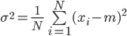
gives us a measure for how much observed values deviate on average from the mean value found.
Note that variance is thus measured in deviations from the mean, squared. This means variance is not a very 'natural' or human measure to us. To scale back to the order of magnitude that the observations were made in, one scales back to the standard deviation, which is the square root of σ², so σ.
Variance and variants relate in the sense that we can count variants as data points. For instance, there is a certain spread on average in the amount of variants per document or witness. What does it mean if we find a witness that is extremely deviant in that amount? But we can also count variants into categories, at which point they may become genetically relevant, acting in similar way as DNA mutations cause variance and are tell tale of genetic provenance.

In other languages
DE: Varianz
FR: variance
IT: varianza
JZ

Variant graph
A variant graph is a means of representing the variation in a text via a directed acyclic graph. Each such graph has a beginning node and an ending node; each textual witness is represented through a single path through the graph from beginning to end, taking in along the way the sequence of readings that make up that text.
The variant graph was pioneered by Schmidt/Colomb (2009), who proposed a model in which both the text versions and the witness labels are put on the graph edges, while the nodes represent waypoints within the text where divergence begins or ends. An example of this style of variant graph is given in Fig. 1; the graph represents three witnesses A, B, and C, whose texts read respectively:

A – Questa è l'ultima traccia d'un antico acquedotto di sguardi, una orbita assorta e magica:
B – Questa è l'ultima cenno d'un antico acquedotto di sguardi, la sua curva sacra e muta:
C – Questa è l'ultima porta d'un antico acquedotto di sguardi, la sua curva sacra e solitaria:
Illustration
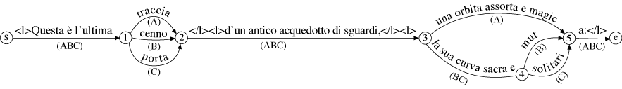
Fig. 1. An example of a variant graph, from Schmidt 2009.
The version of the variant graph now most commonly in use (e.g. in the CollateX and StemmaWeb tools) instead displays the text readings themselves on the nodes of the graph, while the edges carry labels only for the witnesses, as they take a particular path between the nodes to string together their readings. An example of this graph is given in Fig. 2; the graph represents seven witnesses which read thus:
Va6: Apostolus insignes quae pertineant ad deum
Vb11: Apostolus insignes quae ad deum pertinent
Vb12: Apostolus insignis quae pertineant ad deum
Vb18: Apostolus insignes in his qui pertinent ad deum
Vb20: Apostolus insignes quae pertineant ad eos
Vb21: Apostolus insignes in his quae pertinent ad deum
Vb9: Apostolus insignes quae pertineant ad christum
Illustration
Fig. 2. An example of a variant graph produced by the StemmaWeb tool (the data is from a sermon by St Augustine quoted in Shari/Partoens 2012, the graph also in Andrews/Macé 2013)
In some cases (e.g. in Stemmaweb) variant graphs may be annotated with links between readings that describe their relationship to each other; in order to preserve the directed and acyclic properties of the rest of the graph, these annotation links must be stored and analysed separately. An example is given in Fig. 3, where the transposition of 'pertinent' is noted with a red link, the near-synonym 'christum' and 'deum' is shown with a green link, and the grammatical relationship between the readings insignes/insigis, qui/quae, and pertinent/ pertineant are shown with blue links.
Illustration
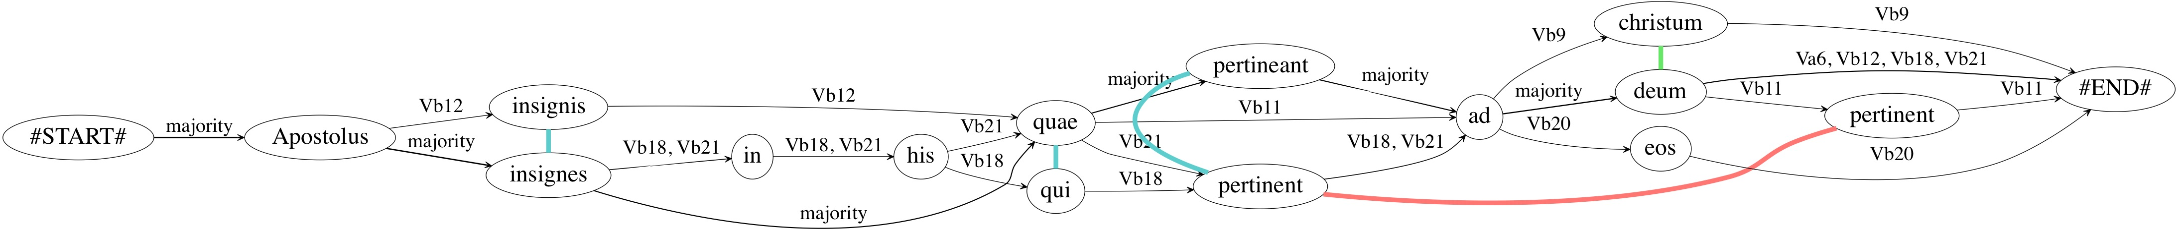
Fig. 3. An example of an annotated variant graph (same provenance as fig. 2).

References
– Andrews, Tara L., and Caroline Macé. 2013. “Beyond the Tree of Texts: Building an Empirical Model of Scribal Variation through Graph Analysis of Texts and Stemmata.” Literary and Linguistic Computing 28 (4): 504–521, doi:10.1093/llc/fqt032.
– Boodts, Shari, and Gert Partoens. 2012. “The Manuscript Transmission of the De Uerbis Apostoli Collection: A New Perspective.” In Tractatio Scripturarum: Philological, Exegetical, Rhetorical, and Theological Studies on Augustine’s Sermons, edited by Anthony Dupont, Gert Partoens, and Mathijs Lamberigts, 79–96. Turnhout: Brepols.
– Schmidt, Desmond. 2009. “Merging Multi-Version Texts: A Generic Solution to the Overlap Problem.” In Proceedings of Balisage: The Markup Conference.Balisage Series on Markup Technologies, vol. 3. doi:10.4242/BalisageVol3.Schmidt01.
– Schmidt, Desmond, and Robert Colomb. 2009. "A Data Structure for Representing Multi-Version Texts Online.” International Journal of Human-Computer Studies 67: 497–514.

In other languages
DE: Variantengraph
FR: graphe des variantes
IT: grafo delle varianti / grafico variante (the latter is rarely used)
TA

Variant location
A variant location is a place in a reference text where the witnesses present different variant readings: cf.locus criticus. On one variant location, there must be at least two variants, but there can be more (multiple variant location).
A variant location may include one word (in some extreme cases one character) or one group of words, consecutive (e.g. in case of an omission) or not (e.g. in case of a transposition). Cf. examples below.
Fig. 1. Macé, De Vos, and Geutens 2012, 114 (Figure 2).

References
– Irigoin, Jean. 1979. “Sélections et utilisations des variantes.” In La pratique des ordinateurs dans la critique des textes: Paris 29–31 mars 1978, edited by Jean Irigoin and Gian Zarri, 265–271. Paris: Éditions du CNRS.
– Macé, Caroline, Ilse De Vos, and Koen Geuten. 2012. “Comparison of stemmatological and phylogenetic methods to understand the copying history of the Florilegium Coislinianum.” In Ars edendi lectures Series, edited by Alessandra Bucossi and Erika Kihlman, vol. 2, 107–129. Stockholm: Stockholm University Press.

In other languages
DE: variierende Stelle (rarely used)
FR: lieu variant
IT: luogo variante (rarely used)
CM

Variant (reading)
Cf. reading, variant.

Version
In textual criticism a version is a major revision of a work. In Latin, the verb vertere means to turn over, and in a very concrete sense, versions were used of texts which were changed e.g. from a metrical form to a prosaic form either within the same language or through the process of translation. Perhaps more frequently, the term is being used of any revision of a text which is so distinctive that each version may aspire to be regarded as a work of its own. However, as long as the revised form is referred to as a version, it is usually seen as belonging to a single work. In the FRBR typology, versions should be located to the level of expression, below the level of the work and above the level of manifestation (Functional Requirement for Bibliographical Records 1998, p. 14).
Versions are generally held to be of a higher level of difference than redactions and recensions of a work.

Reference
– Functional Requirements for Bibliographical Records. Final Report. München: Saur, 1998. – http://www.ifla.org/publications/functional-requirements-for-bibliographic-records. Accessed 1 November 2015.

In other languages
DE: Fassung
FR: version
IT: versione
OH

Vulgarisation
In several cases we have reasons to assume that a text written in antiquity (often but not always in Late Antiquity) was written in a more orthodox form of language than the one met with in the manuscripts and that it has thus been ”vulgarised” in the transmission during the early middle ages (see: analysis of forms). For both Greek and Latin there were orthographic and grammatical standards, which those writing in those languages tried to follow as well as they could. In the early middle ages, literacy decreased considerably and the copyists were often less familiar with the established norms than during previous centuries.
The changes then introduced regard both orthography (due to phonetic changes) and morphology (certain endings were no more in use in the spoken language and thus confused in writing) and in certain cases even syntax.
The texts thus affected are often anonymous technical texts, but in some cases texts written by authors known to us, who probably had received a reasonably good literary training, have been vulgarised in the later transmission. the Regula Benedicti written by Benedict of Nursia around 540 and the Decem libri historiarum (sometimes called Historia Francorum) written by Gregory of Tours in the late 6th century are examples of texts which seem to have been affected by this.
Even texts written in elegant classical Latin were sometimes affected by vulgarisation – there are, for instance, traces of such a tradition in some manuscripts to Caesar’s De bello Gallico.
The introduction of unorthodox orthography and morphology is explained more easily if the texts in question were copied by dictation.
The texts which had been vulgarised in the early middle ages were often also affected by "normalisation" in the high middle ages when the scribes were more familiar with the classical standards.
See also normalisation.

References
– Bayet, Jean, ed. 1961. Tite-Live: Histoire romaine. Livre I. Texte établi par Jean Bayet et traduit par Gaston Baillet. Paris: Les Belles Lettres. || See p. LXXXVI.
– Coleman, Robert. 1999. “Vulgarism and normalization in the text of Regula Sancti Benedicti.” In Latin vulgaire – Latin tardif V: Actes du Ve Colloque International sur le latin vulgaire et tardif, Heidelberg, 5–8 septembre 1997, edited by Hubert Petersmann and Rudolph Kettemann, 345–356. Bibliothek der klassischen Altertumswissenschaften, N.F. 2: 105. Heidelberg: Winter.
– Giunta, Francesco, and Antonino Grillone. 1991. Iordanis De origine actibusque Getarum. Fonti per la Storia d’Italia pubblicate dall’Istituto Storico Italiano per il Medio Evo, vol. 17. Roma: Istituto Palazzo Borromini.
– Haverling, Gerd V.M. 2008. “On Variation in Syntax and Morphology in Late Latin texts.” In Latin vulgaire – Latin tardif VIII: Actes du VIIIe Colloque International sur le latin vulgaire et tardif, Oxford, 6–9 septembre 2006, edited by Roger Wright, 351–360. Hildesheim: Olms Weidmann.
– Hilchenbach, Kai Peter. 2009. Das vierte Buch der Historien von Gregor von Tours: Edition mit sprachwissenschaftlich-textkritischem und historischem Kommentar, Teil I + II. Lateinische Sprache und Literatur des Mittelalters, vol. 42. Bern: Peter Lang.

In other languages
DE: Vulgarisierung
FR: vulgarisation
IT: volgarizzazione
GH

Vulgate
From the Latin vulgata 'spread among the multitude (vulgus)'; the noun editio f. ‘edition’ is implied, so the form is feminine.
In textual criticism, a vulgate text means the text form that reached the widest distribution in a time, possibly long after the archetype, when a heightened interest in the text surged for one reason or another and many copies were made. When interest in a text is high, it is also likely that some people compare witnesses in order to arrive at the "best" text. Thus vulgate texts are often a kind of early text edition, or, to use a more negative formulation, the product of heavy contamination. Their text may supplant all other text forms and thus eradicate them. For an example cf. Trovato's discussion of the transmission of Dante's Divina commedia (2014, 299ff.).
With cladistic methods (if one groups any variants, instead of sticking to common errors) there is a great danger to arrive at a vulgate text instead of the archetype (cf. Trovato 2014, 138-144).
A vulgate reading is a reading present in a vulgate.

Reference
– Trovato, Paolo. 2014. Everything You Always Wanted to Know about Lachmann’s Method: A Non-Standard Handbook of Genealogical Textual Criticism in the Age of Post-Structuralism, Cladistics, and Copy-Text. Foreword by Michael D. Reeve. Firenze: Libreriauniversitaria.it edizioni.

In other languages
DE: Vulgata
FR: vulgate
IT: vulgata
PR

West, Martin Litchfield
Martin Litchfield West was born in London, September 23rd 1937, and died in Oxford, July 13th 2015. After undergraduate studies in Oxford (1955–1959), he remained there first as a junior research fellow (1959–1963) and then as a fellow and praelector in Classics (1963–1974). From 1974 to 1991 he was professor of Greek in London, but in 1991 he returned to Oxford to be a Senior research fellow at All Souls College (Oxford 1991–2004). After his retirement he was first an Emeritus fellow (2004–2014) and then an Honorary Fellow at All Souls College (from 2014).
West’s research interests range from ancient Greek language, literature and music and Indo-European poetry and myth to early Zoroastrianism. He has published important editions of and commentaries on early and classical Greek poetry, but he has also written important works on Greek and Indo-European metre and music. Lately he has also published works on the Avestan language and on Zoroastrianism. In 1973, he published an influential introductory work to textual criticism and editorial technique (cf. West 1973).
Martin L. West has published numerous books and editions and hundreds of articles and review articles. In the following list, we focus on his works relevant to this lexicon.

Works by West
– West, Martin Litchfield. 1966.Hesiod, Theogony. Oxford: Clarendon Press.
– ———. 1971 and 1972. Iambi et Elegi Graeci ante Alexandrum cantati, vol. I & 2. Oxonii: Clarendon Press. – 2nd improved and augmented edition 1989 and 1992 respectively.
– ———. 1973. Textual Criticism and Editorial Technique Applicable to Greek and Latin Texts. Stuttgart: Teubner. – Translated into Greek 1989, Italian 1991 and Hungarian 1999.
– ———. 1978. Hesiod, Works and Days. Oxford: Clarendon Press.
– ———. 1984. Carmina Anacreontea. Bibliotheca Teubneriana. Stutgardiae: Teubner. – Revised and augmented 2nd edition 1993.
– ———. 1987. Introduction to Greek Metre. Oxford: Clarendon Press. – Translated into Polish 2003.
– ———. 1990. Aeschyli Tragoediae cum incerti poetae Prometheo.Bibliotheca Teubneriana. Stutgardiae: Teubner.
– ———. 1992. Ancient Greek Music. Oxford: Clarendon Press. – Reprinted with minor corrections 1994; translated into modern Greek 1999, Polish 2003 and Italian 2007.
– ———. 1998 and 2000. Homeri Ilias. Recensuit/testimonia congessit Martin L. West. Vol. 1 and 2, Stutgardiae: Teubner.
– ———. 2003. Greek Epic Fragments from the Seventh to the Fifth Centuries BC. Cambridge, Mass.: Harvard University Press.
– ———. 2003. Homeric Hymns, Homeric Apocrypha, Lives of Homer. Cambridge, Mass.: Harvard University Press.
– ———. 2007. Indo-European Poetry and Myth. Oxford: Oxford University Press.
GH

Witness
A witness is an existing instance of a text (see also copy). The witnesses form the evidence for the textual tradition of a given text, and are the basis from which stemmata are constructed. Witnesses may be carried in any physical medium; normally these will be manuscripts or printed books, but can also include oral recordings and the like in the case of folk tales and other oral traditions. A single manuscript is often witness to multiple texts, as manuscripts generally carry more than one text.
A distinction is normally drawn between a ‘direct witness’, which is an instance of the text observed directly in a document, and an ‘indirect witness', which may be a paraphrase, a translation, or even merely a reference to the text. Witnesses may be complete or incomplete, i.e. fragmentary or lacunary. Some scholars may also speak of a ‘conjectural witness’, which is not an extant textual witness but rather a postulated lost intermediary in a stemma.

In other languages
DE: Zeuge
FR: témoin
IT: testimone
TA

Work
The term work is used in a number of languages with more or less the same meaning – in German Werk, in French œuvre, in the Scandinavian languages verk or værk, etc. It is primarily a literary term, and belongs to the taxonomy of the textual material which usually is a basis for the actual stemmatological investigation. Works are identified in catalogues in which their transmission in manuscripts is described. In academic literature, works are commonly referred to by italicised titles, typically in the language of the work itself. For example, the Old Icelandic work Njáls saga (The saga of Njáll) is preserved in a number of manuscripts, and can only be accessed through these manuscripts or any editions based on these.
It happens that the textual critic decides to change the delineation of the work, e.g. by removing or adding manuscripts, but for most types of literature, the works have been rather firmly established, and the interest for the textual critic is to trace their transmission rather than to analyse their contents or historical settings.
In the FRBR model, the work is at the very top of the model, being represented by expressions, manifestations and individual items (Functional Requirement for Bibliographical Records, 1998, p. 14).

Reference
– Functional Requirements for Bibliographical Records. Final Report. München: Saur, 1998. – http://www.ifla.org/publications/functional-requirements-for-bibliographic-records. Accessed 1 November 2015.

In other languages
DE: Werk
FR: œuvre
IT: opera
OH

––– EXPLICIT LEXICON –––

